**MINISTRY OF EDUCATION AND TRAINING**

**FPT UNIVERSITY**

Capstone Project Document

JobHub - JobFair online management

|  |  |
| --- | --- |
| **Group GSU22SE01** | |
| **Group Members** | Truong Tran Tien - SE140104  Pham Cao Son - SE140012  Bui Minh Khoi - SE140038 |
| **Supervisor** | Mr. Kieu Trong Khanh |
| **Ext Supervisor** | Công TY CỔ PHẦN MD ONLINE - Võ Hoàng Nam |
| **Capstone Project code** | SU22SE23 |

- Ho Chi Minh City, 14 August 2022 –

*This page is intentionally left blank*

**Table of Contents**

List of Tables 6

List of Figures 7

Definitions and Acronyms 11

I. Project Introduction 12

1. Overview 12

1.1 Project Information 12

1.2 Project Team 12

2. Introduction 12

3. Product Background 13

4. Existing Systems 13

4.1 Traditional 13

4.2 VFairs 14

4.3 Brazen 14

4. Business Opportunity 14

5. Software Product Vision 14

6. Project Scope & Limitations 15

6.1 Major Features 15

6.2 Limitations & Exclusions 15

II. Project Management Plan 16

1. Overview 16

1.1 Scope & Estimation 16

1.2 Project Objectives 18

1.3 Project Risks 18

1.4 Product Risks 19

2. Management Approach 19

2.1 Project Process 19

2.2 Quality Management 20

2.3 Training Plan 21

3. Project deliverables 21

4. Project Organization 22

4.1 Team & Structures 22

4.2 Roles & Responsibilities 22

5. Project Communication 23

5.1 Communication Plan 23

5.2 External Interface 24

6. Configuration Management 24

6.1 Document Management 24

6.2 Source Code Management 24

6.3 Tools & Infrastructures 25

III. Software Requirement Specification 26

1. Product Overview 26

2. User Requirements 26

2.1 Actors 26

2.2 Use Cases 27

3. Functional Requirements 161

3.1 System Functional Overview 161

4. Non-Functional Requirements 173

4.1 External Interfaces 173

4.2 Quality Attributes 173

IV. Software Design Document 175

1. System Design 175

1.1 System Architecture 175

1.2 Package Diagram 177

2. Database Design 180

2.1. Physical diagram 180

2.2. Data dictionary 180

3. Detailed Design 203

3.1 Manager organizes a job fair 203

3.2 Supervisor fills booth information and decorator decorate booth 218

3.3 Attendant apply CV 250

3.4 Interviewer and attendant in interview process 275

4. Algorithms 291

4.1 Calculate matching point between CV and job position 291

V. Software Testing Documentation 297

1. Overall Description 297

1.1 Test Model 297

1.2 Testing Levels 297

2. Test Plan 297

2.1 Test Stages 297

2.2 Human Resources 297

2.3 Deliverables 297

3. Test Cases & Test Reports 297

VI. Release Package & User Guides 299

1. Deliverable Package 299

1.1 Source codes & documents 299

2. Installation Guides 300

2.1 System Requirements 300

2.2 Installation Instruction 300

2.3 Deployment Guide 301

3. User Manual 325

3.1 Feature 1 – Organize job fair 325

3.2 Feature 2 – Decorate job fair booth 333

3.3 Feature 3 – Attendant join job fair & Apply resume to job position 340

3.4 Feature 4 – Interview process 345

3.5 Feature 5 – Job fair statistic 356

# List of Tables

Table 1. Supervisor contact information 12

Table 2. Team member contact information 12

Table 3. Scope and estimation 18

Table 4. Project objective 18

Table 5. Project risks 18

Table 6. Product risks 19

Table 7. Training plan 21

Table 8. Project deliverables 21

Table 9. Role and responsibilities 23

Table 10. Communication plan 23

Table 11. FU contact 24

Table 12. Customer contact 24

Table 13. Tool & Infrastructure 25

Table 14. System main actors 26

Table 15. Use case list 30

Table 16. Screen description 169

Table 17. Screen authorizations 172

Table 18. Entity descriptions 173

Table 19. System architecture component descriptions 176

Table 20. Back-end package descriptions 178

Table 21. Front-end package description 179

Table 22. Test Stages 297

Table 23. Human Resources 297

Table 24. Deliverables 297

Table 25. Test Cases & Test Reports 298

Table 26. Source code and documentations 299

Table 27. Hardware requirements 300

Table 28. Software requirements 300

# List of Figures

Figure 1. Scrum Process 19

Figure 2. CI/CD Process 20

Figure 3. Team structure 22

Figure 4. Use case diagrams 27

Figure 5. Guest screens flow 161

Figure 6. Admin screens flow 162

Figure 7. Company Manager screens flow 163

Figure 8. Company Employee screens flow 164

Figure 9. Attendant screen flows 164

Figure 10. Entity Relationship diagram 171

Figure 11. System architecture 174

Figure 12. Back-end package diagram 176

Figure 13. Front-end package diagram 176

Figure 14. Database physical diagram 179

Figure 15. Class diagram - Manager organizes a job fair 203

Figure 16. Sequence diagram – Organize job fair 214

Figure 17. Sequence diagram –Update job fair 215

Figure 18. Sequence diagram –Get job fair list 215

Figure 19. Sequence diagram –Get job fair by ID 216

Figure 20. Class diagram – Supervisor fills booth information 217

Figure 21. Class diagram – Supervisor assigns tasks 227

Figure 22. Class diagram – Decorator decorates booth 239

Figure 23. Sequence diagram – Supervisor gets booth information 245

Figure 24. Sequence diagram – Supervisor updates booth information 246

Figure 25. Sequence diagram – Supervisor gets assignment task 246

Figure 26. Sequence diagram – Supervisor assigns task 247

Figure 27. Sequence diagram – Decorator gets booth decoration 247

Figure 28. Sequence diagram – Decorator saves booth decoration 248

Figure 29. Class diagram – Attendant applies CV 249

Figure 30. Sequence diagram – Attendant applies CV 272

Figure 31. Sequence diagram – Attendant gets application list 272

Figure 32. Sequence diagram – Attendant gets application by ID 273

Figure 33. Class diagram – Interview process 274

Figure 34. Sequence diagram –Interviewer gets application list 287

Figure 35. Sequence diagram –Interviewer gets application by ID 287

Figure 36. Sequence diagram –Interviewer evaluates application 288

Figure 37. Calculate matching point flow diagram 292

Figure 38. AWS Elastic Beanstalk – Access from console page 298

Figure 39. AWS Elastic Beanstalk - dashboard 299

Figure 40. AWS Elastic Beanstalk - Create new application 300

Figure 41. AWS Elastic Beanstalk – Create new environments 300

Figure 42. AWS Elastic Beanstalk – environment configuration 301

Figure 43. AWS Elastic Beanstalk – Platform configuration 301

Figure 44. AWS Elastic Beanstalk – Upload code 302

Figure 45. AWS Elastic Beanstalk – Configure more options 302

Figure 46. AWS Elastic Beanstalk – configure high availability 302

Figure 47. AWS Elastic Beanstalk – Edit software 303

Figure 48. AWS Elastic Beanstalk – Add environment properties 303

Figure 49. AWS Elastic Beanstalk – configure capacity 303

Figure 50. AWS Elastic Beanstalk – Configure scaling trigger 304

Figure 51. AWS Elastic Beanstalk – Access application 305

Figure 52. AWS Elastic Beanstalk – Link environment to application 305

Figure 53. AWS Elastic Beanstalk – get back-end URL 306

Figure 54. Back-end Swagger page 306

Figure 55. AWS EC2 – access from console page 307

Figure 56. AWS EC2 – Launch instance 307

Figure 57. AWS EC2 – Configure Operating System 308

Figure 58. AWS EC2 – Configure instance type 308

Figure 59. AWS EC2 -Generate key pair 309

Figure 60. AWS EC2 – confirm key pair 309

Figure 61. AWS EC2 – network setting 310

Figure 62. AWS EC2 – remove default security rule 311

Figure 63. AWS EC2 – add new security rule 311

Figure 64. AWS EC2 – configure new security rule 311

Figure 65. AWS EC2 – launch instance 312

Figure 66. AWS EC2 – get instance ID 312

Figure 67. AWS EC2 – confirm instance ID 312

Figure 68. AWS EC2 – get instance IPv4 313

Figure 69. AWS EC2 – connect to instance’s console 313

Figure 70. Multi-user server health check 314

Figure 71. AWS S3 – access from console page 315

Figure 72. AWS S3 – create new bucket 315

Figure 73. AWS S3 – configure bucket access rules 316

Figure 74 – AWS S3 – configure bucket rules 317

Figure 75. AWS S3 – Access new bucket 318

Figure 76. AWS S3 – access permissions tab 319

Figure 77. AWS S3 – edit permission rule 319

Figure 78. AWS S3 – access Objects tab 319

Figure 79. AWS S3 – upload FE code 320

Figure 80. AWS S3 – configure static website hosting 320

Figure 81. AWS S3 – configure static website hosting 321

Figure 82. AWS S3 – get front-end URL 321

Figure 83. AWS S3 – access front-end URL 322

Figure 84. Organize job fair – Access “My company job fairs” page 322

Figure 85. Organize job fair – Create new job fair 323

Figure 86. Organize job fair- Use default layout 323

Figure 87. Organize job fair – Review layout 324

Figure 88. Organize job fair – Upload new layout 324

Figure 89. Organize job fair – GLB rules 325

Figure 90. Organize job fair – Confirm choose layout 325

Figure 91. Organize job fair – Schedule job fair event 326

Figure 92. Organize job fair – Assign employees 326

Figure 93. Organize job fair – Assign employees CSV format 327

Figure 94. Organize job fair – Design landing page 328

Figure 95. Organize job fair – Review landing page 328

Figure 96. Organize job fair – Publish job fair 329

Figure 97. Organize job fair – Confirm publish job fair 329

Figure 98. Organize job fair – Created job fair 330

Figure 99. Decorate job fair booth – Supervisor task 330

Figure 100. Decorate job fair booth – Supervisor access fill booth information task 331

Figure 101. Decorate job fair booth – Booth information page 331

Figure 102. Decorate job fair booth – Booth job position detail 332

Figure 103. Decorate job fair booth – Fill booth job position detail 332

Figure 104. Decorate job fair booth – Supervisor assign task 333

Figure 105. Decorate job fair booth – Supervisor assign task manually 333

Figure 106. Decorate job fair booth – Supervisor confirm assign task 334

Figure 107. Decorate job fair booth – Decorator access decorate tasks 334

Figure 108. Decorate job fair booth – Decorator access decorate page 335

Figure 109. Decorate job fair booth – Decorator add more 3d component 335

Figure 110. Decorate job fair booth – Decorator save decoration 336

Figure 111. Decorate job fair booth – Decorator review decoration on map 336

Figure 112. Receptionist joins 3D booth 337

Figure 113. Receptionist waits for attendants 337

Figure 114. Attendant accesses job fair list 338

Figure 115. Attendant accesses job fair’s landing page 338

Figure 116. Attendant joins booth 339

Figure 117. Attendant communicates with receptionist 339

Figure 118. Attendant checks for company information 340

Figure 119. Attendant views job position detail 340

Figure 120. Attendant confirms do test 341

Figure 121. Attendant does test 341

Figure 122. Attendant submits test 342

Figure 123. Attendant applies job position 342

Figure 124. Interviewer accesses application lists 343

Figure 125. Interviewer views application list 343

Figure 126. Interviewer views application details 344

Figure 127. Interviewer views approved application list 344

Figure 128. Interviewers accesses interview schedule 345

Figure 129. Interviewer accesses daily schedule 345

Figure 130. Attendant accesses interview schedule 346

Figure 131. Attendant accesses daily interview schedule 346

Figure 132. Interviewer joins interview room 347

Figure 133. Interview room 347

Figure 134. Attendant joins waiting room 348

Figure 135. Waiting room 348

Figure 136. Attendant accepts interview invitation 349

Figure 137. Attendant joined interview room 349

Figure 138. Interviewer starts interview 350

Figure 139. Interviewer takes report 350

Figure 140. Interviewer checks attendant’s cv 351

Figure 141. Interviewer submits report 351

Figure 142. Interviewer ends interview 352

Figure 143. Interviewer removes attendant 352

Figure 144. Attendant checks interview status 353

Figure 145. Interviewer checks interview status 353

Figure 146. Job fair statistics page 354

Figure 147. Booth statistics page 354

# Definitions and Acronyms

|  |  |
| --- | --- |
| **Name** | **Definition** |
| Company | A company or an organization that registered to JobHub system and have the need to speed up their recruitment process. |
| Company manager | A person associates with a company, oversees company activities on JobHub system. |
| Company employee | A person works for a company, is under supervise of company manager. |
| Attendant | A person wants to find job position with suitable environment, benefit…. |
| API | Application Programming Interface |
| HTTP | Hyper Text Transfer Protocol |

# I. Project Introduction

## 1. Overview

### 1.1 Project Information

* Project name: JobFair online management
* Project code: GSU22SE01
* Group name: JobHub
* Software type: Web application

### 1.2 Project Team

#### a. Supervisor

|  |  |  |  |
| --- | --- | --- | --- |
| **Full Name** | **Email** | **Phone Number** | **Title** |
| Kieu Trong Khanh | khanhkt@fe.edu.vn | 0908133304 | Lecturer |
| Công TY CỔ PHẦN MD ONLINE - Võ Hoàng Nam | nam@mdonline.vn | 0933397604 | Representator |

Table 1. Supervisor contact information

#### b. Team Members

|  |  |  |  |
| --- | --- | --- | --- |
| **Full Name** | **Email** | **Mobile** | **Role** |
| Truong Tran Tien | tienttse140104@fpt.edu.vn | 0938815822 | Leader |
| Pham Cao Son | sonpcse140012@fpt.edu.vn | 0523787357 | Member |
| Bui Minh Khoi | khoibmse140038@fpt.edu.vn | 0917499917 | Member |

Table 2. Team member contact information

## 2. Introduction

Starting from April 1st 2021, the nationwide partial lockdown in Vietnam has shown the effectiveness in stopping the community transmission of COVID-19, however, it also produced many impacts on the event organizations. The number of canceled events is increasing rapidly, forcing companies to delay or reschedule event plans.

According to the World Bank, the use of digital platforms and specialized applications in Vietnam has increased sharply in response to the COVID-19 epidemic, from 48% of businesses in June 2020 to 73% in June 2021[1]. The transformation of the traditional job fair model into an online one is a suitable trend in the current Industry 4.0, helping to speed up the recruitment process

Aware of those problems, our team has developed an application called **JobHub**. JobHub is a B2B2C platform that simulates a job fair experience with a unique 3D interactive environment. JobHub is a support tool to create and organize instant job fairs in order to speed up the recruitment process. There are 2 main customers of JobHub, which are companies that want to create and organize a job fair, and candidates who are seeking career opportunities.

On the companies side, JobHub provides fast and convenient ways to organize and operate a job fair, with the goal of reducing logistic costs in renting a venue, and minimizing travel costs. JobHub has a set of functions assisting in managing and interacting with suitable candidates, such as matching resumes with job position requirements, ability to create interviews,...

For candidates, using JobHub will save travel time because events are held 100% online. JobHub provides easy ways to discover suitable jobs matching their skill set. The candidates can find, attend any job fair and interact with companies’ employees in real-time to acquire more information. They can also manage their resumes, and view statistics of their account.

## 3. Product Background

Nowadays, the organization and operation of a traditional job fair often encounters many risks. The cost of organizing and operating a job fair can vary from 10 million to 15 million VND depending on the company's financial capability. The time frame of the job fair may not be suitable for each company or candidate, leading to lack of concerns to potential candidates. It is a fact that candidates are often attracted to large and well-known enterprises, that allows an unfair disadvantage for small and minimum companies The COVID 19 has shown that all offline events can be easilyhalted. The current process of recruitment is lengthening with many complexsteps for both candidates and recruiters. In some situations, companies have a need for immediate recruitment but cannot proceed because the recruitment process must follow some planning.

## 4. Existing Systems

The organization of a traditional job fair is unsuitable for the current situation, especially the current situation of the Covid-19 epidemic. Therefore, the need for an online job fair platform seems to be an urgent need, providing many opportunities for businesses and candidates to find the right audience. VFairs is a prime example of organizing an online job fair platform, which states the core value about providing 3D Virtual Design and Animations, promising an outstanding experience while using. Moreover, Brazen is known as the lowest cost online job fair platform on the market, providing opportunities for startups to access quality human resources at a low cost.

### 4.1 Traditional

It is familiar with the image of a traditional job fair, which is a bridge connecting employers and candidates. Job fairs provide opportunities for candidates to meet potential employers, learn more about their companies, network with them, and acquire valuable insight into the job market. However, traditional job fairs require attendants to show up, which means attendants are restricted to geographical proximity[2]. Also, the resources for organizing a job fair consisting of money, human resources, experience of the organizers,... are tremendous.

### 4.2 VFairs

<https://www.vfairs.com/>

VFairs is a virtual event platform, offers a broad range of solutions to help businesses virtualize a traditional event. VFairs provides the user-friendly interface, custom event landing page and registration, making attendants feel at home with customizable 3D virtual environments. Additionally, the system brings visibility with virtual advertising space and custom exhibits. Using multiple networking features to chat, book meetings, and pitch business brands. However, the price of a basic subscription package is quite expensive (around 300 - 500$) with startups and low-budget businesses. Also, VFairs just provides training tours in person and webinar, no documentation and video records for later.

### 4.3 Brazen

<https://www.brazen.com>

Brazen has been a virtual event software since 2012 and recently released its 3rd generation platform. Brazen provides account management and training support to customers and provides live event user support to all attendees, admins, and users. With the advantage of lowest cost or highest cost solution, Brazen is widely used in many markets around the world. However, 3D technology is not integrated yet with Brazen, so the audience’s experience will be adversely affected. Finally, because of development since 2012, the technology and architecture may be outdated and there is no warranty if the product is defective.

## 4. Business Opportunity

According to TopDev.vn[3], a total of 430 000 persons who are currently working in the software industry and 55 000 college students graduate with information technology majors every year. 27.2% of asked persons consider looking for another job. Currently, on the market, there are no fully 3D interactive applications that can help simulate a real-life job fair.

For companies hosting, JobHub will promise to bring great profit because the market is new and there are few competitors.

For attendants, JobHub is a great choice in matching with suitable desired jobs to save attendants time and efforts in finding suitable jobs. They feel free to interact with employers without going directly to the job fair. Moreover, JobHub also supports attendants in creating resumes and scheduling online interviews.

For companies, JobHub helps them brand their booths with their own logos, marketing collateral, and standees. Building eye-catching booths that attract attention and boost brand awareness is a good strategy to impress and attract attendants. Also, JobHub will let companies post job openings and job descriptions on their booths, which help attendees browse through information at their own place. This will help companies to quickly attract and recruit suitable candidates.

## 5. Software Product Vision

In the future, our system is able to export interview results and attendant resumes as pdf or other formats, in order to deliver or import to other systems. In addition, the system will also allow the

company to freely edit the job fair map without having to import the template file like now. In theend, we plan to develop the application on the mobile environment, instead of just the web application.

## 6. Project Scope & Limitations

The system is designed to support companies in quickly organizing a job fair in the period of initializing, happening and ending a job fair. The system supports scheduling interviews, providing interview rooms. The system does not provide a task management module, a HR management system. Finally, the system is not involved in the interview process between the employer and the candidate.

### 6.1 Major Features

* FE-01: Company managers organize a job fair.
* FE-02: Company employees receive booths then decorate job fair’s booths.
* FE-03: Attendants join a job fair and walk through the job fair’s booth.
* FE-04: Attendants apply resume to job positions.
* FE-05: Company employees evaluate attendants’ resume.
* FE-06: Company employees’ interview with attendants.
* FE-07: Admin manages registered companies’ profile.

### 6.2 Limitations & Exclusions

* EX-01: JobHub does not provide functions to replace companies’ recruitment process.
* EX-02: JobHub only provides rooms for interviewing and manages interview’s result. Everything that happens during interviews is beyond the system's responsibility.
* EX-03: JobHub does not provide functions to manage human resources of a company.

# II. Project Management Plan

## 1. Overview

### 1.1 Scope & Estimation

|  |  |  |  |
| --- | --- | --- | --- |
| **No.** | **WBS Item** | **Complexity** | **Est. Effort**  **(man-days)** |
| ***1*** | ***Research 3D technology*** | | ***21*** |
| 1.1 | Research display 3D on website (three.js) | Complex | 7 |
| 1.2 | Research display 3D on website with React library (ThreeJS Fiber) | Complex | 7 |
| 1.3 | Research 3D model animation on website | Complex | 7 |
| ***2*** | ***Java language*** | | ***10*** |
| 2.1 | Learn Spring Framework | Complex | 10 |
| ***3*** | ***Javascript language*** | | ***9*** |
| 3.1 | Learn React library | Complex | 5 |
| 3.2 | Learn Redux-toolkit | Simple | 2 |
| 3.3 | Learn Ant Design Component Library | Simple | 2 |
| ***4*** | ***Admin application*** | | ***28*** |
| 4.1 | Implement moderate user account | Medium | 7 |
| 4.2 | Implement booth templates management | Medium | 7 |
| 4.3 | Implement job fair templates management | Medium | 7 |
| 4.4 | Implement decorated items template management | Medium | 7 |
| ***5*** | ***Attendant application*** | | ***59*** |
| 5.1 | Implement resume management | Medium | 8 |
| 5.2 | Implement join a job fair | Complex | 12 |
| 5.3 | Implement walk through booth | Complex | 12 |
| 5.4 | Implement apply for a job position | Medium | 5 |
| 5.5 | Implement join an online interview meeting | Complex | 12 |
| 5.6 | Implement profile management | Medium | 5 |
| 5.7 | Implement tracking application status | Medium | 5 |
| ***6*** | ***Company manager application*** | | ***51*** |
| 6.1 | Implement company profile management | Medium | 5 |
| 6.2 | Implement job fair management | Easy | 3 |
| 6.3 | Implement company layout management | Easy | 3 |
| 6.4 | Implement question bank for job position | Complex | 10 |
| 6.5 | Implement manage employee | Medium | 5 |
| 6.6 | Implement company's job positions management | Complex | 10 |
| 6.7 | Implement organizing a job fair | Complex | 10 |
| 6.8 | Implement review booth decoration | Medium | 5 |
| ***7*** | ***Company employee application*** | | ***40*** |
| 7.1 | Implement check-in to the assigned booth | Medium | 5 |
| 7.2 | Implement decorate booth | Complex | 15 |
| 7.3 | Implement evaluate the attendant's application. | Medium | 5 |
| 7.4 | Implement interview with an attendant. | Complex | 15 |
| ***8*** | ***System handler*** | | ***32*** |
| 8.1 | Implement matching algorithm for resume and job position | Complex | 7 |
| 8.2 | Implement video call and real-time message | Complex | 10 |
| 8.3 | Implement multi-user server | Complex | 10 |
| 8.4 | Implement notification handler | Medium | 5 |
| ***9*** | ***Database design*** | | ***7*** |
| 9.1 | Implement database | Complex | 7 |
| ***Total Estimated Effort (man-days)*** | | | ***257*** |

Table 3. Scope and estimation

### 1.2 Project Objectives

|  |  |  |  |  |
| --- | --- | --- | --- | --- |
| **No.** | **Quality Stage** | **No. of Defects** | **Percentage of Defect** | **Notes** |
| 1 | System Test | 20 | 66.7 |  |
| 2 | User Acceptance Test | 10 | 33.3 |  |
| ***Total*** | | ***30*** | ***100%*** |  |

Table 4. Project objective

### 1.3 Project Risks

|  |  |  |  |  |
| --- | --- | --- | --- | --- |
| **No.** | **Risk Description** | **Impact** | **Possibility** | **Response Plans** |
| 1 | Uncontrolled change of project scope | High | High | - Create a detailed roadmap with clear objectives and requirements  - Make frequent communication with stakeholders. |
| 2 | Delay in timeline | High | High | - Investigate the cause of the delay, either because of human reason or technical reason  - Create a back-up plan. If the delay comes from the GD team, the SE team will implement a wireframe flow first. |
| 3 | Lack of clarity | High | High | - Tracking every requirements, business rules in a systematic documents and make sure to have all stakeholders’ confirmation |

Table 5. Project risks

### 1.4 Product Risks

|  |  |  |  |  |
| --- | --- | --- | --- | --- |
| **No.** | **Risk Description** | **Impact** | **Possibility** | **Response Plans** |
| 1 | Bug in system | High | High | - Using multiple environments to test before publishing to production.  - Using immediate failure detection systems to easily and quickly detect and fix bugs. |
| 2 | Deployment risk | High | High | - Using deployment automation tools which help minimize errors, speed up and simplifier the process. |

Table 6. Product risks

## 2. Management Approach

In this project, we will be working with MD ONLINE which contacts directly with one of the mentors. We divide this project into 3 groups of modules which relate to each other. Each group of modules will be developing following these steps: plan, design, develop, test, deploy, and review by customer.

### 2.1 Project Process

Because the business of this project is not clearly defined in the beginning, we need to iteratively work with MD Online to discuss business rules or receive feedback from them. We also need to communicate with our supervisor every week with a viable process on the product itself. With the above condition, we decided to use the Scrum framework for this project. Scrum is a lightweight framework with little sub-process which is suitable for a small team (3 members).

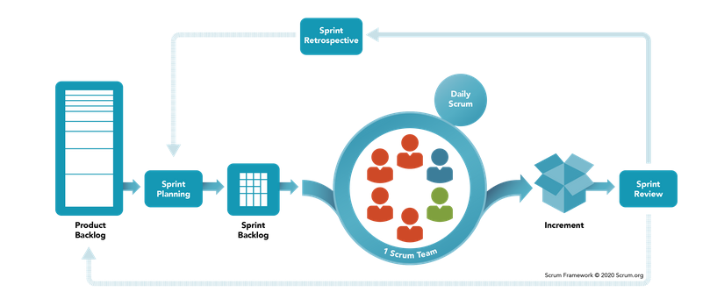

Figure 1. Scrum Process

*Image source:* [*https://www.scrum.org*](https://www.scrum.org)

To match with the iterative of the Scrum framework, we apply DevOps into our model to deploy CI/CD. CI (Continuous Integration) will allow us performance integration tests between our code, mitigating the risk of defects in the production system. CD (Continuous Delivery) helps us build production deployment as soon as possible. It led to customers being able to have production deployment. DevOps helps us improve the build and test process, prevent errors, and handle issues easier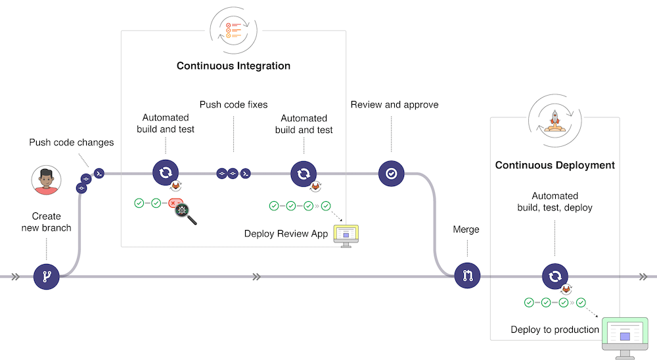

Figure 2. CI/CD Process

*Image source:* [*https://docs.gitlab.com/ee/ci/introduction/*](https://docs.gitlab.com/ee/ci/introduction/)

### 2.2 Quality Management

For quality management we use below:

* Integration Testing: Each function after implementation always requires a checklist containing all test cases which are summarized by every member.
* System Testing: Testing the system as a whole to confirm that every feature of the application functions correctly.

### 2.3 Training Plan

|  |  |  |  |
| --- | --- | --- | --- |
| **Training Area** | **Participants** | **When, Duration** | **Waive r Criteria** |
| Java Spring Boot | All member | Week 1 - 10 days | Mandatory |
| React | Trương Trần Tiến, Phạm Cao Sơn | Week 1 - 9 days | Mandatory |
| Git, Github | All member | Week 1 - 1 days | Mandatory |
| ThreeJS | Trương Trần Tiến | Week 1 - 10 days | Mandatory |

Table 7. Training plan

## 3. Project deliverables

|  |  |  |  |
| --- | --- | --- | --- |
| **No.** | **Deliverable** | **Due Date** | **Deliverable Scope** |
| 1 | Project Plan Document, SRS Document | 14 days | Project Planning, SRS, Business rule |
| 2 | Design Document | 14 days | Architecture Design, Detailed Design |
| 3 | Authentication Module, Account Module | 14 days | Code & Test, System test cases |
| 4 | System Admin Module | 14 days | Code & Test, System test cases |
| 5 | Company manager Module | 14 days | Code & Test, System test cases |
| 6 | Company Employee Module | 14 days | Code & Test, System test cases |
| 7 | Attendant Module | 14 days | Code & Test, System test cases |
| 8 | Testing | 7 days | Testing report |
| 9 | Finalization | 7 days | Documents, User guides |
| 10 | Final  Presentation | 1 days | Complete Capstone Project |

Table 8. Project deliverables

## 4. Project Organization

### 4.1 Team & Structures

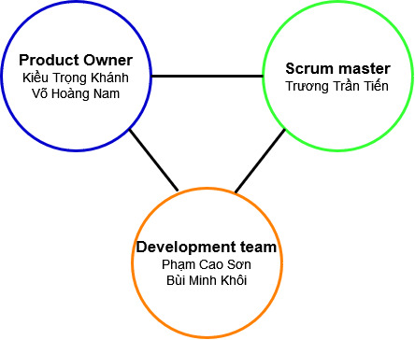

Figure 3. Team structure

### 4.2 Roles & Responsibilities

|  |  |
| --- | --- |
| **Role** | **Responsibility** |
| Product Owner | - Specify user requirement  - Control the development process  - Give out technique and business analysis support |
| Scrum master | - Managing process  - Track backlog  - Designing database  - Clarifying requirements  - Prepare documents  - GUI design  - Coding  - Quality management  - Create test plan  - Testing  - Support other team members  - Arrange meeting |
| Development Team | - Designing database  - Clarifying requirements  - Prepare documents  - Coding  - Testing  - GUI design  - Support other team members |

Table 9. Role and responsibilities

## 5. Project Communication

### 5.1 Communication Plan

|  |  |  |  |  |
| --- | --- | --- | --- | --- |
| **Communication Item** | **Who/ Target** | **Purpose** | **When, Frequency** | **Type, Tool, Method(s)** |
| - Business logic  - Technique | Team member | Exchange information | Everyday | Google  Meet,  Messenger |
| - Task  - Capstone Information | Team member | Manage tasks | Everyday | Jira |
| - Task  - Capstone  Information | Team member | Exchange information | 3 times/week | Google meet, face to face |
| - Tasks  - Business logic  - Instructions | Mentors | Review task | 2 times/week | Google meet, face to face |

Table 10. Communication plan

### 5.2 External Interface

#### a. FU Contacts

|  |  |  |  |
| --- | --- | --- | --- |
| **Function** | **Contact Person**  **(name, position)** | **Contact address**  **(email, telephone)** | **Responsibility** |
| Supervisor | Kiều Trọng Khánh | khanhkt@fe.edu.vn | - Give instruction to project team  - Consulting business related information |

Table 11. FU contact

#### b. Customer Contacts

|  |  |  |  |
| --- | --- | --- | --- |
| **Function** | **Contact Person**  **(name, position)** | **Contact address**  **(email, telephone)** | **Responsibility** |
| Exchange  business | Võ Hoàng Nam | nam@mdonline.vn | - Give instruction to project team  - Consulting business related information |

Table 12. Customer contact

## 6. Configuration Management

### 6.1 Document Management

We use Google Docs to manage documents. Google Docs allows team members to conveniently collaborate in real-time. We create documents on Google Docs based on the FPT document template, then divide the document writing work for members based on their predefined responsibilities. Thanks to real-time data synchronization, each member can see the results of the other members' work immediately. Google Docs also has a function to review document changes, so we can review document changes when needed.

*Link to Documents: http://bitly.ws/tyT2*

### 6.2 Source Code Management

We choose Github to manage the source code. The version control system allows members to collaboratively work on a source code efficiently and conveniently.

*Link to BE:* [*https://github.com/jobfaironline/jobfair-backend*](https://github.com/jobfaironline/jobfair-backend)

*Link to FE:* [*https://github.com/jobfaironline/jobfair-frontend*](https://github.com/jobfaironline/jobfair-frontend)

*Link to Game server:* [*https://github.com/jobfaironline/game-server*](https://github.com/jobfaironline/game-server)

### 6.3 Tools & Infrastructures

|  |  |
| --- | --- |
| **Category** | **Tools / Infrastructure** |
| Programming languages | Java 8, Javascript |
| Framework | Java Spring Boot |
| DBMS | MySQL 8.0 |
| IDEs/Editors | Visual Studio Code, Intelij |
| UML tools | StarUML 4.1.6 |
| Version Control | Github |
| Deployment server | Amazon Web Service |
| Project management tool | Jira |

Table 13. Tool & Infrastructure

# III. Software Requirement Specification

## 1. Product Overview

JobHub is a B2B2C platform that allows companies to join in and create their own job fair. With each job fair, JobHub also supports numerous utilities that allows companies and attendants to participate in a quick and remote recruitment process.

## 2. User Requirements

### 2.1 Actors

|  |  |  |
| --- | --- | --- |
| **No.** | **Actor** | **Description** |
| 1 | Guest | Users who have not logged into JobHub system |
| 2 | Authenticated user | Users who have logged into JobHub system |
| 3 | Administrator | Administrator of the system |
| 4 | Attendant | Users who want to participate in job fairs |
| 5 | Company manager | Manager of a company that registered in JobHub system |
| 6 | Company employee | Employee of a company that registered in JobHub system |
| 7 | System handler | JobHub system |

Table 14. System main actors

### 2.2 Use Cases

#### 2.2.1 Diagram(s)

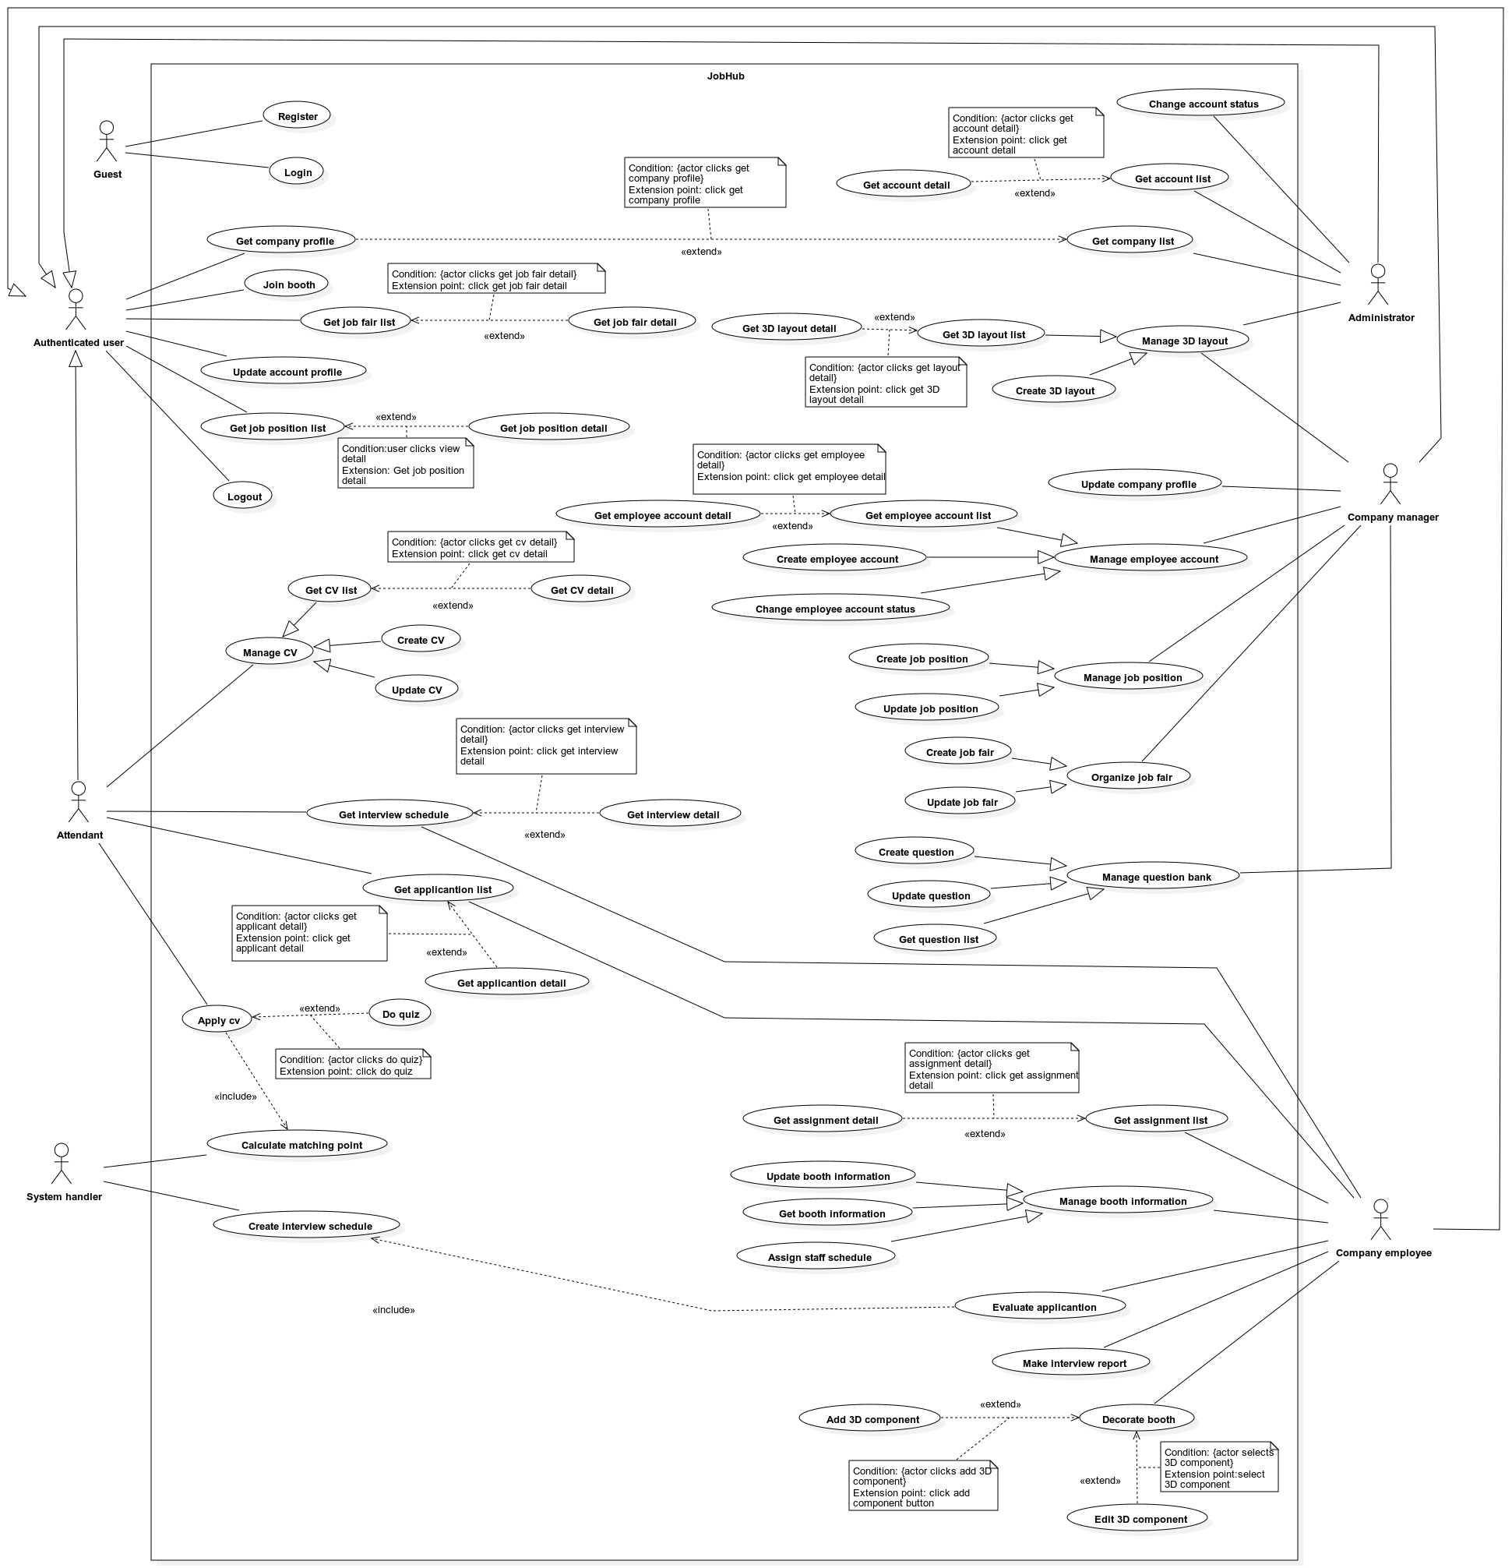

Figure 4. Use case diagrams

#### 2.2.2 Use case list

|  |  |  |  |
| --- | --- | --- | --- |
| **ID** | **Use Case** | **Actors** | **Author** |
| UC-01 | Register | Guest | TienTT |
| UC-02 | Login | Guest | TienTT |
| UC-03 | Get company profile | Authenticated user | TienTT |
| UC-04 | Join booth | Authenticated user | TienTT |
| UC-05 | Get job fair list | Authenticated user | TienTT |
| UC-06 | Get job fair detail | Authenticated user | TienTT |
| UC-07 | Update account profile | Authenticated user | TienTT |
| UC-08 | Get job position list | Authenticated user | TienTT |
| UC-09 | Get job position detail | Authenticated user | TienTT |
| UC-10 | Logout | Authenticated user | TienTT |
| UC-11 | Get account list | Administrator | TienTT |
| UC-12 | Get account detail | Administrator | TienTT |
| UC-13 | Change account status | Administrator | TienTT |
| UC-14 | Get company list | Administrator | TienTT |
| UC-15 | Get 3D layout list | Administrator, Company manager | TienTT |
| UC-16 | Get 3D layout detail | Administrator, Company manager | TienTT |
| UC-17 | Create 3D layout | Administrator, Company manager | TienTT |
| UC-18 | Get CV list | Attendant | TienTT |
| UC-19 | Get CV detail | Attendant | TienTT |
| UC-20 | Create CV | Attendant | TienTT |
| UC-21 | Update CV | Attendant | TienTT |
| UC-22 | Get interview schedule | Attendant, Company employee | TienTT |
| UC-23 | Get interview detail | Attendant, Company employee | TienTT |
| UC-24 | Apply CV | Attendant | TienTT |
| UC-25 | Do quiz | Attendant | TienTT |
| UC-26 | Get application list | Attendant, Company employee | TienTT |
| UC-27 | Get application detail | Attendant, Company employee | TienTT |
| UC-28 | Update company profile | Company manager | TienTT |
| UC-29 | Get employee account list | Company manager | TienTT |
| UC-30 | Get employee account detail | Company manager | TienTT |
| UC-31 | Create employee account | Company manager | TienTT |
| UC-32 | Change employee account status | Company manager | TienTT |
| UC-33 | Create job position | Company manager | TienTT |
| UC-34 | Update job position | Company manager | TienTT |
| UC-35 | Get question list | Company manager | TienTT |
| UC-36 | Create question | Company manager | TienTT |
| UC-37 | Update question | Company manager | TienTT |
| UC-38 | Create job fair | Company manager | TienTT |
| UC-39 | Update job fair | Company manager | TienTT |
| UC-40 | Get assignment list | Company employee | TienTT |
| UC-41 | Get assignment detail | Company employee | TienTT |
| UC-42 | Get booth information | Company employee | TienTT |
| UC-43 | Update booth information | Company employee | TienTT |
| UC-44 | Assign staff schedule | Company employee | TienTT |
| UC-45 | Evaluate application | Company employee | TienTT |
| UC-46 | Make interview report | Company employee | TienTT |
| UC-47 | Decorate booth | Company employee | TienTT |
| UC-48 | Add 3D component | Company employee | TienTT |
| UC-49 | Edit 3D component | Company employee | TienTT |
| UC-50 | Calculate matching point | System handler | TienTT |
| UC-51 | Create interview schedule | System handler | TienTT |

Table 15. Use case list

#### 2.2.3 Use case specification

##### 2.2.3.1 <Guest> - Use case overview

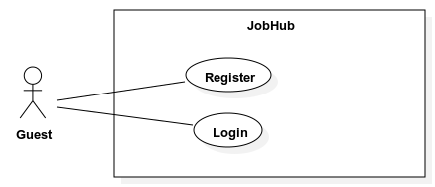

###### UC-01 <Guest> Register

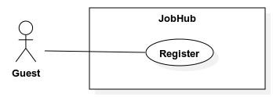

|  |  |  |  |
| --- | --- | --- | --- |
| **ID and Name:** | **UC-01: Register** | | |
| Created By: | TienTT | Date Created: | 01/08/2022 |
| Primary Actor: | Guest | Secondary Actors: | N/A |
| Priority: | Normal | Frequency of Use: | Usually |
| Trigger: | The actor sends a request to register new account. | | |
| Description: | This feature allows actor to create a new account with either role “Attendant”, “Company Manager” with status REGISTERED. | | |
| Preconditions: | N/A | | |
| Post-conditions: | * **Success**: A new account is created with either role “Attendant” or “Company Manager” and with status REGISTERED. * **Fail:** - The error message “Something went wrong” is shown if there is any error occurred in the system.   - Specific error messages will be shown based on the actor’s actions | | |
| Normal Flow: | |  |  |  | | --- | --- | --- | | Step | Actor Action | System Response | | 1 | The actor sends request to register a new account as “*Attendant”*.  **[Alternative 1]** | System requires information from actor:  - First name: text input, required, length: 1-100, not contain special characters.  - Middle name: text input, length: 1-100, not contain special characters.  - Last name: text input, required, length: 1 – 100, not contain special characters.  - Email: email input, required.  - Password: password input, required.  - Confirm password: password input, required.  - Agree to conditions: checkbox, required. | | 2 | Actor inputs information. |  | | 3 | Actor submits information. | System validates and creates new account with role *“Attendant”* and with status REGISTERED.  **[Exception 1, 2]** | | | |
| Alternative Flows: | **Alternative 1:**   |  |  |  | | --- | --- | --- | | Step | Actor Action | System Response | | 1 | The actor sends request to register a new account as “*Company Manager”*. | System requires information from actor:  - Email: email input, required  - First name: text input, required, length 1-100  - Middle name: text input, required, length 1-100  - Last name: text input, required, length 1- 100  - Password: password input, required  - Confirm password: password input, required  - Company name: text input, required, length 1-1000  - Company email: email input, required  - Tax ID: text input, required, length 9-10  - Company size: dropdown list, required  - Company industries: multiple select dropdown list, required  - Agree to conditions: checkbox, required | | 2 | Actor inputs information. |  | | 3 | Actor submits information. | System validates and creates new account with role *“Company manager”* and with status REGISTERED.  **[Exception 1, 2]** | | | |
|  | | |
| Exceptions: | |  |  |  | | --- | --- | --- | | No | Cause | System Response | | 1 | All inputs’ information is not obeyed constraints. | Show error message to ask user input required input or follow the input’s constraint. | | 2 | Email exists in the system | Show error message to notify user that the inputted email exists in the system | | | |
| Business Rules: | * When a “*Guest*” registers to create an account in the system, the account status must be REGISTERED. * An email with a verify link must be sent to the inputted email. * After user click on the verify link, the account status will be updated to VERIFIED * The password must be hashed before storing. * Password must have length > 2. | | |
| Assumptions: | * Actor’s internet connection is available | | |

###### UC-02 <Guest> Login

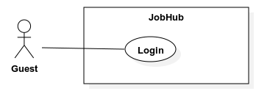

|  |  |  |  |
| --- | --- | --- | --- |
| **ID and Name:** | **UC-02: Logic** | | |
| Created By: | TienTT | Date Created: | 01/08/2022 |
| Primary Actor: | High | Secondary Actors: | N/A |
| Priority: | Normal | Frequency of Use: | Always |
| Trigger: | The actor sends a request to login | | |
| Description: | This use case allows *“Guest”* to login into the system and performs specific features based on their role. | | |
| Preconditions: | N/A | | |
| Post-conditions: | * **Success:** Actors successfully access the system and use specific features corresponding with their roles. * **Fail:** - The error message “Login failed – Invalid email or password” is shown if the system cannot authenticate user   - Specific error messages will be shown based on the actor’s actions | | |
| Normal Flow: | |  |  |  | | --- | --- | --- | | Step | Actor Action | System Response | | 1 | The actor sends request to login. | System requires information from actor:  - Email: email input, required  - Password: password input, required | | 2 | Actor inputs information. |  | | 3 | Actor submits information. | System validates and show login successfully message.  **[Exception 1, 2, 3, 4]** | | | |
| Alternative Flows: | N/A | | |
| Exceptions: | |  |  |  | | --- | --- | --- | | No | Cause | System Response | | 1 | All inputs’ information is not obeyed constraints. | Show error message to ask user input required input or follow the input’s constraint. | | 2 | User enters wrong email or password. | Show error message “Login failed – Invalid email or password” is shown. | | 3 | User’s account status is REGISTERED. | Show error message “Your account is not verified”. | | 4 | User’s account status is SUSPENDED. | Show error message “Your account is suspended”. | | | |
| Business Rules: | * The user must be authenticated if the following is true:   + The inputted email is existed inside the system.   + The hashed version of the inputted password must match the existed account’s password.   + The existed account must have status VERIFIED or INACTIVE. * If the user’s account is authenticated but the status is INACTIVE, update account’s status to VERIFED. | | |
| Assumptions: | * Actor’s internet connection is available | | |

###### UC-03 <Authenticated user> Get company profile

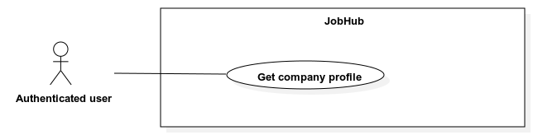

|  |  |  |  |
| --- | --- | --- | --- |
| **ID and Name:** | **UC-03: Get company profile** | | |
| Created By: | TienTT | Date Created: | 01/08/2022 |
| Primary Actor: | Authenticated user | Secondary Actors: | N/A |
| Priority: | High | Frequency of Use: | Usually |
| Trigger: | The actor sends a request to get company profile. | | |
| Description: | This use case allows an *“Authenticated user”* to get company profile. | | |
| Preconditions: | The actor must login into the system. | | |
| Post-conditions: | * **Success:** The company profile is shown. * **Fail:** The error message “Something went wrong” is shown if there is any error occurred in the system. | | |
| Normal Flow: | |  |  |  | | --- | --- | --- | | Step | Actor Action | System Response | | 1 | The actor sends request to get company profile. | System shows the company profile with the following information:  - “Logo”: image  - “Name”: label  - “Email”: label.  - “Phone number”: label.  - “Address”: label.  - “Tax ID”: label.  - “URL”: label.  - “Description”: label.  - “Size”: label.  - “Industry”: label.  - List of company’s benefits, each benefit contains:  - “Name”: label.  - “Description”: label. | | | |
| Alternative Flows: | N/A | | |
| Exceptions: | N/A | | |
| Business Rules: | N/A | | |
| Assumptions: | * Actor’s internet connection is available | | |

###### UC-04 <Authenticated user> Join booth

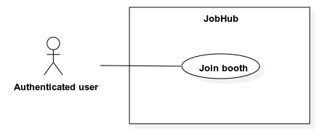

|  |  |  |  |
| --- | --- | --- | --- |
| **ID and Name:** | **UC-04: Join booth** | | |
| Created By: | TienTT | Date Created: | 01/08/2022 |
| Primary Actor: | Authenticated user | Secondary Actors: | N/A |
| Priority: | High | Frequency of Use: | Usually |
| Trigger: | The actor sends a request to job a booth | | |
| Description: | This use case allows *“Authenticated user”* to join in a job fair’s booth | | |
| Preconditions: | The actor must login into the system. | | |
| Post-conditions: | * **Success:** Actors successfully join into a job fair’s booth. * **Fail:** - The error message “Booth is full. We will notify you as soon as there is an empty slot” is shown if the booth has maximum number of users joined into.   - The error message “Something went wrong” is shown if there is any error occurred in the system. | | |
| Normal Flow: | |  |  |  | | --- | --- | --- | | Step | Actor Action | System Response | | 1 | The actor sends request to join a booth.  **[Alternative 1]** | System shows dialog that contains:  - “Booth name”: label  - “Booth description”: label  - “Join booth”: button | | 2 | The actor clicks “Join booth” button. | System renders booth model and character models. | | | |
| Alternative Flows: | **Alternative 1**   |  |  |  | | --- | --- | --- | | Step | Actor Action | System Response | | 1 | The actor sends request to join a booth. | Show message “Booth is full. We will notify you as soon as there is an empty slot” | | | |
| Exceptions: | N/A | | |
| Business Rules: | * The booth must be rendered in 3D environment as well as the actor’s character. * The actor when joins into a booth must be able to move around the booth and interact with other actors via chat message or video call. * If the current booth has maximum allowed user joined in, the actor must be queued and notified as soon as another user leaves the booth. * The maximum allowed user for each booth is 10, this number must be store in config file. * The list of job positions must be ordered ascending by their created time. | | |
| Assumptions: | * Actor’s internet connection is available | | |

###### UC-05 <Authenticated user> Get job fair list

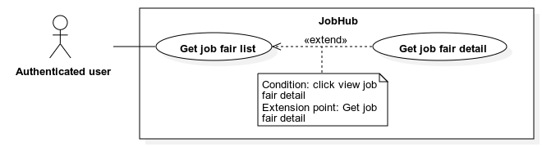

|  |  |  |  |
| --- | --- | --- | --- |
| **ID and Name:** | **UC-05: Get job fair list** | | |
| Created By: | TienTT | Date Created: | 01/08/2022 |
| Primary Actor: | Authenticated user | Secondary Actors: | N/A |
| Priority: | High | Frequency of Use: | Usually |
| Trigger: | The actor sends a request to get job fair list. | | |
| Description: | This use case allows *“Authenticated user”* to get job fair list. | | |
| Preconditions: | The actor must login into the system | | |
| Post-conditions: | * **Success:** - The job fair list is shown.   - The message “No data” is shown if the job fair list is empty.   * **Fail:** The error message “Something went wrong” is shown if there is any error occurred in the system. | | |
| Normal Flow: | |  |  |  | | --- | --- | --- | | Step | Actor Action | System Response | | 1 | The actor with role *“Attendant”* sends request to get list of job fairs.  **[Alternative 1, 2]** | System shows a list of job fairs. The item is list has the following fields:   * “Name”: label * “Company name”: label * “Remaining time”: label * “Visitors”: label * “View detail”: button   **[Alternative 3]** | |  |  |  | | | |
| Alternative Flows: | **Alternative 1**   |  |  |  | | --- | --- | --- | | Step | Actor Action | System Response | | 1 | The actor with role “*Company Manager”, “Company employee”* sends request to get list of job fair. | System shows a list of job fairs. The item is list has the following fields:   * “Name”: label * “Status”: label * “Create time”: label * “View detail”: button   **[Alternative 3]** |   **Alternative 2**   |  |  |  | | --- | --- | --- | | Step | Actor Action | System Response | | 1 | The actor with role “*Admin”* sends request to get list of job fair. | System shows a list of job fairs. The item is list has the following fields:   * “Name”: label * “Company name”: label * “Status”: label * “Create time”: date time * “Start time”: date time * “End time”: date time * “View detail”: button   **[Alternative 3]** |   **Alternative 3**   |  |  |  | | --- | --- | --- | | Step | Actor Action | System Response | | 1 |  | System returns an empty job fair list, shows message “No data” | | | |
| Exceptions: | N/A | | |
| Business Rules: | * Search bar on the top and fast scroll bar on the right help user finding job fair faster. * The search criteria are by job fair’s name. * If no search value is inputted, the default behavior is getting all job fair. * If the actor has role *“Attendant”,* the list of job fair is the list of all job fair in the system that has status PUBLISHED and the current time is between job fair’s public time range. This list is ordered descending by their public time. * If the actor has role *“Company manager”*, *“Company employee”,* the list of job fairs is only the list of that company job fairs. This list is ordered descending by their create time. * If the actor has role *“Admin”,* the list of job fairs is the list of all job fair in the system. This list is ordered descending by their create time. * The job fair status for role *“Company manager”*, *“Company employee”* is PUBLISH and DRAFT. * The job fair status for role *“Admin”* is HAPPENED, HAPPENING, IN_COMMING. * The “Remaining time” is the different between current time and job fair’s public end time. | | |
| Assumptions: | - Actor’s internet connection is available | | |

###### UC-06 <Authenticated user> Get job fair detail



|  |  |  |  |
| --- | --- | --- | --- |
| **ID and Name:** | **UC-06: Get job fair detail** | | |
| Created By: | TienTT | Date Created: | 01/08/2022 |
| Primary Actor: | Authenticated user | Secondary Actors: | N/A |
| Priority: | High | Frequency of Use: | Usually |
| Trigger: | The actor sends a request to get job fair detail. | | |
| Description: | This use case allows *“Authenticated user”* to get job fair detail. | | |
| Preconditions: | The actor must login into the system. | | |
| Post-conditions: | * **Success:** The job fair detail is shown. * **Fail:** The error message “Something went wrong” is shown if there is any error occurred in the system. | | |
| Normal Flow: | |  |  |  | | --- | --- | --- | | Step | Actor Action | System Response | | 1 | The actor with role *“Attendant”* sends request to get job fair detail  **[Alternative 1, 2]** | System shows the detail of the job fair with the following information:  - “Thumbnail”: image  - “Name”: label  - “Public start date”: date time  - “Public end date”: date time  - “Host name”: label  - “Job fair description”: label  - “Company name”: label  - “Company logo”: image  - “Company address”: label  - “Company website url”: link  - “Company categories”: label | | | |
| Alternative Flows: | **Alternative 1**   |  |  |  | | --- | --- | --- | | Step | Actor Action | System Response | | 1 | The actor with role “*Company Manager”, “Company employee”* sends request to get job fair detail. | System shows the detail of the job fair with the following information:  - “Name”: image  - “Layout thumbnail”: image  - “Decorate start time”: date time  - “Decorate end time”: date time  - “Public start time: date time  - “Public end time”: date time  - “Morning shift start time”: date time  - “Morning shift end time”: date time  - “Afternoon shift start time”: date time  - “Afternoon shift end time”: date time  - “Description”: label  - “Host name”: label  - “Target attendant”: label  - “Status”: label  - “List of assigned employees”: each item contains:   * “Employee name”: label * “Booth name”: label * “Assignment type”: label |   **Alternative 2**   |  |  |  | | --- | --- | --- | | Step | Actor Action | System Response | | 1 | The actor with role “*Admin”* sends request to get job fair detail. | System shows the detail of the job fair with the following information:  - “Name”: label  - “Decorate start time”: date time  - “Decorate end time”: date time  - “Public start time”: date time  - “Public end time”: date time  - “Morning shift start time”: date time  - “Morning shift end time”: date time  - “Afternoon shift start time”: date time  - “Afternoon shift end time”: date time  - “Description”: label  - “Host name”: label  - “Target attendant”: label  - “Status”: label | | | |
| Exceptions: | N/A | | |
| Business Rules: | * The job fair status for role *“Company manager”*, *“Company employee”* is PUBLISH and DRAFT. * The job fair status for role *“Admin”* is HAPPENED, HAPPENING, IN_COMMING. * The list of assigned employees is group by booth name and ordered descending by booth create time. | | |
| Assumptions: | * Actor’s internet connection is available | | |

###### UC-07 <Authenticated user> Update account profile

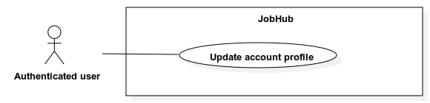

|  |  |  |  |
| --- | --- | --- | --- |
| **ID and Name:** | **UC-07: Update account profile** | | |
| Created By: | TienTT | Date Created: | 01/08/2022 |
| Primary Actor: | Authenticated user | Secondary Actors: | N/A |
| Priority: | Normal | Frequency of Use: | Usually |
| Trigger: | The actor sends a request to update their account profile. | | |
| Description: | This use case allows *“Authenticated user”* to update their account profile. | | |
| Preconditions: | The actor must login into the system. | | |
| Post-conditions: | * **Success:** The system updates actor’s profile and show success message. * **Fail:** - Discard all unsaved changes.   - The error message “Something went wrong” is shown if there is any error occurred in the system.  - Specific error messages will be shown based on the actor’s actions | | |
| Normal Flow: | |  |  |  | | --- | --- | --- | | Step | Actor Action | System Response | | 1 | The actor with role *“Attendant”* sends request to update account profile.  **[Alternative 1]** | System requires information from actor:  - “Avatar”: file selected, must be .PNG, .JPEG, .JPG.  - “First name”: text input, required, length: 1-100, not contain special characters.  - “Middle name”: text input, length: 1-100, not contain special characters.  - “Last name”: text input, required, length: 1-100, not contain special characters.  - “Phone number”: phone input, required.  - “Gender”: radio button.  - “Date of birth”: date time, required.  - “Title”: dropdown select, required.  - “Marital status”: radio button.  - “Country”: dropdown select, required.  - “Province”: dropdown select.  - “Address”: text input, required, length: 1-1000.  - “Job title”: text input, required, length: 1-100.  - “Job level”: dropdown select, required.  - “Year of experience”: number, range: 0-50  **[Alternative 2, 3, 4, 5, 6, 7]** | | 2 | Actor inputs information. |  | | 3 | Actor submits information. | System validates, updates account profile, and shows success message.  **[Exception 1, 2]** | | | |
| Alternative Flows: | **Alternative 1**   |  |  |  | | --- | --- | --- | | Step | Actor Action | System Response | | 1 | The actor with role “*Company Manager”, “Company employee”, “Admin”* sends request to update account profile. | System requires information from actor:  - “Avatar”: file selected, must be .PNG, .JPEG, .JPG.  - “First name”: text input, required, length: 1-100, not contain special characters.  - “Middle name”: text input, length: 1-100, not contain special characters.  - “Last name”: text input, required, length: 1-100, not contain special characters.  - “Phone number”: phone input, required.  - “Gender”: radio button. | | 2 | Continue step 2 of normal flow |  |   **Alternative 2**   |  |  |  | | --- | --- | --- | | Step | Actor Action | System Response | | 1 | The actor with role *“Attendant”* sends request to add or update skill. | System requires information from actor:  - “Name”: text input, required, length: 1-100.  - “Proficiency”: number input, required, range 0-5 | | 2 | Actor inputs information. | System validates information.  **[Exception 1]** | | 3 | Continue step 3 of normal flow |  |   **Alternative 3**   |  |  |  | | --- | --- | --- | | Step | Actor Action | System Response | | 1 | The actor with role *“Attendant”* sends request to add or update work history. | System requires information from actor:  - “Position”: text input, required, length: 1-100.  - “Company”: text input, required, length: 1-100.  - “Date range”: date picker, required.  - “Current job”: radio button, required.  - “Description”: text input, required, length: 1-5000. | | 2 | Actor inputs information. | System validates information.  **[Exception 1]** | | 3 | Continue step 3 of normal flow |  |   **Alternative 4**   |  |  |  | | --- | --- | --- | | Step | Actor Action | System Response | | 1 | The actor with role *“Attendant”* sends request to add or update education. | System requires information from actor:  - “School”: text input, required, length: 1-100.  - “Subject”: text input, required, length: 1-100  - “Date range”: date picker, required.  - “Achievement”: text input, required, length: 1-5000. | | 2 | Actor inputs information. | System validates information.  **[Exception 1]** | | 3 | Continue step 3 of normal flow |  |   **Alternative 5**   |  |  |  | | --- | --- | --- | | Step | Actor Action | System Response | | 1 | The actor with role *“Attendant”* sends request to add or update certification. | System requires information from actor:  - “Name”: text input, required, length: 1-100.  - “Institution”: text input, required, length: 1-100.  - “Issue date”: date picker, required.  - Certification link: input text, required, length: 1-2048.  - “Description”: text input, required, length: 1-5000. | | 2 | Actor inputs information. | System validates information.  **[Exception 1]** | | 3 | Continue step 3 of normal flow |  |   **Alternative 6**   |  |  |  | | --- | --- | --- | | Step | Actor Action | System Response | | 1 | The actor with role *“Attendant”* sends request to add or update reference. | System requires information from actor:  - “Full name”: text input, required, length: 1-1000.  - “Company”: text input, required, length: 1-1000.  - “Email”: email input, required, length 1-322.  - “Position”: input text, required, length: 1-100.  - “Phone”: phone input, required, length: 1-11. | | 2 | Actor inputs information. | System validates information.  **[Exception 1]** | | 3 | Continue step 3 of normal flow |  |   **Alternative 7**   |  |  |  | | --- | --- | --- | | Step | Actor Action | System Response | | 1 | The actor with role *“Attendant”* sends request to add or update activity. | System requires information from actor:  - “Name”: text input, required, length: 1-100.  - “Function title”: text input, required, length: 1-100.  - “Organization”: text input, required, length 1-100.  - “Date range”: date time range picker, required.  - “Description”: phone input, required, length: 1-5000. | | 2 | Actor inputs information. | System validates information.  **[Exception 1]** | | 3 | Continue step 3 of normal flow |  | | | |
| Exceptions: | |  |  |  | | --- | --- | --- | | No | Cause | System Response | | 1 | All inputs’ information are not obeyed constraints. | Show error message to ask user input required input or follow the input’s constraint. | | 2 | User not existed in system | Show error message user not existed in system | | | |
| Business Rules: | N/A | | |
| Assumptions: | * Actor’s internet connection is available | | |

###### UC-08 <Authenticated user> Get job position list

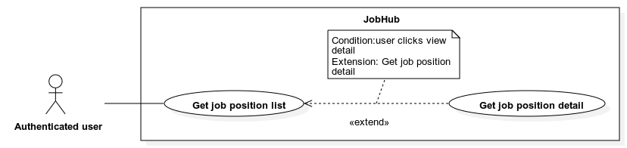

|  |  |  |  |
| --- | --- | --- | --- |
| **ID and Name:** | **UC-08: Get job position list** | | |
| Created By: | TienTT | Date Created: | 01/08/2022 |
| Primary Actor: | Authenticated user | Secondary Actors: | N/A |
| Priority: | High | Frequency of Use: | Usually |
| Trigger: | The actor sends a request to get job position list. | | |
| Description: | This use case allows an “Authenticated user” to get a job position list. | | |
| Preconditions: | The actor must login into the system | | |
| Post-conditions: | * **Success:** - The job position list is shown.   - The message “No data” is shown if the job position list is empty.   * **Fail:** The error message “Something went wrong” is shown if there is any error occurred in the system. | | |
| Normal Flow: | |  |  |  | | --- | --- | --- | | Step | Actor Action | System Response | | 1 | The actor with role *“Attendant”* sends request to get list of job position  **[Alternative 1]** | System shows a list of job positions. The item is list has the following fields:   * “Title”: label * “Job’s level”: label * “Job’s type”: label * “List of job’s categories”: label * “List of job’s required skill”: label * “View detail”: button   **[Alternative 2]** | | | |
| Alternative Flows: | **Alternative 1**   |  |  |  | | --- | --- | --- | | Step | Actor Action | System Response | | 1 | The actor with role *“Company manager” or “Company employee”* sends request to get list of job position | System shows a list of job positions. The item is list has the following fields:   * “Title”: label * “Job’s level”: label * “Job’s type”: label * “List of job’s categories”: label * “List of job’s required skill”: label * “View detail”: button * “Edit”: button * “Delete”: button   **[Alternative 2]** |   **Alternative 2**   |  |  |  | | --- | --- | --- | | Step | Actor Action | System Response | | 1 |  | System returns an empty job position list, shows message “No data” | | | |
| Exceptions: | N/A | | |
| Business Rules: | * The list is ordered descending by their create time. | | |
| Assumptions: | * Actor’s internet connection is available | | |

###### UC-09 <Authenticated user> Get job position detail



|  |  |  |  |
| --- | --- | --- | --- |
| **ID and Name:** | **UC-09: Get job position detail** | | |
| Created By: | TienTT | Date Created: | 01/08/2022 |
| Primary Actor: | Authenticated user | Secondary Actors: | N/A |
| Priority: | Normal | Frequency of Use: | Usually |
| Trigger: | The actor sends a request to get job fair detail. | | |
| Description: | This use case allows *“Authenticated user”* to get job position detail. | | |
| Preconditions: | The actor must login into the system. | | |
| Post-conditions: | * **Success:** The job position detail is shown. * **Fail:** The error message “Something went wrong” is shown if there is any error occurred in the system. | | |
| Normal Flow: | |  |  |  | | --- | --- | --- | | Step | Actor Action | System Response | | 1 | The actor with role *“Attendant”* sends request to get job position detail.  **[Alternative 1]** | System shows the detail of the job position with the following information:  - “Title”: label  - “Job level”: label  - “Job type”: label  - “Prefer language”: label  - “Skill tags”: label  - “Category tags”: label  - “Contact person”: label  - “Contact email”: label  - “Description”: label  - “Requirement”: label  - “Apply CV”: button | | | |
| Alternative Flows: | **Alternative 1**   |  |  |  | | --- | --- | --- | | Step | Actor Action | System Response | | 1 | The actor with role *“Company manager” or “Company employee”* sends request to get job position detail. | System shows the detail of the job position with the following information:  - “Title”: label  - “Job level”: label  - “Job type”: label  - “Prefer language”: label  - “Skill tags”: label  - “Category tags”: label  - “Contact person”: label  - “Contact email”: label  - “Description”: label  - “Requirement”: label  - “Edit”: button  - “Delete”: button | | | |
| Exceptions: | N/A | | |
| Business Rules: | N/A | | |
| Assumptions: | * Actor’s internet connection is available | | |

###### UC-10 <Authenticated user> Logout

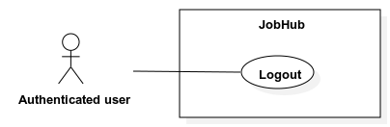

|  |  |  |  |
| --- | --- | --- | --- |
| **ID and Name:** | **UC-10: Logout** | | |
| Created By: | TienTT | Date Created: | 01/08/2022 |
| Primary Actor: | Authenticated user | Secondary Actors: | N/A |
| Priority: | Normal | Frequency of Use: | Usually |
| Trigger: | The actor sends a request to logout | | |
| Description: | This use case allows *“Guest”* to login into the system and performs specific features based on their role. | | |
| Preconditions: | The actor must login into the system. | | |
| Post-conditions: | * **Success:** Logout actor and show success message. * **Fail:** - Specific error messages will be shown based on the actor’s actions | | |
| Normal Flow: | |  |  |  | | --- | --- | --- | | Step | Actor Action | System Response | | 1 | The actor sends request to logout. | System terminates actor’s session and show success message | | | |
| Alternative Flows: | N/A | | |
| Exceptions: | N/A | | |
| Business Rules: | N/A | | |
| Assumptions: | * Actor’s internet connection is available | | |

##### 2.2.3.3 <Administrator> - Use case overview

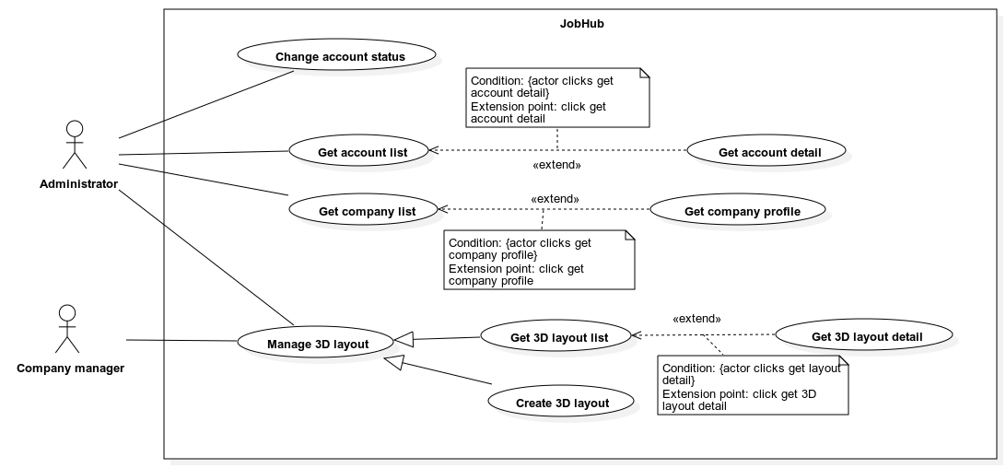

###### UC-11 <Administrator> Get account list

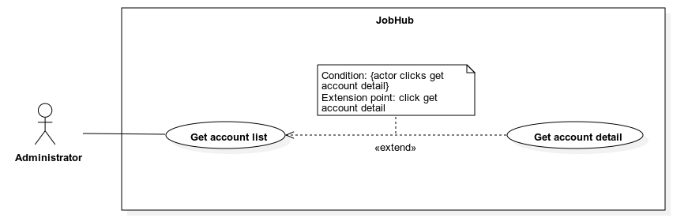

|  |  |  |  |
| --- | --- | --- | --- |
| **ID and Name:** | **UC-11: Get account list** | | |
| Created By: | TienTT | Date Created: | 01/08/2022 |
| Primary Actor: | Administrator | Secondary Actors: | N/A |
| Priority: | Normal | Frequency of Use: | Usually |
| Trigger: | The actor sends a request to get account list. | | |
| Description: | This use case allows an *“Administrator”* to get an account list. | | |
| Preconditions: | The actor must login into the system | | |
| Post-conditions: | * **Success:** - The account list is shown.   - The message “No data” is shown if the account list is empty.   * **Fail:** The error message “Something went wrong” is shown if there is any error occurred in the system. | | |
| Normal Flow: | |  |  |  | | --- | --- | --- | | Step | Actor Action | System Response | | 1 | The actor sends request to get account list. | System shows a list of account. The item is list has the following fields:  - “Email”: label  - “Avatar”: image  - “Full name”: label  - “Phone”: label  - “Role”: label  - “Status”: label  - “View detail”: button  - “Suspend”: button  - “Unsuspend”: button  **[Alternative 1]** | | | |
| Alternative Flows: | **Alternative 1**   |  |  |  | | --- | --- | --- | | Step | Actor Action | System Response | | 1 | The actor sends request to get employee account list. | System returns an empty account list, shows message “No data” | | | |
| Exceptions: | N/A | | |
| Business Rules: | * The list is ordered descending by their create time. * Search bar on the top and fast scroll bar on the right help user finding account faster. * The search criteria are by account’s name. * If no search value is inputted, the default behavior is getting all account. * The “Suspend” button is only shown when the account status is not “SUSPENDED”. * The “Activate” button is only shown when the account status is “SUSPENDED”. | | |
| Assumptions: | * Actor’s internet connection is available | | |

###### UC-12 <Administrator> Get account detail



|  |  |  |  |
| --- | --- | --- | --- |
| **ID and Name:** | **UC-12: Get account detail** | | |
| Created By: | TienTT | Date Created: | 01/08/2022 |
| Primary Actor: | Administrator | Secondary Actors: | N/A |
| Priority: | Low | Frequency of Use: | Usually |
| Trigger: | The actor sends a request to get account detail. | | |
| Description: | This use case allows an *“Administrator”* to get account detail. | | |
| Preconditions: | The actor must login into the system. | | |
| Post-conditions: | * **Success:** The account detail is shown. * **Fail:** The error message “Something went wrong” is shown if there is any error occurred in the system. | | |
| Normal Flow: | |  |  |  | | --- | --- | --- | | Step | Actor Action | System Response | | 1 | The actor sends request to get account detail. | System shows the detail of the account with the following information:  - “Avatar”: image  - “Full name”: label  - “Email”: label  - “Phone”: label  - “Status”: label  - “Gender”: label  - “Role”: label  - “Create time”: label  - “Suspend”: button  - “Unsuspend”: button | | | |
| Alternative Flows: | N/A | | |
| Exceptions: | N/A | | |
| Business Rules: | - The “Suspend” button is only shown when the account status is not “SUSPENDED”.  - The “Unsuspend” button is only shown when the account status is “SUSPENDED”. | | |
| Assumptions: | * Actor’s internet connection is available | | |

###### UC-13 <Administrator> Change account status

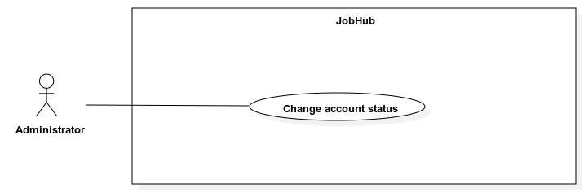

|  |  |  |  |
| --- | --- | --- | --- |
| **ID and Name:** | **UC-13: Change account status** | | |
| Created By: | TienTT | Date Created: | 01/08/2022 |
| Primary Actor: | Administrator | Secondary Actors: | N/A |
| Priority: | Low | Frequency of Use: | Usually |
| Trigger: | The actor sends a request to change account status. | | |
| Description: | This use case allows an *“Administrator”* to change account status. | | |
| Preconditions: | The actor must login into the system. | | |
| Post-conditions: | * **Success:** Change status on an account and show success message. * **Fail:** The error message “Something went wrong” is shown if there is any error occurred in the system. | | |
| Normal Flow: | |  |  |  | | --- | --- | --- | | Step | Actor Action | System Response | | 1 | The actor sends request to suspend account.  **[Alternative 1]** | System asks for confirmation. | | 2 | The actor confirms. | System changes account status to “SUSPENDED” and show success message. | | | |
| Alternative Flows: | **Alternative 1**   |  |  |  | | --- | --- | --- | | Step | Actor Action | System Response | | 1 | The actor sends request to unsuspend employee account. | System asks for confirmation. | | 2 | The actor confirms. | System changes employee’s account status to “VERIFIED” and show success message. | | | |
| Exceptions: | N/A | | |
| Business Rules: | - The actor can only suspend an account when that account status is not “SUSPENDED”.  - The actor can only unsuspend an employee account when that account status is “SUSPENDED”. | | |
| Assumptions: | * Actor’s internet connection is available | | |

###### UC-14 <Administrator> Get company list

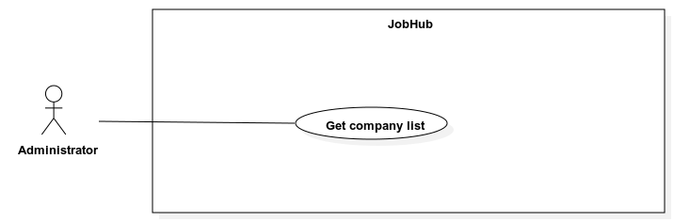

|  |  |  |  |
| --- | --- | --- | --- |
| **ID and Name:** | **UC-14: Get company list** | | |
| Created By: | TienTT | Date Created: | 01/08/2022 |
| Primary Actor: | Administrator | Secondary Actors: | N/A |
| Priority: | Low | Frequency of Use: | Usually |
| Trigger: | The actor sends a request to get company list. | | |
| Description: | This use case allows an *“Administrator”* to get company list. | | |
| Preconditions: | The actor must login into the system | | |
| Post-conditions: | * **Success:** - The company list is shown.   - The message “No data” is shown if the account list is empty.   * **Fail:** The error message “Something went wrong” is shown if there is any error occurred in the system. | | |
| Normal Flow: | |  |  |  | | --- | --- | --- | | Step | Actor Action | System Response | | 1 | The actor sends request to get company list. | System shows a list of company. The item is list has the following fields:  - “Email”: label  - “Logo”: image  - “Name”: label  - “Phone”: label  - “Status”: label  - “View detail”: button  **[Alternative 1]** | | | |
| Alternative Flows: | **Alternative 1**   |  |  |  | | --- | --- | --- | | Step | Actor Action | System Response | | 1 | The actor sends request to get company list. | System returns an empty company list, shows message “No data” | | | |
| Exceptions: | N/A | | |
| Business Rules: | * The list is ordered descending by their create time. * Search bar on the top and fast scroll bar on the right help user finding company faster. * The search criteria are by company’s name. * If no search value is inputted, the default behavior is getting all company. | | |
| Assumptions: | * Actor’s internet connection is available | | |

###### UC-15 <Administrator, Company manager> Get 3D layout list

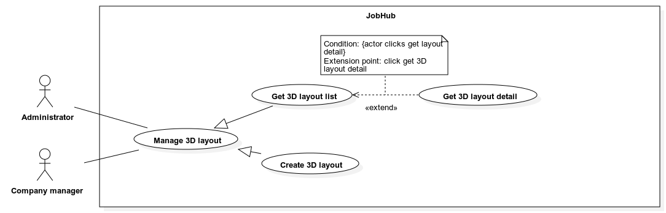

|  |  |  |  |
| --- | --- | --- | --- |
| **ID and Name:** | **UC-15: Get 3D layout list** | | |
| Created By: | TienTT | Date Created: | 01/08/2022 |
| Primary Actor: | Company manager | Secondary Actors: | Administrator |
| Priority: | Normal | Frequency of Use: | Usually |
| Trigger: | The actor sends a request to get 3D layout list. | | |
| Description: | This use case allows a *“Company manager”* or an *“Administrator”* to get a 3D layout list. | | |
| Preconditions: | The actor must login into the system | | |
| Post-conditions: | * **Success:** - The 3D layout list is shown.   - The message “No data” is shown if the layout list is empty.   * **Fail:** The error message “Something went wrong” is shown if there is any error occurred in the system. | | |
| Normal Flow: | |  |  |  | | --- | --- | --- | | Step | Actor Action | System Response | | 1 | The actor sends request to get 3D layout list. | System shows a list of 3D layout. The item is list has the following fields:  - “Thumbnail”: image  - “Name”: label  - “Description”: label  **[Alternative 1]** | | | |
| Alternative Flows: | **Alternative 1**   |  |  |  | | --- | --- | --- | | Step | Actor Action | System Response | | 1 | The actor sends request to get 3D layout list. | System returns an empty 3D layout list, shows message “No data” | | | |
| Exceptions: | N/A | | |
| Business Rules: | * The list is ordered descending by their create time. * If the actor has role *“Company manager”*, only the 3D layouts of actor’s company are returned. * If the actor has role *“Administrator”,* only the 3D layouts of system are returned. | | |
| Assumptions: | * Actor’s internet connection is available | | |

###### UC-16 <Administrator, Company manager> Get 3D layout detail



|  |  |  |  |
| --- | --- | --- | --- |
| **ID and Name:** | **UC-16: Get 3D layout detail** | | |
| Created By: | TienTT | Date Created: | 01/08/2022 |
| Primary Actor: | Company manager | Secondary Actors: | Administrator |
| Priority: | Low | Frequency of Use: | Usually |
| Trigger: | The actor sends a request to get 3D layout detail. | | |
| Description: | This use case allows a *“Company manger”* or an *“Administrator”* to get 3D layout detail. | | |
| Preconditions: | The actor must login into the system. | | |
| Post-conditions: | * **Success:** The 3D layout detail is shown. * **Fail:** The error message “Something went wrong” is shown if there is any error occurred in the system. | | |
| Normal Flow: | |  |  |  | | --- | --- | --- | | Step | Actor Action | System Response | | 1 | The actor sends request to get 3D layout detail. | System renders the 3D layout.  System shows the following information:  - “Name”: label  - “Description”: label  - “Create time”: label | | | |
| Alternative Flows: | N/A | | |
| Exceptions: | N/A | | |
| Business Rules: | - The system should support some actions to interact with the 3D layout such as: rotate, zoom. | | |
| Assumptions: | * Actor’s internet connection is available | | |

###### UC-17 <Administrator, Company manager> Create 3D layout



|  |  |  |  |
| --- | --- | --- | --- |
| **ID and Name:** | **UC-17: Create 3D layout** | | |
| Created By: | TienTT | Date Created: | 01/08/2022 |
| Primary Actor: | Company manager | Secondary Actors: | Administrator |
| Priority: | Low | Frequency of Use: | Usually |
| Trigger: | The actor sends a request to create new 3D layout. | | |
| Description: | This use case allows an *”Administrator”* or a *“Company manager”* to create new 3D layout. | | |
| Preconditions: | The actor must login into the system. | | |
| Post-conditions: | * **Success:** The system creates new 3D layout and show success message. * **Fail:** - The error message “Something went wrong” is shown if there is any error occurred in the system.   - Specific error messages will be shown based on the actor’s actions | | |
| Normal Flow: | |  |  |  | | --- | --- | --- | | Step | Actor Action | System Response | | 1 | The actor sends request to create new 3D layout. | System requires information from actor:  - “Name”: text input, required, length: 1-100.  - “Description”: text input, required, length: 1-500.  - “File glb”: file selected, must be .GLB.  - “Thumbnail”: file selected, must be .PNG, .JPEG, .JPG. | | 2 | Actor inputs information. |  | | 3 | Actor submits information. | System validates, parse glb file, create new 3D layout, and shows success message.  **[Exception 1]** | | | |
| Alternative Flows: | N/A | | |
| Exceptions: | |  |  |  | | --- | --- | --- | | No | Cause | System Response | | 1 | All inputs’ information is not obeyed constraints. | Show error message to ask user input required input or follow the input’s constraint. | | | |
| Business Rules: | - For the system to be able parsing 3D layout, glb file must follow some conventions:  - To represent a booth slot on the 3D layout, a rectangle base is used, and the name of the 3D mesh must have prefix “company”. Ex “company.01”.  - The glb file parsing process has the following step:  - Step 1: validating glb file  - Step 2: get all mesh objects that have name with prefix “company”  - Step 3: get x, y, z coordinate of the above mesh objects  - Step 4: create booth slot for those x, y, z coordinates.  - If the actor has role *“Administrator”,* the 3D layout will become system default layout. This layout can be access by all “Company manager” when organizing a job fair.  - If the actor has role *“Company manager”,* the 3D layout will only belongs to the actor’s company. | | |
| Assumptions: | * Actor’s internet connection is available | | |

##### 2.2.3.4 <Attendant> - Use case overview

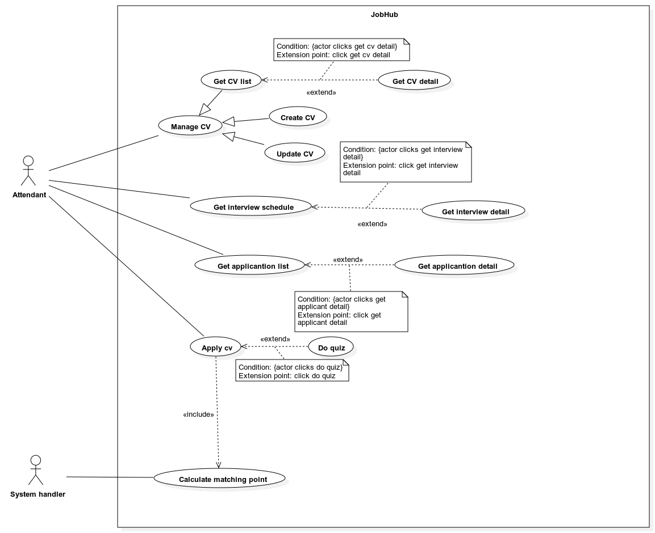

###### UC-18 <Attendant> Get CV list

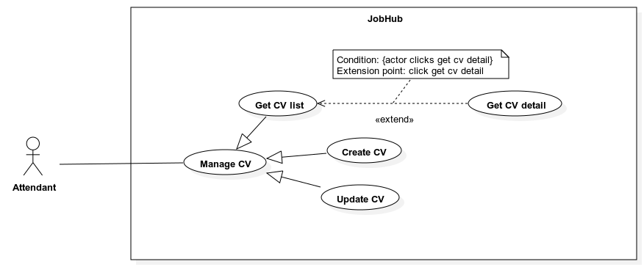

|  |  |  |  |
| --- | --- | --- | --- |
| **ID and Name:** | **UC-18: Get cv list** | | |
| Created By: | TienTT | Date Created: | 01/08/2022 |
| Primary Actor: | Attendant | Secondary Actors: | N/A |
| Priority: | High | Frequency of Use: | Usually |
| Trigger: | The actor sends a request to get cv list. | | |
| Description: | This use case allows an “Attendant” to get a cv list. | | |
| Preconditions: | The actor must login into the system | | |
| Post-conditions: | * **Success:** - The cv list is shown.   - The message “No data” is shown if the cv list is empty.   * **Fail:** The error message “Something went wrong” is shown if there is any error occurred in the system. | | |
| Normal Flow: | |  |  |  | | --- | --- | --- | | Step | Actor Action | System Response | | 1 | The actor sends request to get list of cv. | System shows a list of cv. The item is list has the following fields:  - “Name”: label  - “Profile image”: image  - “Created time”: date time  - “Last update”: date time  - “View detail”: button  - “Edit”: button  - “Delete”: button  **[Alternative 1]** | | | |
| Alternative Flows: | **Alternative 1**   |  |  |  | | --- | --- | --- | | Step | Actor Action | System Response | | 1 | The actor sends request to get list of cv. | System returns an empty cv list, shows message “No data” | | | |
| Exceptions: | N/A | | |
| Business Rules: | * The list is ordered descending by their create time. * Search bar on the top and fast scroll bar on the right help user finding cv faster. * The search criteria are by cv’s name. * If no search value is inputted, the default behavior is getting all cv. | | |
| Assumptions: | * Actor’s internet connection is available | | |

###### UC-19 <Attendant> Get CV detail



|  |  |  |  |
| --- | --- | --- | --- |
| **ID and Name:** | **UC-19: Get CV detail** | | |
| Created By: | TienTT | Date Created: | 01/08/2022 |
| Primary Actor: | Attendant | Secondary Actors: | N/A |
| Priority: | High | Frequency of Use: | Usually |
| Trigger: | The actor sends a request to get cv detail. | | |
| Description: | This use case allows *“Attendant”* to get cv detail. | | |
| Preconditions: | The actor must login into the system. | | |
| Post-conditions: | * **Success:** The cv detail is shown. * **Fail:** The error message “Something went wrong” is shown if there is any error occurred in the system. | | |
| Normal Flow: | |  |  |  | | --- | --- | --- | | Step | Actor Action | System Response | | 1 | The actor sends request get cv detail. | System shows the detail of the cv with the following information:  - “Cv name”: label  - “Full name”: label  - “Email”: label  - “Phone”: label  - “Location”: label  - “Education”: label  - “Education”: label  - “Job title”: label  - “Experience”: label  - “About me”: label  - Education list with each item contains:  - “School name”: label  - “Qualification”: label  - “Subject”: label  - “Enrolled date”: label  - “Graduate date”: label  - “Achievement”: label  - Work history list with each item contains:  - “Position”: label  - “Company name”: label  - “Start date”: date time  - “End date”: date time  - “Description”: label  - Skill list with each item contains:  - “Name”: label  - “Proficiency”: label  - Certification list with each item contains:  - “Name”: label  - “Institution”: label  - “Issue date”: date time  - "Link”: link  - Reference list with each item contains:  - “Name”: label  - “Company”: label  - “Email”: label  - “Position”: label  - “Phone”: label  - Activity list with each item contains:  - “Name”: label  - “Title”: label  - “Organization”: label  - “Begin date”: date time  - “End date”: date time  - “Description”: date time  - “Edit”: button  - “Delete”: button | | | |
| Alternative Flows: | N/A | | |
| Exceptions: | N/A | | |
| Business Rules: | N/A | | |
| Assumptions: | * Actor’s internet connection is available | | |

###### UC-20 <Attendant> Create CV



|  |  |  |  |
| --- | --- | --- | --- |
| **ID and Name:** | **UC-20: Create CV** | | |
| Created By: | TienTT | Date Created: | 01/08/2022 |
| Primary Actor: | Attendant | Secondary Actors: | N/A |
| Priority: | High | Frequency of Use: | Usually |
| Trigger: | The actor sends a request to create CV. | | |
| Description: | This use case allows an *”Attendant”* to create new CV. | | |
| Preconditions: | The actor must login into the system. | | |
| Post-conditions: | * **Success:** The system creates new CV for attendant and show success message. * **Fail:** - The error message “Something went wrong” is shown if there is any error occurred in the system.   - Specific error messages will be shown based on the actor’s actions | | |
| Normal Flow: | |  |  |  | | --- | --- | --- | | Step | Actor Action | System Response | | 1 | The actor sends request to create new CV. | System requires information from actor:  - “Avatar”: file selected, must be .PNG, .JPEG, .JPG.  - “Full name”: text input, required, length: 1-300, not contain special characters.  - “Country”: dropdown select, required.  - “Phone number”: phone input, required.  - “Email”: email input, required.  - “Job title”: text input, required, length: 1-100.  - “Year of experience”: number, range: 0-50.  - “Job level”: dropdown select, required.  - “About me”: text input, length: 0 – 5000.  **[Alternative 1, 2, 3, 4, 5, 6]** | | 2 | Actor inputs information. |  | | 3 | Actor submits information. | System validates, create new CV, and shows success message.  **[Exception 1]** | | | |
| Alternative Flows: | **Alternative 1**   |  |  |  | | --- | --- | --- | | Step | Actor Action | System Response | | 1 | The actor sends request to add skill. | System requires information from actor:  - “Name”: text input, required, length: 1-100.  - “Proficiency”: number input, required, range 0-5 | | 2 | Actor inputs information. | System validates information.  **[Exception 1]** | | 3 | Continue step 3 of normal flow |  |   **Alternative 2**   |  |  |  | | --- | --- | --- | | Step | Actor Action | System Response | | 1 | The actor sends request to add work history. | System requires information from actor:  - “Position”: text input, required, length: 1-100.  - “Company”: text input, required, length: 1-100.  - “Date range”: date picker, required.  - “Current job”: radio button, required.  - “Description”: text input, required, length: 1-5000. | | 2 | Actor inputs information. | System validates information.  **[Exception 1]** | | 3 | Continue step 3 of normal flow |  |   **Alternative 3**   |  |  |  | | --- | --- | --- | | Step | Actor Action | System Response | | 1 | The actor sends request to add education. | System requires information from actor:  - “School”: text input, required, length: 1-100.  - “Subject”: text input, required, length: 1-100  - “Date range”: date picker, required.  - “Achievement”: text input, required, length: 1-5000. | | 2 | Actor inputs information. | System validates information.  **[Exception 1]** | | 3 | Continue step 3 of normal flow |  |   **Alternative 4**   |  |  |  | | --- | --- | --- | | Step | Actor Action | System Response | | 1 | The actor sends request to add certification. | System requires information from actor:  -“Name”: text input, required, length: 1-100.  -“Institution”: text input, required, length: 1-100.  - “Issue date”: date picker, required.  - “Certification link”: input text, required, length: 1-2048.  - “Description”: text input, required, length: 1-5000. | | 2 | Actor inputs information. | System validates information.  **[Exception 1]** | | 3 | Continue step 3 of normal flow |  |   **Alternative 5**   |  |  |  | | --- | --- | --- | | Step | Actor Action | System Response | | 1 | The actor sends request to add reference. | System requires information from actor:  - “Full name”: text input, required, length: 1-1000.  - “Company”: text input, required, length: 1-1000.  - “Email”: email input, required, length 1-322.  - “Position”: input text, required, length: 1-100.  - “Phone”: phone input, required, length: 1-11. | | 2 | Actor inputs information. | System validates information.  **[Exception 1]** | | 3 | Continue step 3 of normal flow |  |   **Alternative 6**   |  |  |  | | --- | --- | --- | | Step | Actor Action | System Response | | 1 | The actor sends request to add activity. | System requires information from actor:  - “Name”: text input, required, length: 1-100.  - “Function title”: text input, required, length: 1-100.  - “Organization”: text input, required, length 1-100.  - “Date range”: date time range picker, required.  - “Description”: phone input, required, length: 1-5000. | | 2 | Actor inputs information. | System validates information.  **[Exception 1]** | | 3 | Continue step 3 of normal flow |  | | | |
| Exceptions: | |  |  |  | | --- | --- | --- | | No | Cause | System Response | | 1 | All inputs’ information is not obeyed constraints. | Show error message to ask user input required input or follow the input’s constraint. | | | |
| Business Rules: | N/A | | |
| Assumptions: | * Actor’s internet connection is available | | |

###### UC-21 <Attendant> Update CV



|  |  |  |  |
| --- | --- | --- | --- |
| **ID and Name:** | **UC-21: Update CV** | | |
| Created By: | TienTT | Date Created: | 01/08/2022 |
| Primary Actor: | Attendant | Secondary Actors: | N/A |
| Priority: | High | Frequency of Use: | Usually |
| Trigger: | The actor sends a request to update CV. | | |
| Description: | This use case allows an *”Attendant”* to update a CV. | | |
| Preconditions: | The actor must login into the system. | | |
| Post-conditions: | * **Success:** The system updates CV for attendant and show success message. * **Fail:** - Discard all unsaved changes.   - The error message “Something went wrong” is shown if there is any error occurred in the system.  - Specific error messages will be shown based on the actor’s actions. | | |
| Normal Flow: | |  |  |  | | --- | --- | --- | | Step | Actor Action | System Response | | 1 | The actor sends request to update a CV. | System requires information from actor:  - “Avatar”: file selected, must be .PNG, .JPEG, .JPG.  - “Full name”: text input, required, length: 1-300, not contain special characters.  - “Country”: dropdown select, required.  - “Phone number”: phone input, required.  - “Email”: email input, required.  - “Job title”: text input, required, length: 1-100.  - “Year of experience”: number, range: 0-50.  - “Job level”: dropdown select, required.  - “About me”: text input, length: 0 – 5000.  **[Alternative 1, 2, 3, 4, 5, 6]** | | 2 | Actor inputs information. |  | | 3 | Actor submits information. | System validates, update CV, and shows success message.  **[Exception 1, 2]** | | | |
| Alternative Flows: | **Alternative 1**   |  |  |  | | --- | --- | --- | | Step | Actor Action | System Response | | 1 | The actor sends request to add or update skill. | System requires information from actor:  - “Name”: text input, required, length: 1-100.  - “Proficiency”: number input, required, range 0-5 | | 2 | Actor inputs information. | System validates information.  **[Exception 1]** | | 3 | Continue step 3 of normal flow |  |   **Alternative 2**   |  |  |  | | --- | --- | --- | | Step | Actor Action | System Response | | 1 | The actor sends request to add or update work history. | System requires information from actor:  - “Position”: text input, required, length: 1-100.  - “Company”: text input, required, length: 1-100.  - “Date range”: date picker, required.  - “Current job”: radio button, required.  - “Description”: text input, required, length: 1-5000. | | 2 | Actor inputs information. | System validates information.  **[Exception 1]** | | 3 | Continue step 3 of normal flow |  |   **Alternative 3**   |  |  |  | | --- | --- | --- | | Step | Actor Action | System Response | | 1 | The actor sends request to add or update education. | System requires information from actor:  - “School”: text input, required, length: 1-100.  - “Subject”: text input, required, length: 1-100  - “Date range”: date picker, required.  - “Achievement”: text input, required, length: 1-5000. | | 2 | Actor inputs information. | System validates information.  **[Exception 1]** | | 3 | Continue step 3 of normal flow |  |   **Alternative 4**   |  |  |  | | --- | --- | --- | | Step | Actor Action | System Response | | 1 | The actor sends request to add or update certification. | System requires information from actor:  - “Name”: text input, required, length: 1-100.  - “Institution”: text input, required, length: 1-100.  - “Issue date”: date picker, required.  - “Certification link”: input text, required, length: 1-2048.  - “Description”: text input, required, length: 1-5000. | | 2 | Actor inputs information. | System validates information.  **[Exception 1]** | | 3 | Continue step 3 of normal flow |  |   **Alternative 5**   |  |  |  | | --- | --- | --- | | Step | Actor Action | System Response | | 1 | The actor sends request to add or update reference. | System requires information from actor:  - “Full name”: text input, required, length: 1-1000.  - “Company”: text input, required, length: 1-1000.  - “Email”: email input, required, length 1-322.  - “Position”: input text, required, length: 1-100.  - “Phone”: phone input, required, length: 1-11. | | 2 | Actor inputs information. | System validates information.  **[Exception 1]** | | 3 | Continue step 3 of normal flow |  |   **Alternative 6**   |  |  |  | | --- | --- | --- | | Step | Actor Action | System Response | | 1 | The actor sends request to add or update activity. | System requires information from actor:  - “Name”: text input, required, length: 1-100.  - “Function title”: text input, required, length: 1-100.  - “Organization”: text input, required, length 1-100.  - “Date range”: date time range picker, required.  - “Description”: phone input, required, length: 1-5000. | | 2 | Actor inputs information. | System validates information.  **[Exception 1]** | | 3 | Continue step 3 of normal flow |  | | | |
| Exceptions: | |  |  |  | | --- | --- | --- | | No | Cause | System Response | | 1 | All inputs’ information is not obeyed constraints. | Show error message to ask user input required input or follow the input’s constraint. | | 2 | CV does not exist in the system. | Show error message to notify CV does not exist in the system. | | | |
| Business Rules: | N/A | | |
| Assumptions: | * Actor’s internet connection is available | | |

###### UC-22 <Attendant, Interviewer> Get interview schedule

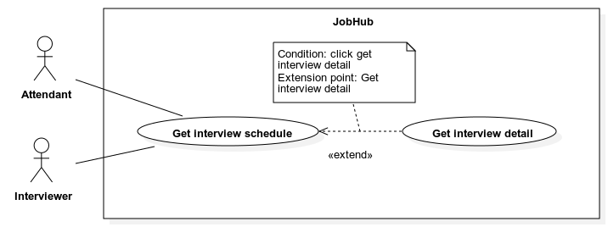

|  |  |  |  |
| --- | --- | --- | --- |
| **ID and Name:** | **UC-22: Get interview schedule** | | |
| Created By: | TienTT | Date Created: | 01/08/2022 |
| Primary Actor: | Interviewer | Secondary Actors: | Attendant |
| Priority: | High | Frequency of Use: | Usually |
| Trigger: | The actor sends a request to get interview schedule. | | |
| Description: | This use case allows *“Attendant”* or *“Interviewer”* to get interview schedule. | | |
| Preconditions: | The actor must login into the system. | | |
| Post-conditions: | * **Success:** The interview schedule is shown. * **Fail:** The error message “Something went wrong” is shown if there is any error occurred in the system. | | |
| Normal Flow: | |  |  |  | | --- | --- | --- | | Step | Actor Action | System Response | | 1 | The actor sends request to get interview schedule. | System shows a calendar grid with each cells represent a date.  Each cell contains a list of interview schedule.  An interview schedule has the following information:  - “Interview name”: label  - “Interview start time”: label  - “Interview end time”: label  - “Interview status”: label  - “View detail”: button  If a cell does not have interview schedule, show empty cell. | | | |
| Alternative Flows: | N/A | | |
| Exceptions: | N/A | | |
| Business Rules: | - The actor must be able to view interview schedule by month.  - The interview schedule is ordered ascending by interview start time. | | |
| Assumptions: | * Actor’s internet connection is available | | |

###### UC-23 <Attendant, Interviewer> Get interview detail



|  |  |  |  |
| --- | --- | --- | --- |
| **ID and Name:** | **UC-23: Get interview detail** | | |
| Created By: | TienTT | Date Created: | 01/08/2022 |
| Primary Actor: | Attendant | Secondary Actors: | Interviewer |
| Priority: | High | Frequency of Use: | Usually |
| Trigger: | The actor sends a request to get interview schedule detail. | | |
| Description: | This use case allows *“Attendant”, “Interviewer”* to get interview schedule detail. | | |
| Preconditions: | The actor must login into the system. | | |
| Post-conditions: | * **Success:** The interview schedule detail is shown. * **Fail:** The error message “Something went wrong” is shown if there is any error occurred in the system. | | |
| Normal Flow: | |  |  |  | | --- | --- | --- | | Step | Actor Action | System Response | | 1 | The actor sends request get interview schedule detail. | System shows the detail of interview schedule with the following information:  - “Name”: label  - “Description”: label  - “Status”: label  - “Interview date”: label  - “Start time”: label  - “End time”: label  - “Join interview room”: button  - “Join waiting room”: button  - “See report”: button | | | |
| Alternative Flows: | N/A | | |
| Exceptions: | N/A | | |
| Business Rules: | - The “Join interview room” button is shown only when the actor has role “*Interviewer*”, and the interview status is NOT_YET  - The “Join waiting room” button is shown only when the actor has role *“Attendant”*, and the interview status is NOT_YET  - The “See report” button is shown only when the actor has role *“Interviewer”,* and the interview status is DONE | | |
| Assumptions: | * Actor’s internet connection is available | | |

###### UC-24 <Attendant> Apply CV

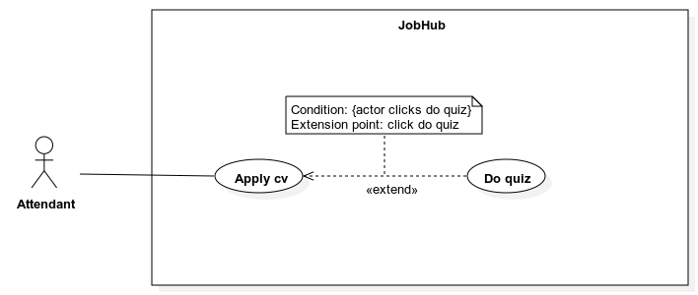

|  |  |  |  |
| --- | --- | --- | --- |
| **ID and Name:** | **UC-24: Apply CV** | | |
| Created By: | TienTT | Date Created: | 01/08/2022 |
| Primary Actor: | Attendant | Secondary Actors: | N/A |
| Priority: | High | Frequency of Use: | Usually |
| Trigger: | The actor sends a request to apply CV | | |
| Description: | This use case allows *“Attendant”* to apply CV. | | |
| Preconditions: | The actor must login into the system.  The actor must have at least 1 CV in the system.  The actor must select a job position to apply to.  The job fair that the job position belongs to must be public. | | |
| Post-conditions: | * **Success:** A new application with specific status is created. * **Fail:** - The error message “You have applied for this job position”   - The error message “Something went wrong” is shown if there is any error occurred in the system. | | |
| Normal Flow: | |  |  |  | | --- | --- | --- | | Step | Actor Action | System Response | | 1 | The actor sends request to apply CV to job position. | System shows a list of actor’s CVs which contains following information:  - “CV’s name”: label  - “Select”: button  - “View detail”: button  **[Exception 1]** | | 2 | The actor clicks “Select” button from a specific CV. | System shows the message “Your CV is suitable for this job position”.  System shows “Apply” button.  **[Alternative 1]** | | 3 | The actor clicks “Apply” button. | System asks for conformation and create new application. | | | |
| Alternative Flows: | **Alternative 1**   |  |  |  | | --- | --- | --- | | Step | Actor Action | System Response | | 1 | The actor clicks “Select” button from a specific CV. | System shows the message “Your CV is not suitable for this job position”.  System shows “Apply” button. | | 2 | Continue step 3 of main flow |  | | | |
| Exceptions: | |  |  |  | | --- | --- | --- | | No | Cause | System Response | | 1 | The job position has already been applied before. | Show error message “You have been applied to this job position”. | | | |
| Business Rules: | - A user can only apply 1 CV per 1 job position.  - The matching statement depends on the matching point between the CV and the job position. If the matching point is higher than 50% than the CV is considered suitable for the job position.  - The matching point will be calculated by the system.  - The list of CVs is ordered descending by their created time.  - The application’s initial status is PENDING. After the interviewer evaluate the application, the status can be APPROVED or REJECTED.  - If after the job fair public time and no interview evaluates the job application, the application will change its status to REJECTED.  - When an application has been applied successfully, the system should notify the available interviewers responsible for this job positions.  - If the job position is required an entry quiz, *“attendant”* must first take and pass the entry quiz to be able to apply to this job position. | | |
| Assumptions: | * Actor’s internet connection is available | | |

###### UC-25 <Attendant> Do quiz



|  |  |  |  |
| --- | --- | --- | --- |
| **ID and Name:** | **UC-25: Do quiz** | | |
| Created By: | TienTT | Date Created: | 01/08/2022 |
| Primary Actor: | Attendant | Secondary Actors: | N/A |
| Priority: | High | Frequency of Use: | Usually |
| Trigger: | The actor sends a request to do quiz. | | |
| Description: | This use case allows *“Attendant”* to do an entry quiz. | | |
| Preconditions: | The actor must login into the system.  The actor is applying to a job position. | | |
| Post-conditions: | * **Success:** A quiz is created for the actor and result message after the actor had done the quiz. * **Fail:** - The error message “This quiz has been submitted.”   - The error message “Something went wrong” is shown if there is any error occurred in the system. | | |
| Normal Flow: | |  |  |  | | --- | --- | --- | | Step | Actor Action | System Response | | 1 | The actor sends request to do quiz. | System creates a quiz based on the configuration of the job position.  System shows a list of questions and their answer options.  **[Exception 1]** | | 2 | The actor does the quiz and submits the answer.  **[Alternative 1]** | System shows the quiz result. | | | |
| Alternative Flows: | **Alternative 1**   |  |  |  | | --- | --- | --- | | Step | Actor Action | System Response | | 1 | The time count down reach 0. | System automatically submits the user’s current answers and shows the quiz result. | | | |
| Exceptions: | |  |  |  | | --- | --- | --- | | No | Cause | System Response | | 1 | The quiz has been submitted. | Show error message “This quiz has been submitted”. | | | |
| Business Rules: | - Systems will generate the quiz based on the job position configurations when supervisor update booth information. These configurations are time length, number of question and pass mark.  - The questions will be randomly selected from the question bank that associate with that job position. This question bank is managed by *“Company manager”.*  - The system should automatically save the actor questions every 1 minute.  - A question is considered answered correctly when the actor selected all correct options and selected no wrong options.  - The mark of a quiz is calculated by the formula: number of correct answered questions / number of questions.  - The actor is considered pass the quiz if the mark of the quiz is higher or equal to the pass mark. | | |
| Assumptions: | * Actor’s internet connection is available | | |

###### UC-26 <Attendant, Company employee> Get application list

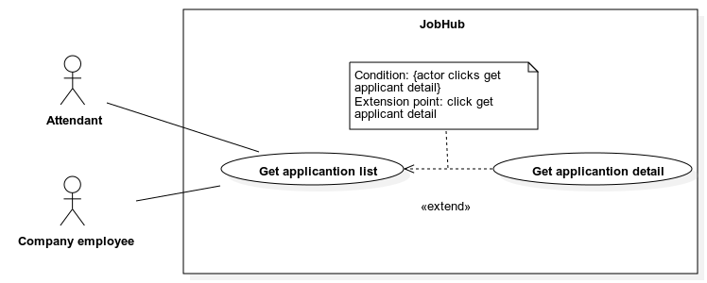

|  |  |  |  |
| --- | --- | --- | --- |
| **ID and Name:** | **UC-26: Get application list** | | |
| Created By: | TienTT | Date Created: | 01/08/2022 |
| Primary Actor: | Attendant | Secondary Actors: | Company employee |
| Priority: | High | Frequency of Use: | Usually |
| Trigger: | The actor sends a request to get application list. | | |
| Description: | This use case allows an *“Attendant”* or a *“Company employee”* to get a cv list. | | |
| Preconditions: | The actor must login into the system | | |
| Post-conditions: | * **Success:** - The application list is shown.   - The message “No data” is shown if the application list is empty.   * **Fail:** The error message “Something went wrong” is shown if there is any error occurred in the system. | | |
| Normal Flow: | |  |  |  | | --- | --- | --- | | Step | Actor Action | System Response | | 1 | The actor whose role is *“Attendant”* sends request to get list of application.  **[Alternative 1]** | System shows a list of application. The item is list has the following fields:  - “Job position name”: label  - “Company name”: label  - “Applied date”: label  - “Applied job fair”: label  - “Status”: label  - “View detail”: button  **[Alternative 2]** | | | |
| Alternative Flows: | **Alternative 1**   |  |  |  | | --- | --- | --- | | Step | Actor Action | System Response | | 1 | The actor whose role is *“Company employee”* sends request to get list of application. | System shows a list of application. The item is list has the following fields:  - “Job position name”: label  - “Candidate name”: label  - “Applied date”: label  - “Applied job fair”: label  - “Status”: label  - “Matching point”: label  - “View detail”: button  **[Alternative 2]** |   **Alternative 2**   |  |  |  | | --- | --- | --- | | Step | Actor Action | System Response | | 1 | The actor sends request to get list of application. | System returns an empty application list, shows message “No data”. | | | |
| Exceptions: | N/A | | |
| Business Rules: | * If the actor has role *“Attendant”,* the application list belongs only to the actor. * If the actor has role *“Company employee”,* the application list is all the application that applied to the booth that the actor get assigned to as “Interviewer”. * The application list is ordered descending by their applied time. * Search bar on the top and fast scroll bar on the right help user finding application faster. * The search criteria are by candidate’s name. * If no search value is inputted, the default behavior is getting all application. * If the actor has role *“Company employee”,* the actor must first be assigned to a booth as “Interviewer”. * System should allow the actor to sort by matching point. | | |
| Assumptions: | * Actor’s internet connection is available | | |

###### UC-27 <Attendant, Company employee> Get application detail



|  |  |  |  |
| --- | --- | --- | --- |
| **ID and Name:** | **UC-27: Get application detail** | | |
| Created By: | TienTT | Date Created: | 01/08/2022 |
| Primary Actor: | Attendant | Secondary Actors: | Company employee |
| Priority: | High | Frequency of Use: | Usually |
| Trigger: | The actor sends a request to get an application detail. | | |
| Description: | This use case allows an *“Attendant”* or a *“Company employee”* to get an application detail. | | |
| Preconditions: | The actor must login into the system. | | |
| Post-conditions: | * **Success:** The application detail is shown. * **Fail:** The error message “Something went wrong” is shown if there is any error occurred in the system. | | |
| Normal Flow: | |  |  |  | | --- | --- | --- | | Step | Actor Action | System Response | | 1 | The actor sends request to an application detail. | System shows the detail of the application with the following information:  - “Profile image”: image  - “Full name”: label  - “Location”: label  - “Education”: label  - “Education”: label  - “Job title”: label  - “Experience”: label  - “About me”: label  - Education list with each item contains:  - “School name”: label  - “Qualification”: label  - “Subject”: label  - “Enrolled date”: label  - “Graduate date”: label  - “Achievement”: label  - Work history list with each item contains:  - “Position”: label  - “Company name”: label  - “Start date”: date time  - “End date”: date time  - “Description”: label  - Skill list with each item contains:  - “Name”: label  - “Proficiency”: label  - Certification list with each item contains:  - “Name”: label  - “Institution”: label  - “Issue date”: date time  - "Link”: link  - Reference list with each item contains:  - “Name”: label  - “Company”: label  - “Email”: label  - “Position”: label  - “Phone”: label  - Activity list with each item contains:  - “Name”: label  - “Title”: label  - “Organization”: label  - “Begin date”: date time  - “End date”: date time  - “Description”: date time  - “Matching point”: label  - “Interview status”: label  - “Interviewer’s note”: label  - “Candidate’s advantage”: label  - “Candidate’s disadvantage”: label | | | |
| Alternative Flows: | N/A | | |
| Exceptions: | N/A | | |
| Business Rules: | - The “Matching point”, “Interviewer’s note”, “Candidate’s advantage”, and “Candidate’s disadvantage” labels are shown only for the actor who has role *“Company employee”.*  - The “Interview status” is only shown when the application has status “APPROVED”.  - The “Interview’s note”, “Candidate’s advantage”, “Candidate’s disadvantage” labels are only shown when the application’s interview status is “DONE”. | | |
| Assumptions: | * Actor’s internet connection is available | | |

##### 2.2.3.5 <Company manager> - Use case overview

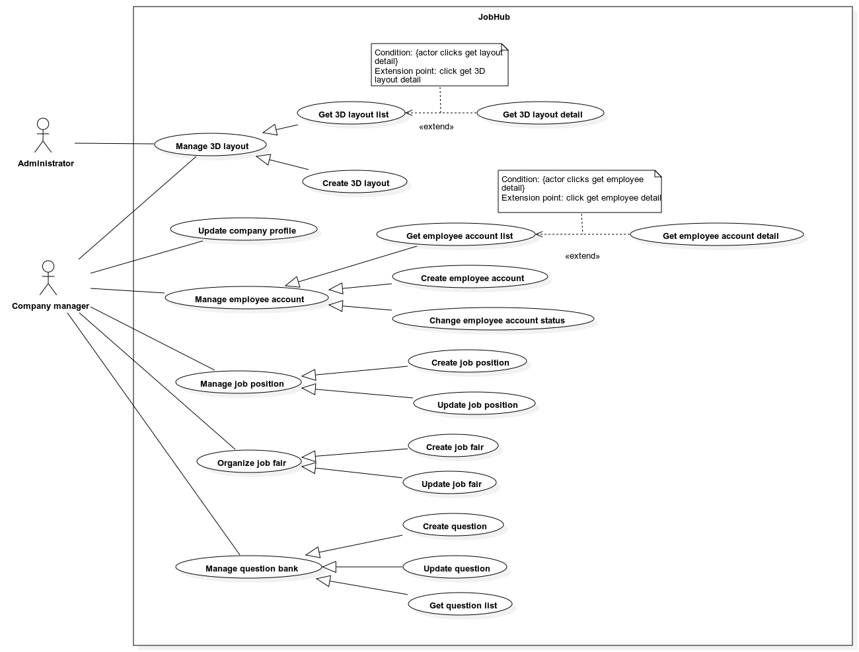

###### UC***-28 <Company manager> Update company profile***

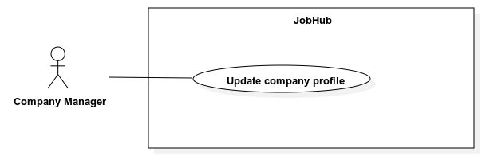

|  |  |  |  |
| --- | --- | --- | --- |
| **ID and Name:** | **UC-28: Update company profile** | | |
| Created By: | TienTT | Date Created: | 01/08/2022 |
| Primary Actor: | Company manager | Secondary Actors: | N/A |
| Priority: | Normal | Frequency of Use: | Usually |
| Trigger: | The actor sends a request to update company profile. | | |
| Description: | This use case allows an *”Company manager”* to update company profile. | | |
| Preconditions: | The actor must login into the system. | | |
| Post-conditions: | * **Success:** The system updates company profile and show success message. * **Fail:** - The error message “Something went wrong” is shown if there is any error occurred in the system.   - Specific error messages will be shown based on the actor’s actions | | |
| Normal Flow: | |  |  |  | | --- | --- | --- | | Step | Actor Action | System Response | | 1 | The actor sends request to update company profile. | System requires information from actor:  - “Logo”: file selected, must be .PNG, .JPEG, .JPG.  - “Name”: text input, required, length: 1-100, not contain special characters.  - “Email”: email input, required.  - “Phone number”: phone input, required.  - “Address”: text input, required, length: 1-1000.  - “Tax ID”: text input, required, length 1-15.  - “URL”: text input, length: 0-2048.  - “Description”: text input, required, length: 1-5000.  - “Size”: select dropdown, required.  - “Industry”: multiple select dropdown, required.  **[Alternative 1]** | | 2 | Actor inputs information. |  | | 3 | Actor submits information. | System validates, update company profile, and shows success message.  **[Exception 1, 2]** | | | |
| Alternative Flows: | **Alternative 1**   |  |  |  | | --- | --- | --- | | Step | Actor Action | System Response | | 1 | The actor sends request to add or update company benefit. | System requires information from actor:  - “Benefit type”: select dropdown, required.  - “Description”: text input, required, length: 1-200 | | 2 | Actor inputs information. | System validates information.  **[Exception 1]** | | 3 | Continue step 3 of normal flow |  | | | |
| Exceptions: | |  |  |  | | --- | --- | --- | | No | Cause | System Response | | 1 | All inputs’ information is not obeyed constraints. | Show error message to ask user input required input or follow the input’s constraint. | | 2 | The Tax ID is existed in the system. | Show error message to notify that the tax ID must be unique. | | | |
| Business Rules: | N/A | | |
| Assumptions: | * Actor’s internet connection is available | | |

###### UC-29 <Company manager> Get employee account list

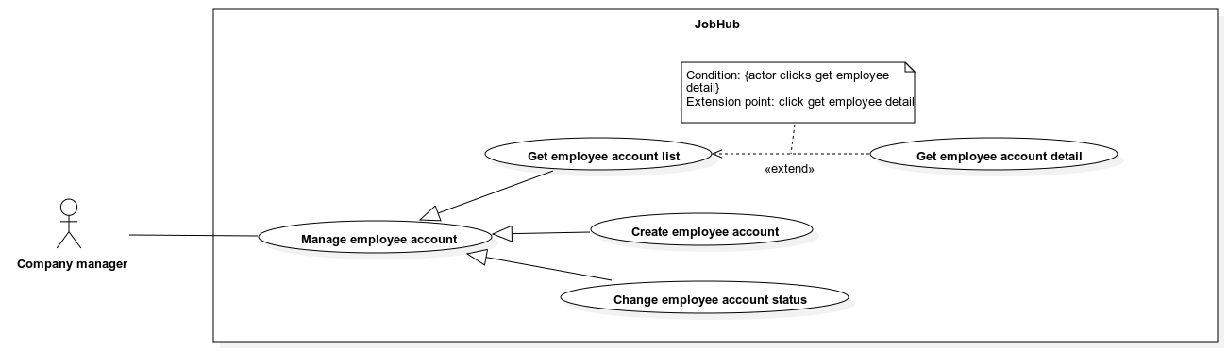

|  |  |  |  |
| --- | --- | --- | --- |
| **ID and Name:** | **UC-29: Get employee account list** | | |
| Created By: | TienTT | Date Created: | 01/08/2022 |
| Primary Actor: | Company manager | Secondary Actors: | N/A |
| Priority: | Normal | Frequency of Use: | Usually |
| Trigger: | The actor sends a request to get employee account list. | | |
| Description: | This use case allows *“Company manager”* to get an employee account list. | | |
| Preconditions: | The actor must login into the system | | |
| Post-conditions: | * **Success:** - The employee account list is shown.   - The message “No data” is shown if the account list is empty.   * **Fail:** The error message “Something went wrong” is shown if there is any error occurred in the system. | | |
| Normal Flow: | |  |  |  | | --- | --- | --- | | Step | Actor Action | System Response | | 1 | The actor sends request to get employee account list. | System shows a list of account. The item is list has the following fields:  - “Full name”: label  - “Employee’s id”: label  - “Department”: label  - “Email”: label  - “Status”: label  - “View detail”: button  - “Deactivate”: button  - “Activate”: button  **[Alternative 1]** | | | |
| Alternative Flows: | **Alternative 1**   |  |  |  | | --- | --- | --- | | Step | Actor Action | System Response | | 1 | The actor sends request to get employee account list. | System returns an empty account list, shows message “No data” | | | |
| Exceptions: | N/A | | |
| Business Rules: | * The list is ordered descending by their create time. * Search bar on the top and fast scroll bar on the right help user finding account faster. * The search criteria are by employee’s name. * If no search value is inputted, the default behavior is getting all company employee. * The “Deactivate” button is only shown when the account status is not “INACTIVE”. * The “Activate” button is only shown when the account status is “INACTIVE”. | | |
| Assumptions: | * Actor’s internet connection is available | | |

###### UC-30 <Company manager> Get employee account detail



|  |  |  |  |
| --- | --- | --- | --- |
| **ID and Name:** | **UC-30: Get employee account detail** | | |
| Created By: | TienTT | Date Created: | 01/08/2022 |
| Primary Actor: | Company manager | Secondary Actors: | N/A |
| Priority: | Normal | Frequency of Use: | Usually |
| Trigger: | The actor sends a request to get employee account detail. | | |
| Description: | This use case allows *“Company manger”* to get employee account detail. | | |
| Preconditions: | The actor must login into the system. | | |
| Post-conditions: | * **Success:** The employee detail is shown. * **Fail:** The error message “Something went wrong” is shown if there is any error occurred in the system. | | |
| Normal Flow: | |  |  |  | | --- | --- | --- | | Step | Actor Action | System Response | | 1 | The actor sends request to get employee account detail. | System shows the detail of the employee with the following information:  - “Avatar”: image  - “Id”: label  - “Full name”: label  - “Email”: label  - “Phone”: label  - “Status”: label  - “Gender”: label  - “Role”: label  - “Department”: label  - “Create time”: label  - “Deactivate”: button  - “Activate”: button | | | |
| Alternative Flows: | N/A | | |
| Exceptions: | N/A | | |
| Business Rules: | - The “Deactivate” button is only shown when the account status is not “INACTIVE”.  - The “Activate” button is only shown when the account status is “INACTIVE”. | | |
| Assumptions: | * Actor’s internet connection is available | | |

###### UC-31 <Company manager> Create employee account



|  |  |  |  |
| --- | --- | --- | --- |
| **ID and Name:** | **UC-31: Create employee account** | | |
| Created By: | TienTT | Date Created: | 01/08/2022 |
| Primary Actor: | Company manager | Secondary Actors: | N/A |
| Priority: | Normal | Frequency of Use: | Usually |
| Trigger: | The actor sends a request to create employee account. | | |
| Description: | This use case allows a *”Company manager”* to create new employee account. | | |
| Preconditions: | The actor must login into the system. | | |
| Post-conditions: | * **Success:** The system creates new employee account with specific status. * **Fail:** - The error message “Something went wrong” is shown if there is any error occurred in the system.   - Specific error messages will be shown based on the actor’s actions | | |
| Normal Flow: | |  |  |  | | --- | --- | --- | | Step | Actor Action | System Response | | 1 | The actor sends request to create new employee account. | System requires information from actor:  - “First name”: text input, required, length: 1-100.  - “Middle name”: text input, required, length: 1-100.  - “Last name”: text input, required, length: 1-100.  - “Department”: text input, required, length: 1-100.  - “Employee’s id”: text input, required, length: 1-40.  - “Email”: email input, required. | | 2 | Actor inputs information. |  | | 3 | Actor submits information. | System validates, create new employee account, and shows success message.  **[Exception 1, 2, 3]** | | | |
| Alternative Flows: | N/A | | |
| Exceptions: | |  |  |  | | --- | --- | --- | | No | Cause | System Response | | 1 | All inputs’ information is not obeyed constraints. | Show error message to ask user input required input or follow the input’s constraint. | | 2 | The inputted email has already existed in the system. | Show error message to notify user that the inputted email has already existed in the system. | | 3 | This company has maximum allowed active employee. | Show error message to notify user that this company has maximum allowed active employee. | | | |
| Business Rules: | - After success create the employee account, the account will have status “VERIFIED” and the password for that account will be random generated.  - The generated password has length of 10 and each letter belongs to “0123456789QWERTYUIOPASDFGHJKLZXCVBNMqwertyuiopasdfghjklzxcvbnm!@#$%^&*()_”.  - An email will be sent to the new account’s email address with the generated password.  - When the employee first login to the system, the account will change status to “ACTIVE”.  - Each company have a maximum company employee account with status “ACTIVE”. This value is 100 accounts per company. | | |
| Assumptions: | * Actor’s internet connection is available | | |

###### UC-32 <Company manager> Change employee account status



|  |  |  |  |
| --- | --- | --- | --- |
| **ID and Name:** | **UC-32: Change employee account status** | | |
| Created By: | TienTT | Date Created: | 01/08/2022 |
| Primary Actor: | Company Manager | Secondary Actors: | N/A |
| Priority: | Low | Frequency of Use: | Usually |
| Trigger: | The actor sends a request to change employee account status. | | |
| Description: | This use case allows a *“Company manager”* to change employee account status. | | |
| Preconditions: | The actor must login into the system. | | |
| Post-conditions: | * **Success:** Change status on employee’s account and show success message. * **Fail:** The error message “Something went wrong” is shown if there is any error occurred in the system. | | |
| Normal Flow: | |  |  |  | | --- | --- | --- | | Step | Actor Action | System Response | | 1 | The actor sends request to deactivate employee account.  **[Alternative 1]** | System asks for confirmation. | | 2 | The actor confirms. | System changes employee’s account status to “INACTIVE” and show success message. | | | |
| Alternative Flows: | **Alternative 1**   |  |  |  | | --- | --- | --- | | Step | Actor Action | System Response | | 1 | The actor sends request to activate employee account. | System asks for confirmation. | | 2 | The actor confirms. | System changes employee’s account status to “VERIFIED” and show success message. | | | |
| Exceptions: | N/A | | |
| Business Rules: | - The actor can only deactivate an employee account when that account status is not “INACTIVE”.  - The actor can only activate an employee account when that account status is “INACTIVE”. | | |
| Assumptions: | * Actor’s internet connection is available | | |

###### UC-33 <Company manager> Create job position

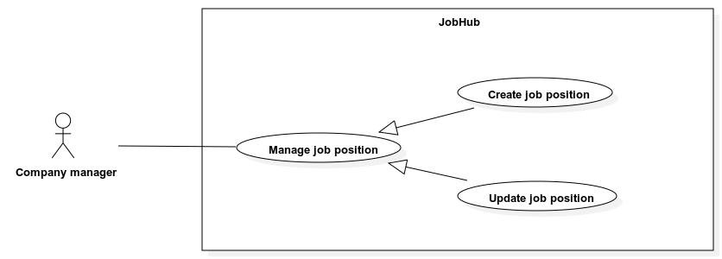

|  |  |  |  |
| --- | --- | --- | --- |
| **ID and Name:** | **UC-33: Create job position** | | |
| Created By: | TienTT | Date Created: | 01/08/2022 |
| Primary Actor: | Company manager | Secondary Actors: | N/A |
| Priority: | High | Frequency of Use: | Usually |
| Trigger: | The actor sends a request to create a new job position. | | |
| Description: | This use case allows a *”Company manager”* to create a new job position. | | |
| Preconditions: | The actor must login into the system. | | |
| Post-conditions: | * **Success:** The system creates new job position. * **Fail:** - The error message “Something went wrong” is shown if there is any error occurred in the system.   - Specific error messages will be shown based on the actor’s actions | | |
| Normal Flow: | |  |  |  | | --- | --- | --- | | Step | Actor Action | System Response | | 1 | The actor sends request to create new job position. | System requires information from actor:  - “Job title”: text input, required, length: 1-200  - “Job level”: select dropdown, required.  - “Job type”: select dropdown, required.  - “Prefer language”: select dropdown, required.  - “Skill tags”: multiple select dropdown, required.  - “Category tags”: multiple select drop down, required.  - “Contact person”: text input, required, length: 1-100.  - “Contact email”, text input, required, length: 1-322.  - “Description”: text input, required, length: 1-5000.  - “Requirement”: text input, required, length: 1-5000. | | 2 | Actor inputs information. |  | | 3 | Actor submits information. | System validates, create new employee account, and shows success message.  **[Exception 1]** | | | |
| Alternative Flows: | N/A | | |
| Exceptions: | |  |  |  | | --- | --- | --- | | No | Cause | System Response | | 1 | All inputs’ information is not obeyed constraints. | Show error message to ask user input required input or follow the input’s constraint. | | | |
| Business Rules: | - The system should suggest “contact person”, “contact email” input based on the company’s employee list. | | |
| Assumptions: | * Actor’s internet connection is available | | |

###### UC-34 <Company manager> Update job position



|  |  |  |  |
| --- | --- | --- | --- |
| **ID and Name:** | **UC-34: Update job position** | | |
| Created By: | TienTT | Date Created: | 01/08/2022 |
| Primary Actor: | Company manager | Secondary Actors: | N/A |
| Priority: | High | Frequency of Use: | Usually |
| Trigger: | The actor sends a request to update job position. | | |
| Description: | This use case allows a *”Company manager”* to update a job position. | | |
| Preconditions: | The actor must login into the system. | | |
| Post-conditions: | * **Success:** The system updates job position and show success message. * **Fail:** - Discard all unsaved changes.   - The error message “Something went wrong” is shown if there is any error occurred in the system.  - Specific error messages will be shown based on the actor’s actions. | | |
| Normal Flow: | |  |  |  | | --- | --- | --- | | Step | Actor Action | System Response | | 1 | The actor sends request to update a job position. | System requires information from actor:  - “Job title”: text input, required, length: 1-200  - “Job level”: select dropdown, required.  - “Job type”: select dropdown, required.  - “Prefer language”: select dropdown, required.  - “Skill tags”: multiple select dropdown, required.  - “Category tags”: multiple select drop down, required.  - “Contact person”: text input, required, length: 1-100.  - “Contact email”, text input, required, length: 1-322.  - “Description”: text input, required, length: 1-5000.  - “Requirement”: text input, required, length: 1-5000. | | 2 | Actor inputs information. |  | | 3 | Actor submits information. | System validates, create new CV, and shows success message.  **[Exception 1]** | | | |
| Alternative Flows: | N/A | | |
| Exceptions: | |  |  |  | | --- | --- | --- | | No | Cause | System Response | | 1 | All inputs’ information is not obeyed constraints. | Show error message to ask user input required input or follow the input’s constraint. | | | |
| Business Rules: | - The system should suggest “contact person”, “contact email” input based on the company’s employee list. | | |
| Assumptions: | * Actor’s internet connection is available | | |

###### UC-35 <Company manager> Get question list

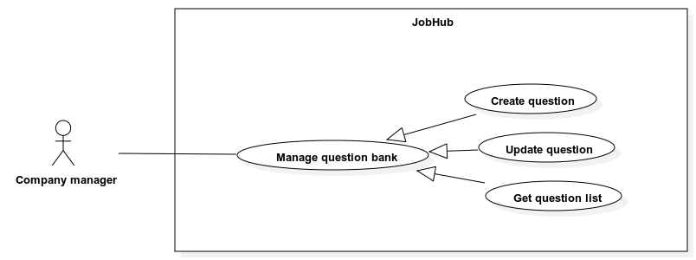

|  |  |  |  |
| --- | --- | --- | --- |
| **ID and Name:** | **UC-35: Get question list** | | |
| Created By: | TienTT | Date Created: | 01/08/2022 |
| Primary Actor: | Company manager | Secondary Actors: | N/A |
| Priority: | High | Frequency of Use: | Usually |
| Trigger: | The actor sends a request to get question list. | | |
| Description: | This use case allows *“Company manager”* to get a question list. | | |
| Preconditions: | The actor must login into the system | | |
| Post-conditions: | * **Success:** - The question list is shown.   - The message “No data” is shown if the question list is empty.   * **Fail:** The error message “Something went wrong” is shown if there is any error occurred in the system. | | |
| Normal Flow: | |  |  |  | | --- | --- | --- | | Step | Actor Action | System Response | | 1 | The actor sends request to get question list. | System shows a list of question. The item is list has the following fields:  - “Question content”: label  - List of associate options, each item contains:  - “Option content”: label  - “Is correct”: label  - “Edit”: button  **[Alternative 1]** | | | |
| Alternative Flows: | **Alternative 1**   |  |  |  | | --- | --- | --- | | Step | Actor Action | System Response | | 1 | The actor sends request to get question list. | System returns an empty question list, shows message “No data” | | | |
| Exceptions: | N/A | | |
| Business Rules: | * The list is ordered descending by their create time. * Search bar on the top and fast scroll bar on the right help user finding question faster. * The search criteria are by question’s content. * If no search value is inputted, the default behavior is getting all questions. | | |
| Assumptions: | * Actor’s internet connection is available | | |

###### UC-36 <Company manager> Create question



|  |  |  |  |
| --- | --- | --- | --- |
| **ID and Name:** | **UC-36: Create question** | | |
| Created By: | TienTT | Date Created: | 01/08/2022 |
| Primary Actor: | Company manager | Secondary Actors: | N/A |
| Priority: | High | Frequency of Use: | Usually |
| Trigger: | The actor sends a request to create a new question. | | |
| Description: | This use case allows a *”Company manager”* to create a new question. | | |
| Preconditions: | The actor must login into the system. | | |
| Post-conditions: | * **Success:** The system creates a new question. * **Fail:** - The error message “Something went wrong” is shown if there is any error occurred in the system.   - Specific error messages will be shown based on the actor’s actions | | |
| Normal Flow: | |  |  |  | | --- | --- | --- | | Step | Actor Action | System Response | | 1 | The actor sends request to create a new question. | System requires information from actor:  - “Question content”: text input, required, length: 1-500.  **[Alternative 1]** | | 2 | Actor inputs information. |  | | 3 | Actor submits information. | System validates, create new question, and shows success message.  **[Exception 1, 2]** | | | |
| Alternative Flows: | **Alternative 1**   |  |  |  | | --- | --- | --- | | Step | Actor Action | System Response | | 1 | The actor sends request to add an option. | System requires information from actor:  - “Option content”: text input, required, length: 1-500.  - “Is correct”: checkbox. | | 2 | Actor inputs information. | System validates information.  **[Exception 1]** | | 3 | Continue step 3 of normal flow |  | | | |
| Exceptions: | |  |  |  | | --- | --- | --- | | No | Cause | System Response | | 1 | All inputs’ information is not obeyed constraints. | Show error message to ask user input required input or follow the input’s constraint. | | 2 | Question does not have at least 1 correct option. | Show error message to ask user to add at least 1 correct option. | | | |
| Business Rules: | N/A | | |
| Assumptions: | * Actor’s internet connection is available | | |

###### UC-37 <Company manager> Update question



|  |  |  |  |
| --- | --- | --- | --- |
| **ID and Name:** | **UC-37: Update question** | | |
| Created By: | TienTT | Date Created: | 01/08/2022 |
| Primary Actor: | Company manager | Secondary Actors: | N/A |
| Priority: | High | Frequency of Use: | Usually |
| Trigger: | The actor sends a request to update question. | | |
| Description: | This use case allows a *”Company manager”* to update a question. | | |
| Preconditions: | The actor must login into the system. | | |
| Post-conditions: | * **Success:** The system updates question and show success message. * **Fail:** - Discard all unsaved changes.   - The error message “Something went wrong” is shown if there is any error occurred in the system.  - Specific error messages will be shown based on the actor’s actions. | | |
| Normal Flow: | |  |  |  | | --- | --- | --- | | Step | Actor Action | System Response | | 1 | The actor sends request to update a question. | System requires information from actor:  - “Question content”: text input, required, length: 1-500.  **[Alternative 1]** | | 2 | Actor inputs information. |  | | 3 | Actor submits information. | System validates, update question, and shows success message.  **[Exception 1, 2]** | | | |
| Alternative Flows: | **Alternative 1**   |  |  |  | | --- | --- | --- | | Step | Actor Action | System Response | | 1 | The actor sends request to add an option. | System requires information from actor:  - “Option content”: text input, required, length: 1-500.  - “Is correct”: checkbox. | | 2 | Actor inputs information. | System validates information.  **[Exception 1]** | | 3 | Continue step 3 of normal flow |  | | | |
| Exceptions: | |  |  |  | | --- | --- | --- | | No | Cause | System Response | | 1 | All inputs’ information is not obeyed constraints. | Show error message to ask user input required input or follow the input’s constraint. | | 2 | Question does not have at least 1 correct option. | Show error message to ask user to add at least 1 correct option. | | | |
| Business Rules: | - When a question get updated, all other past quiz that contains this question must not updated its content or correct options. | | |
| Assumptions: | * Actor’s internet connection is available | | |

###### Diagram Description automatically generatedUC-38 <Company manager> Create job fair

|  |  |  |  |
| --- | --- | --- | --- |
| **ID and Name:** | **UC-38: Create job fair** | | |
| Created By: | TienTT | Date Created: | 01/08/2022 |
| Primary Actor: | Company manager | Secondary Actors: | N/A |
| Priority: | High | Frequency of Use: | Usually |
| Trigger: | The actor sends a request to create a job fair. | | |
| Description: | This use case allows a *”Company manager”* to create a new job fair. | | |
| Preconditions: | The actor has been login to the system.  The system must have at least 1 default 3D layout.  All system’s default 3D layout and company’s 3D layout has at least 1 booth slot. | | |
| Post-conditions: | * **Success:** A new job fair will be created with specific status. * **Fail:** - The error message “Something went wrong” is shown if there is any error occurred in the system.   - Specific error messages will be shown based on the actor’s actions. | | |
| Normal Flow: | |  |  |  | | --- | --- | --- | | Step | Actor Action | System Response | | 1 | The actor sends request to create a job fair. | System gets a list of system’s default job fair 3D layout or company’s 3D layout. The item in list must has the following fields:  - “Name”: label  - “Thumbnail image”: image  **[Alternative 1]** | | 2 | The actor sends request choosing a layout to apply for job fair. | System renders chosen 3D layout and requests confirmation.  System creates new job fair with status “DRAFT”, generates booth’s slots based on actor’s chosen layout, shows successful message, and ask user to process assigning employees. | | 3 | The actor sends request to assign employee. | System shows assignment list. The item in list must has the following field:  - “Booth slot’s name”: label  - “Supervisor’s name”: label  - “Decorator’s name”: label  - “Staff’s names”: label | | 4 | The actor clicks a booth slot. | System shows list of assignable employees and list of assigned employees for this booth slot. The item in assignable employee list must have the following fields:  - “Name”: label  - “Id”: label  The item in assigned employees list must have the following fields:  - “Name”: label  - “Id”: label  - “Role”: label  **[Alternative 2]** | | 5 |  | System required information:  - “Employee’s name”: dropdown list, value based on assignable employee list, required  - “Role”: select dropdown, value: “Supervisor”-“Decorator”-“Staff”, required | | 6 | The actor inputs information.  The actor sends request to assign employee to booth slot. | System validates information, and request confirmation.  **[Exception 1]**  The system saved assignment list, show successful message, and ask user to process to fill job fair information. | | 7 | The actor sends request to fill job fair information. | System requires information from actor:  - “Name”: text input, required, length: 1-100  - “Decoration booth time range”: date picker, required, minimum 24h  - “Public time range”: date picker, required, minimum 24h  - “Job fair shift”: dropdown number, required  - “Shift length”: time picker, required  - “Job fair thumbnail”: file selected, must be .PNG, .JPEG, .JPG, file size < 15MB  - “Host name”: text input, required, length: 1-100  - “Target attendant”: input , required, length: 1-100  - “Description”: text input, required, length: 1-500 | | 8 | The actor sends request to submit job fair information. | The system shows job fair’s detail, and requests confirmation.  **[Exception 2, 3, 4]**  The system changes job fair status to “Publish” and show successful message. | | | |
| Alternative Flows: | **Alternative 1**   |  |  |  | | --- | --- | --- | | Step | Actor Action | System Response | | 1 | System gets empty list of company’s 3D layout. | Show message to notify the layout list is empty. |   **Alternative 2**   |  |  |  | | --- | --- | --- | | Step | Actor Action | System Response | | 1 | System gets empty list of assignable employees or assigned employee. | Show message to notify the assignable employees or assigned employee list is empty. | | | |
| Exceptions: | |  |  |  | | --- | --- | --- | | No | Cause | System Response | | 1 | The booth slot does not have the required number of employees. | Show message to notify that the booth slot does not have the required number of employees | | 2 | All inputs’ information is not obeyed constraints. . | Show error message to ask user input required input or follow the input’s constraint. | | 3 | The public time range is overlapped with decorate time range. | Show error message to notify user that the public time range cannot overlaps with decorate time range. | | 4 | The job fair shift is overlapped with each other. | Show error message to notify user that the job fair shift is overlapped with each other. | | | |
| Business Rules: | - New job fair will be created in the system with inputted information.  - The initial status of job fair is “DRAFT”.  - After user confirm the job fair’s detail, the job fair’s status will change to “PUBLISH”.  - The list of 3D layout must be order descending by created date.  - The booth slot for job fair must be generated with the same coordination with the booth slot of the selected layout.  - The assignment list must be order descending by created date of booth slot.  - The assignable employee list must be order descending by employee account’s created date.  - The assigned employee list must be order descending by assignment date.  - 1 employee cannot be assigned to many booth slots (excepts with role decorator, supervisor).  - 1 booth slot must have at least 4 roles: 1 supervisor, 1 decorator, 2 staff.  - System must ensure the decorate time range and the public time range does not overlap.  - System must ensure the maximum of job fair existed range cannot exceed the company current subscription limit.  - System must ensure the job fair shift cannot be overlapped.  - Assigned company employees will receive a notification about their new assignment. | | |
| Assumptions: | * Actor’s internet connection is available | | |

###### UC-39 <Company manager> Update job fair

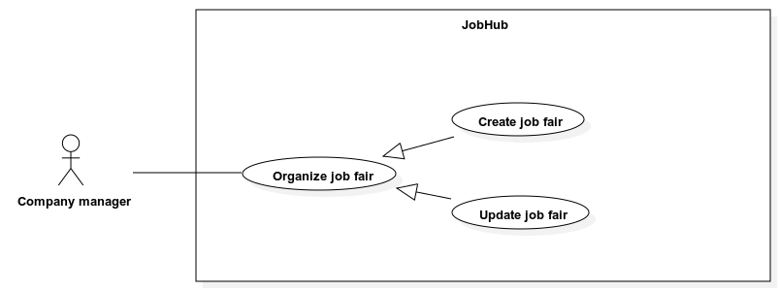

|  |  |  |  |
| --- | --- | --- | --- |
| **ID and Name:** | **UC-39: Update job fair** | | |
| Created By: | TienTT | Date Created: | 01/08/2022 |
| Primary Actor: | Company manager | Secondary Actors: | N/A |
| Priority: | High | Frequency of Use: | Usually |
| Trigger: | The actor sends a request to create a job fair. | | |
| Description: | This use case allows a *”Company manager”* to update a draft job fair. | | |
| Preconditions: | The actor has been login to the system.  The system must have at least 1 default 3D layout.  All system’s default 3D layout and company’s 3D layout has at least 1 booth slot. | | |
| Post-conditions: | * **Success:** System updates job fair and show success message. * **Fail:** - Discard all unsaved change.   - The error message “Something went wrong” is shown if there is any error occurred in the system.  - Specific error messages will be shown based on the actor’s actions. | | |
| Normal Flow: | |  |  |  | | --- | --- | --- | | Step | Actor Action | System Response | | 1 | The actor sends request to update a job fair. | System gets a list of system’s default job fair 3D layout or company’s 3D layout. The item in list must has the following fields:  - “Name”: label  - “Thumbnail image”: image  **[Alternative 1]** | | 2 | The actor sends request choosing a layout to apply for job fair. | System renders chosen 3D layout and requests confirmation.  System creates new job fair with status “DRAFT”, generates booth’s slots based on actor’s chosen layout, shows successful message, and ask user to process assigning employees. | | 3 | The actor sends request to assign employee. | System shows assignment list. The item in list must has the following field:  - “Booth slot’s name”: label  - “Supervisor’s name”: label  - “Decorator’s name”: label  - “Staff’s names”: label | | 4 | The actor clicks a booth slot. | System shows list of assignable employees and list of assigned employees for this booth slot. The item in assignable employee list must have the following fields:  - “Name”: label  - “Id”: label  The item in assigned employees list must have the following fields:  - “Name”: label  - “Id”: label  - “Role”: label  **[Alternative 2]** | | 5 |  | System required information:  - “Employee’s name”: dropdown list, value based on assignable employee list, required  - “Role”: select dropdown, value: “Supervisor”-“Decorator”-“Staff”, required | | 6 | The actor inputs information.  The actor sends request to assign employee to booth slot. | System validates information, and request confirmation.  **[Exception 1]**  The system saved assignment list, show successful message, and ask user to process to fill job fair information. | | 7 | The actor sends request to fill job fair information. | System requires information from actor:  - “Name”: text input, required, length: 1-100  - “Decoration booth time range”: date picker, required, minimum 24h  - “Public time range”: date picker, required, minimum 24h  - “Job fair shift”: dropdown number, required  - “Shift length”: time picker, required  - “Job fair thumbnail”: file selected, must be .PNG, .JPEG, .JPG, file size < 15MB  - “Host name”: text input, required, length: 1-100  - “Target attendant”: input , required, length: 1-100  - “Description”: text input, required, length: 1-500 | | 8 | The actor sends request to submit job fair information. | The system shows job fair’s detail, and requests confirmation.  **[Exception 2, 3, 4]**  The system changes job fair status to “Publish” and show successful message. | | | |
| Alternative Flows: | **Alternative 1**   |  |  |  | | --- | --- | --- | | Step | Actor Action | System Response | | 1 | System gets empty list of company’s 3D layout. | Show message to notify the layout list is empty. |   **Alternative 2**   |  |  |  | | --- | --- | --- | | Step | Actor Action | System Response | | 1 | System gets empty list of assignable employees or assigned employee. | Show message to notify the assignable employees or assigned employee list is empty. | | | |
| Exceptions: | |  |  |  | | --- | --- | --- | | No | Cause | System Response | | 1 | The booth slot does not have the required number of employees. | Show message to notify that the booth slot does not have the required number of employees | | 2 | All inputs’ information is not obeyed constraints. . | Show error message to ask user input required input or follow the input’s constraint. | | 3 | The public time range is overlapped with decorate time range. | Show error message to notify user that the public time range cannot overlaps with decorate time range. | | 4 | The job fair shift is overlapped with each other. | Show error message to notify user that the job fair shift is overlapped with each other. | | | |
| Business Rules: | - The selected job fair must have status “DRAFT”  - After user confirm the job fair’s detail, the job fair’s status will change to “PUBLISH”.  - The list of 3D layout must be order descending by created date.  - The booth slot for job fair must be generated with the same coordination with the booth slot of the selected layout.  - The assignment list must be order descending by created date of booth slot.  - The assignable employee list must be order descending by employee account’s created date.  - The assigned employee list must be order descending by assignment date.  - 1 employee cannot be assigned to many booth slots (excepts with role decorator, supervisor).  - 1 booth slot must have at least 4 roles: 1 supervisor, 1 decorator, 2 staff.  - System must ensure the decorate time range and the public time range does not overlap.  - System must ensure the maximum of job fair existed range cannot exceed the company current subscription limit.  - System must ensure the job fair shift cannot be overlapped.  - Assigned company employees will receive a notification about their new assignment. | | |
| Assumptions: | * Actor’s internet connection is available | | |

##### 2.2.3.6 <Company employee> - Use case overview

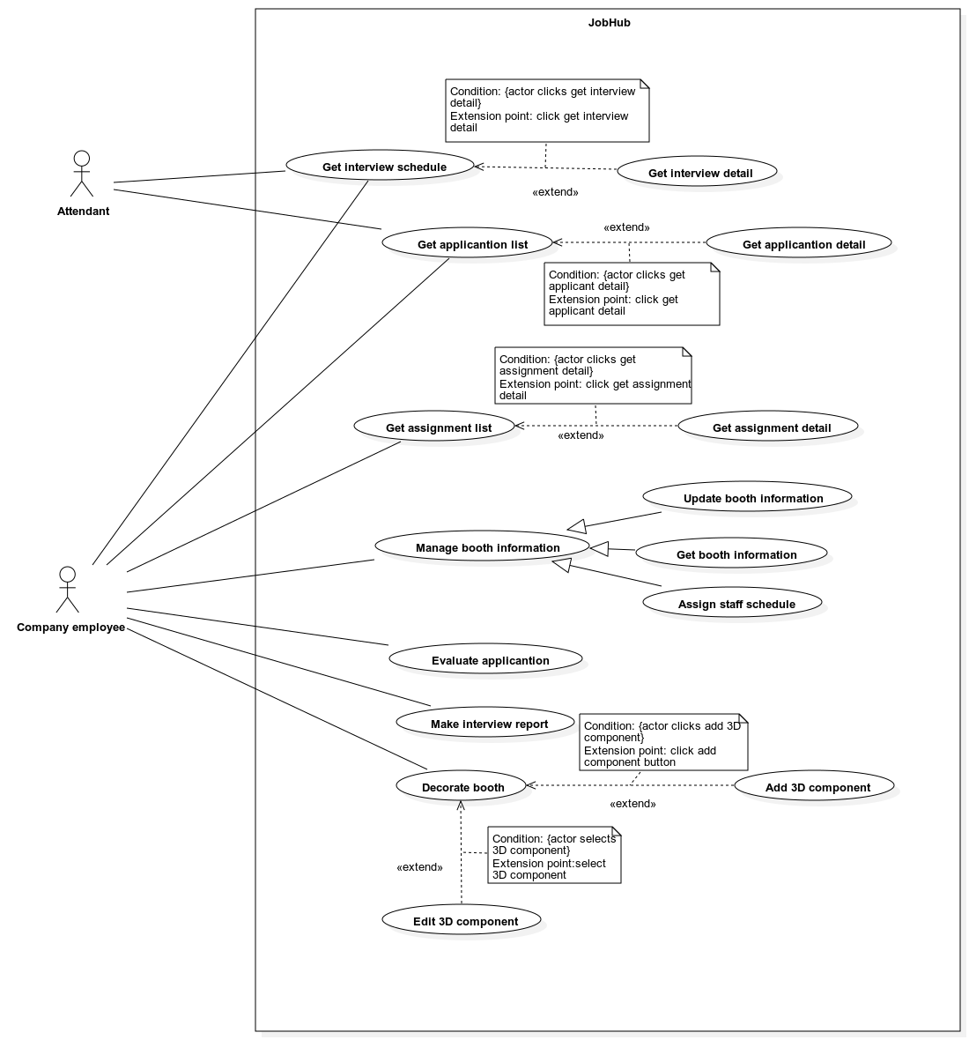

###### UC-40 <Company employee> Get assignment list

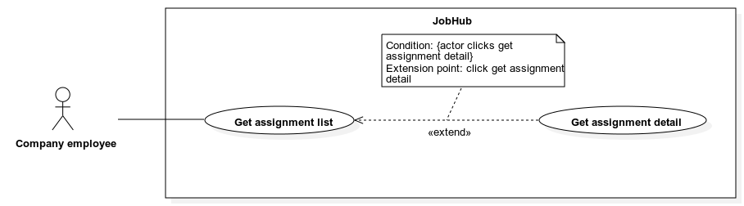

|  |  |  |  |
| --- | --- | --- | --- |
| **ID and Name:** | **UC-40: Get assignment list** | | |
| Created By: | TienTT | Date Created: | 01/08/2022 |
| Primary Actor: | Company employee | Secondary Actors: | N/A |
| Priority: | High | Frequency of Use: | Usually |
| Trigger: | The actor sends a request to get assignment list. | | |
| Description: | This use case allows *“Company employee”* to get an assignment list. | | |
| Preconditions: | The actor must login into the system | | |
| Post-conditions: | * **Success:** - The assignment list is shown.   - The message “No data” is shown if the assignment list is empty.   * **Fail:** The error message “Something went wrong” is shown if there is any error occurred in the system. | | |
| Normal Flow: | |  |  |  | | --- | --- | --- | | Step | Actor Action | System Response | | 1 | The actor sends request to get assignment list. | System shows a list of assignment. The item is list has the following fields:  - “Job fair name”: label  - “Booth name”: label  - “Assignment type”: label  - “Assigner”: label  - “Create time”: label  - “Begin time”: label  - “Deadline”: label  - “Status”: label  - “My booth profile”: button  - “Assign task”: button  - “Decorate”: button  - “Application list”: button  - “Interview schedule”: button  - “Go to booth”: button  **[Alternative 1]** | | | |
| Alternative Flows: | **Alternative 1**   |  |  |  | | --- | --- | --- | | Step | Actor Action | System Response | | 1 | The actor sends request to get assignment list. | System returns an empty assignment list, shows message “No data” | | | |
| Exceptions: | N/A | | |
| Business Rules: | * The list is ordered descending by their create time. * Search bar on the top and fast scroll bar on the right help user finding assignment faster. * The search criteria are by job fair’s name. * If no search value is inputted, the default behavior is getting all assignment. * The “My booth profile” and “Assign task” buttons are shown if the assignment type is “Supervisor”. * The “Decorate” button is shown if the assignment type is “Decorator”. * The “Application list” and “Interview schedule” buttons are shown if the assignment type is “Interviewer”. * The “Go to booth” button is shown if the assignment type is “Receptionist” | | |
| Assumptions: | * Actor’s internet connection is available | | |

###### UC-41 <Company employee> Get assignment detail



|  |  |  |  |
| --- | --- | --- | --- |
| **ID and Name:** | **UC-41: Get assignment detail** | | |
| Created By: | TienTT | Date Created: | 01/08/2022 |
| Primary Actor: | Company employee | Secondary Actors: | N/A |
| Priority: | High | Frequency of Use: | Usually |
| Trigger: | The actor sends a request to get assignment detail. | | |
| Description: | This use case allows *“Company employee”* to get assignment detail. | | |
| Preconditions: | The actor must login into the system. | | |
| Post-conditions: | * **Success:** The assignment detail is shown. * **Fail:** The error message “Something went wrong” is shown if there is any error occurred in the system. | | |
| Normal Flow: | |  |  |  | | --- | --- | --- | | Step | Actor Action | System Response | | 1 | The actor sends request to get assignment detail. | System shows the detail of the employee with the following information:  - “Job fair name”: label  - “Booth name”: label  - “Assignment type”: label  - “Assigner”: label  - “Create time”: label  - “Begin time”: label  - “Deadline”: label  - “Status”: label  - “My booth profile”: button  - “Assign task”: button  - “Decorate”: button  - “Application list”: button  - “Interview schedule”: button  - “Go to booth”: button | | | |
| Alternative Flows: | N/A | | |
| Exceptions: | N/A | | |
| Business Rules: | * The “My booth profile” and “Assign task” buttons are shown if the assignment type is “Supervisor”. * The “Decorate” button is shown if the assignment type is “Decorator”. * The “Application list” and “Interview schedule” buttons are shown if the assignment type is “Interviewer”. * The “Go to booth” button is shown if the assignment type is “Receptionist” | | |
| Assumptions: | * Actor’s internet connection is available | | |

###### UC-42 <Company employee> Get booth information

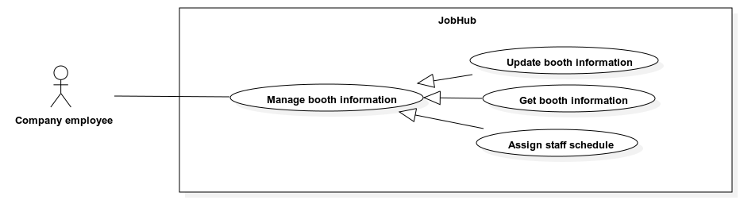

|  |  |  |  |
| --- | --- | --- | --- |
| **ID and Name:** | **UC-42: Get booth information** | | |
| Created By: | TienTT | Date Created: | 01/08/2022 |
| Primary Actor: | Company employee | Secondary Actors: | N/A |
| Priority: | High | Priority: | High |
| Trigger: | The actor sends a request to get booth information. | | |
| Description: | This use case allows a *”Company employee”* to get booth information. | | |
| Preconditions: | The actor must login into the system.  The job fair that the booth belongs must be in decorate time range.  The actor must be assigned to this booth as “Supervisor”. | | |
| Post-conditions: | * **Success:** The system get booth information. * **Fail:** - The error message “Something went wrong” is shown if there is any error occurred in the system.   - Specific error messages will be shown based on the actor’s actions | | |
| Normal Flow: | |  |  |  | | --- | --- | --- | | Step | Actor Action | System Response | | 1 | The actor sends request to get booth information. | System shows information from booth:  - “Name”: label  - “Description”: label  System shows a list of booth’s job position. Each booth’s job position contains information:  - “Title”: label  - “Min salary”: label  - “Max salary”: label  - “Number of positions”: label  - “Is have test”: labels  - “Edit”: button  **[Alternative 1]** | | | |
| Alternative Flows: | **Alternative 1**   |  |  |  | | --- | --- | --- | | Step | Actor Action | System Response | | 1 | The actor sends request to get booth information. | System shows information from booth:  - “Name”: label  - “Description”: label  System returns an empty job position list, shows message “No data” **[Alternative 1]** | | | |
| Exceptions: | N/A | | |
| Business Rules: | N/A | | |
| Assumptions: | * Actor’s internet connection is available | | |

###### UC-43 <Company employee> Update booth information



|  |  |  |  |
| --- | --- | --- | --- |
| **ID and Name:** | **UC-43: Update booth information** | | |
| Created By: | TienTT | Date Created: | 01/08/2022 |
| Primary Actor: | Company employee | Secondary Actors: | N/A |
| Priority: | High | Priority: | High |
| Trigger: | The actor sends a request to update booth information. | | |
| Description: | This use case allows a *”Company employee”* to update a booth information. | | |
| Preconditions: | The actor must login into the system.  The job fair that the booth belongs must be in decorate time range.  The actor must be assigned to this booth as “Supervisor”. | | |
| Post-conditions: | * **Success:** The system updates booth information and show success message. * **Fail:** - The error message “Something went wrong” is shown if there is any error occurred in the system.   - Specific error messages will be shown based on the actor’s actions | | |
| Normal Flow: | |  |  |  | | --- | --- | --- | | Step | Actor Action | System Response | | 1 | The actor sends request to update booth information. | System requires information from actor:  - “Name”: text input, required, length: 1-100.  - “Description”: text input, required, length: 1-500.  System shows a list of booth’s job position. Each booth’s job position contains information:  - “Title”: label  - “Min salary”: label  - “Max salary”: label  - “Number of positions”: label  - “Is have test”: label  **[Alternative 1, 2]** | | 2 | Actor inputs information. |  | | 3 | Actor submits information. | System validates, update booth information, and shows success message.  **[Exception 1, 2]** | | | |
| Alternative Flows: | **Alternative 1**   |  |  |  | | --- | --- | --- | | Step | Actor Action | System Response | | 1 | The actor sends request to add job position to booth information. | System popups and shows list of job position which each position contains the following information:  - “Job title”: label  - “Job level”: label  - “Select”: radio button  - “Detail”: button  **[Alternative 3]**  System shows “Choose” button. | | 2 | Actor checks “Select” radio buttons and clicks “Choose” button | Systems displays a list of chosen job positions. Each position requires information from the actor:  - “Note”: text input, length: 0-500.  - “Number of positions”: number input, required, range: 1-100.  - “Min salary”: number input, required, range: 1-10000.  - “Max salary”: number input, required, range: 1-1000.  - “Have test”: check box  - “Test duration”: number input, required, range: 15-120.  - “Pass mark”: number input, required, range: 0-10.  - “Number of questions”: number input, required, range 5-100. | | 3 | Continue step 2 of normal flow. |  |   **Alternative 2**   |  |  |  | | --- | --- | --- | | Step | Actor Action | System Response | | 1 | The actor sends request to delete booth’s job position. | System asks for confirmation and remove the booth’s job position. | | 3 | Continue step 2 of normal flow. |  |   **Alternative 3**   |  |  |  | | --- | --- | --- | | Step | Actor Action | System Response | | 1 | The actor sends request to add job position to booth information. | System popups and show “No data” if there is not any job position in the system. | | 2 | Continue step 2 of normal flow. |  | | | |
| Exceptions: | |  |  |  | | --- | --- | --- | | No | Cause | System Response | | 1 | All inputs’ information is not obeyed constraints. | Show error message to ask user input required input or follow the input’s constraint. | | 2 | The max salary is smaller than the min salary | Show error message to notify that max salary cannot be smaller than min salary | | | |
| Business Rules: | - The list job position is the list job position managed by *“Company Manager”*.  - The list job position is ordered descending by created time.  - The list booth’s job position is ordered descending by create time.  - When add a job position to the booth information, that job position information such as title, description… must be immutable and will not change if the *“Company Manager”* change the origin job position information.  - The input “Test duration”, “Pass mark”, “Number of questions” only shows if the check box “Have test” is checked. | | |
| Assumptions: | * Actor’s internet connection is available | | |

###### UC-44 <Company employee> Assign staff schedule



|  |  |  |  |
| --- | --- | --- | --- |
| **ID and Name:** | **UC-44: Assign staff schedule** | | |
| Created By: | TienTT | Date Created: | 01/08/2022 |
| Primary Actor: | Company employee | Secondary Actors: | N/A |
| Priority: | High | Priority: | High |
| Trigger: | The actor sends a request to assign staff schedule. | | |
| Description: | This use case allows a *”Company employee”* to assign staff schedule. | | |
| Preconditions: | The actor must login into the system.  The job fair that the booth belongs must be in decorate time range.  The actor must be assigned to this booth as “Supervisor”. | | |
| Post-conditions: | * **Success:** The system makes assignment with schedule for “*Company Employee*” who are assigned to this booth as “Staff”. * **Fail:** - The error message “Something went wrong” is shown if there is any error occurred in the system.   - Specific error messages will be shown based on the actor’s actions | | |
| Normal Flow: | |  |  |  | | --- | --- | --- | | Step | Actor Action | System Response | | 1 | The actor sends request to assign staff schedule. | System shows “Save schedule” button.  System shows a table with each column represents the date in public time range and with each row is the name of a *“Company Employee”.* Each cell in the table contains the following:  - “Edit schedule”: button | | 2 | The actor clicks “Edit schedule” button | System shows a popup that contains list of job fair shift which each shift display and requires some information:  - “Shift name”: label  - “Shift range”: label  - “Is working”: checkbox  - “Role”: select dropdown list contains “Receptionist” and “Interviewer” | | 3 | The actor submits information | System validates and close the popup. | | 3 | The actor clicks “Save schedule” button | System validates create new assignments for employees.  **[Exception 1]** | | | |
| Alternative Flows: | N/A | | |
| Exceptions: | |  |  |  | | --- | --- | --- | | No | Cause | System Response | | 1 | All shift in job public range have not been assign with an employee. | Show error message to ask the actor to assign all shifts in job fair public range. | | | |
| Business Rules: | - The employees getting assigned is the employees who have been previous assigned as “Staff” in this booth by the *“Company Manager”* when organizing a job fair.  - The list of actors when display in shift table is ordered ascending by their name.  - The list of job fair shift is ordered ascending by the begin time.  - The “Role” select dropdown is only shown when the “Is working” checkbox is checked.  - When the actor save schedule, the system should notify the employees that have just been assigned. | | |
| Assumptions: | * Actor’s internet connection is available | | |

###### UC***-45 <Company employee> Evaluate application***

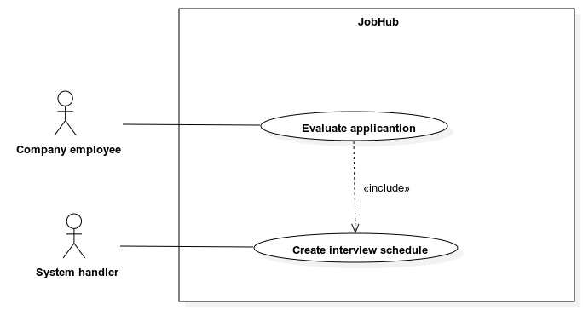

|  |  |  |  |
| --- | --- | --- | --- |
| **ID and Name:** | **UC-45: Evaluate application** | | |
| Created By: | TienTT | Date Created: | 01/08/2022 |
| Primary Actor: | Company employee | Secondary Actors: | N/A |
| Priority: | High | Frequency of Use: | Usually |
| Trigger: | The actor sends a request evaluate an applicant. | | |
| Description: | This use case allows an *“Company employee”* to evaluate an applicant. | | |
| Preconditions: | - The actor must login into the system.  - The actor must be assigned to a booth as “Interviewer”.  - The job fair that this application belonging to must still in public time range.  - The application status must be “PENDING”. | | |
| Post-conditions: | * **Success:** Change application status and show success message. * **Fail:** The error message “Something went wrong” is shown if there is any error occurred in the system. | | |
| Normal Flow: | |  |  |  | | --- | --- | --- | | Step | Actor Action | System Response | | 1 | The actor sends request to evaluate an applicant. | System shows some information:  - “Matching point”: label  - “Suggestion”: label  - “Approve”: button  - “Reject”: button | | 2 | The actor clicks “Approve” button.  **[Alternative 1]** | System changes application status to “APPROVED” and show success message. | | | |
| Alternative Flows: | **Alternative 1**   |  |  |  | | --- | --- | --- | | Step | Actor Action | System Response | | 1 | The actor clicks “Reject” button. | System changes application status to “REJECTED” and show success message. | | | |
| Exceptions: | N/A | | |
| Business Rules: | - The “Suggestion” label is “This application is suitable for your job position” if the matching point is bigger than 50% else is “This application is not suitable for your job position”.  - If after the job fair public range, all “PENDING” application will change status to “REJECTED”. | | |
| Assumptions: | * Actor’s internet connection is available | | |

###### UC***-46 <Company employee> Make interview report***

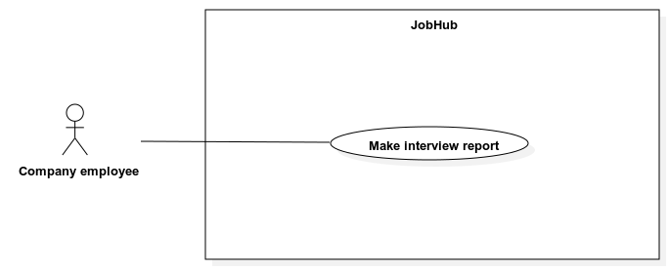

|  |  |  |  |
| --- | --- | --- | --- |
| **ID and Name:** | **UC-46: Make interview report** | | |
| Created By: | TienTT | Date Created: | 01/08/2022 |
| Primary Actor: | Company employee | Secondary Actors: | N/A |
| Priority: | High | Frequency of Use: | Usually |
| Trigger: | The actor sends a request to make interview report. | | |
| Description: | This use case allows a *“Company employee”* to make an interview report. | | |
| Preconditions: | The actor must login into the system.  The actor must be assigned to a booth as “Interviewer”.  The job fair that this application belonging to must still in public time range.  The application status must be “APPROVED”.  Tha application’s interview status must be “INTERVIEWING”. | | |
| Post-conditions: | * **Success:** Make interview report and show success message.   **Fail:** - Specific error messages will be shown based on the actor’s actions.  - The error message “Something went wrong” is shown if there is any error occurred in the system. | | |
| Normal Flow: | |  |  |  | | --- | --- | --- | | Step | Actor Action | System Response | | 1 | The actor sends request to make an interview report. | System requires information from actor:  - “Note”: text input, required, length: 1-500  - “Disadvantage”: text input, required, length: 1-500.  - “Advantage”: text input, required, length: 1-500. | | 2 | Actor inputs information. |  | | 3 | Actor submits information. | System validates, create new interview report, and shows success message.  **[Exception 1]** | | | |
| Alternative Flows: | N/A | | |
| Exceptions: | |  |  |  | | --- | --- | --- | | No | Cause | System Response | | 1 | All inputs’ information is not obeyed constraints. | Show error message to ask user input required input or follow the input’s constraint. | | | |
| Business Rules: | - To be able to make interview report, the applicant and the interviewer must join into the same interview room and start the interviewing process. | | |
| Assumptions: | * Actor’s internet connection is available | | |

###### UC***-47 <Company employee> Decorate booth***

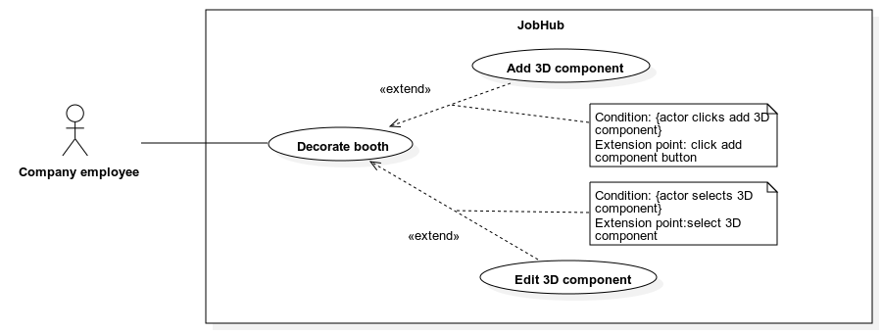

|  |  |  |  |
| --- | --- | --- | --- |
| **ID and Name:** | **UC-19: Decorate booth** | | |
| Created By: | TienTT | Date Created: | 01/08/2022 |
| Primary Actor: | Company employee | Secondary Actors: | N/A |
| Priority: | High | Priority: | High |
| Trigger: | The actor sends a request to decorate booth. | | |
| Description: | This use case allows a *”Company employee”* to decorate booth. | | |
| Preconditions: | The actor must login into the system.  The job fair that the booth belongs must be in decorate time range.  The actor must be assigned to this booth as “Decorator”. | | |
| Post-conditions: | * **Success:** Create new decoration for this booth. * **Fail:** The error message “Something went wrong” is shown if there is any error occurred in the system. | | |
| Normal Flow: | |  |  |  | | --- | --- | --- | | Step | Actor Action | System Response | | 1 | The actor sends request to decorate booth. | System renders 3D model of the booth.  System shows the following:  - “Save”: button  - “Add component”: button  - “Review”: button | | 2 | The actor clicks “Save” button. | System saves the new decoration of this booth. | | | |
| Alternative Flows: | N/A | | |
| Exceptions: | N/A | | |
| Business Rules: | - The latest decoration of the booth will be rendered. If the booth has not yet been decorated, the based model will be rendered.  - The based model is a rectangle base that has white color and has size of 20x20x1(m).  - System should auto save the decoration every 5 minutes.  - If there are any changes in the current decoration and the actor has not yet saved, any actions that resulted in loss of unsaved changes must be asked for the actor confirmation.  - The 3D model of the decoration must have the following rules for its 3D child components:  - The ground component must be named “sand”.  - The elements that allows media upload must has the media plane named “image-plane”. | | |
| Assumptions: | * Actor’s internet connection is available | | |

###### UC***-48 <Company employee> Add 3D component***



|  |  |  |  |
| --- | --- | --- | --- |
| **ID and Name:** | **UC-48: Add 3D component** | | |
| Created By: | TienTT | Date Created: | 01/08/2022 |
| Primary Actor: | Company employee | Secondary Actors: | N/A |
| Priority: | High | Priority: | High |
| Trigger: | The actor sends a request to add new 3D component to booth decoration. | | |
| Description: | This use case allows a *”Company employee”* to add 3D component to booth decoration. | | |
| Preconditions: | The actor must login into the system.  The job fair that the booth belongs must be in decorate time range.  The actor must be assigned to this booth as “Decorator”. | | |
| Post-conditions: | * **Success:** Add new 3D component to the booth’s decoration. * **Fail:** The error message “Something went wrong” is shown if there is any error occurred in the system. | | |
| Normal Flow: | |  |  |  | | --- | --- | --- | | Step | Actor Action | System Response | | 1 | The actor sends request to add 3D component. | System shows a list of 3D component which contains:  - “Component thumbnail”: image  - “Component name”: label  - “Choose”: button | | 2 | The actor clicks “Choose” and clicks on the ground component. | System renders the selected component on the ground base component. | | | |
| Alternative Flows: | N/A | | |
| Exceptions: | N/A | | |
| Business Rules: | - When renders the selected component on the ground base, the system should put the selected component on top of the ground base.  - The projection of the component’s center point onto the ground base should be the point when the user clicked on the ground base.  - The 3D component list is ordered by their created time. | | |
| Assumptions: | * Actor’s internet connection is available | | |

###### UC***-49 <Company employee> Edit 3D component***



|  |  |  |  |
| --- | --- | --- | --- |
| **ID and Name:** | **UC-48: Edit 3D component** | | |
| Created By: | TienTT | Date Created: | 01/08/2022 |
| Primary Actor: | Company employee | Secondary Actors: | N/A |
| Priority: | High | Priority: | High |
| Trigger: | The actor sends a request to edit 3D component | | |
| Description: | This use case allows a *”Company employee”* to edit 3D component in booth decoration. | | |
| Preconditions: | The actor must login into the system.  The job fair that the booth belongs must be in decorate time range.  The actor must be assigned to this booth. | | |
| Post-conditions: | * **Success:** Edit 3D component to the booth’s decoration. * **Fail:** - Discard all unsaved changes.   - The error message “Something went wrong” is shown if there is any error occurred in the system. | | |
| Normal Flow: | |  |  |  | | --- | --- | --- | | Step | Actor Action | System Response | | 1 | The actor clicks on any components on the booth 3D decoration | System display and requires some information:  - “Colour”: colour selector  - “x position”: number input  - “y position”: number input  - “z position”: number input  - “Left rotation”: button  - “Right rotation”: button  - “Upload media”: file selected, must be .PNG, .JPEG, .JPG, .MP4, file size < 15MB - “Image sharpness”: slide bar contains 3 values: “normal”, “sharper”, “sharpest”.  - “Image brightness”: slide bar, range 0-100.  - “Delete item”: button | | 2 | The actor enters or changes values of the above fields to edit component properties. | System re-renders the selected component. | | | |
| Alternative Flows: | N/A | | |
| Exceptions: | N/A | | |
| Business Rules: | - The “x position”, “y position”, and “z position” are the x, y, z value of the component’s center point based on the Cartesian coordinate system.  - The “left rotation”, “right rotation” will rotate the component 10 degree per every click.  - When upload image to a component, the image plane must be named “image-plane”.  - All components in the booth’s decoration can be selected except the ground component, which name is “sand”.  - The system should support basic sliding object physics when sliding components on ground component.  - When editing a component, the system should have an indicator on the 3D model to let the user know which component is being edited. | | |
| Assumptions: | * Actor’s internet connection is available | | |

##### 2.2.3.7 <System handler> - Use case overview

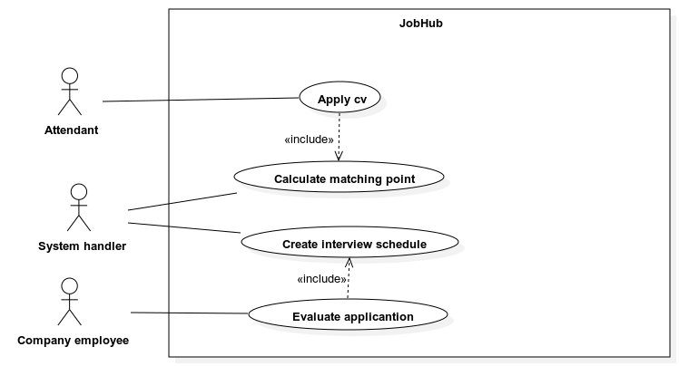

###### UC***-50 <System handler> Calculate matching point***

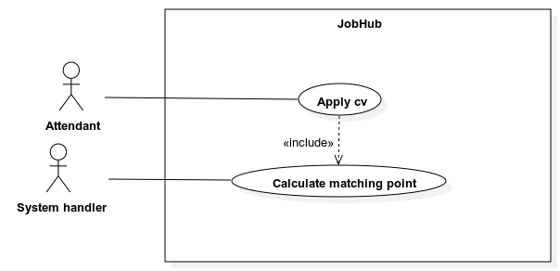

|  |  |  |  |
| --- | --- | --- | --- |
| **ID and Name:** | **UC-50: Calculate matching point** | | |
| Created By: | TienTT | Date Created: | 01/08/2022 |
| Primary Actor: | System handler | Secondary Actors: | N/A |
| Priority: | High | Priority: | High |
| Trigger: | An CV has been applied to a job position. | | |
| Description: | This use case describes how system handler generating matching point | | |
| Preconditions: | An CV has been applied to a job position. | | |
| Post-conditions: | * **Success:** Create matching point between CV and job position. * **Fail:** Return default matching point. | | |
| Normal Flow: | |  |  |  | | --- | --- | --- | | Step | Actor Action | System Response | | 1 | An CV has been applied to a job position. | System calculates matching point and save the matching point. | | | |
| Alternative Flows: | N/A | | |
| Exceptions: | N/A | | |
| Business Rules: | N/A | | |
| Assumptions: | * Actor’s internet connection is available | | |

###### UC***-51 <System handler> Create interview schedule***

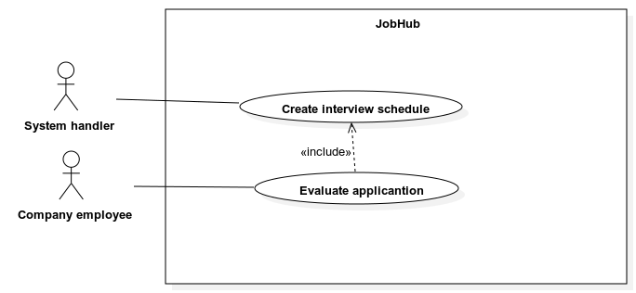

|  |  |  |  |
| --- | --- | --- | --- |
| **ID and Name:** | **UC-51: Create interview schedule** | | |
| Created By: | TienTT | Date Created: | 01/08/2022 |
| Primary Actor: | System handler | Secondary Actors: | N/A |
| Priority: | High | Priority: | High |
| Trigger: | A “*Company employee*” has just accepted an application | | |
| Description: | This use case describes how system handler create interview schedule for accepted application. | | |
| Preconditions: | An application has been accepted | | |
| Post-conditions: | * **Success:** Create interview schedule. * **Fail:** Return error message “Cannot find available empty slot”. | | |
| Normal Flow: | |  |  |  | | --- | --- | --- | | Step | Actor Action | System Response | | 1 | An application has been accepted. | System creates interview schedule for the *“Company employee”* and the *“Attendant”*  **[Exception 1]** | | | |
| Alternative Flows: | N/A | | |
| Exceptions: | |  |  |  | | --- | --- | --- | | No | Cause | System Response | | 1 | Cannot find available schedule. | Show error message to show cannot find available schedule. | | | |
| Business Rules: | - The available schedule is calculated by finding the earliest matching free schedule of the interviewer and the attendant.  - The interviewer’s free schedule is bounded by shift and job fair public time range. | | |
| Assumptions: | * Actor’s internet connection is available | | |

## 3. Functional Requirements

### 3.1 System Functional Overview

#### 3.1.1 Screens Flow

##### 3.1.1.1 Guest Flow

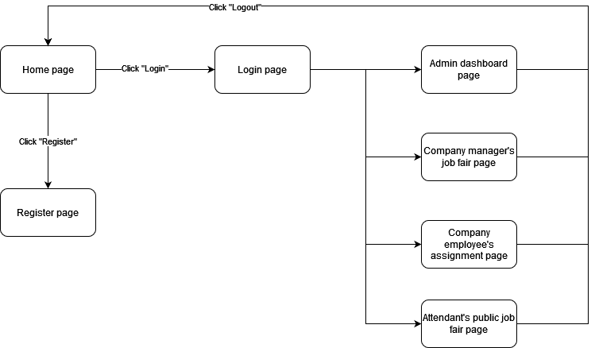

Figure 5. Guest screens flow

##### 3.1.1.2 Admin Flow

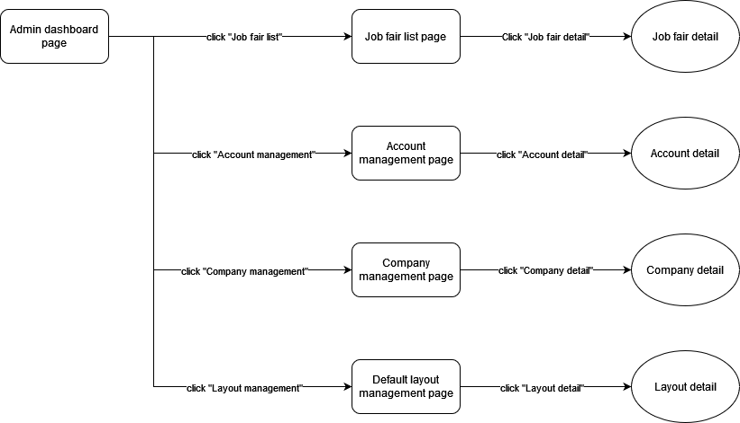

Figure 6. Admin screens flow

##### 3.1.1.3 Company Manager Flow

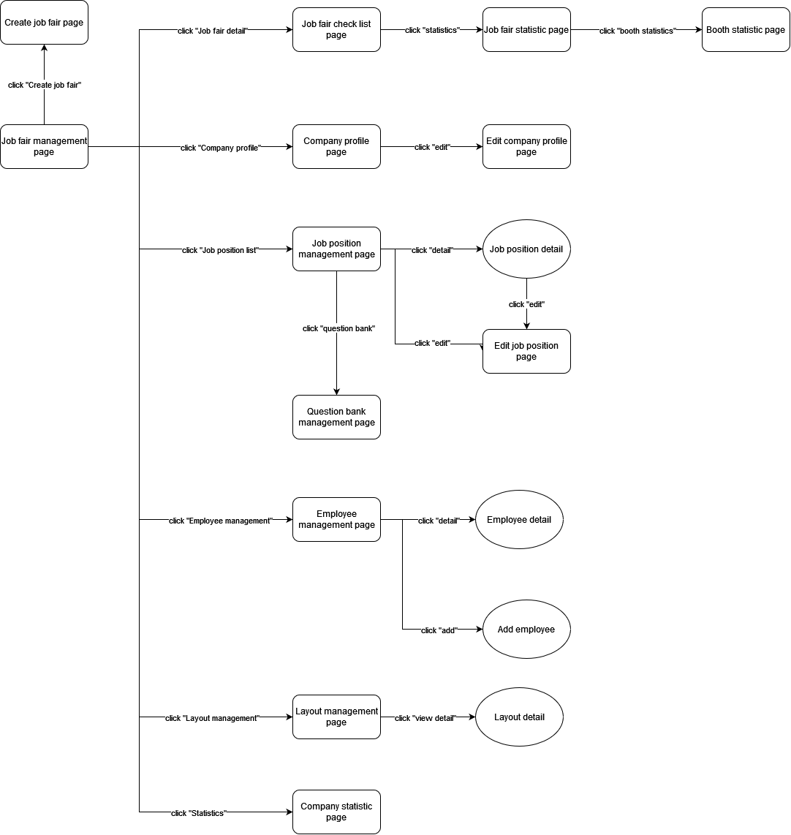

Figure 7. Company Manager screens flow

##### 3.1.1.4 Company Employee Flow

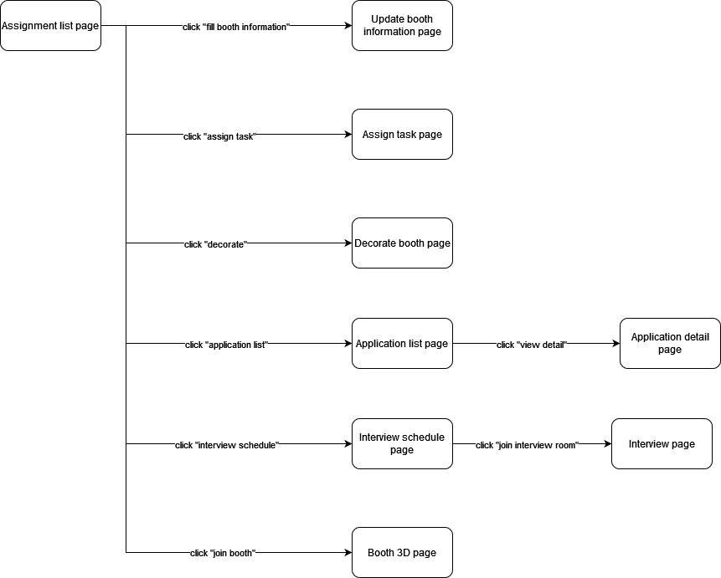

Figure 8. Company Employee screens flow

##### 3.1.1.5 Attendant Flow

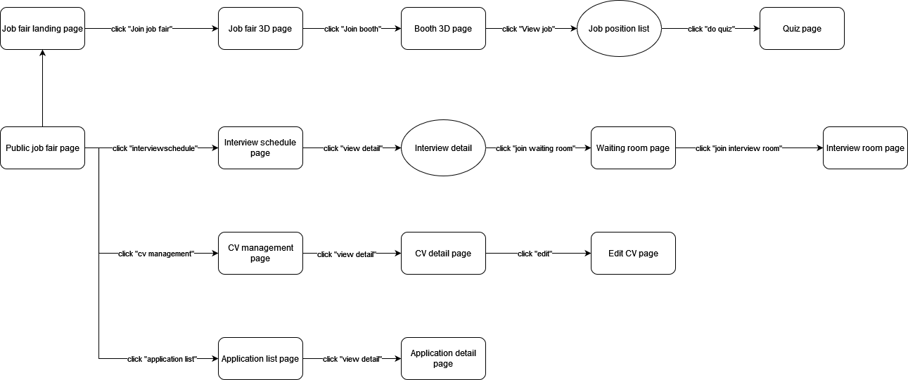

Figure 9. Attendant screen flows

#### 3.1.2 Screen Descriptions

|  |  |  |  |
| --- | --- | --- | --- |
| **No.** | **Feature** | **Screen** | **Description** |
| ***Guest Flow*** | | | |
| 1 | JobHub overview | Home page | A page contains information about JobHub. |
| 2 | Login | Login page | A page contains a form to login. |
| 3 | Register | Register page | A page contains form for Guest to create new account in JobHub system. |
| 4 | Get system statistic | Admin dashboard page | A page contains system statistics |
| 5 | Get company job fair list | Company manager’s job fair page | A page contains list of job fair plan |
| 6 | Get assignment list | Company employee’s assignment page | A page contains list of employee’s assignment |
| 7 | Get public job fair list | Attendant’s public job fair page | A page contains list of public job fair |
| ***Admin Flow*** | | | |
| 8 | Get system statistic | Admin dashboard page | A page contains system statistics |
| 9 | Get job fair list for admin | Job fair list page | A page contains list of all job fairs from the past to the in-coming ones. |
| 10 | Get account list | Account management page | A page contains list of all accounts in JobHub system |
| 11 | Get company list | Company management page | A page contains list of all companies in JobHub system |
| 12 | Get default layout list | Default layout management page | A page contains list of all default layouts in JobHub system |
| 13 | Get job fair detail | Job fair detail | A page contains job fair detail such as job fair’s name, decorate time range, public time range… |
| 14 | Get account detail | Account detail | A page contains account detail such as email, phone… |
| 15 | Get company detail | Company detail | A page contains company detail such as company’s name, address… |
| 16 | Get layout detail | Layout detail | A page that will render 3D layout |
| ***Company Manager Flow*** | | | |
| 17 | Get job fair list | Job fair management page | A page contains list of company’s job fairs, both draft and publish status |
| 18 | Create job fair | Create job fair page | A page contains step by step form to create new job fair |
| 19 | Get job fair progress | Job fair check list page | A page contains check list for steps in creating new job fair |
| 20 | Get company profile | Company profile page | A page contains company detail such as company’s name, address… |
| 21 | Get job position | Job position management page | A page contains list of all company’s job position |
| 22 | Get employee | Employee management page | A page contains list of all company’s employee |
| 23 | Get layout | Layout management page | A page contains list of all company’s layout |
| 24 | Get company statistic | Company statistic page | A page contains company’s statistic such as number of submitted CV, interview ratio… |
| 25 | Get job fair statistic | Job fair statistic page | A page contains job fair’s statistic such as number of submitted CV, interview ratio… |
| 26 | Get booth statistic | Booth statistic page | A page contains booth’s statistic such as number of submitted CV, interview ratio… |
| 27 | Edit company profile | Edit company profile page | A page contains form to update company profile |
| 28 | Get job position detail | Job position detail | A page contains job position detail such as title, requirement… |
| 29 | Edit job position | Edit job position page | A page contains form to update job position |
| 30 | Get questions | Question bank management page | A page contains list of all questions belongs to a job |
| 31 | Get employee detail | Employee detail | A page contains employ detail such as name, email… |
| 32 | Add employee account | Add employee | A page contains form to add new employee account |
| 33 | Get layout detail | Layout detail | A page that will render 3D layout |
| ***Company Employee Flow*** | | | |
| 34 | Get assignment | Assignment list page | A page contains list of all employee’s assignment |
| 35 | Update booth information | Update booth information page | A page contains form to update booth information |
| 36 | Get booth assignment | Assign task page | A page contains assignments in that booth |
| 37 | Decorate booth | Decorate booth page | A page allows employee to interact and decorate 3D booth |
| 38 | Get application list | Application list page | A page contains list of all attendant’s application |
| 39 | Get interview schedule | Interview schedule page | A page contains interview schedule calendar |
| 40 | Get 3D booth | Booth 3D page | A page that will render 3D booth |
| 41 | Get application detail | Application detail page | A page contains application detail such as attendant’s name, education… |
| 42 | Interview process | Interview page | A page that allows employee and attendant interact with each other |
| ***Attendant Flow*** | | | |
| 43 | Get job fair list | Public job fair page | A page contains list of all public job fair in JobHub system. |
| 44 | Get job fair detail | Job fair landing page | A page contains job fair detail information such as title, time range… |
| 45 | Get interview schedule | Interview schedule page | A page contains interview schedule calendar |
| 46 | Get CV list | CV management page | A page contains list of all attendant’s CV |
| 47 | Get application list | Application list page | A page contains list of all attendant’s application |
| 48 | Get job fair layout | Job fair 3D page | A page that will render 3D job fair environment |
| 49 | Get interview detail | Interview detail | A page that contains interview detail such as interviewer’s name, interview time |
| 50 | Get CV detail | CV detail page | A page contains CV detail such as education, work history… |
| 50 | Get application detail | Application detail page | A page contains application detail such as applied job position, applied company… |
| 51 | Get 3D booth | Booth 3D page | A page that will render 3D booth |
| 52 | Interview process | Waiting room page | A page that allows attendant wait with other attendant before interview time |
| 53 | Edit CV | Edit CV page | A page contains form to update CV information |
| 54 | Get job position list | Job position list | A page contains list of booth job positions |
| 55 | Do entry test | Quiz page | A page contains entry test |

Table 16. Screen description

#### 3.1.3 Screen Authorization

|  |  |  |  |  |  |  |
| --- | --- | --- | --- | --- | --- | --- |
| **Category** | **Screen** | **Guest** | **Attendant** | **Admin** | **Company manager** | **Company employee** |
| Guest Flow | Home page | x | x | x | x | x |
| Login page | x |  |  |  |  |
| Register page | x |  |  |  |  |
| Admin dashboard page |  |  | x |  |  |
| Company manager’s job fair page |  |  |  | x |  |
| Company employee’s assignment page |  |  |  |  | x |
| Attendant’s public job fair page |  | x |  |  |  |
| Admin Flow | Admin dashboard page |  |  | x |  |  |
| Job fair list page |  |  | x |  |  |
| Account management page |  |  | x |  |  |
| Company management page |  |  | x |  |  |
| Default layout management page |  |  | x |  |  |
| Job fair detail |  |  | x |  |  |
| Account detail |  |  | x |  |  |
| Company detail |  |  | x |  |  |
| Layout detail |  |  | x |  |  |
| Company Manager Flow | Job fair management page |  |  |  | x |  |
| Create job fair page |  |  |  | x |  |
| Job fair check list page |  |  |  | x |  |
| Company profile page |  |  |  | x |  |
| Job position management page |  |  |  | x |  |
| Employee management page |  |  |  | x |  |
| Layout management page |  |  |  | x |  |
| Company statistic page |  |  |  | x |  |
| Job fair statistic page |  |  |  | x |  |
| Booth statistic page |  |  |  | x |  |
| Edit company profile page |  |  |  | x |  |
| Job position detail |  |  |  | x |  |
| Edit job position page |  |  |  | x |  |
| Question bank management page |  |  |  | x |  |
| Employee detail |  |  |  | x |  |
| Add employee |  |  |  | x |  |
| Layout detail |  |  |  | x |  |
| Company Employee Flow | Assignment list page |  |  |  |  | x |
| Update booth information page |  |  |  |  | x |
| Assign task page |  |  |  |  | x |
| Decorate booth page |  |  |  |  | x |
| Application list page |  |  |  |  | x |
| Interview schedule page |  |  |  |  | x |
| Booth 3D page |  |  |  |  | x |
| Application detail page |  |  |  |  | x |
| Interview page |  |  |  |  | x |
| Attendant Flow | Public job fair page |  | x |  |  |  |
| Job fair landing page |  | x |  |  |  |
| Interview schedule page |  | x |  |  |  |
| CV management page  Application list page |  | x |  |  |  |
| Job fair 3D page |  | x |  |  |  |
| Interview detail |  | x |  |  |  |
| CV detail page |  | x |  |  |  |
| Application detail page |  | x |  |  |  |
| Booth 3D page |  | x |  |  |  |
| Waiting room page |  | x |  |  |  |
| Edit CV page |  | x |  |  |  |
| Application detail page |  | x |  |  |  |
| Job position list |  | x |  |  |  |
| Quiz page |  | x |  |  |  |

Table 17. Screen authorizations

#### 3.1.4 Entity Relationship Diagram

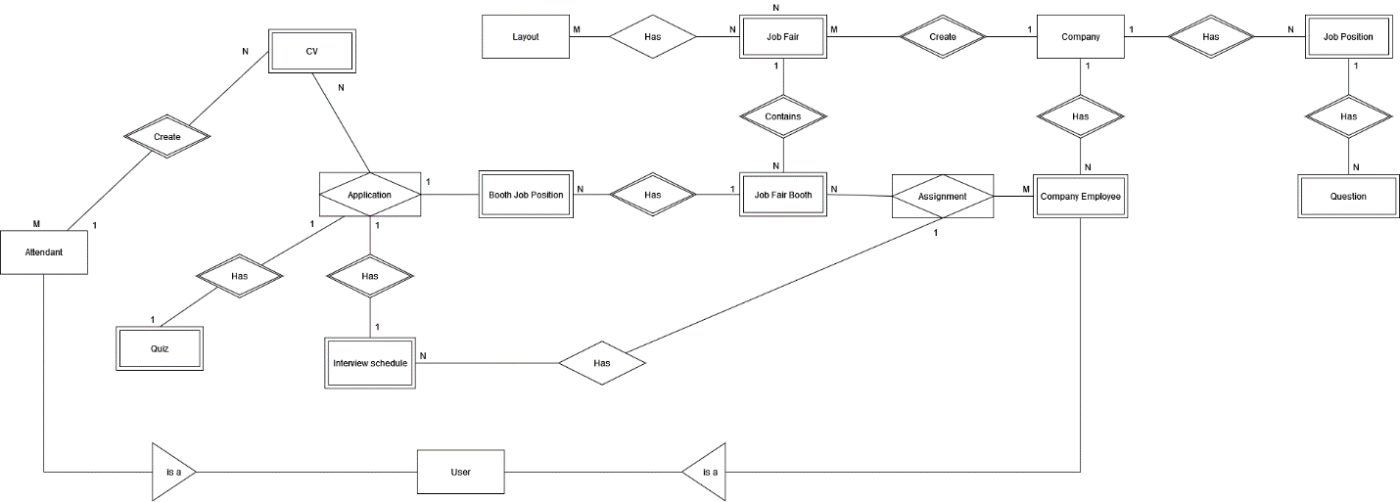

Figure 10. Entity Relationship diagram

***Entities Description***

|  |  |  |
| --- | --- | --- |
| **No.** | **Entity** | **Description** |
| 1 | Attendant | Attendants are people who try to figure out which job position is the most suitable for them. |
| 2 | Quiz | Quizzes will be generated when a job position required an entry test and attendants agree to do the test. |
| 3 | CV | CVs are belonged to an attendant. CVs contain the information that the attendant want to show to the interviewer to prove his/her qualification. |
| 4 | Application | Applications are created when an attendant apply his/her CV to a job position. |
| 5 | Interview Schedule | Interview schedule will be automatically generated when an interviewer approved an application. |
| 6 | User | User is a parent entity that represent an account in JobHub system. |
| 7 | Layout | Layouts represent a 3D job fair layout |
| 8 | Booth Job Position | A booth job position is an instance of a job position. Depending on the demand and requirement for each job fair and each booth, a job position will be added some information to create a booth job position. |
| 9 | Job Fair | Job Fairs are events that help connect job-seeking attendants and high-demand job positions. Each job fair is belonged to a company. |
| 10 | Job Fair Booth | Job fair booths are places where departments of a company show their working environment. |
| 11 | Assignment | Each employee will be assigned to job fair as different roles. |
| 12 | Company | Companies are organizations that want to find a way to attract good candidates for their job positions or want to speed up their recruitment process. |
| 13 | Company Employee | Company employees are the ones working for a company. That includes Company Manager and normal Company Employee. |
| 14 | Job Position | Job positions is the available jobs that a company is currently have. |
| 15 | Question | The question bank that belongs to a job position. |

Table 18. Entity descriptions

## 4. Non-Functional Requirements

### 4.1 External Interfaces

#### 4.1.1 User Interfaces

* The UI must be fully shown in web browsers
* User Interface must be simple and user-friendly.
* Icons must be easy for users to identify what it's present for.
* Colors must have contrast.
* Font must be easy to read.

#### 4.1.2. Communications Interfaces

* HTTP Protocol is used for communication between Web Application and server.
* WebSocket Protocol is used for real-time communication between Web Application and server.
* WebRTC Protocol is used for 3D character synchronization.

### 4.2 Quality Attributes

#### a. Usability

* All text, label, alert, and notification should be written in English.
* Owners and staff can use JobHub after only 1 days of training.

#### b. Portability

* The 3D functions of web application should run well in Chrome version 102 and higher.
* Other functions of web application should run well in.
  + Chrome version 98.0 and higher.
  + Firefox version 98.0 and higher.

#### c. Security

* All input data are validated before saving to the database.
* Each role of the user has a specific permission to interact with the system.

# IV. Software Design Document

## 1. System Design

### 1.1 System Architecture

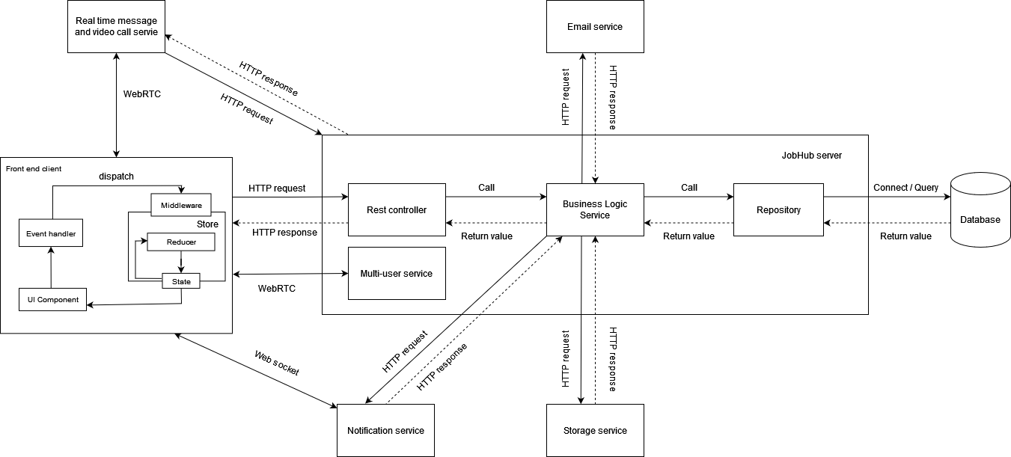

Figure 11. System architecture

|  |  |  |
| --- | --- | --- |
| **No** | **Component** | **Description** |
| 1 | Controller | Controllers are responsible for receiving request, delegating request to Service Layer and return responses. |
| 2 | Service | Services are places containing business logic that responsible for validation, complex logic, calling Repository Layer and return results. |
| 3 | Repository | Repositories are abstract layer handling database connection, database manipulation and return query result from database. |
| 4 | Database | Database is where all data is stored. |
| 5 | Multi-user service | This service will handle the synchronization between 3D character models. |
| 6 | Storage service | This service abstracts the use of third-party services to store files because these services have built-in features like auto optimize media, auto add meta-data for media, get media with suitable size. Moreover, the service's CDN network will make file access faster. |
| 7 | Notification service | This service abstracts the use of third-party services to push notification to client’s devices. |
| 8 | Email service | This service abstracts the use of third-party services to send email to client’s addresses. |
| 9 | Real time message and video call service | This service abstracts the use of third-party services to handle real time messaging and video call between clients. |
| 10 | UI component | The components that render UI to the user on browsers. They will be re-rendered if the states change |
| 11 | Event handler | The functions that get called when there is an interaction from clients. |
| 12 | Middleware | The functions that handle asynchronous logic such as calling API, processing complex logic. |
| 13 | Reducer | The functions that handle logic of creating new state. |
| 14 | State | The data layer to help manage state of the components. |

Table 19. System architecture component descriptions

### 1.2 Package Diagram

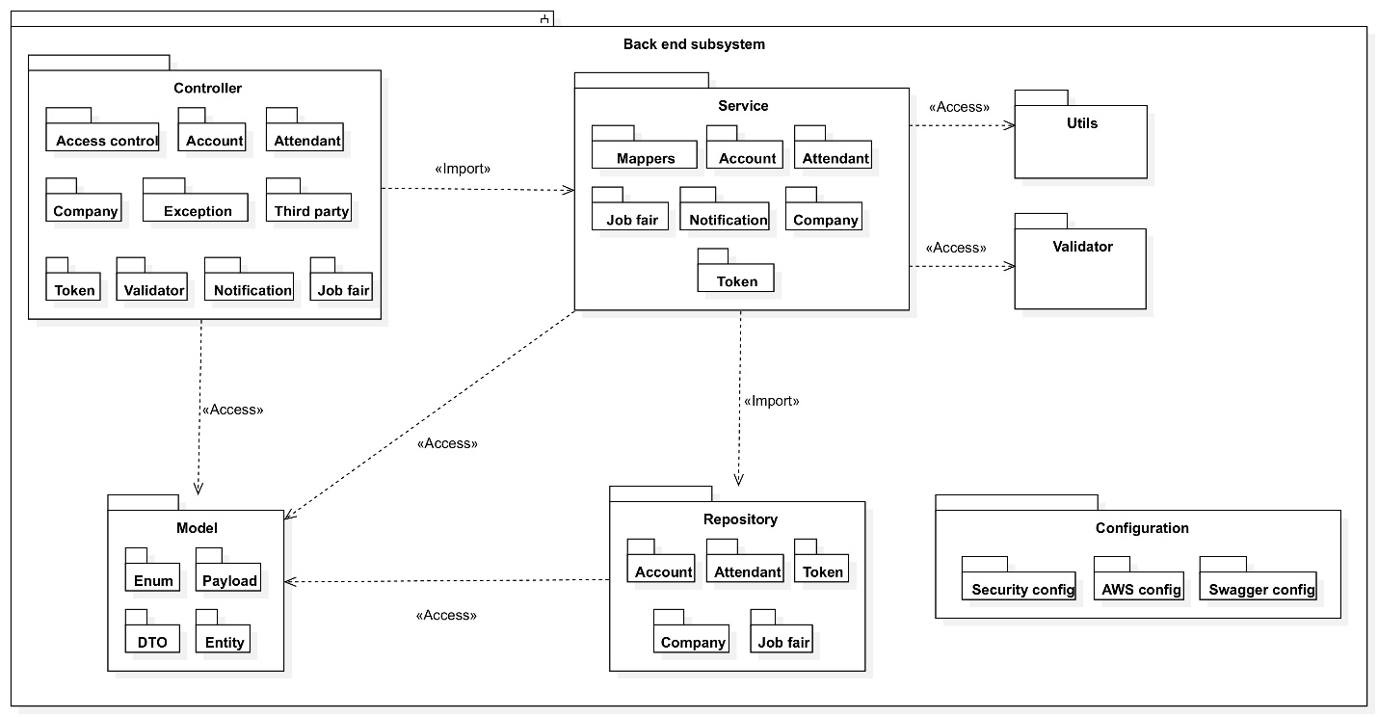

Figure 12. Back-end package diagram

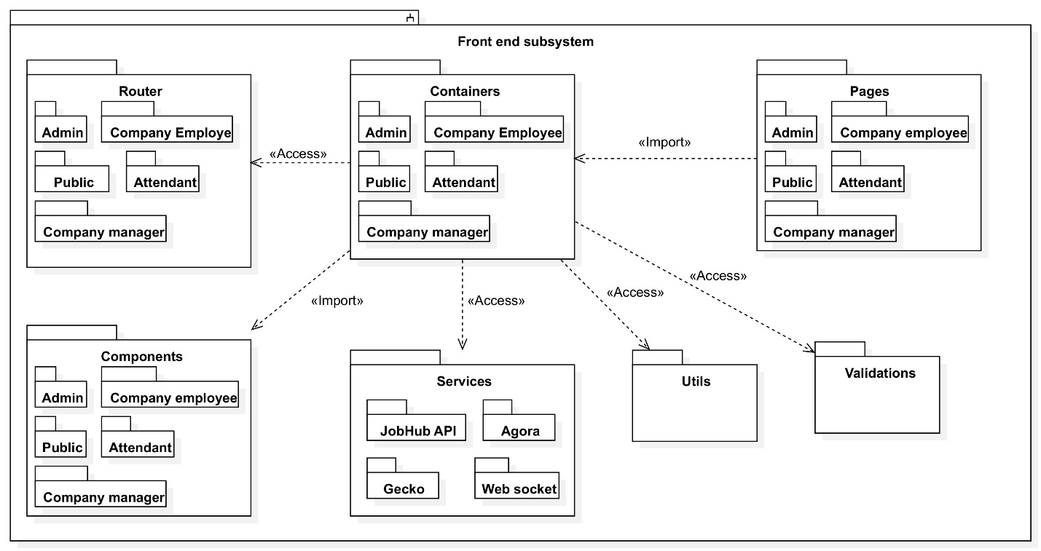

Figure 13. Front-end package diagram

***Package Descriptions***

#### 1.2.1 Back-end subsystem

|  |  |  |
| --- | --- | --- |
| **No** | **Package** | **Description** |
| 01 | Controller | This package contains API Controllers that receive request, delegate request to Service Layer and return responses. |
| 02 | Service | This package contains business logic classes that responsible for validation, complex logic, calling Repository Layer and return results. |
| 03 | Repository | This package contains classes that encapsulate the logic required to access data sources |
| 04 | Model | This package contains classes that used for containing data such as DTO, Entity |
| 05 | Configuration | This package contains classes that used to initialize some specific Spring Bean supporting the application with cross-cutting aspect such as Security, Swagger… |
| 06 | Utils | This package contains classes that contains static method as utility such as read files, compress images…. |
| 07 | Validator | This package contains custom annotations and their respective validation class to validate client’s requests |

Table 20. Back-end package descriptions

#### 1.2.2 Front-end subsystem

|  |  |  |
| --- | --- | --- |
| **No** | **Package** | **Description** |
| 01 | Router | This package contains routing components and sitemap for the entire application |
| 02 | Containers | This package contains container components that handle logic before passing data to pure components. |
| 03 | Components | This package contains pure components that used for rendering the actual UI. |
| 04 | Pages | This package contains components that represent all pages of the entire application. |
| 05 | Services | This package contains code that handle complex logic or call API. |
| 06 | Utils | This package contains code that has methods as utility such as read files, compress images… |
| 07 | Validator | This package contains code that validates user input. |

Table 21. Front-end package description

## 2. Database Design

### 2.1. Physical diagram

Since to ensure the readability of the main diagram, the mutivalued or composite attributes of some main entities will be displayed in different entities.

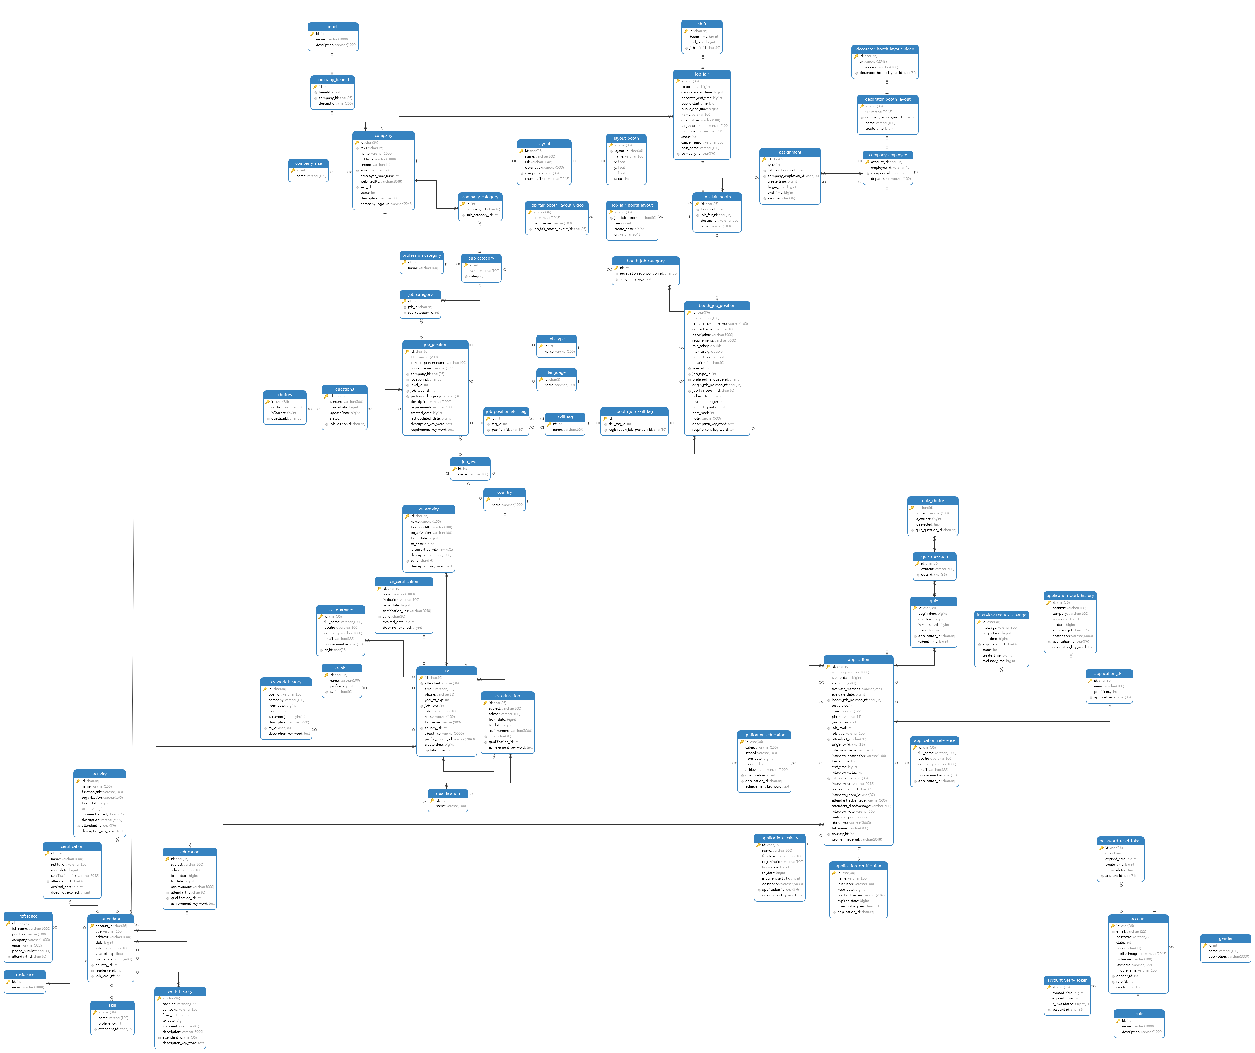

Figure 14. Database physical diagram

### 2.2. Data dictionary

#### 2.2.1 account table

|  |  |  |  |  |  |  |
| --- | --- | --- | --- | --- | --- | --- |
| **No.** | **Field name** | **Type** | **Unique** | **Not null** | **PK/FK** | **Notes** |
| 1 | id | char(36) | x | x | PK |  |
| 2 | email | varchar(322) | x | x |  |  |
| 3 | status | int |  | x |  | Is enum and has value:  - 0: VERIFIED  - 1: INACTIVE  - 2: REGISTERED  - 3: SUSPENDED |
| 4 | phone | char(11) |  | x |  |  |
| 5 | profile_image_url | varchar(2048) |  | x |  |  |
| 6 | firstname | varchar(100) |  | x |  |  |
| 7 | lastname | varchar(100) |  | x |  |  |
| 8 | middlename | varchar(100) |  |  |  |  |
| 9 | gender_id | int |  | x | FK |  |
| 10 | role_id | int |  | x | FK |  |
| 11 | create_time | bigint |  | x |  |  |

#### 2.2.2 role table

|  |  |  |  |  |  |  |
| --- | --- | --- | --- | --- | --- | --- |
| **No.** | **Field name** | **Type** | **Unique** | **Not null** | **PK/FK** | **Notes** |
| 1 | id | char(36) | x | x | PK |  |
| 2 | name | varchar(1000) |  | x |  |  |
| 3 | description | varchar(1000) |  | x |  |  |

#### 2.2.3 gender table

|  |  |  |  |  |  |  |  |  |  |  |
| --- | --- | --- | --- | --- | --- | --- | --- | --- | --- | --- |
| **No.** | **Field name** | **Type** | **Unique** | | **Not null** | | **PK/FK** | | **Notes** | |
| 1 | id | char(36) | | x | | x | | PK | |  |
| 2 | name | varchar(100) | |  | | x | |  | |  |
| 3 | description | varchar(1000) | |  | | x | |  | |  |

#### 2.2.4 password_reset_token table

|  |  |  |  |  |  |  |
| --- | --- | --- | --- | --- | --- | --- |
| **No.** | **Field name** | **Type** | **Unique** | **Not null** | **PK/FK** | **Notes** |
| 1 | id | char(36) | x | x | PK |  |
| 2 | otp | char(6) |  | x |  |  |
| 3 | expired_time | bigint |  | x |  |  |
| 4 | create_time | bigint |  | x |  |  |
| 5 | is_invalidated | tinyint(1) |  | x |  |  |
| 6 | account_id | char(36) |  | x | FK |  |

#### 2.2.5 account_verify_token table

|  |  |  |  |  |  |  |
| --- | --- | --- | --- | --- | --- | --- |
| **No.** | **Field name** | **Type** | **Unique** | **Not null** | **PK/FK** | **Notes** |
| 1 | id | char(36) | x | x | PK |  |
| 3 | expired_time | bigint |  | x |  |  |
| 4 | create_time | bigint |  | x |  |  |
| 5 | is_invalidated | tinyint(1) |  | x |  |  |
| 6 | account_id | char(36) |  | x | FK |  |

#### 2.2.6 attendant table

|  |  |  |  |  |  |  |
| --- | --- | --- | --- | --- | --- | --- |
| **No.** | **Field name** | **Type** | **Unique** | **Not null** | **PK/FK** | **Notes** |
| 1 | account_id | char(36) | x | x | PK |  |
| 2 | title | varchar(100) |  |  |  | Has value: “Mr”, “Mrs”, or “Miss” |
| 3 | address | varchar(1000) |  |  |  |  |
| 4 | dob | bigint |  |  |  |  |
| 5 | job_title | varchar(100) |  |  |  |  |
| 6 | year_of_exp | float |  |  |  |  |
| 7 | marital_status | tinyint(1) |  |  |  | Is marriage or not |
| 8 | country_id | int |  |  | FK |  |
| 9 | residence_id | int |  |  | FK |  |
| 10 | job_level_id | int |  |  | FK |  |

#### 2.2.7 residence table

|  |  |  |  |  |  |  |
| --- | --- | --- | --- | --- | --- | --- |
| **No.** | **Field name** | **Type** | **Unique** | **Not null** | **PK/FK** | **Notes** |
| 1 | id | int | x | x | PK |  |
| 2 | name | varchar(1000) |  |  |  |  |

#### 2.2.8 skill table

|  |  |  |  |  |  |  |
| --- | --- | --- | --- | --- | --- | --- |
| **No.** | **Field name** | **Type** | **Unique** | **Not null** | **PK/FK** | **Notes** |
| 1 | id | char(36) | x | x | PK |  |
| 2 | name | varchar(100) |  |  |  |  |
| 3 | proficiency | int |  |  |  |  |
| 4 | attendant_id | char(36) |  | x | FK |  |

#### 2.2.9 work_history table

|  |  |  |  |  |  |  |
| --- | --- | --- | --- | --- | --- | --- |
| **No.** | **Field name** | **Type** | **Unique** | **Not null** | **PK/FK** | **Notes** |
| 1 | id | char(36) | x | xx | PK |  |
| 2 | position | varchar(100) |  |  |  |  |
| 3 | company | varchar(100) |  |  |  |  |
| 4 | from_date | bigint |  |  |  |  |
| 5 | to_date | bigint |  |  |  |  |
| 6 | is_current_job | tinyint(1) |  |  |  |  |
| 7 | description | varchar(5000) |  |  |  |  |
| 8 | attendant_id | char(36) |  | x | FK |  |
| 9 | description_key_word | text |  |  |  |  |

#### 2.2.10 reference table

|  |  |  |  |  |  |  |
| --- | --- | --- | --- | --- | --- | --- |
| **No.** | **Field name** | **Type** | **Unique** | **Not null** | **PK/FK** | **Notes** |
| 1 | id | char(36) | x | x | PK |  |
| 2 | full_name | varchar(1000) |  |  |  |  |
| 3 | position | varchar(100) |  |  |  |  |
| 4 | company | varchar(1000) |  |  |  |  |
| 5 | email | varchar(322) |  |  |  |  |
| 6 | phone_number | char(11) |  |  |  |  |
| 7 | attendant_id | char(36) |  | x | FK |  |

#### 2.2.11 certification table

|  |  |  |  |  |  |  |
| --- | --- | --- | --- | --- | --- | --- |
| **No.** | **Field name** | **Type** | **Unique** | **Not null** | **PK/FK** | **Notes** |
| 1 | id | char(36) | x | x | PK |  |
| 2 | name | varchar(1000) |  |  |  |  |
| 3 | institution | varchar(100) |  |  |  |  |
| 4 | issue_date | bigint |  |  |  |  |
| 5 | certification_link | varchar(2048) |  |  |  |  |
| 6 | attendant_id | char(36) |  | xx | FK |  |
| 7 | expired_date | bigint |  |  |  |  |
| 8 | does_not_expired | tinyint |  |  |  |  |

#### 2.2.12 activity table

|  |  |  |  |  |  |  |
| --- | --- | --- | --- | --- | --- | --- |
| **No.** | **Field name** | **Type** | **Unique** | **Not null** | **PK/FK** | **Notes** |
| 1 | id | char(36) | x | x | PK |  |
| 2 | name | varchar(100) |  |  |  |  |
| 3 | function_title | varchar(100) |  |  |  |  |
| 4 | organization | varchar(100) |  |  |  |  |
| 5 | from_data | bigint |  |  |  |  |
| 6 | to_data | bigint |  |  |  |  |
| 7 | is_current_activity | tinyint(1) |  |  |  |  |
| 8 | description | varchar(5000) |  |  |  |  |
| 9 | attendant_id | char(36) |  | x | FK |  |
| 10 | description_key_word | text |  |  |  |  |

#### 2.2.13 education table

|  |  |  |  |  |  |  |
| --- | --- | --- | --- | --- | --- | --- |
| **No.** | **Field name** | **Type** | **Unique** | **Not null** | **PK/FK** | **Notes** |
| 1 | id | char(36) | x | x | PK |  |
| 2 | subject | varchar(100) |  |  |  |  |
| 3 | school | varchar(100) |  |  |  |  |
| 4 | from_date | bigint |  |  |  |  |
| 5 | to_date | bigint |  |  |  |  |
| 6 | achievement | varchar(5000) |  |  |  |  |
| 7 | attendant_id | char(36) |  | x | FK |  |
| 8 | qualification_id | int |  | x | FK |  |
| 9 | achievement_key_word | text |  |  |  |  |

#### 2.2.14 CV table

|  |  |  |  |  |  |  |
| --- | --- | --- | --- | --- | --- | --- |
| **No.** | **Field name** | **Type** | **Unique** | **Not null** | **PK/FK** | **Notes** |
| 1 | id | char(36) | x | x | PK |  |
| 2 | attendant_id | char(36) |  |  | FK |  |
| 3 | email | varchar(322) |  |  |  |  |
| 4 | phone | varchar(11) |  |  |  |  |
| 5 | year_of_exp | int |  |  |  |  |
| 6 | job_level | int |  |  | FK |  |
| 7 | job_title | varchar(100) |  |  |  |  |
| 8 | name | varchar(100) |  |  |  |  |
| 9 | full_name | varchar(300) |  |  |  |  |
| 10 | country_id | int |  |  | FK |  |
| 11 | about_me | varchar(5000) |  |  |  |  |
| 12 | profile_image_url | varchar(2048) |  |  |  |  |
| 13 | create_time | bigint |  |  |  |  |
| 14 | update_time | bigint |  |  |  |  |

#### 2.2.15 qualification table

|  |  |  |  |  |  |  |
| --- | --- | --- | --- | --- | --- | --- |
| **No.** | **Field name** | **Type** | **Unique** | **Not null** | **PK/FK** | **Notes** |
| 1 | id | int | x | x | PK |  |
| 2 | name | varchar(100) |  |  |  |  |

#### 2.2.16 CV_education table

|  |  |  |  |  |  |  |
| --- | --- | --- | --- | --- | --- | --- |
| **No.** | **Field name** | **Type** | **Unique** | **Not null** | **PK/FK** | **Notes** |
| 1 | id | char(36) | x | x | PK |  |
| 2 | subject | varchar(100) |  |  |  |  |
| 3 | school | varchar(100) |  |  |  |  |
| 4 | from_date | bigint |  |  |  |  |
| 5 | to_date | bigint |  |  |  |  |
| 6 | achievement | varchar(5000) |  |  |  |  |
| 7 | cv_id | char(36) |  | x | FK |  |
| 8 | qualification_id | int |  | x | FK |  |
| 9 | achievement_key_word | text |  |  |  |  |

#### 2.2.17 CV_work_history table

|  |  |  |  |  |  |  |
| --- | --- | --- | --- | --- | --- | --- |
| **No.** | **Field name** | **Type** | **Unique** | **Not null** | **PK/FK** | **Notes** |
| 1 | id | char(36) | x | x | PK |  |
| 2 | position | varchar(100) |  |  |  |  |
| 3 | company | varchar(100) |  |  |  |  |
| 4 | from_date | bigint |  |  |  |  |
| 5 | to_date | bigint |  |  |  |  |
| 6 | is_current_job | tinyint(1) |  |  |  |  |
| 7 | description | varchar(5000) |  |  |  |  |
| 8 | cv_id | char(36) |  | x | FK |  |
| 9 | description_key_word | text |  |  |  |  |

#### 2.2.18 CV_skill table

|  |  |  |  |  |  |  |
| --- | --- | --- | --- | --- | --- | --- |
| **No.** | **Field name** | **Type** | **Unique** | **Not null** | **PK/FK** | **Notes** |
| 1 | id | char(36) | x | x | PK |  |
| 2 | name | varchar(100) |  |  |  |  |
| 3 | proficiency | int |  |  |  |  |
| 4 | cv_id | char(36) |  | x | FK |  |

#### 2.2.19 CV_reference table

|  |  |  |  |  |  |  |
| --- | --- | --- | --- | --- | --- | --- |
| No. | **Field name** | **Type** | **Unique** | **Not null** | **PK/FK** | **Notes** |
| 1 | id | char(36) | x | x | PK |  |
| 2 | full_name | varchar(1000) |  |  |  |  |
| 3 | position | varchar(100) |  |  |  |  |
| 4 | company | varchar(1000) |  |  |  |  |
| 5 | email | varchar(322) |  |  |  |  |
| 6 | phone_number | char(11) |  |  |  |  |
| 7 | cv_id | char(36) |  | x | FK |  |

#### 2.2.20 CV_certification table

|  |  |  |  |  |  |  |
| --- | --- | --- | --- | --- | --- | --- |
| **No.** | **Field name** | **Type** | **Unique** | **Not null** | **PK/FK** | **Notes** |
| 1 | id | char(36) | x | x | PK |  |
| 2 | name | varchar(1000) |  |  |  |  |
| 3 | institution | varchar(100) |  |  |  |  |
| 4 | issue_date | bigint |  |  |  |  |
| 5 | certification_link | varchar(2048) |  |  |  |  |
| 6 | cv_id | char(36) |  | x | FK |  |
| 7 | expired_date | bigint |  |  |  |  |
| 8 | does_not_expired | tinyint |  |  |  |  |

#### 2.2.21 CV_activity table

|  |  |  |  |  |  |  |
| --- | --- | --- | --- | --- | --- | --- |
| **No.** | **Field name** | **Type** | **Unique** | **Not null** | **PK/FK** | **Notes** |
| 1 | id | char(36) | x | x | PK |  |
| 2 | name | varchar(1000) |  |  |  |  |
| 3 | function_title | varchar(100) |  |  |  |  |
| 4 | organization | varchar(100) |  |  |  |  |
| 5 | from_date | bigint |  |  |  |  |
| 6 | to_date | bigint |  |  |  |  |
| 7 | is_current_activity | tinyint(500) |  |  |  |  |
| 8 | description | varchar(5000) |  |  |  |  |
| 9 | cv_id | char(36) |  | x | FK |  |
| 10 | description_key_word | char(36) |  |  |  |  |

#### 2.2.22 country table

|  |  |  |  |  |  |  |
| --- | --- | --- | --- | --- | --- | --- |
| **No.** | **Field name** | **Type** | **Unique** | **Not null** | **PK/FK** | **Notes** |
| 1 | id | int | x | x | PK |  |
| 2 | name | varchar(1000) |  |  |  |  |

#### 2.2.23 job_level table

|  |  |  |  |  |  |  |
| --- | --- | --- | --- | --- | --- | --- |
| **No.** | **Field name** | **Type** | **Unique** | **Not null** | **PK/FK** | **Notes** |
| 1 | id | int | x | x | PK |  |
| 2 | name | varchar(100) |  |  |  |  |

#### 2.2.24 job_position table

|  |  |  |  |  |  |  |
| --- | --- | --- | --- | --- | --- | --- |
| **No.** | **Field name** | **Type** | **Unique** | **Not null** | **PK/FK** | **Notes** |
| 1 | id | char(36) | x | x | PK |  |
| 2 | title | varchar(200) |  |  |  |  |
| 3 | contact_person_name | varchar(100) |  |  |  |  |
| 4 | contact_email | varchar(322) |  |  |  |  |
| 5 | company_id | char(36) |  | x | FK |  |
| 6 | location_id | char(36) |  |  | FK |  |
| 7 | level_id | int |  |  | FK |  |
| 8 | job_type_id | int |  |  | FK |  |
| 9 | preferred_language_id | char(3) |  |  | FK |  |
| 10 | description | varchar(5000) |  |  |  |  |
| 11 | requirements | varchar(5000) |  |  |  |  |
| 12 | created_date | bigint |  |  |  |  |
| 13 | last_updated_date | bigint |  |  |  |  |
| 14 | description_key_word | text |  |  |  |  |
| 15 | requirement_key_word | text |  |  |  |  |

#### 2.2.25 questions table

|  |  |  |  |  |  |  |
| --- | --- | --- | --- | --- | --- | --- |
| **No.** | **Field name** | **Type** | **Unique** | **Not null** | **PK/FK** | **Notes** |
| 1 | id | char(36) | x | x | PK |  |
| 2 | content | varchar(500) |  |  |  |  |
| 3 | createDate | bigint |  |  |  |  |
| 4 | updateDate | bigint |  |  |  |  |
| 5 | status | int |  |  |  | Is enum and has value:  - 0: ACTIVE  - 1: INACTIVE |
| 6 | jobPositionId | char(36) |  | x | FK |  |

#### 2.2.26 choices table

|  |  |  |  |  |  |  |
| --- | --- | --- | --- | --- | --- | --- |
| **No.** | **Field name** | **Type** | **Unique** | **Not null** | **PK/FK** | **Notes** |
| 1 | id | char(36) | x | x | PK |  |
| 2 | content | varchar(500) |  |  |  |  |
| 3 | isCorrect | tinyint |  |  |  |  |
| 4 | questionId | char(36) |  | x | FK |  |

#### 2.2.27 job_position_skill_tag table

|  |  |  |  |  |  |  |
| --- | --- | --- | --- | --- | --- | --- |
| **No.** | **Field name** | **Type** | **Unique** | **Not null** | **PK/FK** | **Notes** |
| 1 | id | int | x | x | PK |  |
| 2 | tag_id | int |  | x | FK |  |
| 3 | position_id | char(36) |  | x | FK |  |

#### 2.2.28 skill_tag table

|  |  |  |  |  |  |  |
| --- | --- | --- | --- | --- | --- | --- |
| **No.** | **Field name** | **Type** | **Unique** | **Not null** | **PK/FK** | **Notes** |
| 1 | id | int | x | x | PK |  |
| 2 | name | varchar(100) |  |  |  |  |

#### 2.2.29 booth_job_skill_tag table

|  |  |  |  |  |  |  |
| --- | --- | --- | --- | --- | --- | --- |
| **No.** | **Field name** | **Type** | **Unique** | **Not null** | **PK/FK** | **Notes** |
| 1 | id | int | x | x | PK |  |
| 2 | skill_tag_id | int |  | x | FK |  |
| 3 | registation_job_position_id | char(36) |  | x | FK |  |

#### 2.2.30 language table

|  |  |  |  |  |  |  |
| --- | --- | --- | --- | --- | --- | --- |
| **No.** | **Field name** | **Type** | **Unique** | **Not null** | **PK/FK** | **Notes** |
| 1 | id | char(3) | x | x | PK |  |
| 2 | name | varchar(100) |  |  |  |  |

#### 2.2.31 job_type table

|  |  |  |  |  |  |  |
| --- | --- | --- | --- | --- | --- | --- |
| **No.** | **Field name** | **Type** | **Unique** | **Not null** | **PK/FK** | **Notes** |
| 1 | id | int | x | x | PK |  |
| 2 | position | varchar(100) |  |  |  |  |

#### 2.2.32 job_category table

|  |  |  |  |  |  |  |
| --- | --- | --- | --- | --- | --- | --- |
| **No.** | **Field name** | **Type** | **Unique** | **Not null** | **PK/FK** | **Notes** |
| 1 | id | int | x | x | PK |  |
| 2 | job_id | char(36) |  | x | FK |  |
| 3 | sub_category_id | int |  | x | FK |  |

#### 2.2.33 profession_category table

|  |  |  |  |  |  |  |
| --- | --- | --- | --- | --- | --- | --- |
| **No.** | **Field name** | **Type** | **Unique** | **Not null** | **PK/FK** | **Notes** |
| 1 | id | int | x | x | PK |  |
| 2 | name | varchar(100) |  |  |  |  |

#### 2.2.34 sub_category table

|  |  |  |  |  |  |  |
| --- | --- | --- | --- | --- | --- | --- |
| **No.** | **Field name** | **Type** | **Unique** | **Not null** | **PK/FK** | **Notes** |
| 1 | id | int | x | x | PK |  |
| 2 | name | varchar(100) |  |  |  |  |
| 3 | category_id | int |  | x | FK |  |

#### 2.2.35 company_category table

|  |  |  |  |  |  |  |
| --- | --- | --- | --- | --- | --- | --- |
| **No.** | **Field name** | **Type** | **Unique** | **Not null** | **PK/FK** | **Notes** |
| 1 | id | int | x | x | PK |  |
| 2 | company_id | char(36) |  |  |  |  |
| 3 | sub_category_id | int |  | x | FK |  |

#### 2.2.36 company table

|  |  |  |  |  |  |  |
| --- | --- | --- | --- | --- | --- | --- |
| **No.** | **Field name** | **Type** | **Unique** | **Not null** | **PK/FK** | **Notes** |
| 1 | id | char(36) | x | x | PK |  |
| 2 | taxID | char(15) | x | x |  |  |
| 3 | name | varchar(1000) |  |  |  |  |
| 4 | address | varchar(1000) |  |  |  |  |
| 5 | phone | varchar(11) |  |  |  |  |
| 6 | email | vachar(322) | x |  |  |  |
| 7 | employee_max_num | int |  |  |  |  |
| 8 | websiteURL | varchar(2048) |  |  |  |  |
| 9 | size_id | int |  |  | FK |  |
| 10 | status | int |  | x |  | Is enum and has value:  - 0: REGISTERD  - 1: ACTIVE  - 2: INACTIVE  - 3: VERIFIED  - 3: SUSPENDED |
| 11 | description | varchar(500) |  |  |  |  |
| 12 | company_logo_url | varchar(2048) |  |  |  |  |

#### 2.2.37 company_size table

|  |  |  |  |  |  |  |
| --- | --- | --- | --- | --- | --- | --- |
| **No.** | **Field name** | **Type** | **Unique** | **Not null** | **PK/FK** | **Notes** |
| 1 | id | int | x | x | PK |  |
| 2 | name | varchar(100) |  | x | FK |  |

#### 2.2.38 company_benefit table

|  |  |  |  |  |  |  |
| --- | --- | --- | --- | --- | --- | --- |
| **No.** | **Field name** | **Type** | **Unique** | **Not null** | **PK/FK** | **Notes** |
| 1 | id | int | x | x | PK |  |
| 2 | benefit_id | int |  | x | FK |  |
| 3 | company_id | char(36) |  | x | FK |  |
| 4 | description | char(200) |  |  |  |  |

#### 2.2.39 benefit table

|  |  |  |  |  |  |  |
| --- | --- | --- | --- | --- | --- | --- |
| **No.** | **Field name** | **Type** | **Unique** | **Not null** | **PK/FK** | **Notes** |
| 1 | id | int | x | x | PK |  |
| 2 | name | varchar(1000) |  |  |  |  |
| 3 | description | varchar(1000) |  |  |  |  |

#### 2.2.40 layout table

|  |  |  |  |  |  |  |
| --- | --- | --- | --- | --- | --- | --- |
| **No.** | **Field name** | **Type** | **Unique** | **Not null** | **PK/FK** | **Notes** |
| 1 | id | char(36) | x | x | PK |  |
| 2 | name | varchar |  |  |  |  |
| 3 | url | varchar(2048) |  | x |  |  |
| 4 | description | varchar(500) |  |  |  |  |
| 5 | company_id | char(36) |  | x | FK |  |
| 6 | thumbnail_url | varchar(2048) |  | x |  |  |

#### 2.2.41 layout_booth table

|  |  |  |  |  |  |  |
| --- | --- | --- | --- | --- | --- | --- |
| **No.** | **Field name** | **Type** | **Unique** | **Not null** | **PK/FK** | **Notes** |
| 1 | id | char(36) | x | x | PK |  |
| 2 | layout_id | char(36) |  | x | FK |  |
| 3 | name | varchar(100) |  |  |  |  |
| 4 | x | float |  | x |  |  |
| 5 | y | float |  | x |  |  |
| 6 | z | float |  | x |  |  |
| 7 | status | int |  | x |  | Is enum and has value:  - 0: ALLOW  - 1: NOT_ALLOW |

#### 2.2.42 job_fair_booth table

|  |  |  |  |  |  |  |
| --- | --- | --- | --- | --- | --- | --- |
| **No.** | **Field name** | **Type** | **Unique** | **Not null** | **PK/FK** | **Notes** |
| 1 | id | char(36) | x | x | PK |  |
| 2 | booth_id | char(36) |  | x | FK |  |
| 3 | job_fair_id | char(36) |  | x | FK |  |
| 4 | description | varchar(500) |  |  |  |  |
| 5 | name | varchar(100) |  |  |  |  |

#### 2.2.43 job_fair_booth_layout table

|  |  |  |  |  |  |  |
| --- | --- | --- | --- | --- | --- | --- |
| **No.** | **Field name** | **Type** | **Unique** | **Not null** | **PK/FK** | **Notes** |
| 1 | id | char(36) | x | x | PK |  |
| 2 | job_fair_booth_id | char(36) |  | x | FK |  |
| 3 | version | int |  |  |  |  |
| 4 | create_date | bigint |  |  |  |  |
| 5 | url | varchar(2048) |  |  |  |  |

#### 2.2.44 job_fair_booth_layout_video table

|  |  |  |  |  |  |  |
| --- | --- | --- | --- | --- | --- | --- |
| **No.** | **Field name** | **Type** | **Unique** | **Not null** | **PK/FK** | **Notes** |
| 1 | id | char(36) | x | x | PK |  |
| 2 | url | varchar(2048) |  |  |  |  |
| 3 | item_name | varchar(100) |  |  |  |  |
| 4 | job_fair_booth_layout_id | char(36) |  | x | FK |  |

#### 2.2.45 booth_job_position table

|  |  |  |  |  |  |  |
| --- | --- | --- | --- | --- | --- | --- |
| **No.** | **Field name** | **Type** | **Unique** | **Not null** | **PK/FK** | **Notes** |
| 1 | id | char(36) | x | x | PK |  |
| 2 | title | varchar(100) |  |  |  |  |
| 3 | contact_person_name | varchar(100) |  |  |  |  |
| 4 | contact_email | varchar(100) |  |  |  |  |
| 5 | description | varchar(5000) |  |  |  |  |
| 6 | requirements | varchar(5000) |  |  |  |  |
| 7 | min_salary | double |  | x |  |  |
| 8 | max_salary | double |  | x |  |  |
| 9 | num_of_position | int |  | x |  |  |
| 10 | location_id | char(36) |  |  |  |  |
| 11 | level_id | int |  |  | FK |  |
| 12 | job_type_id | int |  |  | FK |  |
| 13 | preferred_language_id | char(3) |  |  | FK |  |
| 14 | origin_job_position_id | char(36) |  |  |  |  |
| 15 | job_fair_booth_id | char(36) |  | x | FK |  |
| 16 | is_have_test | tinyint |  |  |  |  |
| 17 | test_time_length | int |  |  |  |  |
| 18 | num_of_question | int |  |  |  |  |
| 19 | pass_mark | int |  |  |  |  |
| 20 | note | varchar(500) |  |  |  |  |
| 21 | description_key_word | text |  |  |  |  |
| 22 | requirement_key_word | text |  |  |  |  |

#### 2.2.46 booth_job_category table

|  |  |  |  |  |  |  |
| --- | --- | --- | --- | --- | --- | --- |
| **No.** | **Field name** | **Type** | **Unique** | **Not null** | **PK/FK** | **Notes** |
| 1 | id | int | x | x | PK |  |
| 2 | registration_job_position_id | char(36) |  | x | FK |  |
| 3 | sub_category_id | int |  | x | FK |  |

#### 2.2.47 job_fair table

|  |  |  |  |  |  |  |
| --- | --- | --- | --- | --- | --- | --- |
| **No.** | **Field name** | **Type** | **Unique** | **Not null** | **PK/FK** | **Notes** |
| 1 | id | char(36) | x | x | PK |  |
| 2 | create_time | bigint |  |  |  |  |
| 3 | decorate_start_time | bigint |  |  |  |  |
| 4 | decorate_end_time | bigint |  |  |  |  |
| 5 | public_start_time | bigint |  |  |  |  |
| 6 | public_end_time | bigint |  |  |  |  |
| 7 | name | varchar(100) |  |  |  |  |
| 8 | description | varchar(500) |  |  |  |  |
| 9 | target_attendant | varchar(100) |  |  |  |  |
| 10 | thumbnail_url | varchar(2048) |  |  |  |  |
| 11 | status | int |  | x |  | Is enum and has value:  - 0: DRAFT  - 1: PUBLISH |
| 12 | cancel_reason | varchar(500) |  |  |  |  |
| 13 | host_name | varchar(100) |  |  |  |  |
| 14 | company_id | char(36) |  | x | FK |  |

#### 2.2.48 shift table

|  |  |  |  |  |  |  |
| --- | --- | --- | --- | --- | --- | --- |
| **No.** | **Field name** | **Type** | **Unique** | **Not null** | **PK/FK** | **Notes** |
| 1 | id | char(36) | x | x | PK |  |
| 2 | begin_time | bigint |  |  |  |  |
| 3 | end_time | bigint |  |  |  |  |
| 4 | job_fair_id | char(36) |  | x | FK |  |

#### 2.2.49 assignment table

|  |  |  |  |  |  |  |
| --- | --- | --- | --- | --- | --- | --- |
| **No.** | **Field name** | **Type** | **Unique** | **Not null** | **PK/FK** | **Notes** |
| 1 | id | char(36) | x | x | PK |  |
| 2 | type | int |  |  |  |  |
| 3 | job_fair_booth_id | char(36) |  | x | FK |  |
| 4 | company_employee_id | char(36) |  | x | FK |  |
| 5 | create_time | bigint |  |  |  |  |
| 6 | begin_time | bigint |  |  |  |  |
| 7 | end_time | bigint |  |  |  |  |
| 8 | assigner | char(36) |  | x | FK |  |

#### 2.2.50 compay_employee table

|  |  |  |  |  |  |  |
| --- | --- | --- | --- | --- | --- | --- |
| **No.** | **Field name** | **Type** | **Unique** | **Not null** | **PK/FK** | **Notes** |
| 1 | account_id | char(36) | x | x | PK |  |
| 2 | employee_id | varchar(40) |  |  |  |  |
| 3 | company_id | char(36) |  | x | FK |  |
| 4 | department | varchar(100) |  |  |  |  |

#### 2.2.51 decorator_booth_layout table

|  |  |  |  |  |  |  |
| --- | --- | --- | --- | --- | --- | --- |
| **No.** | **Field name** | **Type** | **Unique** | **Not null** | **PK/FK** | **Notes** |
| 1 | id | char(36) | x | x | PK |  |
| 2 | url | varchar(2048) |  | x |  |  |
| 3 | company_employee_id | char(36) |  | x | FK |  |
| 4 | name | varchar(100) |  |  |  |  |
| 5 | create_time | bigint |  |  |  |  |

#### 2.2.52 decorator_booth_layout_video table

|  |  |  |  |  |  |  |
| --- | --- | --- | --- | --- | --- | --- |
| **No.** | **Field name** | **Type** | **Unique** | **Not null** | **PK/FK** | **Notes** |
| 1 | id | char(36) | x | x | PK |  |
| 2 | url | varchar(2048) |  |  |  |  |
| 3 | item_name | varchar(100) |  |  |  |  |
| 4 | decorator_booth_layout_id | char(36) |  | x | FK |  |

#### 2.2.53 application table

|  |  |  |  |  |  |  |
| --- | --- | --- | --- | --- | --- | --- |
| **No.** | **Field name** | **Type** | **Unique** | **Not null** | **PK/FK** | **Notes** |
| 1 | id | char(36) | x | x | PK |  |
| 2 | summary | varchar(1000) |  |  |  |  |
| 3 | create_date | bigint |  |  |  |  |
| 4 | status | tinyint(1) |  | x |  | Is enum and has value:  - 0: FINISHED  - 1: DRAFT  - 2: DELETED  - 3: PENDING  - 4: CANCEL  - 5: APPROVE  - 6: REJECT |
| 5 | evaluate_message | varchar(255) |  |  |  |  |
| 6 | evaluate_date | bigint |  |  |  |  |
| 7 | booth_job_position_id | char(36) |  | x | FK |  |
| 8 | test_status | int |  |  |  | Is enum and has value:  - 0: PASS  - 1: FAIL  - 2: IN_PROGRESS  - 3: NOT_TAKEN  - 4: NO_TEST  - 5: DONE |
| 9 | email | varchar(322) |  |  |  |  |
| 10 | phone | varchar(11) |  |  |  |  |
| 11 | year_of_exp | int |  |  |  |  |
| 12 | job_level | int |  |  | FK |  |
| 13 | job_title | varchar(100) |  |  |  |  |
| 14 | attendant_id | char(36) |  | x | FK |  |
| 15 | origin_cv_id | char(36) |  |  |  |  |
| 16 | interview_name | varchar(50) |  |  |  |  |
| 17 | interview_description | varchar(100) |  |  |  |  |
| 18 | begin_time | bigint |  |  |  |  |
| 19 | end_time | bigint |  |  |  |  |
| 20 | interview_status | int |  |  |  | Is enum and has value:  - 0: NOT_YET  - 1: INTERVIEWING  - 2: DONE  - 3: REQUEST_CHANGE  - 4: SUBMITTED_REPORT |
| 21 | interviewer_id | char(36) |  |  | FK |  |
| 22 | interviewer_url | varchar(2048) |  |  |  |  |
| 23 | waiting_room_id | char(37) |  |  |  |  |
| 24 | interview_room_id | char(37) |  |  |  |  |
| 25 | attendant_advantage | varchar(500) |  |  |  |  |
| 26 | attendant_disadvantage | varchar(500) |  |  |  |  |
| 27 | interview_note | varchar(500) |  |  |  |  |
| 28 | matching_point | double |  |  |  |  |
| 29 | about_me | varchar(5000) |  |  |  |  |
| 30 | full_name | varchar(300) |  |  |  |  |
| 31 | country_id | int |  |  | FK |  |
| 32 | profile_image_url | varchar(2048) |  |  |  |  |

#### 2.2.54 application_education table

|  |  |  |  |  |  |  |
| --- | --- | --- | --- | --- | --- | --- |
| **No.** | **Field name** | **Type** | **Unique** | **Not null** | **PK/FK** | **Notes** |
| 1 | id | char(36) | x | x | PK |  |
| 2 | subject | varchar(100) |  |  |  |  |
| 3 | school | varchar(100) |  |  |  |  |
| 4 | from_date | bigint |  |  |  |  |
| 5 | to_date | bigint |  |  |  |  |
| 6 | achievement | varchar(5000) |  |  |  |  |
| 7 | qualification_id | int |  | x | FK |  |
| 8 | application_id | char(36) |  | x | FK |  |
| 9 | achievement_key_word | text |  |  |  |  |

#### 2.2.55 application_activity table

|  |  |  |  |  |  |  |
| --- | --- | --- | --- | --- | --- | --- |
| **No.** | **Field name** | **Type** | **Unique** | **Not null** | **PK/FK** | **Notes** |
| 1 | id | char(36) | x | x | PK |  |
| 2 | name | varchar(100) |  |  |  |  |
| 3 | function_title | varchar(100) |  |  |  |  |
| 4 | organization | varchar(100) |  |  |  |  |
| 5 | from_date | bigint |  |  |  |  |
| 6 | to_date | bigint |  |  |  |  |
| 7 | is_current_activity | tinyint |  |  |  |  |
| 8 | description | varchar(5000) |  |  |  |  |
| 9 | application_id | char(36) |  |  |  |  |
| 10 | description_key_word | text |  |  |  |  |

#### 2.2.56 application_certification table

|  |  |  |  |  |  |  |
| --- | --- | --- | --- | --- | --- | --- |
| **No.** | **Field name** | **Type** | **Unique** | **Not null** | **PK/FK** | **Notes** |
| 1 | id | char(36) | x | x | PK |  |
| 2 | name | varchar(100) |  |  |  |  |
| 3 | institution | varchar(100) |  |  |  |  |
| 4 | issue_date | bigint |  |  |  |  |
| 5 | certification_link | varchar(2048) |  |  |  |  |
| 6 | expired_date | bigint |  |  |  |  |
| 7 | does_not_expired | tinyint(1) |  |  |  |  |
| 8 | application_id | char(36) |  | x | FK |  |

#### 2.2.57 application_reference table

|  |  |  |  |  |  |  |
| --- | --- | --- | --- | --- | --- | --- |
| **No.** | **Field name** | **Type** | **Unique** | **Not null** | **PK/FK** | **Notes** |
| 1 | id | char(36) | x | x | PK |  |
| 2 | full_name | varchar(1000) |  |  |  |  |
| 3 | position | varchar(100) |  |  |  |  |
| 4 | company | varchar(1000) |  |  |  |  |
| 5 | email | varchar(322) |  |  |  |  |
| 6 | phone_number | char(11) |  |  |  |  |
| 7 | application_id | char(36) |  | x | FK |  |

#### 2.2.58 quiz table

|  |  |  |  |  |  |  |
| --- | --- | --- | --- | --- | --- | --- |
| **No.** | **Field name** | **Type** | **Unique** | **Not null** | **PK/FK** | **Notes** |
| 1 | id | char(36) | x | x | PK |  |
| 2 | begin_time | bigint |  |  |  |  |
| 3 | end_time | bigint |  |  |  |  |
| 4 | is_submitted | tinyint |  |  |  |  |
| 5 | mark | double |  |  |  |  |
| 6 | application_id | char(36) |  | x | FK |  |
| 7 | submit_time | bigint |  |  |  |  |

#### 2.2.59 quiz_question table

|  |  |  |  |  |  |  |
| --- | --- | --- | --- | --- | --- | --- |
| **No.** | **Field name** | **Type** | **Unique** | **Not null** | **PK/FK** | **Notes** |
| 1 | id | char(36) | x | x | PK |  |
| 2 | content | varchar(500) |  |  |  |  |
| 3 | quiz_id | char(36) |  | x | FK |  |

#### 2.2.60 quiz_choice table

|  |  |  |  |  |  |  |
| --- | --- | --- | --- | --- | --- | --- |
| **No.** | **Field name** | **Type** | **Unique** | **Not null** | **PK/FK** | **Notes** |
| 1 | id | char(36) | x | x | PK |  |
| 2 | content | varchar(500) |  |  |  |  |
| 3 | is_correct | tinyint |  |  |  |  |
| 4 | is_selected | tinyint |  |  |  |  |
| 5 | quiz_question_id | char(36) |  | x | FK |  |

#### 2.2.61 interview_request_change table

|  |  |  |  |  |  |  |
| --- | --- | --- | --- | --- | --- | --- |
| **No.** | **Field name** | **Type** | **Unique** | **Not null** | **PK/FK** | **Notes** |
| 1 | id | char(36) | x | x | PK |  |
| 2 | message | varchar(300) |  |  |  |  |
| 3 | begin_time | bigint |  |  |  |  |
| 4 | end_time | bigint |  |  |  |  |
| 5 | application_id | char(36) |  | x | FK |  |
| 6 | status | int |  | x |  | Is enum and has value:  - 0: PENDING  - 1: APPROVE  - 2: REJECT |
| 7 | create_time | bigint |  |  |  |  |
| 8 | evaluate_time | bigint |  |  |  |  |

#### 2.2.62 application_work_history table

|  |  |  |  |  |  |  |
| --- | --- | --- | --- | --- | --- | --- |
| **No.** | **Field name** | **Type** | **Unique** | **Not null** | **PK/FK** | **Notes** |
| 1 | id | char(36) | x |  | PK |  |
| 2 | position | varchar(100) |  |  |  |  |
| 3 | company | varchar(100) |  |  |  |  |
| 4 | from_date | bigint |  |  |  |  |
| 5 | to_date | bigint |  |  |  |  |
| 6 | is_current_job | tinyint(1) |  |  |  |  |
| 7 | description | varchar(5000) |  |  |  |  |
| 8 | application_id | char(36) |  |  | FK |  |
| 9 | description_key_word | text |  |  |  |  |

#### 2.2.63 application_skill table

|  |  |  |  |  |  |  |
| --- | --- | --- | --- | --- | --- | --- |
| **No.** | **Field name** | **Type** | **Unique** | **Not null** | **PK/FK** | **Notes** |
| 1 | id | char(36) | x |  | PK |  |
| 2 | name | varchar(100) |  |  |  |  |
| 3 | proficiency | int |  |  |  |  |
| 4 | application_id | char(36) |  |  | FK |  |

## 3. Detailed Design

### 3.1 Manager organizes a job fair

#### 3.1.1 Class Diagram

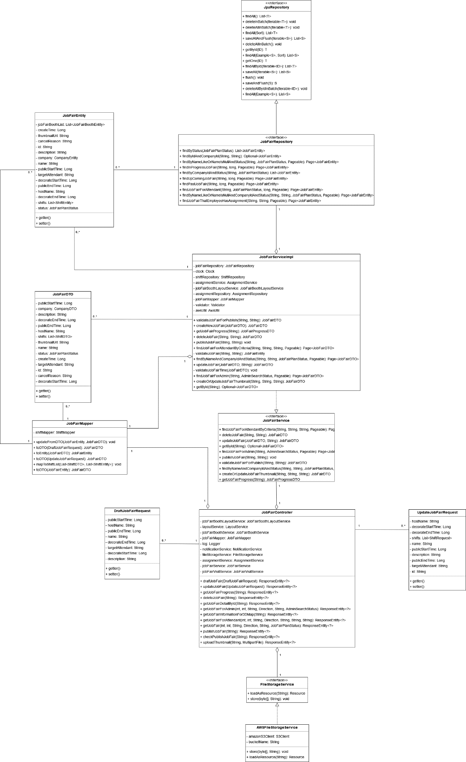

Figure 15. Class diagram - Manager organizes a job fair

##### 3.1.1.1 JpaRepository

|  |  |  |  |  |
| --- | --- | --- | --- | --- |
| **No** | **Method** | **Return Type** | **Visibility** | **Description** |
| 1 | findAll | List<T> | Public | Get all records in database |
| 2 | deleteInBatch | void | Public | Delete multiple records in database |
| 3 | deleteAllInBatch | void | Public | Delete all records in database |
| 4 | saveAllAndBatch | void | Public | Update multiple records in database |
| 5 | getById | T | Public | Find a record by ID in database |
| 6 | findAllById | List<T> | Public | Find all record by list of IDs in database |
| 7 | saveAll | List<S> | Public | Save all records in database |
| 8 | flush | void | Public | Write change to database |
| 9 | saveAndFlush | S | Public | Write change to database |
| 11 | deleteAllByIdInBatch | void | Public | Delete records that have IDs |

##### 3.1.1.2 JobFairRepository

|  |  |  |  |  |
| --- | --- | --- | --- | --- |
| **No** | **Method** | **Return Type** | **Visibility** | **Description** |
| 1 | findByStatus | List<JobFairEntity> | Public | Find JobFair record by status |
| 2 | findByIdAndCompanyId | Optional<JobFairEntity> | Public | Find JobFair record by ID and company ID |
| 3 | findByNameLikeOrNameIsNullAndStatus | Page<JobFairEntity> | Public | Find JobFair record by name and status |
| 4 | findInProgressJobFair | Page<JobFairEntity> | Public | Find JobFair record that has status IN_PROGRESS |
| 5 | findByCompanyIdAndStatus | List<JobFairEntity> | Public | Find JobFair record by company’s id and status |
| 6 | findUpComingJobFair | Page<JobFairEntity> | Public | Find JobFair record that has decorate time > current time |
| 7 | findPastJobFair | Page<JobFairEntity> | Public | Find JobFair record that has public end time < current time |
| 8 | findByNameLikeOrNameIsNullAndCompanyIdAndStatus | Page<JobFairEntity> | Public | Find JobFair record by name and by company id and by status |
| 9 | findJobFairThatEmployeeHasAssignment | Page<JobFairEntity> | Public | Find JobFair record that has employee assignments |

##### 3.1.1.3 JobFairEntity

|  |  |  |  |  |
| --- | --- | --- | --- | --- |
| **No** | **Attribute** | **Data Type** | **Visibility** | **Description** |
| 1 | jobFairBoothList | List<JobFairBoothEntity> | Private | List of job fair booth |
| 2 | createTime | Long | Private | Create time of job fair |
| 3 | thumbnailUrl | String | Private | Job fair’s thumbnail location |
| 4 | cancelReason | String | Private | Job fair’s cancel reason |
| 5 | id | String | Private | Unique identifier for job fair |
| 6 | description | String | Private | Job fair’s description |
| 7 | company | CompanyEntity | Private | Company that job fair belongs to |
| 8 | name | String | Private | Job fair’s name |
| 9 | publicStartTime | Long | Private | Job fair’s public start time |
| 10 | tartgetAttendant | String | Private | Job fair’s target attendant |
| 11 | decorateStartTime | Long | Private | Job fair’s decorate start time |
| 12 | publicEndTime | Long | Private | Job fair’s public end time |
| 13 | hostName | String | Private | Job fair’s host name |
| 14 | decoratedEndTime | Long | Private | Job fair’s decorate end time |
| 15 | shifts | List<ShiftEntity> | Private | Job fair’s shifts |
| 16 | status | JobFairPlanStatus | Private | Job fair’s status |

|  |  |  |  |  |
| --- | --- | --- | --- | --- |
| **No** | **Method** | **Return Type** | **Visibility** | **Description** |
| 1 | getter | data type | Public | Get attribute value |
| 2 | setter | data type | Public | Set value for attribute |

##### 3.1.1.4 JobFairServiceImpl

|  |  |  |  |  |
| --- | --- | --- | --- | --- |
| **No** | **Attribute** | **Data Type** | **Visibility** | **Description** |
| 1 | jobFairRepository | JobFairRepository | Private | Job fair repository |
| 2 | clock | Clock | Private | Clock object to get current timestamp |
| 3 | shiftRepository | ShiftRepository | Private | Shift repository |
| 4 | assignmentService | AssignmentService | Private | Assignment service |
| 5 | jobFairBoothLayoutService | JobFairBoothLayoutService | Private | Job fair booth layout service |
| 6 | assignmentRepository | AssignmentRepository | Private | Assignment repository |
| 7 | jobFairMapper | JobFairMapper | Private | Mapping DTO to entity and vice versa |
| 8 | validator | Validator | Private | DTO validator |
| 9 | awsUtil | AwsUtil | Private | AWS utility class |

|  |  |  |  |  |
| --- | --- | --- | --- | --- |
| **No** | **Method** | **Return Type** | **Visibility** | **Description** |
| 1 | validateJobFairForPublish | JobFairDTO | Public | Check for validate if the eligible for publishing |
| 2 | createNewJobFair | JobFairDTO | Public | Create new job fair draft |
| 3 | getJobFairProgress | JobFairProgressDTO | Public | Get job fair checklist progress |
| 4 | deleteJobFair | JobFairDTO | Public | Delete a draft job fair |
| 5 | publishJobFair | void | Public | Publish a draft job fair |
| 6 | findJobFairFotAttendantByCriteria | Page<JobFairDTO> | Public | Get public job fair for attendant by criteria such as paging, search value |
| 7 | validateJobFair | JobFairEntity | Private | Check for job fair integrity when update |
| 8 | findByNameAndCompanyIdAndStatus | Page<JobFairDTO> | Public | Find job fair by name and by company id and status |
| 9 | updateJobFair | JobFairDTO | Public | Update job fair information |
| 10 | validateJobFairTime | void | Private | Check for job fair time range |
| 11 | findJobFairForAdmin | Page<JobFairDTO> | Public | Get job fair for admin |
| 12 | createOrUpdateJobFairThumbnail | JobFairDTO | Public | Create or update job fair landing page thumbnail |
| 13 | getById | Optional<JobFairDTO> | Public | Get job fair by ID |

##### 3.1.1.5 JobFairDTO

|  |  |  |  |  |
| --- | --- | --- | --- | --- |
| **No** | **Attribute** | **Data Type** | **Visibility** | **Description** |
| 1 | publicStartTime | Long | Private | Job fair’s public start time |
| 2 | company | CompanyDTO | Private | Company that job fair belongs to |
| 3 | description | String | Private | Job fair’s description |
| 4 | decorateEndTime | Long | Private | Job fair’s decorate end time |
| 5 | publicEndTime | Long | Private | Job fair’s public end time |
| 6 | hostName | String | Private | Job fair’s host name |
| 7 | shifts | List<ShiftDTO> | Private | Job fair’s shifts |
| 8 | thumbnailUrl | String | Private | Job fair’s thumbnail location |
| 9 | name | String | Private | Job fair’s name |
| 10 | status | JobFairPlanStatus | Private | Job fair’s status |
| 11 | createTime | Long | Private | Create time of job fair |
| 12 | targetAttendant | String | Private | Job fair’s target attendant |
| 13 | id | String | Private | Unique identifier for job fair |
| 14 | cancelReason | String | Private | Job fair’s cancel reason |
| 15 | decorateStartTime | Long | Private | Job fair’s decorate start time |

|  |  |  |  |  |
| --- | --- | --- | --- | --- |
| **No** | **Method** | **Return Type** | **Visibility** | **Description** |
| 1 | getter | data type | Public | Get attribute value |
| 2 | setter | data type | Public | Set value for attribute |

##### 3.1.1.6 JobFairService

|  |  |  |  |  |
| --- | --- | --- | --- | --- |
| **No** | **Method** | **Return Type** | **Visibility** | **Description** |
| 1 | findJobFairForAttendantByCriteria | Page<JobFairDTO> | Public | Get public job fair for attendant by criteria such as paging, search value |
| 2 | deleteJobFair | JobFairDTO | Public | Delete a draft job fair |
| 3 | updateJobFair | JobFairDTO | Public | Update job fair information |
| 4 | getById | Optional<JobFair> | Public | Get job fair by ID |
| 5 | findJobFairForAdmin | Page<JobFairDTO> | Public | Get job fair for admin |
| 6 | publishJobFair | void | Public | Publish a draft job fair |
| 7 | validateJobFairForPublish | JobFairDTO | Public | Check for validate if the eligible for publishing |
| 8 | findByNameAndCompanyIdAndStatus | Page<JobFairDTO> | Public | Find job fair by name and by company id and status |
| 9 | createOrUpdateJobFairThumbnail | JobFairDTO | Public | Create or update job fair landing page thumbnail |
| 10 | getJobFairProgress | JobFairProgressDTO | Public | Get job fair checklist progress |
| 11 | createNewJobFair | JobFairDTO | Public | Create new job fair draft |

##### 3.1.1.7 JobFairController

|  |  |  |  |  |
| --- | --- | --- | --- | --- |
| **No** | **Attribute** | **Data Type** | **Visibility** | **Description** |
| 1 | jobFairBoothLayoutService | JobFairBoothLayourService | Private | Job fair’s booth layout service |
| 2 | layoutService | LayoutService | Private | Layout service |
| 3 | jobFairBoothService | JobFairBoothService | Private | Job fair’s booth service |
| 4 | jobFairMapper | JobFairMapper | Private | Job fair’s mapper |
| 5 | log | Logger | Private | Log |
| 6 | notificationService | NotificationService | Private | Notification service |
| 7 | fileStorageService | FileStorageService | Private | File storage service |
| 8 | assignmentService | AssignmentService | Private | Assignment service |
| 9 | jobFairService | JobFairService | Private | Job fair service |
| 10 | jobFairVisitService | JobFairVisitService | Private | Job fair visit service |

|  |  |  |  |  |
| --- | --- | --- | --- | --- |
| **No** | **Method** | **Return Type** | **Visibility** | **Description** |
| 1 | draftJobFair | ResponseEntity<?> | Public | Draft job fair |
| 2 | updateJobFairProgress | ResponseEntity<?> | Public | Update job fair’s progress |
| 3 | getJobFairProgress | ResponseEntity<?> | Public | Get job fair’s progress |
| 4 | deleteJobFair | ResponseEntity<?> | Public | Delete job fair |
| 5 | getJobFairDetailbyId | ResponseEntity<?> | Public | Get job fair detail by ID |
| 6 | getJobFairForAdmin | ResponseEntity<?> | Public | Get job fair for admin |
| 7 | getJobFairInformationFor3Dmap | ResponseEntity<?> | Public | Get job fair information for 3D map |
| 8 | getJobFairForAttendant | ResponseEntity<?> | Public | Get job fair for attendant |
| 9 | getJobFair | ResponseEntity<?> | Public | Get job fair |
| 10 | publishJobFair | ResponseEntity<?> | Public | Publish job fair |
| 11 | checkPublishJobFair | ResponseEntity<?> | Public | Check publishes job fair |
| 12 | uploadThumbnail | ResponseEntity<?> | Public | Upload thumbnail |

##### 3.1.1.8 DaftJobFairRequest

|  |  |  |  |  |
| --- | --- | --- | --- | --- |
| **No** | **Attribute** | **Data Type** | **Visibility** | **Description** |
| 1 | publicStartTime | Long | Private | Job fair’s public start time |
| 2 | hostName | String | Private | Job fair’s host name |
| 3 | publicEndTime | Long | Private | Job fair’s public end time |
| 4 | name | String | Private | Job fair’s name |
| 5 | decorateEndTime | Long | Private | Job fair’s decorate end time |
| 6 | targetAttendant | String | Private | Job fair’s target attendant |
| 7 | decorateStartTime | Long | Private | Job fair’s decorate start time |
| 8 | description | String | Private | Job fair’s description |

|  |  |  |  |  |
| --- | --- | --- | --- | --- |
| **No** | **Method** | **Return Type** | **Visibility** | **Description** |
| 1 | getter | data type | Public | Get attribute value |
| 2 | setter | data type | Public | Set value for attribute |

##### 3.1.1.9 UpdateJobFairRequest

|  |  |  |  |  |
| --- | --- | --- | --- | --- |
| **No** | **Attribute** | **Data Type** | **Visibility** | **Description** |
| 1 | hostName | String | Private | Job fair’s host name |
| 2 | decorateStartTime | Long | Private | Job fair’s decorate start time |
| 3 | decorateEndTime | Long | Private | Job fair’s decorate end time |
| 4 | shifts | List<ShiftRequest> | Private | Job fair’s shifts |
| 5 | name | String | Private | Job fair’s name |
| 6 | publicStartTime | Long | Private | Job fair’s public start time |
| 7 | description | String | Private | Job fair’s description |
| 8 | publicEndTime | Long | Private | Job fair’s public end time |
| 9 | targetAttendant | String | Private | Job fair’s target attendant |
| 10 | id | String | Private | Job fair’s ID |

|  |  |  |  |  |
| --- | --- | --- | --- | --- |
| **No** | **Method** | **Return Type** | **Visibility** | **Description** |
| 1 | getter | data type | Public | Get attribute value |
| 2 | setter | data type | Public | Set value for attribute |

##### 3.1.1.10 FileStorageService

|  |  |  |  |  |
| --- | --- | --- | --- | --- |
| **No** | **Method** | **Return Type** | **Visibility** | **Description** |
| 1 | loadAsResource | Resource | Public | Load file |
| 2 | store | void | Public | Store file |

##### 3.1.1.11 AWSFileStorageService

|  |  |  |  |  |
| --- | --- | --- | --- | --- |
| **No** | **Attribute** | **Data Type** | **Visibility** | **Description** |
| 1 | amazonS3Client | S3Client | Private | Amazon S3 client |
| 2 | bucketName | String | Private | Bucket name |

|  |  |  |  |  |
| --- | --- | --- | --- | --- |
| **No** | **Method** | **Return Type** | **Visibility** | **Description** |
| 1 | store | void | Public | Store file |
| 2 | loadAsResource | Resource | Public | Load file |

#### 3.1.2 Sequence Diagrams

##### 3.1.2.1 Organize job fair

***Summary****: this diagram shows how Company Manager can create a job fair.*

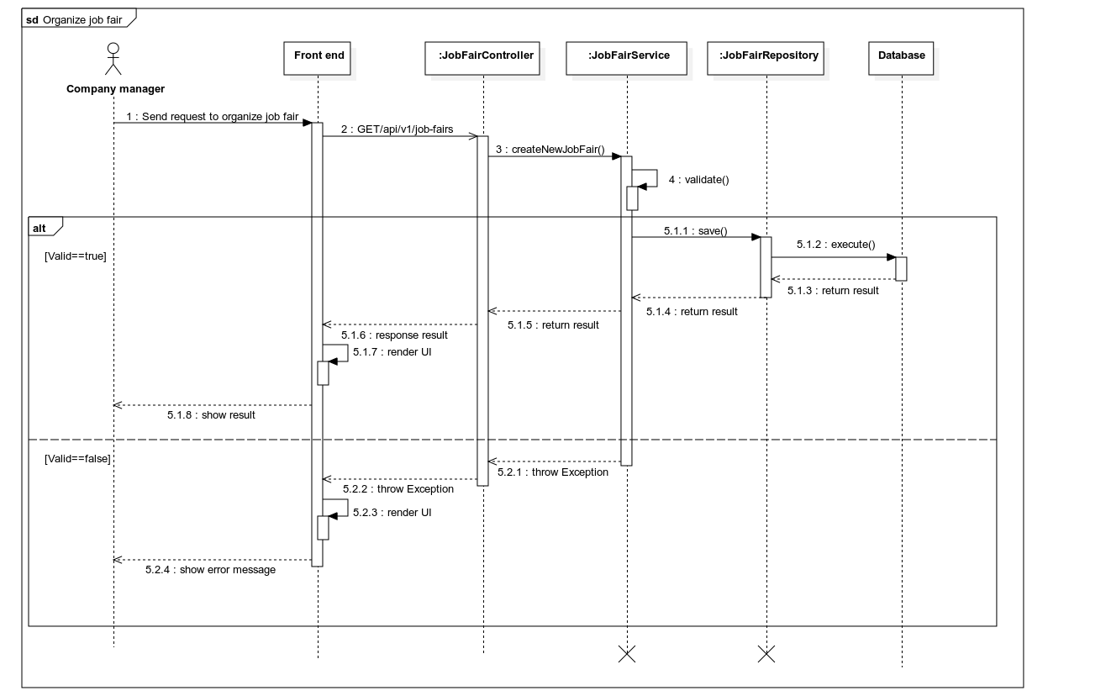

Figure 16. Sequence diagram – Organize job fair

##### 3.1.2.2 Update job fair

***Summary****: this diagram shows how Company Manager can update a job fair*

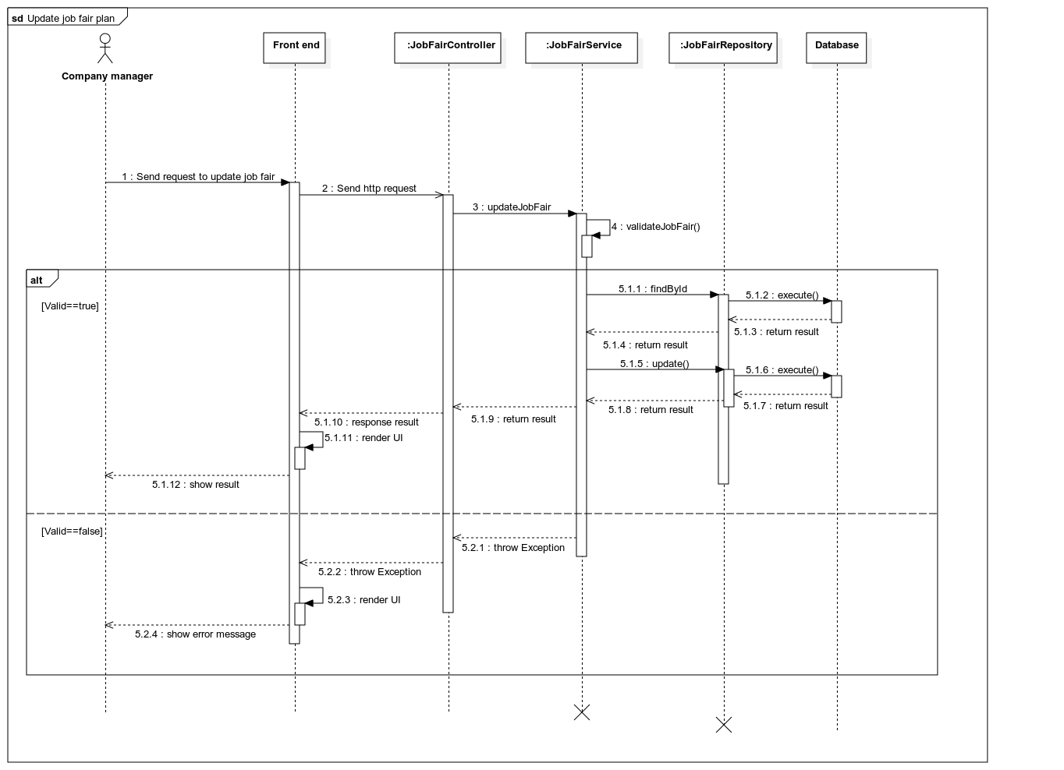

Figure 17. Sequence diagram –Update job fair

##### 3.1.2.3 Get job fair list

***Summary****: this diagram shows how Company Manager can get job fair list*

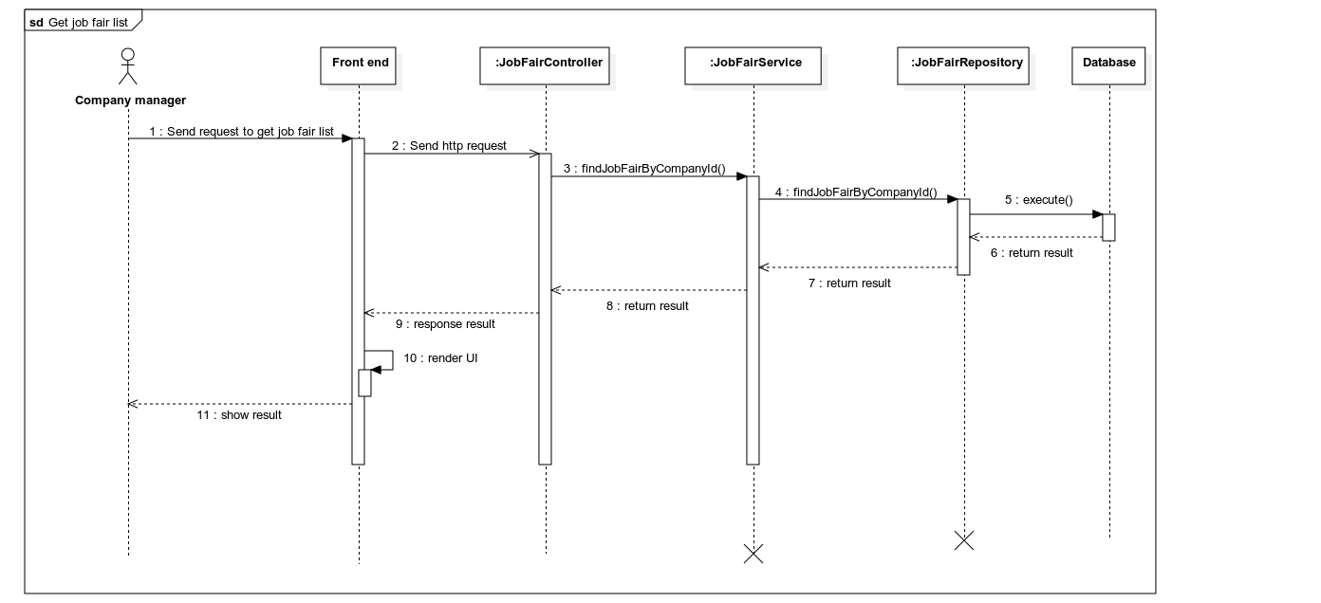

Figure 18. Sequence diagram –Get job fair list

##### 3.1.2.4 Get job fair by ID

***Summary****: this diagram shows how Company Manager can get job fair by ID*

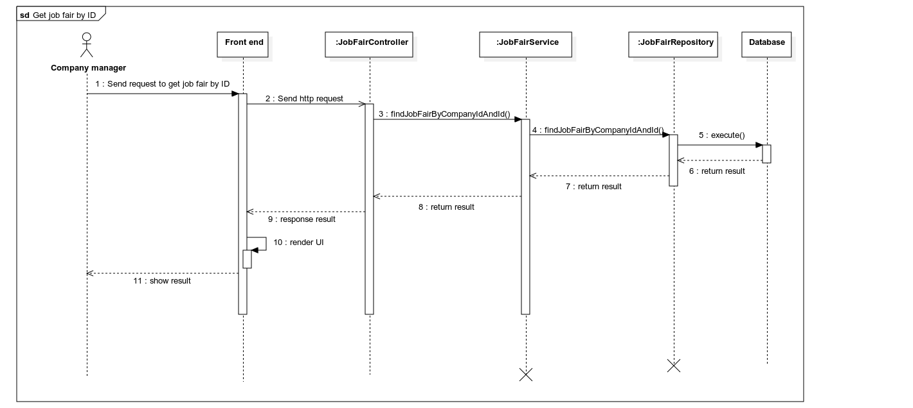

Figure 19. Sequence diagram –Get job fair by ID

### 3.2 Supervisor fills booth information and decorator decorate booth

#### 3.2.1 Class diagram

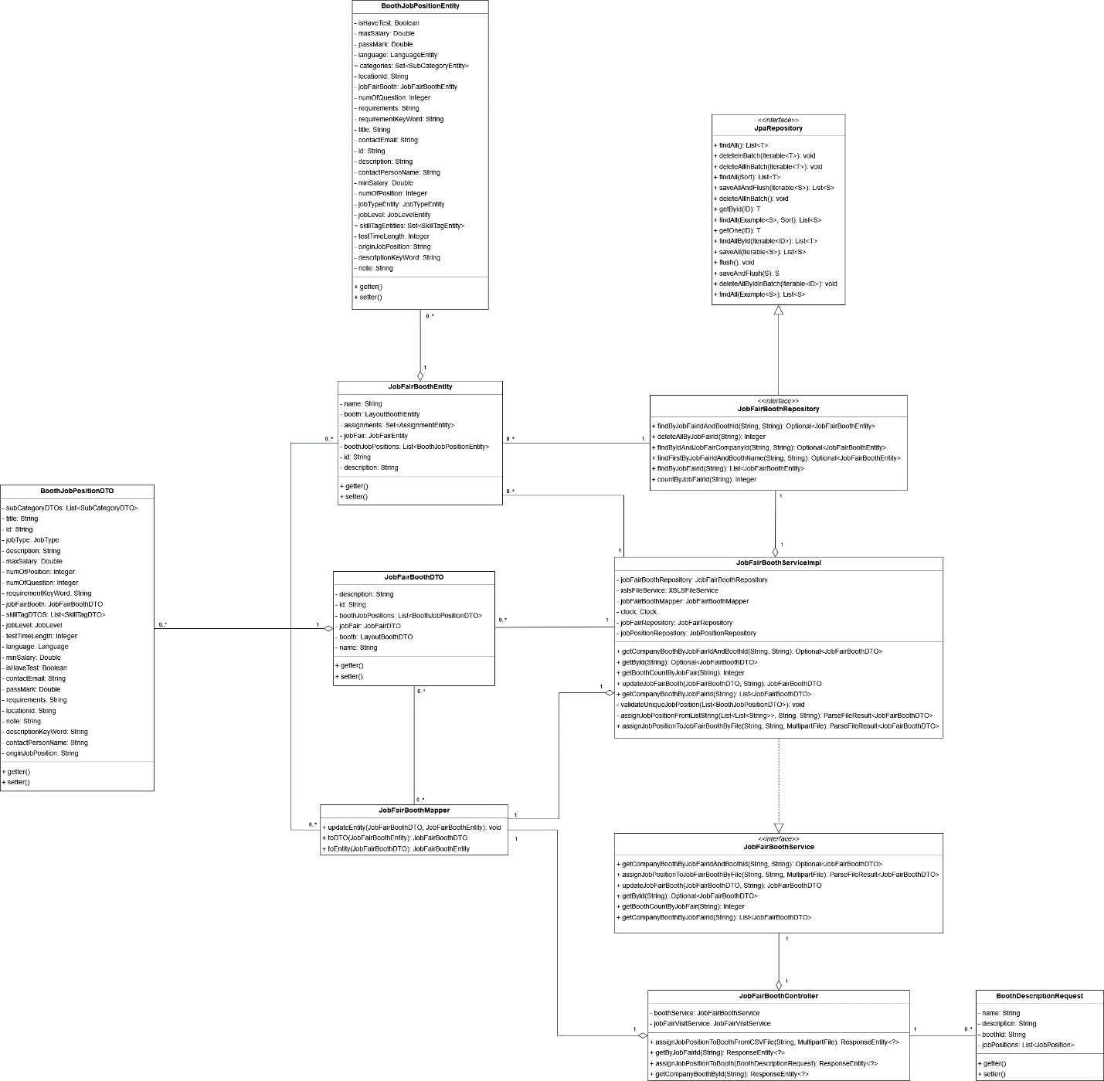

Figure 20. Class diagram – Supervisor fills booth information

##### 3.2.1.1 BoothJobPositionEntity

|  |  |  |  |  |
| --- | --- | --- | --- | --- |
| **No** | **Attribute** | **Data Type** | **Visibility** | **Description** |
| 1 | isHaveTest | Boolean | Private | If this job has entry test |
| 2 | maxSalary | Double | Private | Maximum salary |
| 3 | passMask | Double | Private | The minimum mark that attendant need to achieve to pass the entry test |
| 4 | language | LanguageEntity | Private | Booth job’s position language |
| 5 | categories | Set<SubCategoryEntity> | Default | Booth job’s position categories |
| 6 | locationId | String | Private | Booth job’s location ID |
| 7 | jobFairBootth | JobFairBoothEntity | Private | Job fair’s booth that this job belongs to |
| 8 | numOfQuestion | Integer | Private | Number of questions in booth job position |
| 9 | requirements | String | Private | Booth job position’s requirements |
| 10 | requitementKeyWord | String | Private | Booth job position’s requirement key word |
| 11 | title | String | Private | Booth job position’s title |
| 12 | contactEmail | String | Private | Booth job position’s contact email |
| 13 | id | String | Private | Booth job position’s ID |
| 14 | description | String | Private | Booth job position’s description |
| 15 | contactPersonName | String | Private | Booth job position’s contact person name |
| 16 | minSalary | Double | Private | Minimum salary of booth job position |
| 17 | numOfPosition | Integer | Private | The number of persons this job needs to hire |
| 18 | jobTypeEntiy | JobTypeEntity | Private | Booth job position’s type |
| 19 | jobLevel | JobLevelEntity | Private | Booth job position’s level |
| 20 | skillTagEntities | Set<SkillTagEntitty> | Default | Booth job position’s skill tags |
| 21 | testTimeLength | Integer | Private | Length of entry test |
| 22 | originJobPosition | String | Private | The origin job position id |
| 23 | descriptionKeyWord | String | Private | Key word of description |
| 24 | note | String | Private | Booth job position’s note |

|  |  |  |  |  |
| --- | --- | --- | --- | --- |
| **No** | **Method** | **Return Type** | **Visibility** | **Description** |
| 1 | getter | data type | Public | Get attribute value |
| 2 | setter | data type | Public | Set value for attribute |

##### 3.2.1.2 JpaRepository

|  |  |  |  |  |
| --- | --- | --- | --- | --- |
| **No** | **Method** | **Return Type** | **Visibility** | **Description** |
| 1 | findAll | List<T> | Public | Get all records in database |
| 2 | deleteInBatch | void | Public | Delete multiple records in database |
| 3 | deleteAllInBatch | void | Public | Delete all records in database |
| 4 | saveAllAndBatch | void | Public | Update multiple records in database |
| 5 | getById | T | Public | Find a record by ID in database |
| 6 | findAllById | List<T> | Public | Find all record by list of IDs in database |
| 7 | saveAll | List<S> | Public | Save all records in database |
| 8 | flush | void | Public | Write change to database |
| 9 | saveAndFlush | S | Public | Write change to database |
| 11 | deleteAllByIdInBatch | void | Public | Delete records that have IDs |

##### 3.2.1.3 JobFairBoothRepository

|  |  |  |  |  |
| --- | --- | --- | --- | --- |
| **No** | **Method** | **Return Type** | **Visibility** | **Description** |
| 1 | findByJobFairIdAndBoothId | Optional<JobFairBoothEntity> | Public | Find job fair’s booth by job fair’s ID and booth’s ID |
| 2 | deleteAllByJobFairId | Integer | Public | Delete all job fair’s booth by job fair’s ID |
| 3 | findByIdAndJobFairCompanyId | Optional<JobFairBoothEntity> | Public | Find job fair’s booth by ID and job fair company’s ID |
| 4 | findFirstByJobFairIdAndBoothName | Optional<JobFairBoothEntity> | Public | Find first job fair by job fair’s ID and booth’s name |
| 5 | findByJobFairId | List<JobFairBoothEntity> | Public | Find job fair by job fair’s ID |
| 6 | countByJobFairId | Integer | Public | Count by job fair’s ID |

##### 3.2.1.4 JobFairBoothEntity

|  |  |  |  |  |
| --- | --- | --- | --- | --- |
| **No** | **Attribute** | **Data Type** | **Visibility** | **Description** |
| 1 | name | String | Private | Name of job fair’s booth |
| 2 | booth | LayoutBoothEntity | Private | The booth position in the 3D layout that this job fair booth will be placed on |
| 3 | assignments | Set<AssignmentEntity> | Private | Assignments of job fair’s booth |
| 4 | jobFair | JobFairEntity | Private | Job fair that this booth belongs to |
| 5 | boothJobPositions | List<BoothJobPositionEntity> | Private | Job positions in booth |
| 6 | id | String | Private | Unique identifier of this booth |
| 7 | description | String | Private | Description of job fair booth |

|  |  |  |  |  |
| --- | --- | --- | --- | --- |
| **No** | **Method** | **Return Type** | **Visibility** | **Description** |
| 1 | getter | data type | Public | Get attribute value |
| 2 | setter | data type | Public | Set value for attribute |

##### 3.2.1.5 JobFairBoothServiceImpl

|  |  |  |  |  |
| --- | --- | --- | --- | --- |
| **No** | **Attribute** | **Data Type** | **Visibility** | **Description** |
| 1 | jobFairBoothRepository | JobFairBoothRepository | Private | Job fair booth repository |
| 2 | xslsFileService | XSLFileService | Private | Xsls file service |
| 3 | jobFairBoothMapper | JobFairBoothMapper | Private | Job fair booth’s mapper |
| 4 | clock | Clock | Private | Clock object to get current timestamp |
| 5 | jobFairRepository | JobFairRepository | Private | Job fair’s repository |
| 6 | jobPositionRepository | JobPositionRepository | Private | Job position’s repository |

|  |  |  |  |  |
| --- | --- | --- | --- | --- |
| **No** | **Method** | **Return Type** | **Visibility** | **Description** |
| 1 | getCompanyBoothByJobFairIdAndBoothId | Optional<JobFairBoothDTO> | Public | Get booth by job fair’s ID and booth’s ID |
| 2 | getById | Optional<JobFairBoothDTO> | Public | Get job fair booth by ID |
| 3 | getBoothCountByJobFair | Integer | Public | Get count of job fair’s booth by job fair id |
| 4 | updateJobFairBooth | JobFairBoothDTO | Public | Update job fair’s booth information |
| 5 | getCompanyBoothByJobFairId | List<JobFairBoothDTO> | Public | Get booth by job fair’s ID |
| 6 | validateUniqueJobPosition | void | Private | Validate unique job position |
| 7 | assignJobPositionFromListString | ParseFileResult<JobFairBoothDTO> | Private | Assign job position from list string |
| 8 | assignJobPositionToJobFairBoothByFile | ParseFileResult<JobFairBoothDTO> | Public | Assign job position to job fair’s booth by file |

##### 3.2.1.6 JobFairBoothDTO

|  |  |  |  |  |
| --- | --- | --- | --- | --- |
| **No** | **Attribute** | **Data Type** | **Visibility** | **Description** |
| 1 | description | String | Private | Description of job fair’s booth |
| 2 | id | String | Private | ID of job fair’s booth |
| 3 | boothJobPositions | List<BoothJobPositionDTO> | Private | Job positions in booth |
| 4 | jobFair | JobFairDTO | Private | Job fair that this booth belongs to |
| 5 | booth | LayoutBoothDTO | Private | The booth position in the 3D layout that this job fair booth will be placed on |
| 6 | name | String | Private | Name of job fair’s booth |

|  |  |  |  |  |
| --- | --- | --- | --- | --- |
| **No** | **Method** | **Return Type** | **Visibility** | **Description** |
| 1 | getter | data type | Public | Get attribute value |
| 2 | setter | data type | Public | Set value for attribute |

##### 3.2.1.7 BoothJobPositionDTO

|  |  |  |  |  |
| --- | --- | --- | --- | --- |
| **No** | **Attribute** | **Data Type** | **Visibility** | **Description** |
| 1 | subCategoryDTOs | List<SubCategoryDTO> | Private | Job position’s categories |
| 2 | title | String | Private | Job position’s title |
| 3 | id | String | Private | Unique identifier of job position |
| 4 | jobType | JobType | Private | Job position’s type |
| 5 | description | String | Default | Job position’s description |
| 6 | maxSalary | Double | Private | Maximum salary |
| 7 | numOfPosition | Integer | Private | The number of persons this job needs to hire |
| 8 | numOfQuestion | Integer | Private | Number of questions in booth job position |
| 9 | requirementKeyWord | String | Private | Booth job position’s requirement key word |
| 10 | jobFairBooth | JobFairBoothDTO | Private | Job fair’s booth that this job belongs to |
| 11 | skillTagDTOs | List<SkillTagDTO> | Private | Booth job position’s skill tags |
| 12 | jobLevel | JobLevel | Private | Booth job position’s level |
| 13 | testTimeLength | Integer | Private | Length of entry test |
| 14 | language | Language | Private | Booth job’s position language |
| 15 | minSalary | Double | Private | Minimum salary of booth job position |
| 16 | isHaveTest | Boolean | Private | If this job has entry test |
| 17 | contactEmail | String | Private | Booth job position’s contact email |
| 18 | passMark | Double | Private | The minimum mark that attendant need to achieve to pass the entry test |
| 19 | requirements | String | Private | Booth job position’s requirements |
| 20 | note | String | Private | Booth job position’s note |
| 21 | descriptionKeyWord | String | Private | Key word of description |
| 22 | contacttPersonName | String | Private | Booth job position’s contact person name |
| 23 | originJobPosition | String | Private | The origin job position id |

|  |  |  |  |  |
| --- | --- | --- | --- | --- |
| **No** | **Method** | **Return Type** | **Visibility** | **Description** |
| 1 | getter | data type | Public | Get attribute value |
| 2 | setter | data type | Public | Set value for attribute |

##### 3.2.1.8 JobFairBoothMapper

|  |  |  |  |  |
| --- | --- | --- | --- | --- |
| **No** | **Method** | **Return Type** | **Visibility** | **Description** |
| 1 | updateEntity | void | Public | Update JobFairBoothEntity from JobFairBoothDTO |
| 2 | toDTO | JobFairBoothDTO | Public | Convert Entity to DTO |
| 3 | toEntity | JobFairBoothEntity | Public | Convert DTO to Entity |

##### 3.2.1.9 JobFairBoothService

|  |  |  |  |  |
| --- | --- | --- | --- | --- |
| **No** | **Method** | **Return Type** | **Visibility** | **Description** |
| 1 | getCompanyBoothByJobFairIdAndBoothId | Optional<JobFairBoothDTO> | Public | Get booth by job fair’s ID and booth’s ID |
| 2 | assignJobPositionToJobFairBoothByFile | ParseFileResult<JobFairBoothDTO> | Public | Assign job position to job fair’s booth by file |
| 3 | updateJobFairBooth | JobFairBoothDTO | Public | Update job fair’s booth information |
| 4 | getById | Optional<JobFairBoothDTO> | Public | Get job fair booth by ID |
| 5 | getBoothCountByJobFair | Integer | Public | Get count of job fair’s booth by job fair id |
| 6 | getCompanyBoothByJobFairId | List<JobFairBoothDTO> | Public | Get booth by job fair’s ID |

##### 3.2.1.10 JobFairBoothController

|  |  |  |  |  |
| --- | --- | --- | --- | --- |
| **No** | **Attribute** | **Data Type** | **Visibility** | **Description** |
| 1 | boothService | JobFairBoothService | Private | Job fair booth service |
| 2 | jobFairVisitService | JobFairVisitService | Private | Job fair visit service |

|  |  |  |  |  |
| --- | --- | --- | --- | --- |
| **No** | **Method** | **Return Type** | **Visibility** | **Description** |
| 1 | assignJobPositionToBoothFromCSVFile | ResponseEntity<?> | Public | Allow Supervisor to add job position by CSV file |
| 2 | getByJobFairId | ResponseEntity<?> | Public | Get job fair booth list by job fair’s id |
| 3 | assignJobPositionToBooth | ResponseEntity<?> | Public | Allow Supervisor manually add job position |
| 4 | getCompanyBoothById | ResponseEntity<?> | Public | Get booth by ID |

##### 3.2.1.11 BoothDescriptionRequest

|  |  |  |  |  |
| --- | --- | --- | --- | --- |
| **No** | **Attribute** | **Data Type** | **Visibility** | **Description** |
| 1 | name | String | Private | Booth’s name |
| 2 | description | String | Private | Booth’s description |
| 3 | boothId | String | Private | Booth’s ID |
| 4 | jobPositions | List<JobPosition> | Private | Booth’s job position list |

|  |  |  |  |  |
| --- | --- | --- | --- | --- |
| **No** | **Method** | **Return Type** | **Visibility** | **Description** |
| 1 | getter | data type | Public | Get attribute value |
| 2 | setter | data type | Public | Set value for attribute |

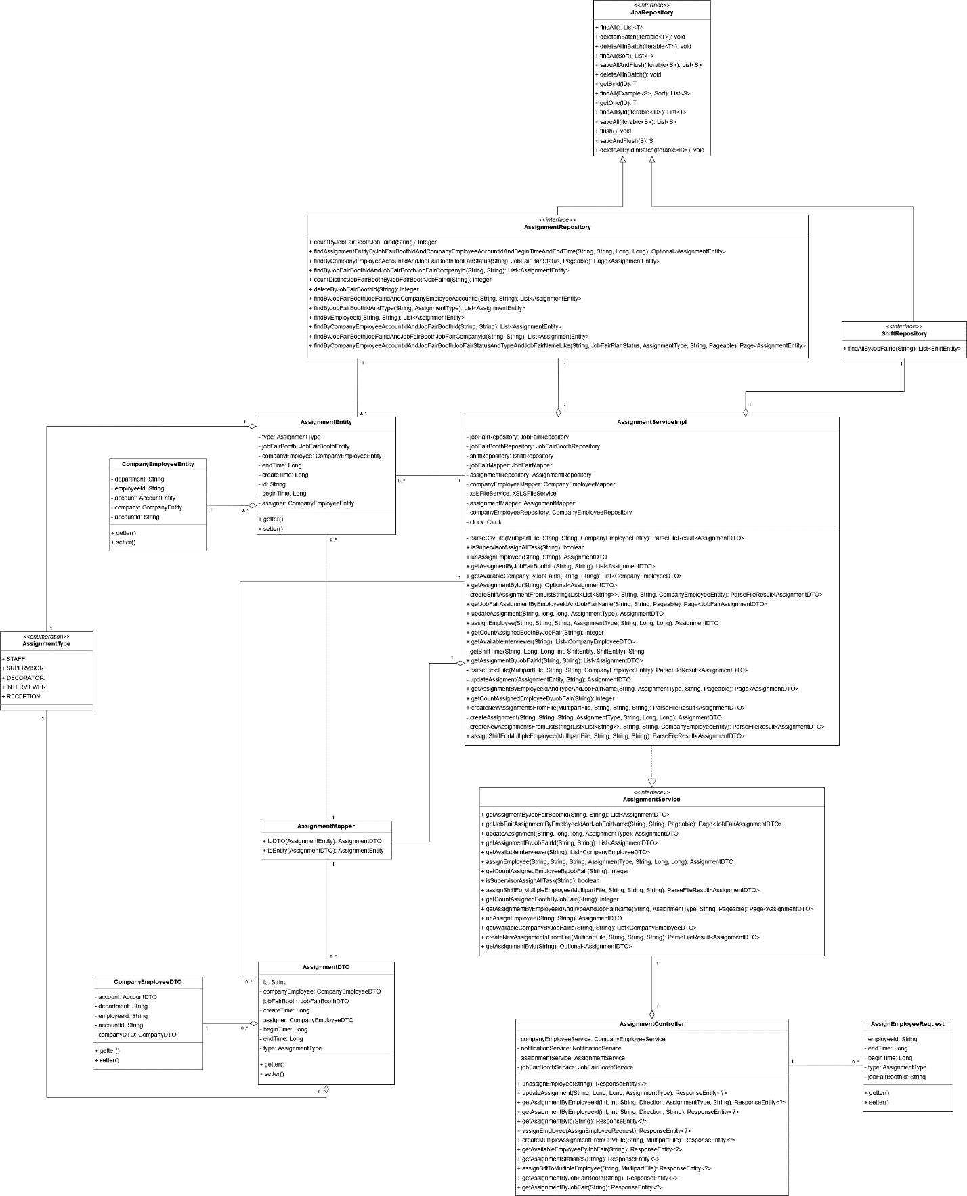

Figure 21. Class diagram – Supervisor assigns tasks

##### 3.2.1.12 AssignmentRepository

|  |  |  |  |  |
| --- | --- | --- | --- | --- |
| **No** | **Method** | **Return Type** | **Visibility** | **Description** |
| 1 | countByJobFairBoothJobFairId | Integer | Public | Get count of assignment by job fair’s id |
| 2 | findAssignmentEntityByJobFairBoothAndCompanyEmployeeAccountIdAndBeginImeAndEndTime | Optional<AssignmentEntity> | Public | Find assignment by job fair booth id and by company employee |
| 3 | findByCompanyEmployeeAccountIdAndJobFairBoothJobFairStatus | Page<AssignmentEntity> | Public | Find assignments by company employee and job fair’s status |
| 4 | findByJobFairBoothIdAndJobFairCompanyId | List<AssignmentEntity> | Public | Find assignments by job fair booth’s id and company’s id |
| 5 | countDistinctJobFairBoothByJobFairId | Integer | Public | Count assignments by job fair’s id |
| 6 | deleteByJobFairBoothId | Integer | Public | Delete assignments by job fair booth’s id |
| 7 | findByJobFairBoothJobFairIdAndCompanyEmployeeAccountId | List<AssignmentEntity> | Public | Find assignments by job fair’s id and company employee |
| 8 | findByJobFairBoothAndType | List<AssignmentEntity> | Public | Find assignments by job fair booth id and type of assignment |
| 9 | findByEmployeeId | List<AssignmentEntity> | Public | Find assignments by company employee’s id |
| 10 | findByCompanyEmployeeAccountIdAndJobFairBoothId | List<AssignmentEntity> | Public | Find assignments by company employee’s id and job fair booth’s id |
| 11 | findByJobFairBoothJobFairIdAndJobFairBoothJobFairCompanyId | List<AssignmentEntity> | Public | Find assignments by job fair booth’s id and company’s id |
| 12 | findByCompanyEmployessAccountAndJobFairBoothJobFairStatusAndTypeAndJobFairNameLike | Page<AssignmentEntity> | Public | Find assignments by company employee’s id and job fair’s status |

##### 3.2.1.13 ShiftRepository

|  |  |  |  |  |
| --- | --- | --- | --- | --- |
| **No** | **Method** | **Return Type** | **Visibility** | **Description** |
| 1 | findAllByJobFairId | List<ShiftEntity> | Public | Find shifts by job fair’s id |

##### 3.2.1.14 AssignmentServiceImpl

|  |  |  |  |  |
| --- | --- | --- | --- | --- |
| **No** | **Attribute** | **Data Type** | **Visibility** | **Description** |
| 1 | jobFairRepository | JobFairRepository | Private | Job fair repository |
| 2 | jobFairBoothRepository | JobFairBoothRepository | Private | Job fair booth repository |
| 3 | shiftRepository | ShiftRepository | Private | Shift repository |
| 4 | jobFairMapper | JobFairMapper | Private | Job fair mapper |
| 5 | assignmentRepository | AssignmentRepository | Private | Assignment repository |
| 6 | companyEmployeeMapper | CompanyEmployeeMapper | Private | Company employee mapper |
| 7 | xslsFileService | XSLSFileService | Private | XSLS File service |
| 8 | assignmentMapper | AssignmentMapper | Private | Assignment mapper |
| 9 | companyEmployeeRepository | CompanyEmployeeRepository | Private | Company employee repository |
| 10 | clock | Clock | Private | Clock object to get current timestamp |

|  |  |  |  |  |
| --- | --- | --- | --- | --- |
| **No** | **Method** | **Return Type** | **Visibility** | **Description** |
| 1 | parseCsvFile | ParseFileResult<AssignmentDTO> | Private | Parse content of CSV file |
| 2 | isSupervisorAssignAllTask | boolean | Public | Check if the supervisor has assigned all staff task during job fair public time range |
| 3 | unAssignEmployee | AssignmentDTO | Public | Un assign employee |
| 4 | getAssignmentByJobFairBoothId | List<AssignmentDTO> | Public | Get assignment by job fair booth’s id |
| 5 | getAvailableCompanyByJobFairId | List<CompanyEmployeeDTO> | Public | Get available company employee to assign task |
| 6 | getAssignmentById | Optinal<AssignmentDTO> | Public | Get assignment by ID |
| 7 | createShiftAssignmentFromListString | ParseFileResult<AssignmentDTO> | Private | Create staff’s assignment from list string |
| 8 | getJobFairAssignmentByEmployeeIdAndJobFairName | Page<JobFairAssignmentDTO> | Public | Get assignments by employee’s id and job fair’s name |
| 9 | updateAssignment | AssignmentDTO | Public | Update assignment |
| 10 | assignEmployee | AssignmentDTO | Public | Assign task to employee |
| 11 | getCountAssignedBoothByJobFair | Integer | Public | Count assignment by booth in job fair |
| 12 | getAvailableInterviewer | List<CompanyEmployeeDTO> | Public | Get available interviewer |
| 13 | getShiftTime | String | Private | Get job fair’s shift time |
| 14 | getAssignmentByJobFairId | List<AssignmentDTO> | Public | Get assignments by job fair id |
| 15 | parseExcelFile | ParseFileResult<AssignmentDTO> | Private | Parse content of excel file |
| 16 | updateAssignment | AssignmentDTO | Private | Update assignment |
| 17 | getAssignmentByEmployeeIdAndTypeAndJobFairName | Page<AssignmentDTO> | Public | Get assignments by employee’s and by type and job fair’s name |
| 18 | getCountAssignedEmployeeByJobFair | Integer | Public | Count assigned employee by job fair’s id |
| 19 | createNewAssignmentsFromFile | ParseFileResult<AssignmentDTO> | Public | Create assignments from file |
| 20 | createAssignment | AssignmentDTO | Private | Create new assignment |
| 21 | createNewAssignmentsFromListString | ParseFileResult<AssignmentDTO> | Private | Create new assignments from list of string |
| 22 | assignShiftForMultipleEmployee | ParseFileResult<AssignmentDTO> | Public | Assign Staff assignments |

##### 3.2.1.15 AssignmentEntity

|  |  |  |  |  |
| --- | --- | --- | --- | --- |
| **No** | **Attribute** | **Data Type** | **Visibility** | **Description** |
| 1 | type | AssignmentType | Private | Assignment’s type |
| 2 | jobFairBooth | JobFairBoothEntity | Private | Job fair booth that this assignment belongs to |
| 3 | companyEmployee | CompanyEmployeeEntity | Private | Company employee that this assignment belongs to |
| 4 | endTime | Long | Private | Assignment’s end time |
| 5 | createTime | Long | Private | Assignment’s create time |
| 6 | id | String | Private | Unique identifier for assignment |
| 7 | beginTime | Long | Private | Assignment’s begin time |
| 8 | assigner | CompanyEmployeeEntity | Private | Assignment’s assigner |

|  |  |  |  |  |
| --- | --- | --- | --- | --- |
| **No** | **Method** | **Return Type** | **Visibility** | **Description** |
| 1 | getter | data type | Public | Get attribute value |
| 2 | setter | data type | Public | Set value for attribute |

##### 3.2.1.16 CompanyEmployeeEntity

|  |  |  |  |  |
| --- | --- | --- | --- | --- |
| **No** | **Attribute** | **Data Type** | **Visibility** | **Description** |
| 1 | department | String | Private | Employee’s department |
| 2 | employeeId | String | Private | Employee’s ID |
| 3 | account | AccountEntity | Private | Account associate with this employee |
| 4 | company | CompanyEntity | Private | Company that this employee belongs to |
| 5 | accountId | String | Private | Employee’s account id |

|  |  |  |  |  |
| --- | --- | --- | --- | --- |
| **No** | **Method** | **Return Type** | **Visibility** | **Description** |
| 1 | getter | data type | Public | Get attribute value |
| 2 | setter | data type | Public | Set value for attribute |

##### 3.2.1.17 AssignmentType

|  |  |  |  |
| --- | --- | --- | --- |
| **No** | **Enum** | **Visibility** | **Description** |
| 1 | STAFF | Public | Employees get assigned as STAFF in a booth |
| 2 | SUPERVISOR | Public | Employees get assigned as SUPERVISOR in a booth |
| 3 | DECORATOR | Public | Employees get assigned as DECORATOR in a booth |
| 4 | INTERVIEWER | Public | Employees get assigned as INTERVIEWER in a booth |
| 5 | RECEPTION | Public | Employees get assigned as RECEPTION in a booth |

##### 3.2.1.18 AssignmentService

|  |  |  |  |  |
| --- | --- | --- | --- | --- |
| **No** | **Method** | **Return Type** | **Visibility** | **Description** |
| 1 | getAssignmentByJobFairBoothId | List<AssignmentDTO> | Public | Get assignment by job fair booth’s id |
| 2 | getJobFairAssignmentByEmployeeIdAndJobFairName | Page<JobFairAssignmentDTO> | Public | Get assignments by employee’s id and job fair’s name |
| 3 | updateAssignment | AssignmentDTO | Public | Update assignment |
| 4 | getAssignmentByJobFairId | List< AssignmentDTO> | Public | Get assignments by job fair id |
| 5 | getAvailableInterviewer | List<CompanyEmployeeDTO> | Public | Get available interviewer |
| 6 | assignEmployee | AssignmentDTO | Public | Assign task to employee |
| 7 | getCountAssignedEmployeeByJobFair | Integer | Public | Count assigned employee by job fair’s id |
| 8 | isSupervisorAssignAllTask | boolean | Public | Check if the supervisor has assigned all staff task during job fair public time range |
| 9 | assignShiftForMultipleEmployee | ParseFileR | Public | Assign Staff assignments |
| 10 | getCountAssignedBoothByJobFair | Integer | Public | Count assignment by booth in job fair |
| 11 | getAssignmentByEmployeeIdAndTypeAndJobAndJobFairName | Page<AssignmentDTO> | Public | Get assignments by employee’s and by type and job fair’s name |
| 12 | unAssignEmployee | AssignmentDTO | Public | Un assign employee |
| 13 | getAvailableCompanyByJobFairId | List<CompanyEmployeeDTO> | Public | getAvailableCompanyByJobFairId |
| 14 | createNewAssignmentFromFile | ParseFileResult<AssignmentDTO> | Public | Create assignments from file |
| 15 | getAssignmentById | Optional<AssignmentDTO> | Public | Get assignment by ID |

##### 3.2.1.19 AssignmentMapper

|  |  |  |  |  |
| --- | --- | --- | --- | --- |
| **No** | **Method** | **Return Type** | **Visibility** | **Description** |
| 1 | toDTO | AssignmentDTO | Public | Mapping Entity to DTO |
| 2 | toEntity | AssignmentEntity | Public | Mapping DTO to Entity |

##### 3.2.1.20 AssignmentController

|  |  |  |  |  |
| --- | --- | --- | --- | --- |
| **No** | **Attribute** | **Data Type** | **Visibility** | **Description** |
| 1 | companyEmployeeService | CompanyEmployeeService | Private | Company employee service |
| 2 | notificationService | NotificationService | Private | Notification service |
| 3 | assignmentService | AssignmentService | Private | Assignment service |
| 4 | jobFairBoothService | JobFairBoothService | Private | Job fair booth service |

|  |  |  |  |  |
| --- | --- | --- | --- | --- |
| **No** | **Method** | **Return Type** | **Visibility** | **Description** |
| 1 | unassignEmployee | ResponseEntity<?> | Public | Un assign employee from task |
| 2 | updateAssignment | ResponseEntity<?> | Public | Update assignment |
| 3 | getAssignmentByEmployeeId | ResponseEntity<?> | Public | Get assignments by employee id |
| 4 | getAssignmentById | ResponseEntity<?> | Public | Get assignment by id |
| 5 | assignEmployee | ResponseEntity<?> | Public | Assign employee to task |
| 6 | createMultipleAssignmentFromCSVFile | ResponseEntity<?> | Public | Create assignments from CSV file |
| 7 | getAvailableEmployeeByJobFair | ResponseEntity<?> | Public | Get available employee for assignment in a job fair |
| 8 | getAssignmentStatistics | ResponseEntity<?> | Public | Get assignment statistic of a job fair |
| 9 | assignSiftToMultipleEmployee | ResponseEntity<?> | Public | Assign Staff task |
| 10 | getAssignmentByJobFairBooth | ResponseEntity<?> | Public | Get assignments by job fair booth’s id |
| 11 | getAssignmentByJobFair | ResponseEntity<?> | Public | Get assignments by job fair’s id |

##### 3.2.1.21 AssignEmployeeRequest

|  |  |  |  |  |
| --- | --- | --- | --- | --- |
| **No** | **Attribute** | **Data Type** | **Visibility** | **Description** |
| 1 | employeeId | String | Private | Assignment’s employee |
| 2 | endTime | Long | Private | Assignment’s end time |
| 3 | beginTime | Long | Private | Assignment’s begin time |
| 4 | type | AssignmentType | Private | Assignment’s type |
| 5 | jobFairBoothId | String | Private | Assignment’s booth id |

|  |  |  |  |  |
| --- | --- | --- | --- | --- |
| **No** | **Method** | **Return Type** | **Visibility** | **Description** |
| 1 | getter | data type | Public | Get attribute value |
| 2 | setter | data type | Public | Set value for attribute |

##### 3.2.1.22 AssignmentDTO

|  |  |  |  |  |
| --- | --- | --- | --- | --- |
| **No** | **Attribute** | **Data Type** | **Visibility** | **Description** |
| 1 | id | String | Private | Unique identifier for assignment |
| 2 | companyEmployee | CompanyEmployeeDTO | Private | Company employee that this assignment belongs to |
| 3 | jobFairBooth | JobFairBoothDTO | Private | Job fair booth that this assignment belongs to |
| 4 | createTime | Long | Private | Assignment’s create time |
| 5 | assigner | CompanyEmployeeDTO | Private | Assignment’s assigner |
| 6 | beginTime | Long | Private | Assignment’s begin time |
| 7 | endTime | Long | Private | Assignment’s end time |
| 8 | type | AssignmentType | Private | Assignment’s type |

|  |  |  |  |  |
| --- | --- | --- | --- | --- |
| **No** | **Method** | **Return Type** | **Visibility** | **Description** |
| 1 | getter | data type | Public | Get attribute value |
| 2 | setter | data type | Public | Set value for attribute |

##### 3.2.1.23 CompanyEmployeeDTO

|  |  |  |  |  |
| --- | --- | --- | --- | --- |
| **No** | **Attribute** | **Data Type** | **Visibility** | **Description** |
| 1 | account | AccountDTO | Private | Account associate with this employee |
| 2 | department | String | Private | Employee’s department |
| 3 | employeeId | String | Private | Employee’s ID |
| 4 | accountId | String | Private | Employee’s account id |
| 5 | companyDTO | CompanyDTO | Private | Company that this employee belongs to |

|  |  |  |  |  |
| --- | --- | --- | --- | --- |
| **No** | **Method** | **Return Type** | **Visibility** | **Description** |
| 1 | getter | data type | Public | Get attribute value |
| 2 | setter | data type | Public | Set value for attribute |

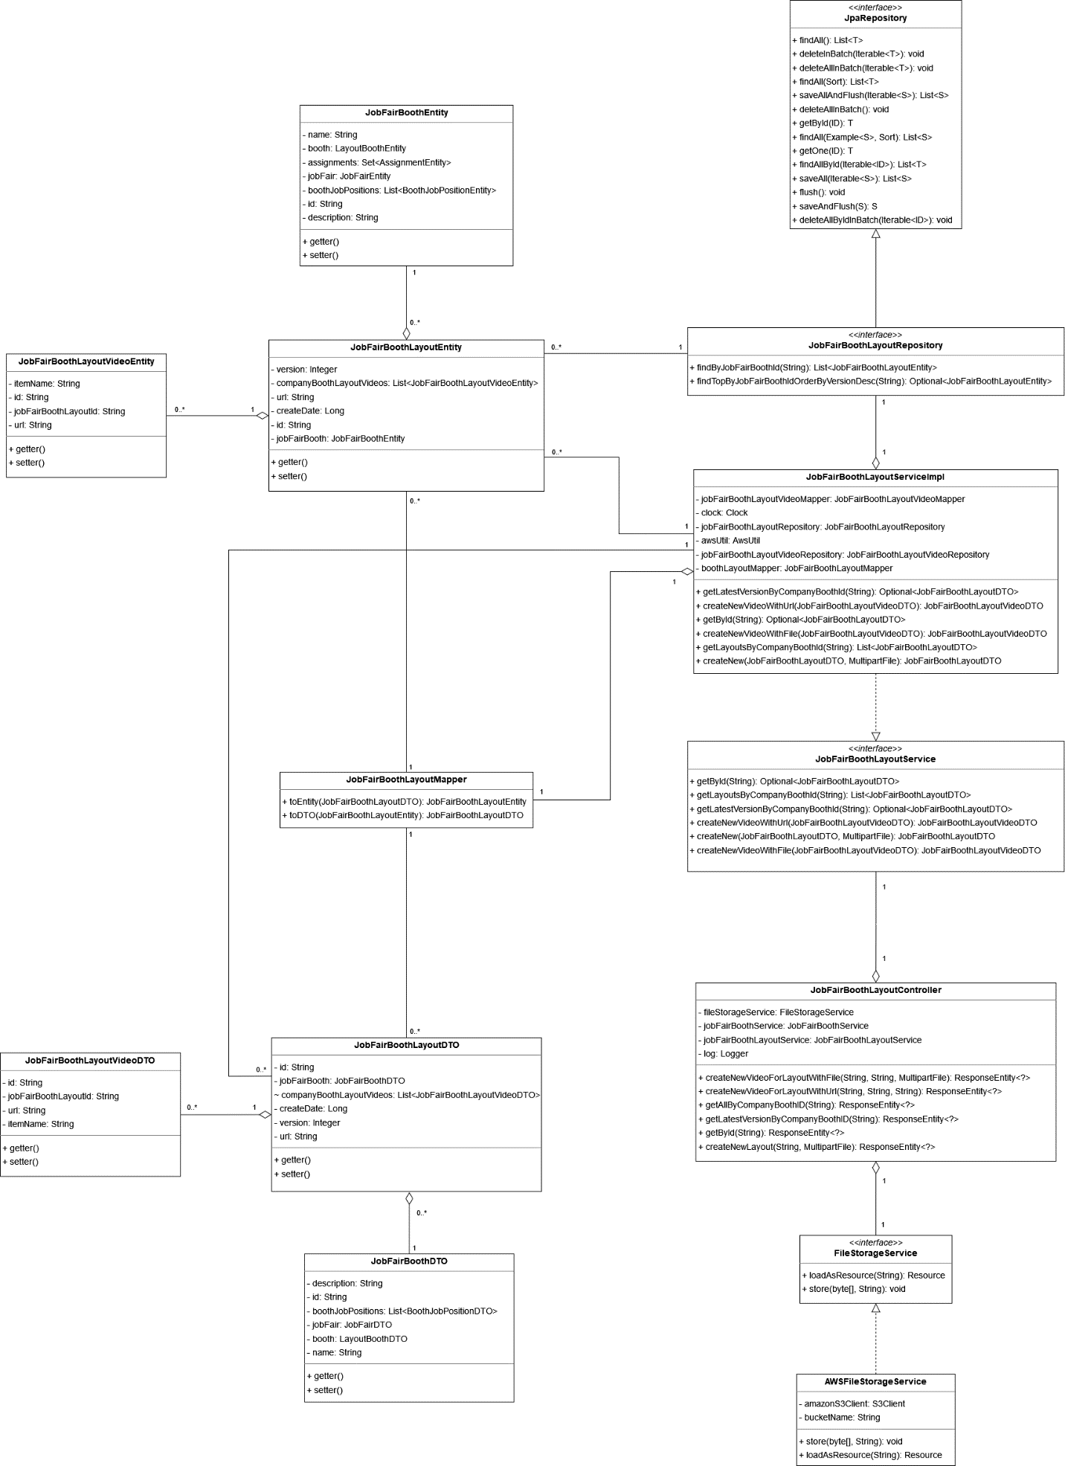

Figure 22. Class diagram – Decorator decorates booth

##### 3.2.1.24 JobFairBoothLayoutRepository

|  |  |  |  |  |
| --- | --- | --- | --- | --- |
| **No** | **Method** | **Return Type** | **Visibility** | **Description** |
| 1 | findByJobFairBoothId | List<JobFairBoothLayoutEntity> | Public | Find layout by job fair booth’s id |
| 2 | findTopByJobFairBoothIdOrderByVersionDesc | Optional<JobFairBoothLayoutEntity> | Public | Find latest booth’s layout |

##### 3.2.1.25 JobFairBoothLayoutEntity

|  |  |  |  |  |
| --- | --- | --- | --- | --- |
| **No** | **Attribute** | **Data Type** | **Visibility** | **Description** |
| 1 | version | Integer | Private | Layout’s version |
| 2 | companyBoothLayoutVideos | List<JobFairBoothLayoutVideoEntity> | Private | Layout’s video media |
| 3 | url | String | Private | Layout’s URL |
| 4 | createDate | Long | Private | Layout’s create date |
| 5 | id | String | Private | Unique identifier of the layout |
| 6 | jobFairBooth | JobFairBoothEntity | Private | Job fair booth that this layout belongs to |

|  |  |  |  |  |
| --- | --- | --- | --- | --- |
| **No** | **Method** | **Return Type** | **Visibility** | **Description** |
| 1 | getter | data type | Public | Get attribute value |
| 2 | setter | data type | Public | Set value for attribute |

##### 3.2.1.26 JobFairBoothLayoutVideoEntity

|  |  |  |  |  |
| --- | --- | --- | --- | --- |
| **No** | **Attribute** | **Data Type** | **Visibility** | **Description** |
| 1 | itemName | String | Private | 3D component’s name that this video belongs to |
| 2 | id | String | Private | Unique identifier of this video |
| 3 | jobFairBoothLayoutId | String | Private | The layout that this video belongs to |
| 4 | url | String | Private | Video’s URL |

|  |  |  |  |  |
| --- | --- | --- | --- | --- |
| **No** | **Method** | **Return Type** | **Visibility** | **Description** |
| 1 | getter | data type | Public | Get attribute value |
| 2 | setter | data type | Public | Set value for attribute |

##### 3.2.1.27 JobFairBoothLayoutServiceImpl

|  |  |  |  |  |
| --- | --- | --- | --- | --- |
| **No** | **Attribute** | **Data Type** | **Visibility** | **Description** |
| 1 | jobFairBoothLayoutVideoMapper | JobFairBoothLayoutVideoMapper | Private | Job fair booth layout video mapper |
| 2 | clock | Clock | Private | Clock object to get current timestamp |
| 3 | jobFairBoothLayoutRepository | JobFairBoothLayoutRepository | Private | Job fair booth layout repository |
| 4 | awsUtil | AwsUtil | Private | Aws utility class |
| 5 | jobFairBoothLayoutVideoRepository | JobFairBoothLayoutVideoRepository | Private | Job fair booth layout video repository |
| 6 | boothLayoutMapper | JobFairBoothLayoutMapper | Private | Booth layout mapper |

|  |  |  |  |  |
| --- | --- | --- | --- | --- |
| **No** | **Method** | **Return Type** | **Visibility** | **Description** |
| 1 | getLatestVersionByCompanyBoothId | Optional<JobFairBoothLayoutDTO> | Public | Get booth latest layout |
| 2 | createNewVideoWithUrl | JobFairBoothLayoutVideoDTO | Public | Create new video with URL |
| 3 | getById | Optional<JobFairBoothLayoutDTO> | Public | Get layout by ID |
| 4 | createNewVideoWithFile | JobFairBoothLayoutVideoDTO | Public | Create new video with file |
| 5 | getLayoutsByCompanyBoothId | List< JobFairBoothLayoutDTO> | Public | Get layout by booth’s id |
| 6 | createNew | JobFairBoothLayoutDTO | Public | Create new layout |

##### 3.2.1.28 JobFairBoothLayoutService

|  |  |  |  |  |
| --- | --- | --- | --- | --- |
| **No** | **Method** | **Return Type** | **Visibility** | **Description** |
| 1 | getById | Optional<JobFairBoothLayoutDTO> | Public | Get layout by ID |
| 2 | getLayoutsByCompanyBoothId | List<JobFairBoothLayoutDTO> | Public | Get layout by booth’s id |
| 4 | getLatestVersionByCompanyBoothId | Optional<JobFairBoothLayoutDTO> | Public | Get booth latest layout |
| 5 | createNewVideoWithUrl | JobFairBoothLayoutVideoDTO | Public | Create new video with URL |
| 6 | createNew | JobFairBoothLayoutDTO | Public | Create new layout |
| 7 | createNewVideoWithFile | JobFairBoothLayoutVideoDTO | Public | Create new video with file |

##### 3.2.1.29 JobFairBoothLayoutMapper

|  |  |  |  |  |
| --- | --- | --- | --- | --- |
| **No** | **Method** | **Return Type** | **Visibility** | **Description** |
| 1 | toEntity | JobFairBoothLayoutEntity | Public | Mapping DTO to Entity |
| 2 | toDTO | JobFairBoothLayoutDTO | Public | Mapping Entity to DTO |

##### 3.2.1.30 JobFairBoothLayoutController

|  |  |  |  |  |
| --- | --- | --- | --- | --- |
| **No** | **Attribute** | **Data Type** | **Visibility** | **Description** |
| 1 | fileStorageService | FileStorageService | Private | File storage service |
| 2 | jobFairBoothService | JobFairBoothService | Private | Job fair booth service |
| 3 | jobFairBoothLayoutService | JobFairBoothLayoutService | Private | Job fair booth layout service |
| 4 | log | Logger | Private | System’s logger |

|  |  |  |  |  |
| --- | --- | --- | --- | --- |
| **No** | **Method** | **Return Type** | **Visibility** | **Description** |
| 1 | createNewVideoForLayoutWithFile | ResponseEntity<?> | Public | Create new video for layout with new file |
| 2 | createNewVideoForLayoutWithUrl | ResponseEntity<?> | Public | Create new video for layout with URL |
| 3 | getAllByCompanyBoothID | ResponseEntity<?> | Public | Get all layout by booth ID |
| 4 | getLatestVersionByCompanyBoothID | ResponseEntity<?> | Public | Get latest layout of a booth |
| 5 | getById | ResponseEntity<?> | Public | Get layout by ID |
| 6 | createNewLayout | ResponseEntity<?> | Public | Create new layout |

##### 3.2.1.31 JobFairBoothLayoutDTO

|  |  |  |  |  |
| --- | --- | --- | --- | --- |
| **No** | **Attribute** | **Data Type** | **Visibility** | **Description** |
| 1 | id | String | Private | Unique identifier of the layout |
| 2 | jobFairBooth | JobFairBoothDTO | Private | Job fair booth that this layout belongs to |
| 3 | companyBoothLayoutVideos | List<JobFairBoothLayoutVideoDTO> | Default | Layout’s video media |
| 4 | createDate | Long | Private | Layout’s create date |
| 5 | version | Integer | Private | Layout’s version |
| 6 | url | String | Private | Layout’s URL |

|  |  |  |  |  |
| --- | --- | --- | --- | --- |
| **No** | **Method** | **Return Type** | **Visibility** | **Description** |
| 1 | getter | data type | Public | Get attribute value |
| 2 | setter | data type | Public | Set value for attribute |

##### 3.2.1.32 JobFairBoothLayoutVideoDTO

|  |  |  |  |  |
| --- | --- | --- | --- | --- |
| **No** | **Attribute** | **Data Type** | **Visibility** | **Description** |
| 1 | id | String | Private | Unique identifier of this video |
| 2 | jobFairBoothLayoutId | String | Private | The layout that this video belongs to |
| 3 | url | String | Private | Video’s URL |
| 4 | itemName | String | Private | 3D component’s name that this video belongs to |

|  |  |  |  |  |
| --- | --- | --- | --- | --- |
| **No** | **Method** | **Return Type** | **Visibility** | **Description** |
| 1 | getter | data type | Public | Get attribute value |
| 2 | setter | data type | Public | Set value for attribute |

##### 3.2.1.33 FileStorageService

|  |  |  |  |  |
| --- | --- | --- | --- | --- |
| **No** | **Method** | **Return Type** | **Visibility** | **Description** |
| 1 | loadAsResource | Resource | Public | Load file |
| 2 | store | void | Public | Store file |

##### 3.2.1.34 AWSFileStorageService

|  |  |  |  |  |
| --- | --- | --- | --- | --- |
| **No** | **Attribute** | **Data Type** | **Visibility** | **Description** |
| 1 | amazinS3Client | S3Client | Private | Amazon S3 client |
| 2 | bucketName | String | Private | Bucket name |

|  |  |  |  |  |
| --- | --- | --- | --- | --- |
| **No** | **Method** | **Return Type** | **Visibility** | **Description** |
| 1 | store | void | Public | Store file |
| 2 | loadAsResource | Resource | Public | Load file |

#### 3.2.2 Sequence Diagrams

##### 3.2.2.1 Supervisor gets booth information

***Summary****: this diagram shows how a Supervisor can get booth information*

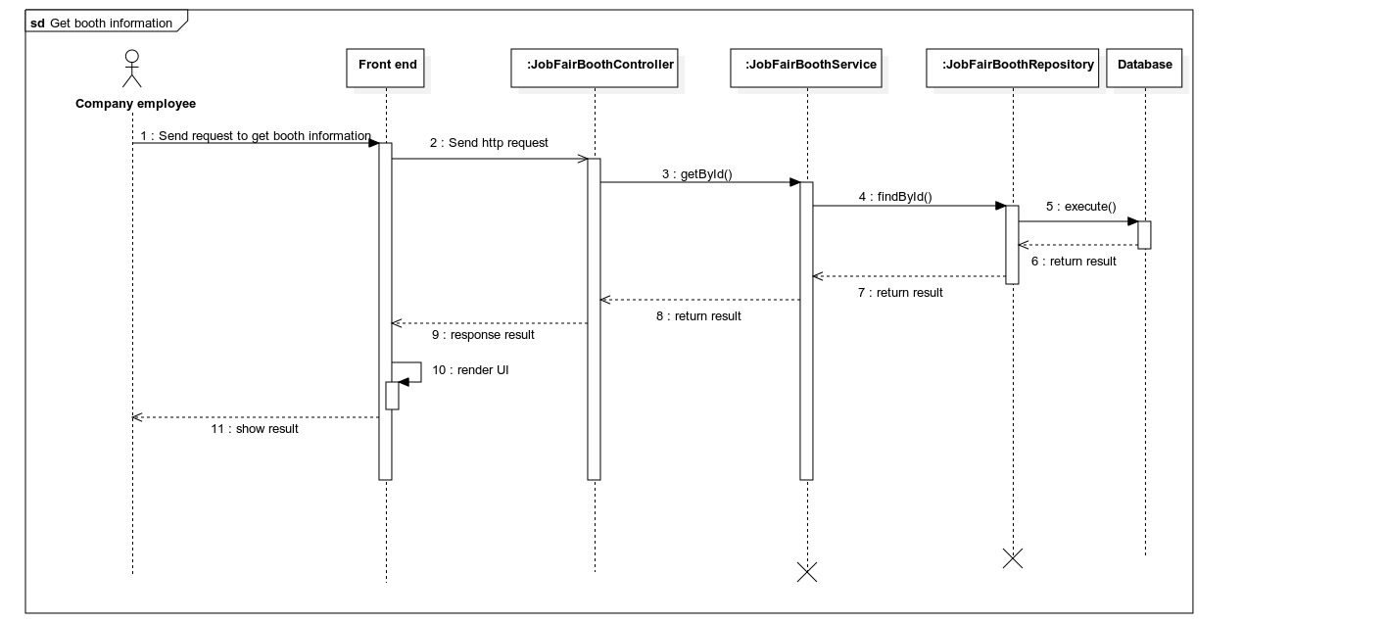

Figure 23. Sequence diagram – Supervisor gets booth information

##### 3.2.2.2 Supervisor updates booth information

***Summary****: this diagram shows how a Supervisor can update booth information*

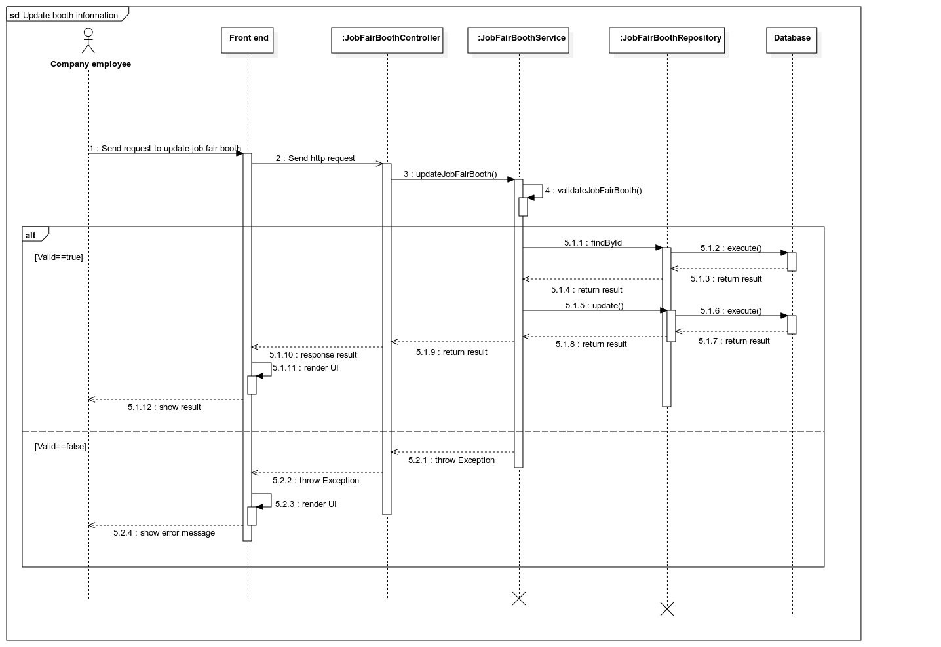

Figure 24. Sequence diagram – Supervisor updates booth information

##### 3.2.2.3 Supervisor gets assignment task

***Summary****: this diagram shows how a Supervisor can get assignment task*

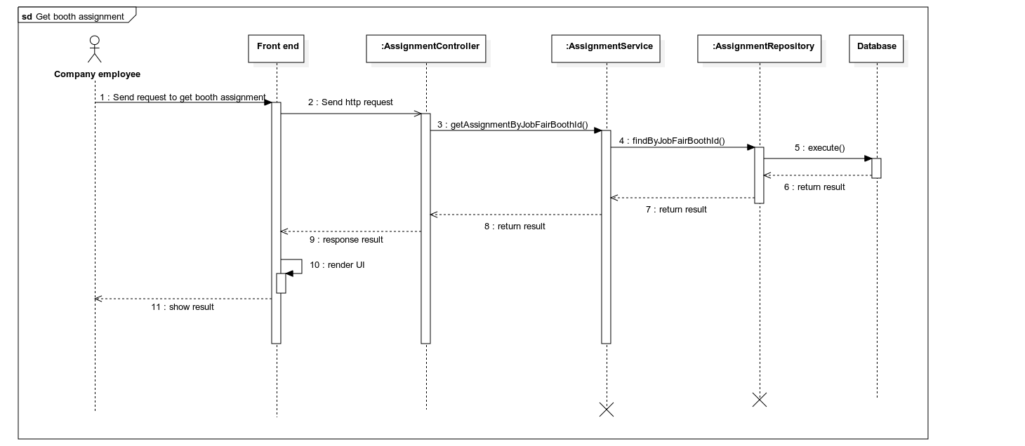

Figure 25. Sequence diagram – Supervisor gets assignment task

##### 3.2.2.4 Supervisor assigns task

***Summary****: this diagram shows how a Supervisor can assign task*

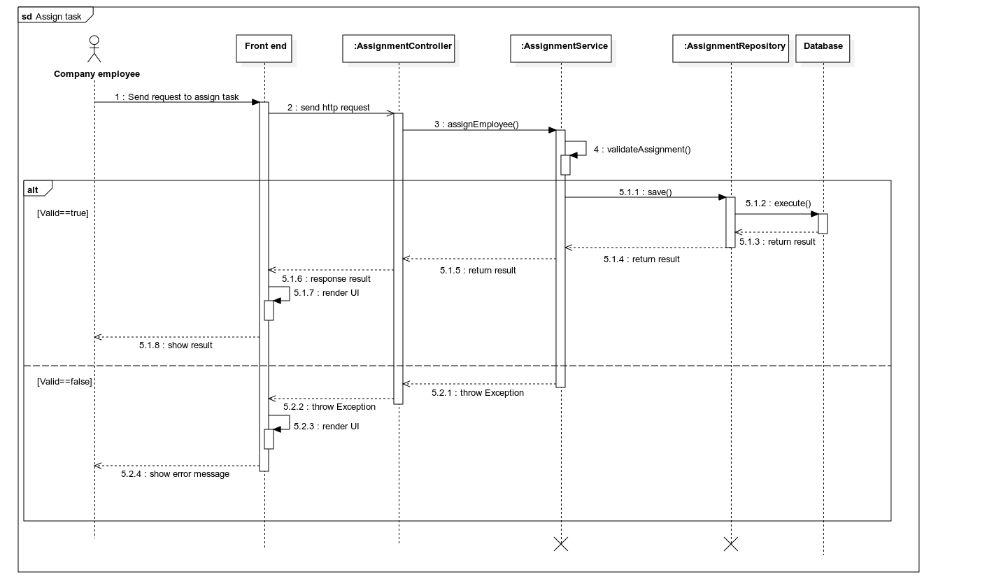

Figure 26. Sequence diagram – Supervisor assigns task

##### 3.2.2.5 Decorator gets booth decoration

***Summary****: this diagram shows how a Decorator can get booth decoration*

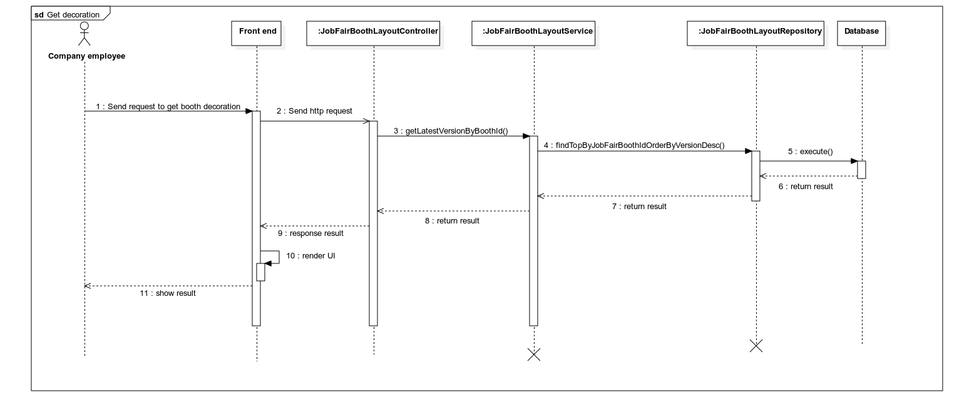

Figure 27. Sequence diagram – Decorator gets booth decoration

##### 3.2.2.6 Decorator saves decoration

***Summary****: this diagram shows how a Decorator can save booth decoration*

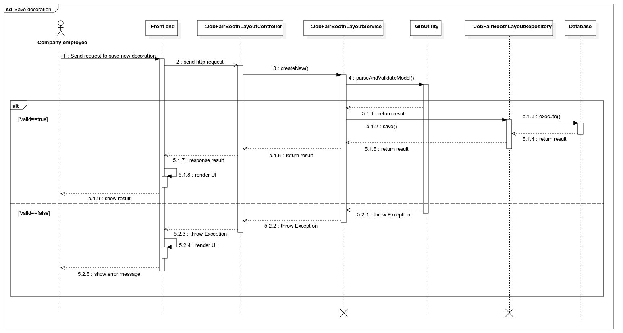

Figure 28. Sequence diagram – Decorator saves booth decoration

### 3.3 Attendant apply CV

#### 3.3.1 Class diagram

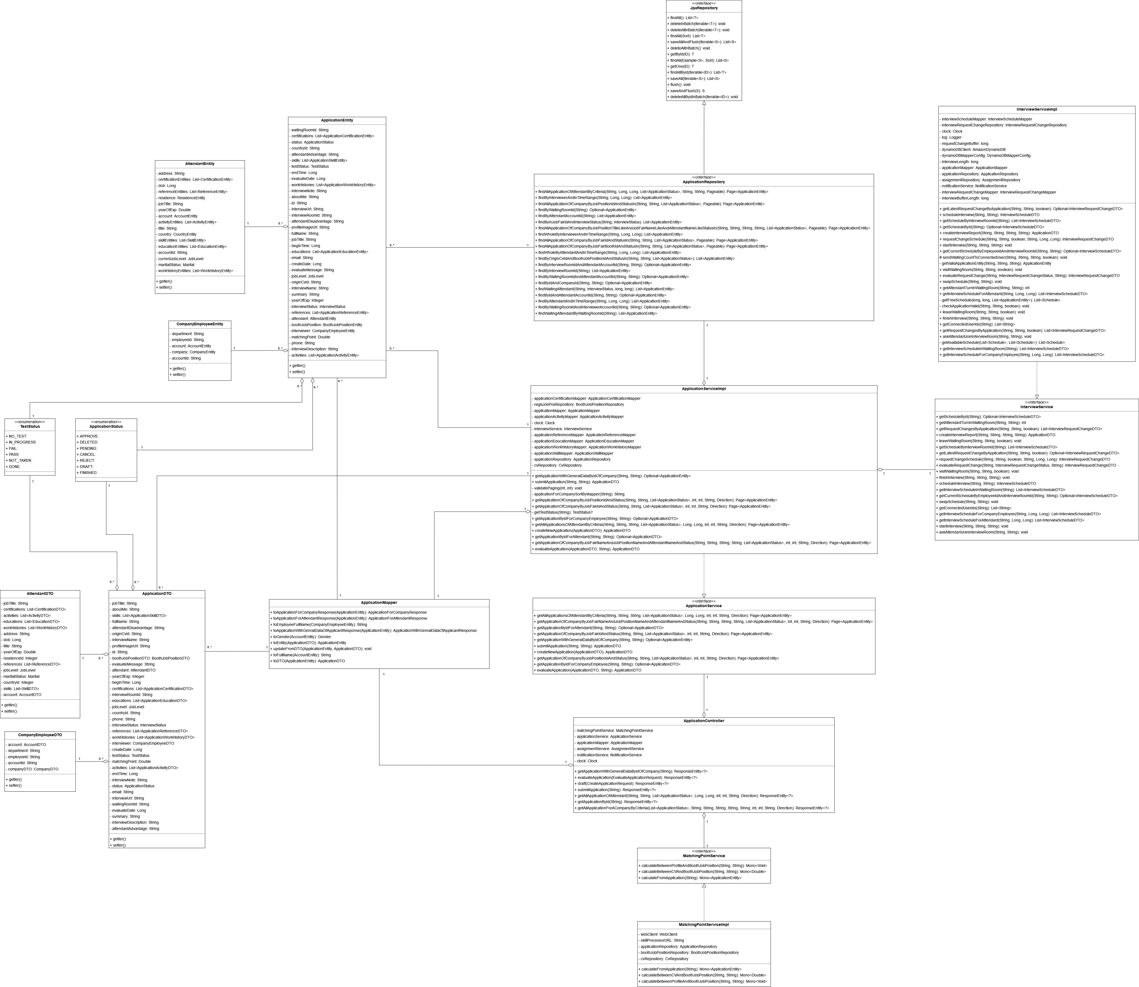

Figure 29. Class diagram – Attendant applies CV

##### 3.3.1.1 JpaRepository

|  |  |  |  |  |
| --- | --- | --- | --- | --- |
| **No** | **Method** | **Return Type** | **Visibility** | **Description** |
| 1 | findAll | List<T> | Public | Get all records in database |
| 2 | deleteInBatch | void | Public | Delete multiple records in database |
| 3 | deleteAllInBatch | void | Public | Delete all records in database |
| 4 | saveAllAndBatch | void | Public | Update multiple records in database |
| 5 | getById | T | Public | Find a record by ID in database |
| 6 | findAllById | List<T> | Public | Find all record by list of IDs in database |
| 7 | saveAll | List<S> | Public | Save all records in database |
| 8 | flush | void | Public | Write change to database |
| 9 | saveAndFlush | S | Public | Write change to database |
| 11 | deleteAllByIdInBatch | void | Public | Delete records that have IDs |

##### 3.3.1.2 ApplicationRepository

|  |  |  |  |  |
| --- | --- | --- | --- | --- |
| **No** | **Method** | **Return Type** | **Visibility** | **Description** |
| 1 | findAllApplicationOfAttendantByCriteria | Page<ApplicationEntity> | Public | Find all application for attendant |
| 2 | findByInterviewerAndInTimeRange | List<ApplicationEntity> | Public | Find applications for interviewer and within time range |
| 3 | findAllApplicationOfCompanyByJobPositionIdAndStatusIn | Page<ApplicationEntity> | Public | Find applications by job position |
| 4 | findByWaitingRoomId | Optional< ApplicationEntity> | Public | Find application by waiting room |
| 5 | findByAttendantAccountId | List<ApplicationEntity> | Public | Find application by attendant ID |
| 6 | findByInJobFairIdAndInterviewStatus | List<ApplicationEntity> | Public | Find applications in a job fair |
| 7 | findAllApplicationOfCompanyByJobPositionTitleLikeAndJobFairNameLikeAndAttendantNameLikeStatusIn | Page<ApplicationEntity> | Public | Search applications by name |
| 8 | findWholeByInterviewerAndInTimeRange | List<ApplicationEntity> | Public | Find applications for interviewer and loosely within time range |
| 9 | findAllApplicationOfCompanyByJobFairIdAndStatusIn | Page<ApplicationEntity> | Public | Find applications of company by job fair’s id |
| 10 | findAllApplicationOfCompanyByJobFairBoothIdAndStatusIn | Page<ApplicationEntity> | Public | Find all application by booth’s id |
| 11 | findWholeByAttendantAndInTimeRange | List<ApplicationEntity> | Public | Find applications for attendant and within time range |
| 12 | findByOriginCvIdAndBoothJobPositionIdAndStatusIn | List<ApplicationEntity> | Public | Find applications by job position |
| 13 | findByInterviewRoomIdAndAttendantAccountId | Optional<ApplicationEntity> | Public | Find application by interview room id and attendant’s id |
| 14 | findByInterviewRoomId | List<ApplicationEntity> | Public | Find applications by interview room id |
| 15 | findByWaitingRoomIdAndAttendantAccountId | Optional<ApplicationEntity> | Public | Find by waiting room id and attendant id |
| 16 | findByIdAndCompanyId | Optional<ApplicationEntity> | Public | Find application by ID and company ID |
| 17 | findWaitingAttendant | List<ApplicationEntity> | Public | Find waiting for interview applications |
| 18 | findByIdAndAttendantAccountId | Optional<ApplicationEntity> | Public | Find application by ID and attendant ID |
| 19 | findByAttendantAndInTimeRange | List<ApplicationEntity> | Public | Find applications by attendant ID and in time range |
| 20 | findByWaitingRoomIdAndInterviewerAccountId | Optional<ApplicationEntity> | Public | Find application by waiting room id and interview id |
| 21 | findWaitingAttendantByWaitingRoomId | List<ApplicationEntity> | Public | Find applications by waiting room id and attendant id |

##### 3.3.1.3 InterviewServiceImpl

|  |  |  |  |  |
| --- | --- | --- | --- | --- |
| **No** | **Attribute** | **Data Type** | **Visibility** | **Description** |
| 1 | interviewScheduleMapper | InterviewScheduleMapper | Private | Interview schedule mapper |
| 2 | interviewRequestChangeRepository | InterviewRequestChangeRepository | Private | Interview request change repository |
| 3 | clock | Clock | Private | Clock object to get current timestamp |
| 4 | log | Logger | Private | System’s logger |
| 5 | requestChangeBuffer | long | Private | Deadline for request change schedule |
| 6 | dynamoDBClient | AmazonDynamoDB | Private | DynamoDB client |
| 7 | dynamoDBMapperConfig | DynamoDBMapperConfig | Private | DynamoDB mapper configuration |
| 8 | interviewLength | long | Private | Interview length |
| 9 | applicationMapper | ApplicationMapper | Private | Application mapper |
| 10 | applicationRepository | ApplicationRepository | Private | Application repository |
| 11 | assignmentRepository | AssignmentRepository | Private | Assignment repository |
| 12 | notificationService | NotificationService | Private | Notification service |
| 13 | interviewRequestChangeMapper | InterviewRequestChangeMapper | Private | Interview request change mapper |
| 14 | interviewBufferLength | long | Private | Time between 2 interview |

|  |  |  |  |  |
| --- | --- | --- | --- | --- |
| **No** | **Method** | **Return Type** | **Visibility** | **Description** |
| 1 | getLatestRequestChangeByApplication | Optional<InterviewRequestChangeDTO> | Public | Get application’s latest request change |
| 2 | scheduleInterview | InterviewScheduleDTO | Public | Schedule interview |
| 3 | getScheduleByInterviewRoomId | List< InterviewScheduleDTO> | Public | Get all interview schedule by interview room’s id |
| 4 | getScheduleById | Optional< InterviewScheduleDTO> | Public | Get schedule by ID |
| 5 | createInterviewReport | ApplicationDTO | Public | Create interview report |
| 6 | requestChangeSchedule | InterviewRequestChangeDTO | Public | Create request change schedule |
| 7 | startInterview | void | Public | Start interview |
| 8 | getCurrentScheduleByEmployeeIdAndInterviewRoomId | Optional< InterviewScheduleDTO> | Public | Get schedule by interviewer ID and interview room ID |
| 9 | sendWaitingCountToConnectedUser | void | Protected | Send waiting list for attendant |
| 10 | getValidApplicationEntity | ApplicationEntity | Private | Get valid application entity |
| 11 | visitWaitingRoom | void | Public | Enter waiting room |
| 12 | evaluateRequestChange | IntervewRequestChangeDTO | Public | Evaluate request change |
| 13 | swapSchedule | void | Public | Swap schedule |
| 14 | getAttendantTurnInWaitingRoom | int | Public | Get attendant waiting turn in waiting room |
| 15 | getInterviewScheduleForAttendant | List< InterviewScheduleDTO> | Public | Get interview schedule for attendant |
| 16 | getFreeSchedule | List<Schedule> | Private | Get free schedule of attendant or interviewer |
| 17 | checkApplicationValide | void | Private | Check for valid application |
| 18 | leaveWaitingRoom | void | Public | Leave waiting room |
| 19 | finishInterview | void | Public | Finish interview |
| 20 | getConnectedUserIds | List<String> | Public | Get connected user in interview room |
| 21 | getRequestChangesByApplication | List< InterviewRequestChangeDTO> | Public | Get application request change schedule |
| 22 | askAttendantJoinInterviewRoom | void | Public | Ask attendant to join interview room |
| 23 | getAvailableSchedule | List<Schedule> | Private | Get available schedule between attendant and interviewer |
| 24 | getInteviewScheduleInWaitingRoom | List<InterviewScheduleDTO> | Public | Get interview schedule by waiting room id |
| 25 | getInterviewScheduleForCompanyEmployee | List<InterviewScheduleDTO> | Public | Get interview schedule for company employee |

##### 3.3.1.4 ApplicationEntity

|  |  |  |  |  |
| --- | --- | --- | --- | --- |
| **No** | **Attribute** | **Data Type** | **Visibility** | **Description** |
| 1 | waitingRoomId | String | Private | Application’s waiting room id |
| 2 | certifications | List<ApplicationCertificationEntity> | Private | Application’s certifications |
| 3 | status | ApplicationStatus | Private | Application’s status |
| 4 | countryId | String | Private | Application’s country id |
| 5 | attendantAdvantage | String | Private | Application’s attendant advantage |
| 6 | skills | List<ApplicationSkillEntity> | Private | Application’s skills |
| 7 | testStatus | TestStatus | Private | Application’s test status |
| 8 | endTime | Long | Private | Application’s end time |
| 9 | evaluateDate | Long | Private | Application’s evaluate date |
| 10 | workHistories | List<ApplicationWorkHistoyEntity> | Private | Application’s work histories |
| 11 | interviewNote | String | Private | Application’s interviewer’s note |
| 12 | aboutMe | String | Private | Application’s about me |
| 13 | id | String | Private | Unique identifier of application |
| 14 | interviewUrl | String | Private | Application’s interview URL |
| 15 | interviewRoomId | String | Private | Application’s interview room ID |
| 16 | attendantDisadvantage | String | Private | Application’s attendant disadvantage |
| 17 | profileImageUrl | String | Private | Application’s profile image URL |
| 18 | fullName | String | Private | Application’s attendant’s full name |
| 19 | jobTitle | String | Private | Application’s attendant’s job title |
| 20 | beginTime | Long | Private | Application’s interview begin time |
| 21 | educations | List<ApplicationEducationEntity> | Private | Application’s educations |
| 22 | email | String | Private | Application’s attendant’s email |
| 23 | createDate | Long | Private | Application’s create date |
| 24 | evaluateMessage | String | Private | Application’s evaluate message |
| 25 | jobLevel | JobLevel | Private | Application’s attendant’s job level |
| 26 | originCvId | String | Private | Application’s origin CV id |
| 27 | interviewName | String | Private | Application’s interview name |
| 28 | summary | String | Private | Application’s summary |
| 29 | yearOfExp | Integer | Private | Application’s attendant’s year of experience |
| 30 | interviewStatus | InterviewStatus | Private | Application’s interview status |
| 31 | references | List<ApplicationReferenceEntity> | Private | Application’s references |
| 32 | attendant | AttendantEntity | Private | Application’s attendant |
| 33 | boothJobPosition | BoothJobPositionentity | Private | Job position that this application applied to |
| 34 | interviewer | CompanyEmployeeEntity | Private | Application’s interviewer |
| 35 | matchingPoint | Double | Private | Application’s matching point |
| 36 | phone | String | Private | Application’s attendant’s phone |
| 37 | interviewDescription | String | Private | Application’s interviewer’s description |
| 38 | activities | List<ApplicationActivityEntity> | Private | Application’s activities |

|  |  |  |  |  |
| --- | --- | --- | --- | --- |
| **No** | **Method** | **Return Type** | **Visibility** | **Description** |
| 1 | getter | data type | Public | Get value of attribute |
| 2 | setter | data type | Public | Set value of attribute |

##### 3.3.1.5 AttendantEntitty

|  |  |  |  |  |
| --- | --- | --- | --- | --- |
| **No** | **Attribute** | **Data Type** | **Visibility** | **Description** |
| 1 | address | String | Private | Attendant’s address |
| 2 | certificationEntities | List<CertificationEntity> | Private | Attendant’s certifications |
| 3 | dob | Long | Private | Attendant’s date of birth |
| 4 | referenceEntities | List<ReferenceEntity> | Private | Attendant’s reference |
| 5 | residence | ResidenceEntity | Private | Attendant’s residence |
| 6 | jobTile | String | Private | Attendant’s job title |
| 7 | yearOfExp | Double | Private | Attendant’s year of experience |
| 8 | account | AccountEntity | Private | Attendant’s account |
| 9 | activityEntities | List<ActivityEntity> | Private | Attendant’s activities |
| 10 | tittle | String | Private | Attendant’s title |
| 11 | country | CountryEntity | Private | Attendant’s country |
| 12 | skillEntities | List<SkillEntity> | Private | Attendant’s skills |
| 13 | educationEntities | List<EducationEntity> | Private | Attendant’s educations |
| 14 | accountId | String | Private | Attendant’s account id |
| 15 | currentJobLevel | JobLevel | Private | Attendant’s job level |
| 16 | maritalStatus | Marital | Private | Attendant’s marital status |
| 17 | workHistoryEntities | List<WorkHistoryEntity> | Private | Attendant’s work history |

|  |  |  |  |  |
| --- | --- | --- | --- | --- |
| **No** | **Method** | **Return Type** | **Visibility** | **Description** |
| 1 | getter | data type | Public | Get value of attribute |
| 2 | setter | data type | Public | Set value of attribute |

##### 3.3.1.6 ApplicationServiceImpl

|  |  |  |  |  |
| --- | --- | --- | --- | --- |
| **No** | **Attribute** | **Data Type** | **Visibility** | **Description** |
| 1 | applicationCertificationMapper | ApplicationCertificationMapper | Private | Application certification mapper |
| 2 | regisJobPosRepository | BoothJobPositionRepository | Private | Booth job position repository |
| 3 | applicationMapper | ApplicationMapper | Private | Application mapper |
| 4 | applicationActivityMapper | ApplicationActivityMapper | Private | Application activity mapper |
| 5 | clock | Clock | Private | Clock object to get current timestamp |
| 6 | interviewService | InterviewService | Private | Interview service |
| 7 | applicationReferenceMapper | ApplicationReferenceMapper | Private | Application reference mapper |
| 8 | applicationEducationMapper | ApplicationEducationMapper | Private | Application education mapper |
| 9 | applicationWorkHistoryMapper | ApplicationWorkHistoryMapper | Private | Application work history mapper |
| 10 | applicationSkillMapper | ApplicationSkillMapper | Private | Application skill mapper |
| 11 | applicationRepository | ApplicationRepository | Private | Application repository |
| 12 | cvRepository | CvRepository | Private | Cv repository |

|  |  |  |  |  |
| --- | --- | --- | --- | --- |
| **No** | **Method** | **Return Type** | **Visibility** | **Description** |
| 1 | getApplicationWithGeneralDataByIdOfCompany | Optional<ApplicationEntity> | Public | Get application for company employee |
| 2 | submitApplication | ApplicationDTO | Public | Submit application |
| 3 | validatePaging | void | Private | Validate paging |
| 4 | applicationForCompanySortByMapper | String | Private | Get applications for company |
| 5 | getApplicaionOfCompanyByJobPositonIdAndStatus | Page<ApplicationEntity> | Public | Get applications for company and by job position’s id |
| 6 | getApplicationOfCompanyByJobFairIdAndStatus | Page<ApplicationEntity> | Public | Get applications for company and by job fair’s id |
| 7 | getTestStatus | TestStatus | Private | Get application test status |
| 8 | getApplicationByIdForCompanyEmployee | Optional<ApplicationDTO> | Public | Get application for company employee and by id |
| 9 | getAllApplicationsOfAttendantByCriteria | Page<ApplicationEntity> | Public | Get all applications for attendant |
| 10 | createNewApplication | ApplicationDTO | Public | Create new application |
| 11 | getApplicationByIdForAttendant | Optional<ApplicationDTO> | Public | Get application by id for attendant |
| 12 | getApplicationOfCompanyByJobFairNameAndJobPositionNameAndAttendantNameAndStatus | Page<ApplicationEntity> | Public | Search application by criteria |
| 13 | evaluateApplication | ApplicationDTO | Public | Evaluate application |

##### 3.3.1.7 InterviewService

|  |  |  |  |  |
| --- | --- | --- | --- | --- |
| **No** | **Method** | **Return Type** | **Visibility** | **Description** |
| 1 | getScheduleById | Optional<InterviewScheduleDTO> | Public | Get schedule by ID |
| 2 | getAttendantTurnInWaitingRoom | int | Public | Get attendant waiting turn in waiting room |
| 3 | getRequestChangesByApplication | List<InterviewRequestChangeDTO> | Public | Get application request change schedule |
| 4 | createInterviewReport | ApplicationDTO | Public | Create interview report |
| 5 | leaveWaitingRoom | void | Public | Leave waiting room |
| 6 | getScheduleByInterviewRoomId | List<InterviewScheduleDTO> | Public | Get all interview schedule by interview room’s id |
| 7 | getLatestRequestChangeByApplication | Optional<InterviewRequestChangeDTO> | Public | Get application’s latest request change |
| 8 | requestChangeSchedule | InterviewRequestChangeDTO | Public | Create request change schedule |
| 9 | evaluateRequestChange | InterviewRequestChangeDTO | Public | evaluateRequestChange |
| 10 | visitWaitingRoom | void | Public | Enter waiting room |
| 11 | finishInterview | void | Public | Finish interview |
| 12 | scheduleInterview | InterviewScheduleDTO | Public | Schedule interview |
| 13 | getInterviewScheduleInWaitingRoom | List<InterviewScheduleDTO> | Public | Get interview schedules by waiting room id |
| 14 | getCurrentScheduleByEmployeeIdAndInterviewRoomId | Optional<InterviewScheduleDTO> | Public | Get schedule by interviewer ID and interview room ID |
| 15 | swapSchedule | void | Public | Swap schedule |
| 16 | getConnectedUserIds | List<String> | Public | Get connected user in interview room |
| 17 | getInterviewScheduleForCompanyEmployee | List<InterviewScheduleDTO> | Public | Get interview schedule for company employee |
| 18 | getInterviewScheduleForAttendant | List<InterviewScheduleDTO> | Public | Get interview schedule for attendant |
| 19 | startInterview | void | Public | Start interview |
| 20 | askAttendantJoinInterviewRoom | void | Public | Ask attendant to join interview room |

##### 3.3.1.8 CompanyEmployeeEntitty

|  |  |  |  |  |
| --- | --- | --- | --- | --- |
| **No** | **Attribute** | **Data Type** | **Visibility** | **Description** |
| 1 | department | String | Private | Employee’s department |
| 2 | employeeId | String | Private | Employee’s ID |
| 3 | account | AccountEntity | Private | Account associate with this employee |
| 4 | company | CompanyEntity | Private | Company that this employee belongs to |
| 5 | accountId | String | Private | Employee’s account id |

|  |  |  |  |  |
| --- | --- | --- | --- | --- |
| **No** | **Method** | **Return Type** | **Visibility** | **Description** |
| 1 | getter | data type | Public | Get value of attribute |
| 2 | setter | data type | Public | Set value of attribute |

##### 3.3.1.9 ApplicationService

|  |  |  |  |  |
| --- | --- | --- | --- | --- |
| **No** | **Method** | **Return Type** | **Visibility** | **Description** |
| 1 | getAllApplicationsOfAttendantByCriteria | Page<ApplicationEntity> | Public | Get all applications for attendant |
| 2 | getApplicationOfCompanyByJobFairNameAndJobPositionNameAndAttendantNameAndStatus | Page<ApplicationEntity> | Public | Search application by criteria |
| 3 | getApplicationByIdForAttendant | Optional<ApplicationDTO> | Public | Get application by id for attendant |
| 4 | getApplicationOfCompanyByJobFairIdAndStatus | Page<ApplicationEntity> | Public | Get applications for company and by job fair’s id |
| 5 | getApplicationWithGeneralDataByIdOfCompany | Optional<ApplicationEntity> | Public | Get application for company employee |
| 6 | submitApplication | ApplicationDTO | Public | Submit application |
| 7 | createNewApplication | ApplicationDTO | Public | Create new application |
| 8 | getApplicationOfCompanyByJobPositionIdAndStatus | Page<ApplicationEntity> | Public | Get applications for company and by job position’s id |
| 9 | getApplicationByIdForCompanyEmployee | Optional<ApplicationDTO> | Public | Get application for company employee and by id |
| 10 | evaluateApplication | ApplicationDTO | Public | Evaluate application |

##### 3.3.1.10 ApplicationMapper

|  |  |  |  |  |
| --- | --- | --- | --- | --- |
| **No** | **Method** | **Return Type** | **Visibility** | **Description** |
| 1 | toApplicationForCompanyResponse | ApplicationForCompanyResponse | Public | Mapping ApplicationEntity to ApplicationForCompanyResponse |
| 2 | toApplicationForAttendantResponse | ApplicationForAttendantResponse | Public | Mapping ApplicationEntity to ApplicationForAttendantResponse |
| 4 | toApplicationWithGenralDataOfApplicantResponse | ApplicationWithGenralDataOfApplicantResponse | Public | Mapping ApplicationEntity to ApplicationWithGenralDataOfApplicantResponse |
| 6 | toEntity | ApplicationEntity | Public | Mapping DTO to Entity |
| 9 | toDTO | ApplicationDTO | Public | Mapping Entity to DTO |

##### 3.3.1.11 ApplicationStatus

|  |  |  |  |
| --- | --- | --- | --- |
| **No** | **Enum** | **Visibility** | **Description** |
| 1 | APPROVE | Public | If Interviewer approves application |
| 2 | DELETED | Public | If Attendant delete application |
| 3 | PENDING | Public | If Attendant applies application |
| 4 | CANCEL | Public | If Attendant cancel application |
| 5 | REJECT | Public | If Interviewer rejects application |
| 6 | DRAFT | Public | If Interviewer applies but not yet pass test |
| 7 | FINISHED | Public | If Interviewer finished making test |

|  |  |  |  |  |
| --- | --- | --- | --- | --- |
| **No** | **Method** | **Return Type** | **Visibility** | **Description** |
| 1 | values | ApplicationStatus[] | Public | Get list of values |
| 2 | valueOf | ApplicationStatus | Public | Mapping int to enum type |

##### 3.3.1.12 TestStatus

|  |  |  |  |
| --- | --- | --- | --- |
| **No** | **Enum** | **Visibility** | **Description** |
| 1 | NO_TEST | Public | If application has not test |
| 2 | IN_PROGRESS | Public | If attendant is doing test |
| 3 | FAIL | Public | If attendant failed test |
| 4 | PASS | Public | If attendant pass test |
| 5 | NOT_TAKEN | Public | If attendant has not taken test |
| 6 | DONE | Public | If attendant has finished test |

|  |  |  |  |  |
| --- | --- | --- | --- | --- |
| **No** | **Method** | **Return Type** | **Visibility** | **Description** |
| 1 | valueOf | TestStatus | Public | Get list of values |
| 2 | values | TestStatus[] | Public | Mapping int to enum type |

##### 3.3.1.13 ApplicationController

|  |  |  |  |  |
| --- | --- | --- | --- | --- |
| **No** | **Attribute** | **Data Type** | **Visibility** | **Description** |
| 1 | matchingPointService | MatchingPointService | Private | Matching point service |
| 2 | applicationService | ApplicationService | Private | Application service |
| 3 | applicationMapper | ApplicationMapper | Private | Application mapper |
| 4 | assignmentService | AssignmentService | Private | Assignment service |
| 5 | notificationService | NotificationService | Private | Notification service |
| 6 | clock | Clock | Private | Clock object to get current timestamp |

|  |  |  |  |  |
| --- | --- | --- | --- | --- |
| **No** | **Method** | **Return Type** | **Visibility** | **Description** |
| 1 | getApplicationWithGeneralDataByIdOfCompany | ResponseEntity<?> | Public | Get application for company employee |
| 2 | evaluateApplication | ResponseEntity<?> | Public | Evaluate application |
| 3 | draft | ResponseEntity<?> | Public | Create new application |
| 4 | submitApplication | ResponseEntity<?> | Public | Submit application |
| 5 | getAllApplicationOfAttendant | ResponseEntity<?> | Public | Get applications for attendant |
| 6 | getApplicationById | ResponseEntity<?> | Public | Get application by id |
| 7 | getAllApplicationForACompanyByCriteria | ResponseEntity<?> | Public | Get applications for company employee |

##### 3.3.1.14 MatchingPointService

|  |  |  |  |  |
| --- | --- | --- | --- | --- |
| **No** | **Method** | **Return Type** | **Visibility** | **Description** |
| 1 | calculateBetweenProfileAndBoothJobPosition | Mono<Void> | Public | Calculate matching point between profile and job position |
| 2 | calculateBetweenCVAndBoothJobPosition | Mono<Double> | Public | Calculate matching point between CV and job position |
| 3 | calculateFromApplication | Mono<ApplicationEntity> | Public | Calculate matching point between application and job position |

##### 3.3.1.15 MatchingPointServiceImpl

|  |  |  |  |  |
| --- | --- | --- | --- | --- |
| **No** | **Attribute** | **Data Type** | **Visibility** | **Description** |
| 1 | webClient | WebClient | Private | HTTP Web client |
| 2 | skillProcessorURL | String | Private | Skill process service URL |
| 3 | applicationRepository | ApplicationRepository | Private | Application repository |
| 4 | boothJobPositionRepository | BoothJobPositionRepository | Private | Booth job position repository |
| 5 | cvRepository | CvRepository | Private | CV repository |

|  |  |  |  |  |
| --- | --- | --- | --- | --- |
| **No** | **Method** | **Return Type** | **Visibility** | **Description** |
| 1 | calculateFromApplication | Mono<ApplicationEntity> | Public | Calculate matching point between application and job position |
| 2 | calculateBetweenCVAndBoothJobPosition | Mono<Double> | Public | Calculate matching point between CV and job position |
| 3 | calculateBetweenProfileAndBoothJobPosition | Mono<Void> | Public | Calculate matching point between profile and job position |

##### 3.3.1.16 ApplicationDTO

|  |  |  |  |  |
| --- | --- | --- | --- | --- |
| **No** | **Attribute** | **Data Type** | **Visibility** | **Description** |
| 1 | waitingRoomId | String | Private | Application’s waiting room id |
| 2 | certifications | List<ApplicationCertificationDTO> | Private | Application’s certifications |
| 3 | status | ApplicationStatus | Private | Application’s status |
| 4 | countryId | String | Private | Application’s country id |
| 5 | attendantAdvantage | String | Private | Application’s attendant advantage |
| 6 | skills | List<ApplicationSkillDTO> | Private | Application’s skills |
| 7 | testStatus | TestStatus | Private | Application’s test status |
| 8 | endTime | Long | Private | Application’s end time |
| 9 | evaluateDate | Long | Private | Application’s evaluate date |
| 10 | workHistories | List<ApplicationWorkHistoyDTO> | Private | Application’s work histories |
| 11 | interviewNote | String | Private | Application’s interviewer’s note |
| 12 | aboutMe | String | Private | Application’s about me |
| 13 | id | String | Private | Unique identifier of application |
| 14 | interviewUrl | String | Private | Application’s interview URL |
| 15 | interviewRoomId | String | Private | Application’s interview room ID |
| 16 | attendantDisadvantage | String | Private | Application’s attendant disadvantage |
| 17 | profileImageUrl | String | Private | Application’s profile image URL |
| 18 | fullName | String | Private | Application’s attendant’s full name |
| 19 | jobTitle | String | Private | Application’s attendant’s job title |
| 20 | beginTime | Long | Private | Application’s interview begin time |
| 21 | educations | List<ApplicationEducationDTO> | Private | Application’s educations |
| 22 | email | String | Private | Application’s attendant’s email |
| 23 | createDate | Long | Private | Application’s create date |
| 24 | evaluateMessage | String | Private | Application’s evaluate message |
| 25 | jobLevel | JobLevel | Private | Application’s attendant’s job level |
| 26 | originCvId | String | Private | Application’s origin CV id |
| 27 | interviewName | String | Private | Application’s interview name |
| 28 | summary | String | Private | Application’s summary |
| 29 | yearOfExp | Integer | Private | Application’s attendant’s year of experience |
| 30 | interviewStatus | InterviewStatus | Private | Application’s interview status |
| 31 | references | List<ApplicationReferenceDTO> | Private | Application’s references |
| 32 | attendant | AttendantDTO | Private | Application’s attendant |
| 33 | boothJobPosition | BoothJobPositionDTO | Private | Job position that this application applied to |
| 34 | interviewer | CompanyEmployeeDTO | Private | Application’s interviewer |
| 35 | matchingPoint | Double | Private | Application’s matching point |
| 36 | phone | String | Private | Application’s attendant’s phone |
| 37 | interviewDescription | String | Private | Application’s interviewer’s description |
| 38 | activities | List<ApplicationActivityDTO> | Private | Application’s activities |

|  |  |  |  |  |
| --- | --- | --- | --- | --- |
| **No** | **Method** | **Return Type** | **Visibility** | **Description** |
| 1 | getter | data type | Public | Get value of attribute |
| 2 | setter | data type | Public | Set value of attribute |

##### 3.3.1.17 AttendantDTO

|  |  |  |  |  |
| --- | --- | --- | --- | --- |
| **No** | **Attribute** | **Data Type** | **Visibility** | **Description** |
| 1 | address | String | Private | Attendant’s address |
| 2 | certificationEntities | List<CertificationDTO> | Private | Attendant’s certifications |
| 3 | dob | Long | Private | Attendant’s date of birth |
| 4 | referenceEntities | List<ReferenceDTO> | Private | Attendant’s reference |
| 5 | residence | ResidenceEntity | Private | Attendant’s residence |
| 6 | jobTile | String | Private | Attendant’s job title |
| 7 | yearOfExp | Double | Private | Attendant’s year of experience |
| 8 | account | AccountDTO | Private | Attendant’s account |
| 9 | activityEntities | List<ActivityDTO> | Private | Attendant’s activities |
| 10 | tittle | String | Private | Attendant’s title |
| 11 | country | CountryDTO | Private | Attendant’s country |
| 12 | skillEntities | List<SkillDTO> | Private | Attendant’s skills |
| 13 | educationEntities | List<EducationDTO> | Private | Attendant’s educations |
| 14 | accountId | String | Private | Attendant’s account id |
| 15 | currentJobLevel | JobLevel | Private | Attendant’s job level |
| 16 | maritalStatus | Marital | Private | Attendant’s marital status |
| 17 | workHistoryEntities | List<WorkHistoryDTO> | Private | Attendant’s work history |

|  |  |  |  |  |
| --- | --- | --- | --- | --- |
| **No** | **Method** | **Return Type** | **Visibility** | **Description** |
| 1 | getter | data type | Public | Get value of attribute |
| 2 | setter | data type | Public | Set value of attribute |

##### 3.3.1.18 CompanyEmployeeDTO

|  |  |  |  |  |
| --- | --- | --- | --- | --- |
| **No** | **Attribute** | **Data Type** | **Visibility** | **Description** |
| 1 | account | AccountDTO | Private | Account associate with this employee |
| 2 | department | String | Private | Employee’s department |
| 3 | employeeId | String | Private | Employee’s ID |
| 4 | accountId | String | Private | Employee’s account id |
| 5 | companyDTO | CompanyDTO | Private | Company that this employee belongs to |

|  |  |  |  |  |
| --- | --- | --- | --- | --- |
| **No** | **Method** | **Return Type** | **Visibility** | **Description** |
| 1 | getter | data type | Public | Get attribute value |
| 2 | setter | data type | Public | Set value for attribute |

#### 3.3.2 Sequence diagram

##### 3.3.2.1 Attendant applies CV

***Summary****: this diagram shows how an Attendant can apply CV*

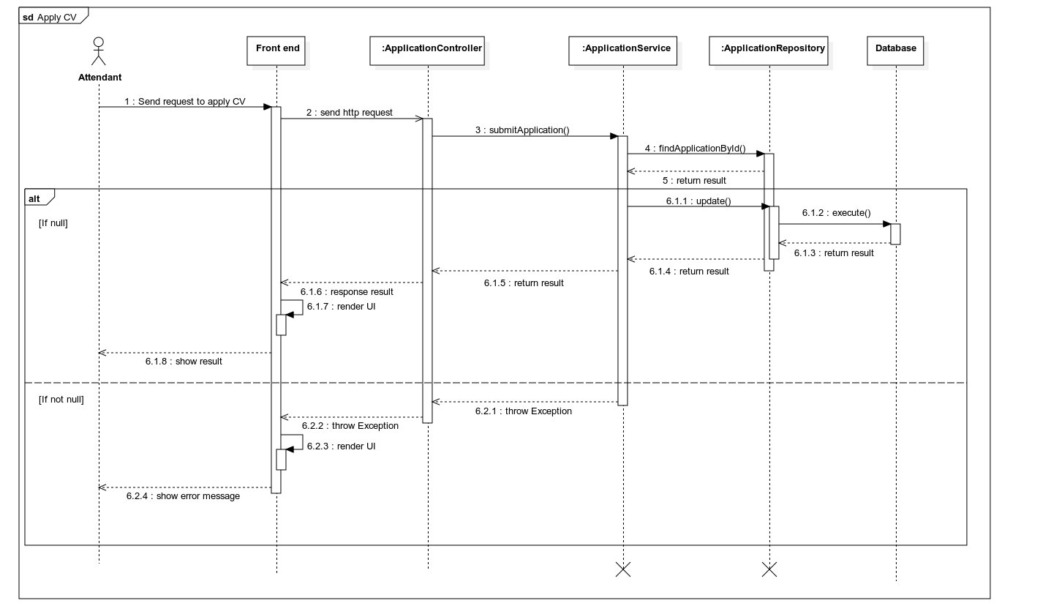

Figure 30. Sequence diagram – Attendant applies CV

##### 3.3.2.2 Attendant gets application list

***Summary****: this diagram shows how an Attendant can get application list*

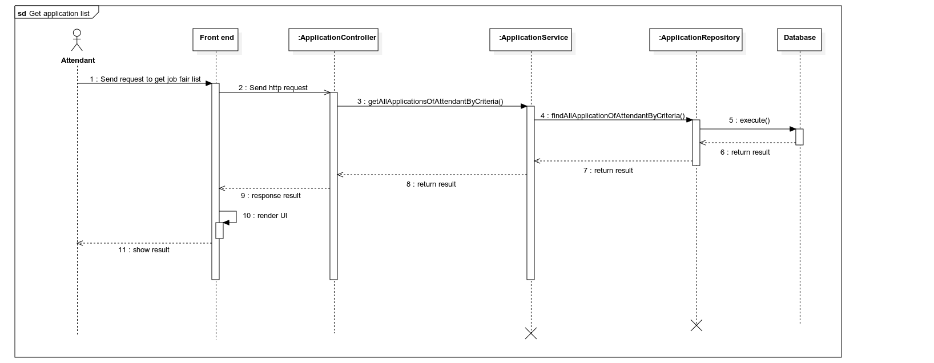

Figure 31. Sequence diagram – Attendant gets application list

##### 3.3.2.3 Attendant gets application by ID

***Summary****: this diagram shows how an Attendant can get application by ID*

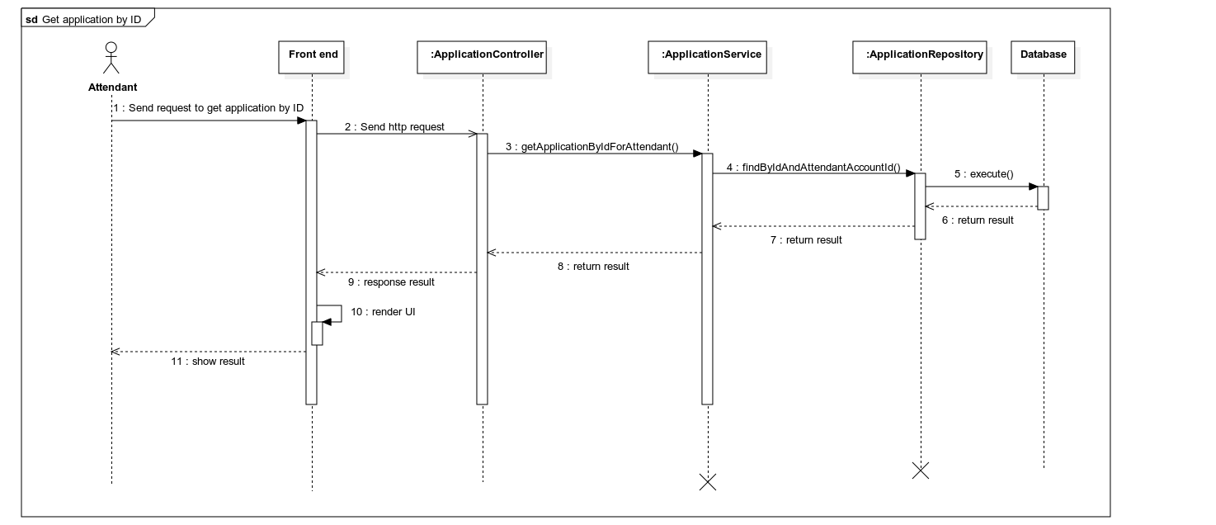

Figure 32. Sequence diagram – Attendant gets application by ID

### 3.4 Interviewer and attendant in interview process

#### 3.4.1 Class diagram

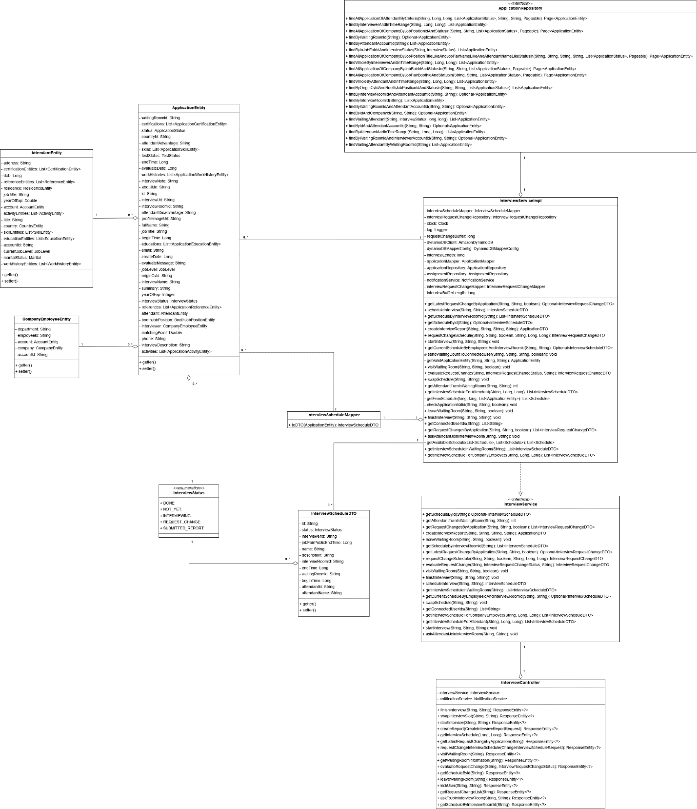

Figure 33. Class diagram – Interview process

##### 3.4.1.1 ApplicationRepository

|  |  |  |  |  |
| --- | --- | --- | --- | --- |
| **No** | **Method** | **Return Type** | **Visibility** | **Description** |
| 1 | findAllApplicationOfAttendantByCriteria | Page<ApplicationEntity> | Public | Find all application for attendant |
| 2 | findByInterviewerAndInTimeRange | List<ApplicationEntity> | Public | Find applications for interviewer and within time range |
| 3 | findAllApplicationOfCompanyByJobPositionIdAndStatusIn | Page<ApplicationEntity> | Public | Find applications by job position |
| 4 | findByWaitingRoomId | Optional< ApplicationEntity> | Public | Find application by waiting room |
| 5 | findByAttendantAccountId | List<ApplicationEntity> | Public | Find application by attendant ID |
| 6 | findByInJobFairIdAndInterviewStatus | List<ApplicationEntity> | Public | Find applications in a job fair |
| 7 | findAllApplicationOfCompanyByJobPositionTitleLikeAndJobFairNameLikeAndAttendantNameLikeStatusIn | Page<ApplicationEntity> | Public | Search applications by name |
| 8 | findWholeByInterviewerAndInTimeRange | List<ApplicationEntity> | Public | Find applications for interviewer and loosely within time range |
| 9 | findAllApplicationOfCompanyByJobFairIdAndStatusIn | Page<ApplicationEntity> | Public | Find applications of company by job fair’s id |
| 10 | findAllApplicationOfCompanyByJobFairBoothIdAndStatusIn | Page<ApplicationEntity> | Public | Find all application by booth’s id |
| 11 | findWholeByAttendantAndInTimeRange | List<ApplicationEntity> | Public | Find applications for attendant and within time range |
| 12 | findByOriginCvIdAndBoothJobPositionIdAndStatusIn | List<ApplicationEntity> | Public | Find applications by job position |
| 13 | findByInterviewRoomIdAndAttendantAccountId | Optional<ApplicationEntity> | Public | Find application by interview room id and attendant’s id |
| 14 | findByInterviewRoomId | List<ApplicationEntity> | Public | Find applications by interview room id |
| 15 | findByWaitingRoomIdAndAttendantAccountId | Optional<ApplicationEntity> | Public | Find by waiting room id and attendant id |
| 16 | findByIdAndCompanyId | Optional<ApplicationEntity> | Public | Find application by ID and company ID |
| 17 | findWaitingAttendant | List<ApplicationEntity> | Public | Find waiting for interview applications |
| 18 | findByIdAndAttendantAccountId | Optional<ApplicationEntity> | Public | Find application by ID and attendant ID |
| 19 | findByAttendantAndInTimeRange | List<ApplicationEntity> | Public | Find applications by attendant ID and in time range |
| 20 | findByWaitingRoomIdAndInterviewerAccountId | Optional<ApplicationEntity> | Public | Find application by waiting room id and interview id |
| 21 | findWaitingAttendantByWaitingRoomId | List<ApplicationEntity> | Public | Find applications by waiting room id and attendant id |

##### 3.4.1.2 InterviewServiceImpl

|  |  |  |  |  |
| --- | --- | --- | --- | --- |
| **No** | **Attribute** | **Data Type** | **Visibility** | **Description** |
| 1 | interviewScheduleMapper | InterviewScheduleMapper | Private | Interview schedule mapper |
| 2 | interviewRequestChangeRepository | InterviewRequestChangeRepository | Private | Interview request change repository |
| 3 | clock | Clock | Private | Clock object to get current timestamp |
| 4 | log | Logger | Private | System’s logger |
| 5 | requestChangeBuffer | long | Private | Deadline for request change schedule |
| 6 | dynamoDBClient | AmazonDynamoDB | Private | DynamoDB client |
| 7 | dynamoDBMapperConfig | DynamoDBMapperConfig | Private | DynamoDB mapper configuration |
| 8 | interviewLength | long | Private | Interview length |
| 9 | applicationMapper | ApplicationMapper | Private | Application mapper |
| 10 | applicationRepository | ApplicationRepository | Private | Application repository |
| 11 | assignmentRepository | AssignmentRepository | Private | Assignment repository |
| 12 | notificationService | NotificationService | Private | Notification service |
| 13 | interviewRequestChangeMapper | InterviewRequestChangeMapper | Private | Interview request change mapper |
| 14 | interviewBufferLength | long | Private | Time between 2 interview |

|  |  |  |  |  |
| --- | --- | --- | --- | --- |
| **No** | **Method** | **Return Type** | **Visibility** | **Description** |
| 1 | getLatestRequestChangeByApplication | Optional<InterviewRequestChangeDTO> | Public | Get application’s latest request change |
| 2 | scheduleInterview | InterviewScheduleDTO | Public | Schedule interview |
| 3 | getScheduleByInterviewRoomId | List< InterviewScheduleDTO> | Public | Get all interview schedule by interview room’s id |
| 4 | getScheduleById | Optional< InterviewScheduleDTO> | Public | Get schedule by ID |
| 5 | createInterviewReport | ApplicationDTO | Public | Create interview report |
| 6 | requestChangeSchedule | InterviewRequestChangeDTO | Public | Create request change schedule |
| 7 | startInterview | void | Public | Start interview |
| 8 | getCurrentScheduleByEmployeeIdAndInterviewRoomId | Optional< InterviewScheduleDTO> | Public | Get schedule by interviewer ID and interview room ID |
| 9 | sendWaitingCountToConnectedUser | void | Protected | Send waiting list for attendant |
| 10 | getValidApplicationEntity | ApplicationEntity | Private | Get valid application entity |
| 11 | visitWaitingRoom | void | Public | Enter waiting room |
| 12 | evaluateRequestChange | IntervewRequestChangeDTO | Public | Evaluate request change |
| 13 | swapSchedule | void | Public | Swap schedule |
| 14 | getAttendantTurnInWaitingRoom | int | Public | Get attendant waiting turn in waiting room |
| 15 | getInterviewScheduleForAttendant | List< InterviewScheduleDTO> | Public | Get interview schedule for attendant |
| 16 | getFreeSchedule | List<Schedule> | Private | Get free schedule of attendant or interviewer |
| 17 | checkApplicationValide | void | Private | Check for valid application |
| 18 | leaveWaitingRoom | void | Public | Leave waiting room |
| 19 | finishInterview | void | Public | Finish interview |
| 20 | getConnectedUserIds | List<String> | Public | Get connected user in interview room |
| 21 | getRequestChangesByApplication | List< InterviewRequestChangeDTO> | Public | Get application request change schedule |
| 22 | askAttendantJoinInterviewRoom | void | Public | Ask attendant to join interview room |
| 23 | getAvailableSchedule | List<Schedule> | Private | Get available schedule between attendant and interviewer |
| 24 | getInteviewScheduleInWaitingRoom | List<InterviewScheduleDTO> | Public | Get interview schedule by waiting room id |
| 25 | getInterviewScheduleForCompanyEmployee | List<InterviewScheduleDTO> | Public | Get interview schedule for company employee |

##### 3.4.1.3 InterviewScheduleMapper

|  |  |  |  |  |
| --- | --- | --- | --- | --- |
| **No** | **Method** | **Return Type** | **Visibility** | **Description** |
| 1 | toDTO | InterviewScheduleDTO | Public | Mapping ApplicationEntity to InterviewScheduleDTO |

##### 3.4.1.4 ApplicationEntity

|  |  |  |  |  |
| --- | --- | --- | --- | --- |
| **No** | **Attribute** | **Data Type** | **Visibility** | **Description** |
| 1 | waitingRoomId | String | Private | Application’s waiting room id |
| 2 | certifications | List<ApplicationCertificationEntity> | Private | Application’s certifications |
| 3 | status | ApplicationStatus | Private | Application’s status |
| 4 | countryId | String | Private | Application’s country id |
| 5 | attendantAdvantage | String | Private | Application’s attendant advantage |
| 6 | skills | List<ApplicationSkillEntity> | Private | Application’s skills |
| 7 | testStatus | TestStatus | Private | Application’s test status |
| 8 | endTime | Long | Private | Application’s end time |
| 9 | evaluateDate | Long | Private | Application’s evaluate date |
| 10 | workHistories | List<ApplicationWorkHistoyEntity> | Private | Application’s work histories |
| 11 | interviewNote | String | Private | Application’s interviewer’s note |
| 12 | aboutMe | String | Private | Application’s about me |
| 13 | id | String | Private | Unique identifier of application |
| 14 | interviewUrl | String | Private | Application’s interview URL |
| 15 | interviewRoomId | String | Private | Application’s interview room ID |
| 16 | attendantDisadvantage | String | Private | Application’s attendant disadvantage |
| 17 | profileImageUrl | String | Private | Application’s profile image URL |
| 18 | fullName | String | Private | Application’s attendant’s full name |
| 19 | jobTitle | String | Private | Application’s attendant’s job title |
| 20 | beginTime | Long | Private | Application’s interview begin time |
| 21 | educations | List<ApplicationEducationEntity> | Private | Application’s educations |
| 22 | email | String | Private | Application’s attendant’s email |
| 23 | createDate | Long | Private | Application’s create date |
| 24 | evaluateMessage | String | Private | Application’s evaluate message |
| 25 | jobLevel | JobLevel | Private | Application’s attendant’s job level |
| 26 | originCvId | String | Private | Application’s origin CV id |
| 27 | interviewName | String | Private | Application’s interview name |
| 28 | summary | String | Private | Application’s summary |
| 29 | yearOfExp | Integer | Private | Application’s attendant’s year of experience |
| 30 | interviewStatus | InterviewStatus | Private | Application’s interview status |
| 31 | references | List<ApplicationReferenceEntity> | Private | Application’s references |
| 32 | attendant | AttendantEntity | Private | Application’s attendant |
| 33 | boothJobPosition | BoothJobPositionentity | Private | Job position that this application applied to |
| 34 | interviewer | CompanyEmployeeEntity | Private | Application’s interviewer |
| 35 | matchingPoint | Double | Private | Application’s matching point |
| 36 | phone | String | Private | Application’s attendant’s phone |
| 37 | interviewDescription | String | Private | Application’s interviewer’s description |
| 38 | activities | List<ApplicationActivityEntity> | Private | Application’s activities |

|  |  |  |  |  |
| --- | --- | --- | --- | --- |
| **No** | **Method** | **Return Type** | **Visibility** | **Description** |
| 1 | getter | data type | Public | Get value of attribute |
| 2 | setter | data type | Public | Set value of attribute |

##### 3.4.1.5 AttendantEntitty

|  |  |  |  |  |
| --- | --- | --- | --- | --- |
| **No** | **Attribute** | **Data Type** | **Visibility** | **Description** |
| 1 | address | String | Private | Attendant’s address |
| 2 | certificationEntities | List<CertificationEntity> | Private | Attendant’s certifications |
| 3 | dob | Long | Private | Attendant’s date of birth |
| 4 | referenceEntities | List<ReferenceEntity> | Private | Attendant’s reference |
| 5 | residence | ResidenceEntity | Private | Attendant’s residence |
| 6 | jobTile | String | Private | Attendant’s job title |
| 7 | yearOfExp | Double | Private | Attendant’s year of experience |
| 8 | account | AccountEntity | Private | Attendant’s account |
| 9 | activityEntities | List<ActivityEntity> | Private | Attendant’s activities |
| 10 | tittle | String | Private | Attendant’s title |
| 11 | country | CountryEntity | Private | Attendant’s country |
| 12 | skillEntities | List<SkillEntity> | Private | Attendant’s skills |
| 13 | educationEntities | List<EducationEntity> | Private | Attendant’s educations |
| 14 | accountId | String | Private | Attendant’s account id |
| 15 | currentJobLevel | JobLevel | Private | Attendant’s job level |
| 16 | maritalStatus | Marital | Private | Attendant’s marital status |
| 17 | workHistoryEntities | List<WorkHistoryEntity> | Private | Attendant’s work history |

|  |  |  |  |  |
| --- | --- | --- | --- | --- |
| **No** | **Method** | **Return Type** | **Visibility** | **Description** |
| 1 | getter | data type | Public | Get value of attribute |
| 2 | setter | data type | Public | Set value of attribute |

##### 3.4.1.6 CompanyEmployeeEntity

|  |  |  |  |  |
| --- | --- | --- | --- | --- |
| **No** | **Attribute** | **Data Type** | **Visibility** | **Description** |
| 1 | department | String | Private | Employee’s department |
| 2 | employeeId | String | Private | Employee’s ID |
| 3 | account | AccountEntity | Private | Account associate with this employee |
| 4 | company | CompanyEntity | Private | Company that this employee belongs to |
| 5 | accountId | String | Private | Employee’s account id |

|  |  |  |  |  |
| --- | --- | --- | --- | --- |
| **No** | **Method** | **Return Type** | **Visibility** | **Description** |
| 1 | getter | data type | Public | Get value of attribute |
| 2 | setter | data type | Public | Set value of attribute |

##### 3.4.1.7 InterviewService

|  |  |  |  |  |
| --- | --- | --- | --- | --- |
| **No** | **Method** | **Return Type** | **Visibility** | **Description** |
| 1 | getScheduleById | Optional<InterviewScheduleDTO> | Public | Get schedule by ID |
| 2 | getAttendantTurnInWaitingRoom | int | Public | Get attendant waiting turn in waiting room |
| 3 | getRequestChangesByApplication | List<InterviewRequestChangeDTO> | Public | Get application request change schedule |
| 4 | createInterviewReport | ApplicationDTO | Public | Create interview report |
| 5 | leaveWaitingRoom | void | Public | Leave waiting room |
| 6 | getScheduleByInterviewRoomId | List<InterviewScheduleDTO> | Public | Get all interview schedule by interview room’s id |
| 7 | getLatestRequestChangeByApplication | Optional<InterviewRequestChangeDTO> | Public | Get application’s latest request change |
| 8 | requestChangeSchedule | InterviewRequestChangeDTO | Public | Create request change schedule |
| 9 | evaluateRequestChange | InterviewRequestChangeDTO | Public | evaluateRequestChange |
| 10 | visitWaitingRoom | void | Public | Enter waiting room |
| 11 | finishInterview | void | Public | Finish interview |
| 12 | scheduleInterview | InterviewScheduleDTO | Public | Schedule interview |
| 13 | getInterviewScheduleInWaitingRoom | List<InterviewScheduleDTO> | Public | Get interview schedules by waiting room id |
| 14 | getCurrentScheduleByEmployeeIdAndInterviewRoomId | Optional<InterviewScheduleDTO> | Public | Get schedule by interviewer ID and interview room ID |
| 15 | swapSchedule | void | Public | Swap schedule |
| 16 | getConnectedUserIds | List<String> | Public | Get connected user in interview room |
| 17 | getInterviewScheduleForCompanyEmployee | List<InterviewScheduleDTO> | Public | Get interview schedule for company employee |
| 18 | getInterviewScheduleForAttendant | List<InterviewScheduleDTO> | Public | Get interview schedule for attendant |
| 19 | startInterview | void | Public | Start interview |
| 20 | askAttendantJoinInterviewRoom | void | Public | Ask attendant to join interview room |

##### 3.4.1.8 InterviewController

|  |  |  |  |  |
| --- | --- | --- | --- | --- |
| **No** | **Attribute** | **Data Type** | **Visibility** | **Description** |
| 1 | interviewService | InterviewService | Private | Interview service |
| 2 | notificationService | NotificationService | Private | Notification service |

|  |  |  |  |  |
| --- | --- | --- | --- | --- |
| **No** | **Method** | **Return Type** | **Visibility** | **Description** |
| 1 | finishInterview | ResponseEntity<?> | Public | Finish interview |
| 2 | swapInterviewSlot | ResponseEntity<?> | Public | Swap 2 interview schedules |
| 3 | startInterview | ResponseEntity<?> | Public | Start interiview |
| 4 | createReport | ResponseEntity<?> | Public | Create report |
| 5 | getInterviewSchedule | ResponseEntity<?> | Public | Get interview schedule |
| 6 | getLatestRequestChangeByApplication | ResponseEntity<?> | Public | Get latest request change schedule |
| 7 | requestChangeInterviewSchedule | ResponseEntity<?> | Public | Request change interview schedule |
| 8 | visitWaitingRoom | ResponseEntity<?> | Public | Visit waiting room |
| 9 | getWaitingRoomInformation | ResponseEntity<?> | Public | Get waiting room information |
| 10 | evaluateRequestChange | ResponseEntity<?> | Public | Evaluate request change |
| 11 | getScheduleById | ResponseEntity<?> | Public | Get schedule by id |
| 12 | leaveWaitingRoom | ResponseEntity<?> | Public | Leave waiting room |
| 13 | kickUser | ResponseEntity<?> | Public | Kick user |
| 14 | getRequestChangeList | ResponseEntity<?> | Public | Get request change list |
| 15 | askToJoinInterviewRoom | ResponseEntity<?> | Public | Ask attendant to join interview room |
| 16 | getScheduleByInterviewRoomId | ResponseEntity<?> | Public | Get schedule by interview room ID |

##### 3.4.1.9 InterviewScheduleDTO

|  |  |  |  |  |
| --- | --- | --- | --- | --- |
| **No** | **Attribute** | **Data Type** | **Visibility** | **Description** |
| 1 | id | String | Private | Schedule’s id |
| 2 | status | InterviewStatus | Private | Interview’s status |
| 3 | interviewerId | String | Private | Interviewer’s id |
| 4 | jobFairPublicEndTime | Long | Private | Job fair public end time |
| 5 | name | String | Private | Interview’s name |
| 6 | description | String | Private | Interview’s description |
| 7 | interviewRoomId | String | Private | Interview room id |
| 8 | endTime | Long | Private | Interview’s end time |
| 9 | waitingRoomId | String | Private | Waiting room id |
| 10 | beginTime | Long | Private | Interview’s begin time |
| 11 | attendantId | String | Private | Interview attendant’s id |
| 12 | attendantName | String | Private | Interview attendant name |

|  |  |  |  |  |
| --- | --- | --- | --- | --- |
| **No** | **Method** | **Return Type** | **Visibility** | **Description** |
| 1 | getter | data type | Public | Get value of attribute |
| 2 | setter | data type | Public | Set value of attribute |

##### 3.4.1.10 InterviewStatus

|  |  |  |  |
| --- | --- | --- | --- |
| **No** | **Enum** | **Visibility** | **Description** |
| 1 | DONE | Public | If interview has finished |
| 2 | NOT_YET | Public | If interview has not yet happened |
| 3 | INTERVIEWING | Public | If interview is currently happening |
| 4 | REQUEST_CHANGE | Public | If interview schedule is being request change |
| 5 | SUBMITTED_REPORT | Public | If interviewer has submitted report |

|  |  |  |  |  |
| --- | --- | --- | --- | --- |
| **No** | **Method** | **Return Type** | **Visibility** | **Description** |
| 1 | valueOf | InterviewStatus | Public | Get list of values |
| 2 | values | InterviewStatus[] | Public | Mapping int to enum type |

#### 3.4.2 Sequence diagram

##### 3.4.2.1 Interviewer gets application list

***Summary****: this diagram shows how an Interviewer can get application list*

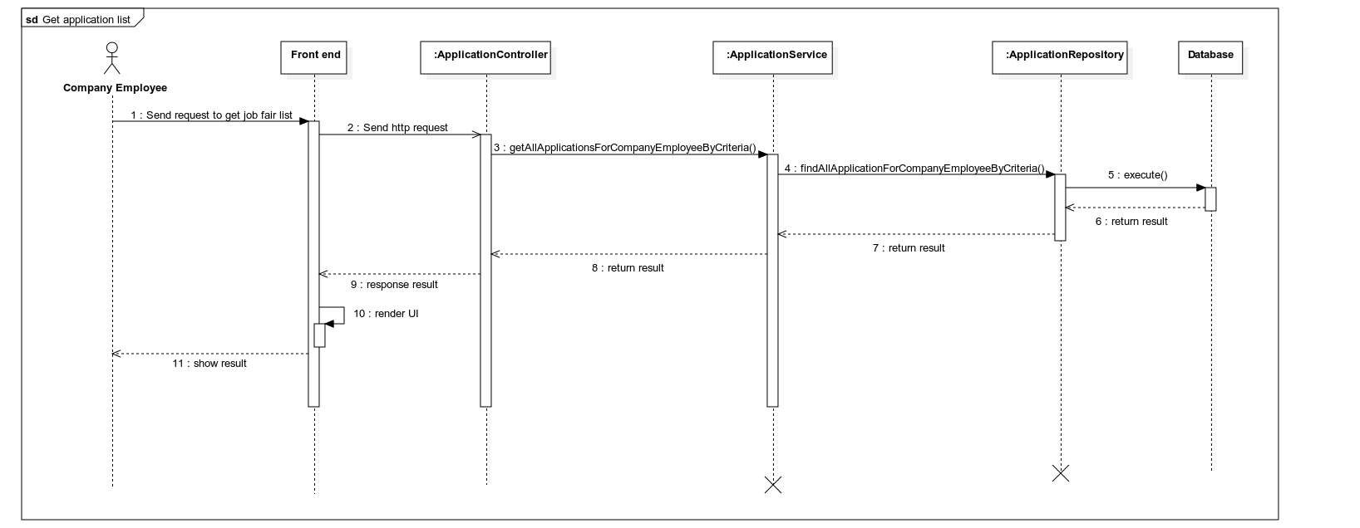

Figure 34. Sequence diagram –Interviewer gets application list

##### 3.4.2.2 Interviewer gets application by ID

***Summary****: this diagram shows how an Interviewer can get application by ID*

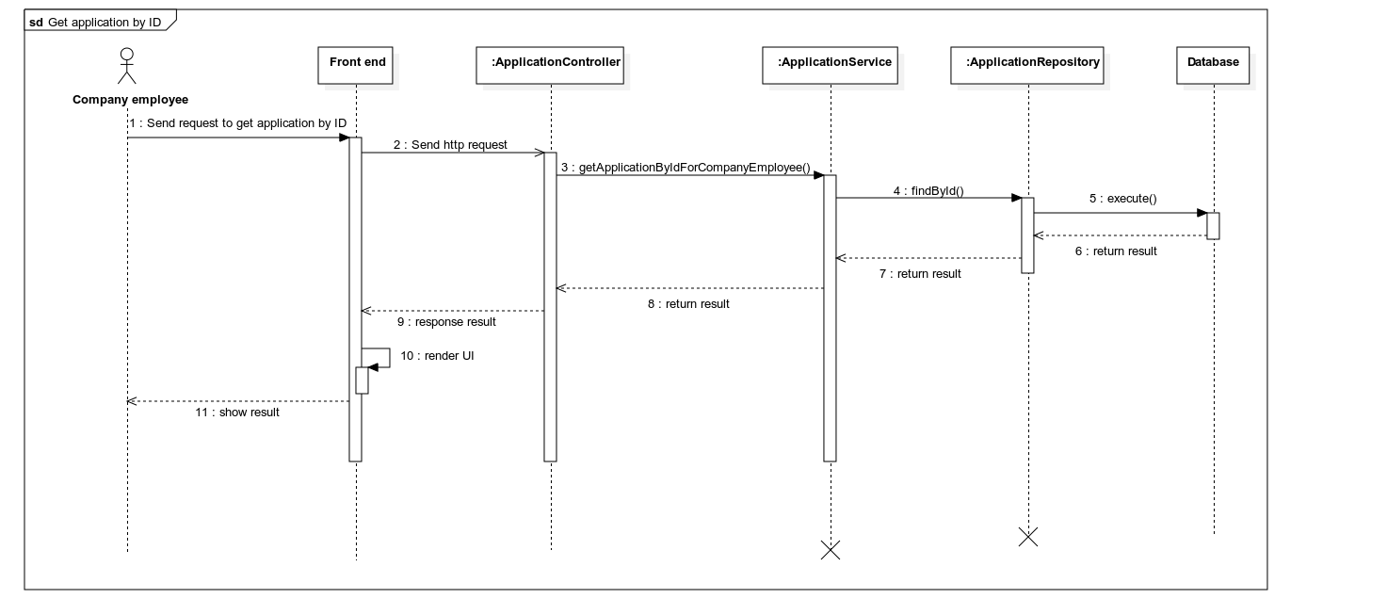

Figure 35. Sequence diagram –Interviewer gets application by ID

##### 3.4.2.3 Interviewer evaluates application

**Summary**: this diagram shows how an Interviewer can evaluate an application

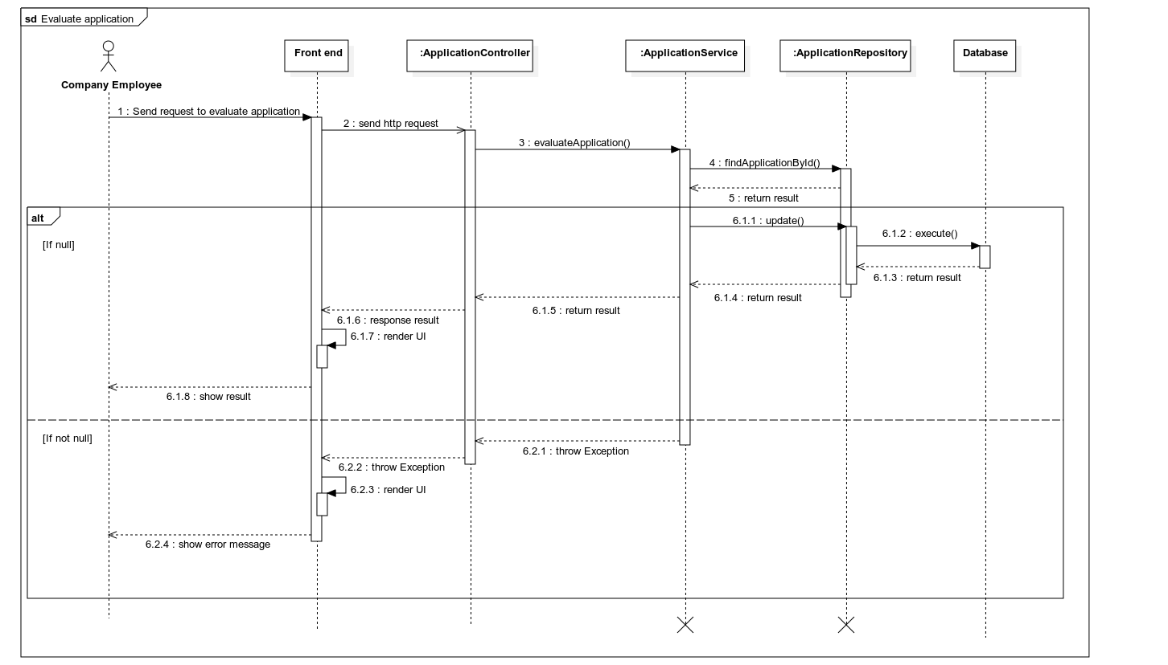

Figure 36. Sequence diagram –Interviewer evaluates application

## 4. Algorithms

### 4.1 Calculate matching point between CV and job position

#### 4.1.1 Summary

This algorithm is used to calculate the matching point between an attendant’s CV and a job position based on multiple categories of CV and job’s information.

Input:

* An attendant’s CV
* A job position

Output: A matching point range from 0 to 1

#### 4.1.2 Defined problem

Traditionally, when evaluating an application, the interviewers usually depend on their experience and have to manually scan through many applications. This process is proved to be error prone. The more suitable candidates, therefore, can be ignored. On the side, candidates also face the same problem as the interviewers. They have to manually look at job description to find a favorable job position.

#### 4.1.3 Attribute definition

* A CV is divided into 5 categories: skill, education, work history, certification, activity.
* A job position is divided into 4 categories: requirement, description, skill, other requirements.

#### 4.1.4 Solution

The algorithm has ***6 main steps***:

* **Step 1:** Extract keywords from CV and sorted them into the 5 above categories.
  + For the skill category, the keywords of each CV’s skill are skill’s name
  + For the education category, the keywords of each CV’s education are:
    - School’s name
    - Subject
    - Qualification’s name,
    - Achievement keywords (the achievement keywords are extracted using the SkillNer module)
  + For the work history category, the keywords of each CV’s work history are
    - Company’s name
    - Position
    - Description keywords (the description keywords are extracted using SkillNer module)
  + For the certification category, the keywords of each CV’s certificate are:
    - Certificate’s name
    - Certificate’s institution.
  + For the activity category, the keywords of each CV’s activity are
    - Activity’s name
    - Function title
    - Description keywords (keywords (the description keywords are extracted using SkillNer module)
* **Step 2:** Extract keywords from job position’s detail and sorted them into the 4 above categories.
  + For the requirement category, the keywords are the requirement keywords extracted using SkillNer module
  + For the description category, the keywords are the description keywords extracted using SkillNer module
  + For the skill category, the keywords are the skill’s name
  + For the other requirements category, the keywords are
    - Prefer language
    - Job’s categories
* **Step 3:** Find max similarity between cv keywords in 5 categories and job position keywords in 4 categories
  + Before finding the similarity, the keywords are mapped to word vector using SpaCy module
  + For each CV’s category, calculate the max similarity point as the following pseudo-code:

max_requirement_score_list = []

For all category keyword **i**:

requirement_score_list := []

For all keywords of job position requirement keyword j**:**

requirement_score_list.add(cosine_similarity(**i**, **j**))

End

max_requirement_score_list.add(max(requirement_score_list))

End

requirement_score:=average(max_requirement_score_list)*job_requirement_weight

max_description_score_list = []

For all category keyword **i**:

description_score_list := []

For all keywords of job position description keyword j**:**

description_score_list.add(cosine_similarity(**i**, **j**))

End

max_requirement_score_list.add(max(description_score_list))

End

description_score:=average(max_description_score_list)*job_description_weight

max_skill_score_list = []

For all category keyword **i**:

skill_score_list := []

For all keywords of job position skill keyword j**:**

skil_score_list.add(cosine_similarity(**i**, **j**))

End

max_skill_score_list.add(max(skill_score_list))

End

skill_score:=average(max_skill_score_list)* job_skill_weight

max_other_score_list = []

For all category keyword **i**:

other_score_list := []

For all keywords of job position other requirement keyword j**:**

other_score_list.add(cosine_similarity(**i**, **j**))

End

max_other_score_list.add(max(other_score_list))

End

other_score:=average(max_other_score_list)*job_other_weight

similarity_point:=(requirement_score + description_score + skill_score + skill_score) / (job_requirement_weight + job_description_weight + job_skill_weight + job_other_weight)

return similarity point

* + The result will be skill similarity point, education similarity point, work history similarity point, certification similarity point and activity point
* **Step 4:** calculate matching point of all 5 CV categories against job position
  + Skill matching point = Skill similarity point * CV’s skill weight
  + Education matching point = Education similarity point * CV’s education weight
  + Work history matching point = Work history similarity point * CV’s work history weight
  + Certification matching point = Work history similarity point * CV’s certification weight
  + Activity matching point = Activity similarity point * CV’s similarity weight
* **Step 5:** calculate the overall matching point
  + Overall matching point = (skill matching point + education matching point + work history matching point + certification matching point + activity matching point) / (CV’s skill weight + CV’s education weight + CV’s education weight + CV’s certification weight + CV’s similarity weight)

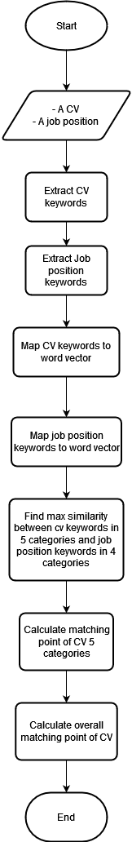

Figure 37. Calculate matching point flow diagram

#### 4.1.5 Improvement

For each category that depending on SkillNer module to extract keywords, the keywords will be extracted when a CV or a job position get created or get updated. These keywords will then be saved into the database as a caching solution.

# V. Software Testing Documentation

## 1. Overall Description

### **1.1 Test Model**

In this project, we use incremental testing for following purposes:

* Each module has defined dependencies and specific role in the entire system.
* The duration of the JobHub project is limited to 16 weeks. Therefore, we need to control critical errors to fix as soon as possible without having to rebuild the modules from scratch.

### **1.2 Testing Levels**

* Testing Level: System Test, User Acceptance Test
* Testing Types: Functional Testing, User Interface Testing

## 2. Test Plan

### 2.1 Test Stages

|  |  |  |  |
| --- | --- | --- | --- |
| **Type of Test** | **Stage of Test** | | |
| **Unit** | **System** | **Acceptance** |
| Functional Testing |  | x | x |
| User Interface Testing |  |  | x |

Table 22. Test Stages

### 2.2 Human Resources

|  |  |  |
| --- | --- | --- |
| **Worker/Doer** | **Role** | **Specific Responsibilities/Comments** |
| Truong Tran Tien | Leader | Planning. Verify test result |
| Pham Cao Son | Member | Execute test and report as planned |
| Bui Minh Khoi | Member | Execute test and report as planned |

Table 23. Human Resources

### 2.3 Deliverables

|  |  |  |
| --- | --- | --- |
| **No** | **Deliverables** | **Due Date** |
| 1 | Test document | 13/08/2022 |

Table 24. Deliverables

## 3. Test Cases & Test Reports

|  |  |
| --- | --- |
| **Testing Level** | **File Name** |
| System Test | Report5_Test Case.xlsx |
| User Acceptance Test | Acceptance Certificate |

Table 25. Test Cases & Test Reports

# VI. Release Package & User Guides

## 1. Deliverable Package

### 1.1 Source codes & documents

| **No.** | **Items** | **Sub-Items** | **Type** | **Version** |
| --- | --- | --- | --- | --- |
| ***Code Package*** | | | | |
| 1 | JobHub Backend | Web Service | Modify | 1.0.0 |
| 2 | JobHub Frontend User | User Web Application | Modify | 1.0.0 |
| ***Database*** | | | | |
| 1 | Script | JobHub’s schema: DDL and DML | Modify | N/A |
| ***Documents*** | | | | |
| 1 | Project  Introduction | Report1_Project Introduction.docx | Modify | 1.0 |
| 2 | Project  Management  Plan | Report2_Project Management Plan.docx | Modify | 1.0 |
| 3 | Software Requirement Specification | Report3_Software Requirement Specification.docx | Modify | 1.0 |
| 4 | Software Design Document | Report4_Software Design Document.docx | Modify | 1.0 |
| 5 | Test Documentation | Report5_Test Documentation.docx | Modify | 1.0 |
| 6 | Software User Guides | Report6_Software User Guides.docx | Modify | 1.0 |
| 7 | Final Project Report | Report7_FinalProjectReport.docx | Modify | 1.0 |

Table 26. Source code and documentations

## 2. Installation Guides

### 2.1 System Requirements

#### 2.2.1 Hardware Requirements

|  |  |  |
| --- | --- | --- |
| **Component** | **Minimum** | **Recommended** |
| CPU | At least 2 core, 2 (GHz) x64-bit  CPU | Core i5 or i7 |
| Memory | At least 2GB RAM | 8GB RAM |
| Storage Space | 10GB HDD | 20GB HDD |
| Network | Internet Connection | 200 Mbps |

Table 27. Hardware requirements

#### 2.2.2 Software Requirements

|  |  |  |
| --- | --- | --- |
| **Component** | **Software and version** | **Description** |
| Operating System | Window 10 or Linux | Operating system for running project |
| DBMS | MySQL 8.0.28 | Manage database |
| Server Environment | Java 1.8 | Environment for running backend |
| Frontend Environment | Nginx in production or NodeJS if running in development | Environment for running frontend |
| IDE | Visual Studio Code, Intelij | Tool for view and edit code |
| VCS | Github | Tool for manage code version |

Table 28. Software requirements

### 2.2 Installation Instruction

#### 2.2.1 Setup files

* JobHub-script.sql on Database repo: Database script for system.
* backend.zip on Backend repo: Web API.
* frontend.zip on Frontend repo: Web application.

***2.2.2 Setup environment***

* Download and install Java1.8 and maven .
* Download and install Nodejs 14.17.3.
* Download and install MySQL server.
* Download and install Visual Studio Code.
* Download and install Git.
* Connect local Git with GitHub account.
* Pull code from GitHub to local.

***2.2.3 Run backend server***

* Clone the repository:

**git clone https://github.com/jobfaironline/jobfair-backend.git**

* Go to ./jobhub-backend folder, run the project in development:

**mvn clean install**

**java -jar /target/backend.jar**

* Navigate to http://localhost:5000/swagger-ui/index.html to see the API home page

***2.2.4 Run frontend web application***

* Install npm:

**npm install**

* Run project:

**npm start**

* Navigate to **http://localhost:3000** to see the website.

### 2.3 Deployment Guide

#### 2.3.1 Deploy backend to Amazon Elastic Beanstalk

* Go to **AWS Console** and search for **Elastic Beanstalk.**

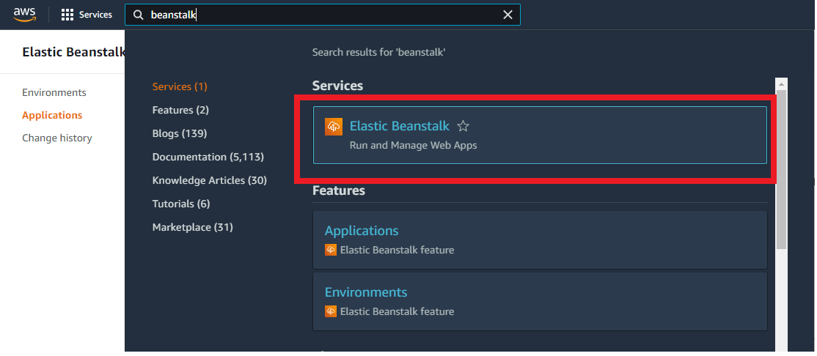

Figure 38. AWS Elastic Beanstalk – Access from console page

* Choose **Create Application**.

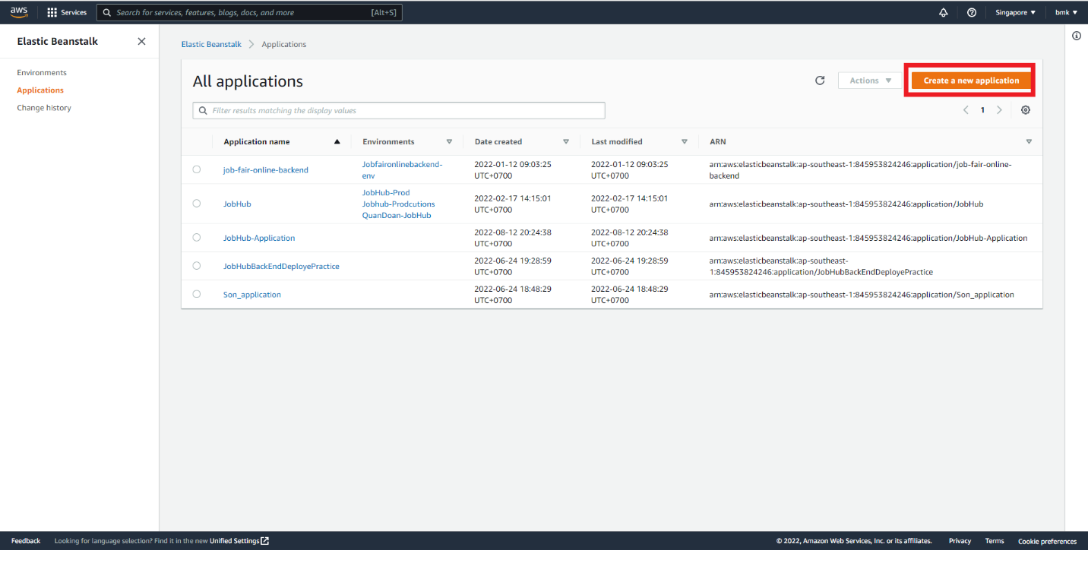

Figure 39. AWS Elastic Beanstalk - dashboard

* Enter Application Name and Description and press **Create** button.

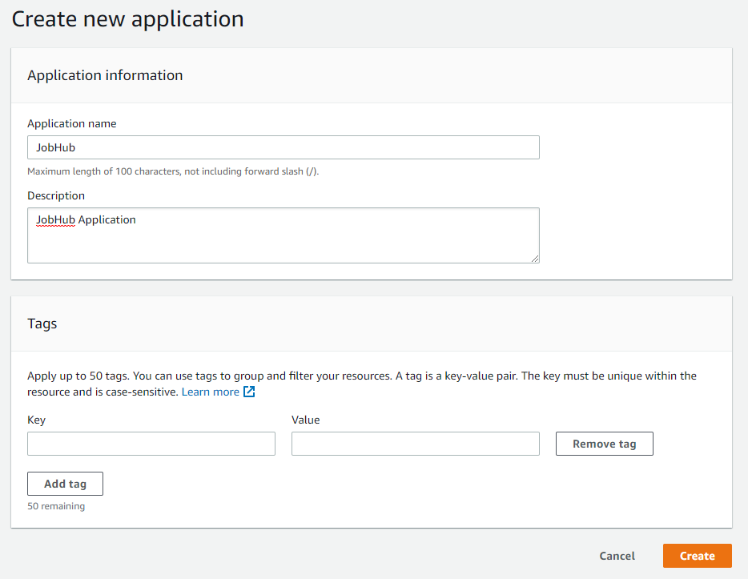

Figure 40. AWS Elastic Beanstalk - Create new application

* Press **Create a new environment** button.

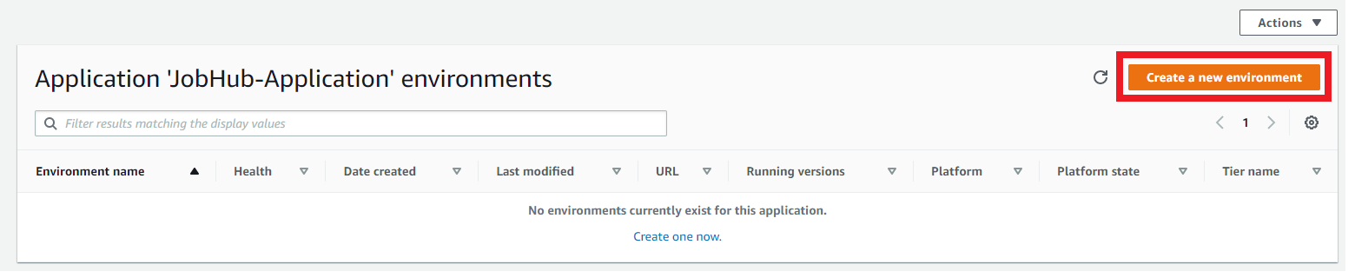

Figure 41. AWS Elastic Beanstalk – Create new environments

* Choose **Web server environment** and press **Select** button.

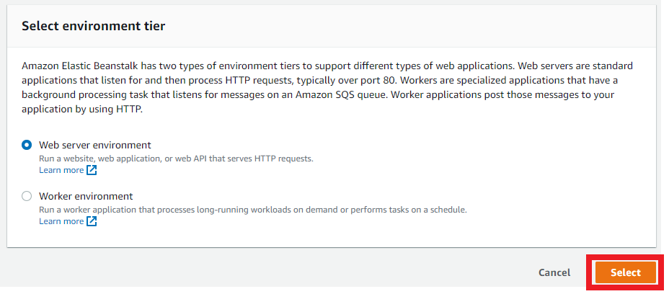

Figure 42. AWS Elastic Beanstalk – environment configuration

* On platform section, choose **Managed platform** with **Java** – **Corretto 17 on 64bit Amazon Linux 2 – 3.3.1 (Recommended)** options.

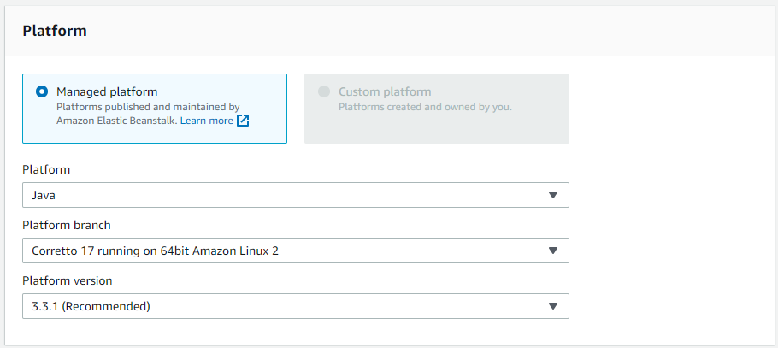

Figure 43. AWS Elastic Beanstalk – Platform configuration

* On **Application code** section**,** choose **Upload your code** and chose **Choose file** button and upload **backend.zip** file.

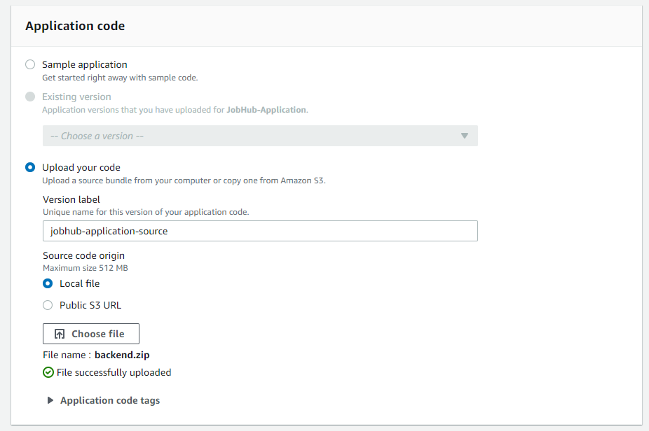

Figure 44. AWS Elastic Beanstalk – Upload code

* Choose **Configure more options** button at the end of page.



Figure 45. AWS Elastic Beanstalk – Configure more options

* On **Preset** section, choose **High availability** option.

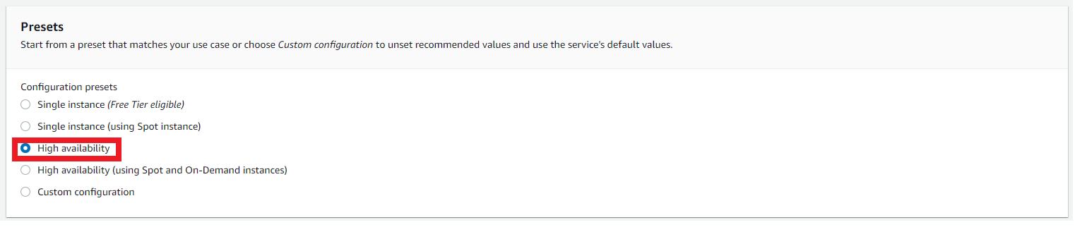

Figure 46. AWS Elastic Beanstalk – configure high availability

* On **Software** section, choose **edit** button.

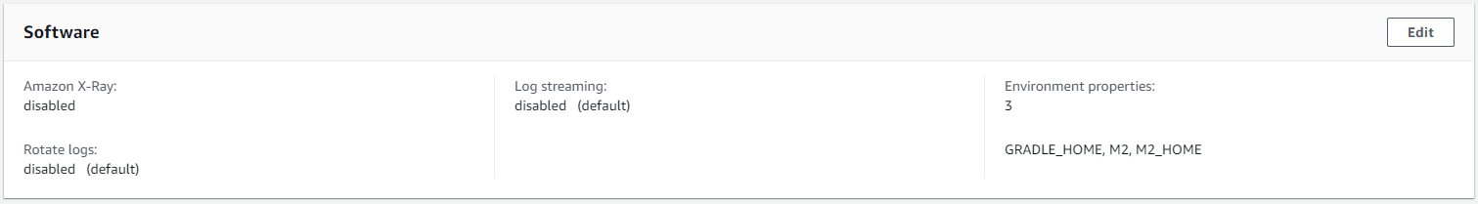

Figure 47. AWS Elastic Beanstalk – Edit software

* Go to **Environment properties**, fill with all the required environment variables for backend.

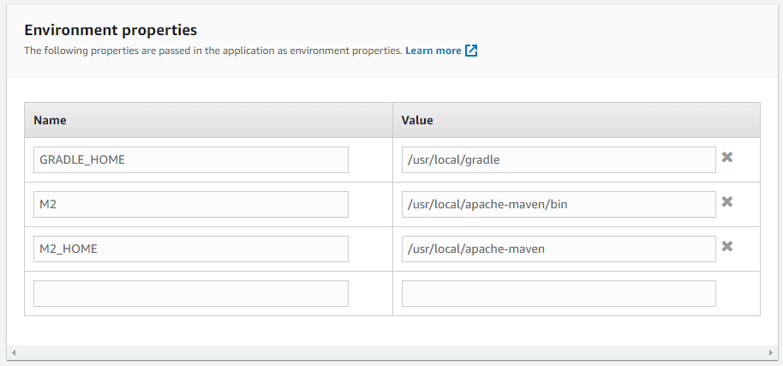

Figure 48. AWS Elastic Beanstalk – Add environment properties

* After filled with all environment variables, press **Save** button.
* On **Capacity** section, choose **Edit** button.

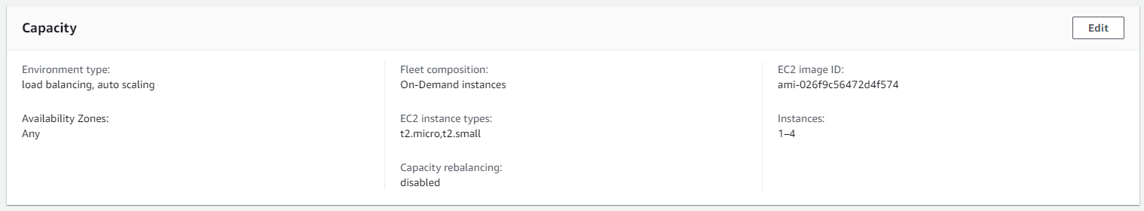

Figure 49. AWS Elastic Beanstalk – configure capacity

* Scroll down to **Scaling triggers,** change these options like picture bellow. After that, press save button

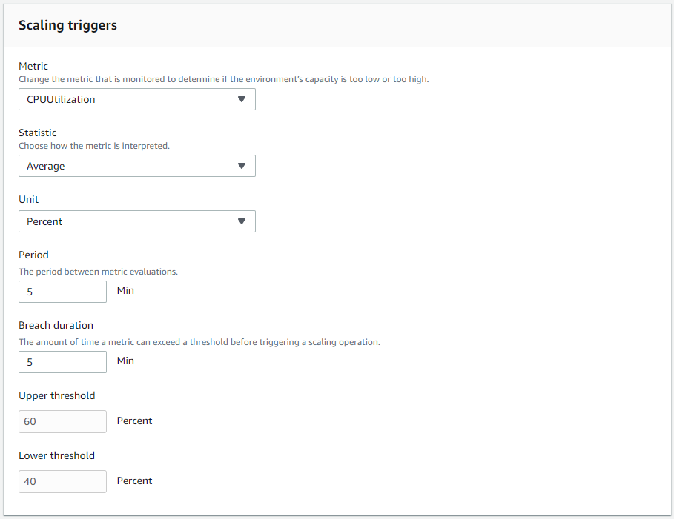

Figure 50. AWS Elastic Beanstalk – Configure scaling trigger

* After finished configuring **Beanstalk** press **Create environment** at the end of page.
* Choose application.

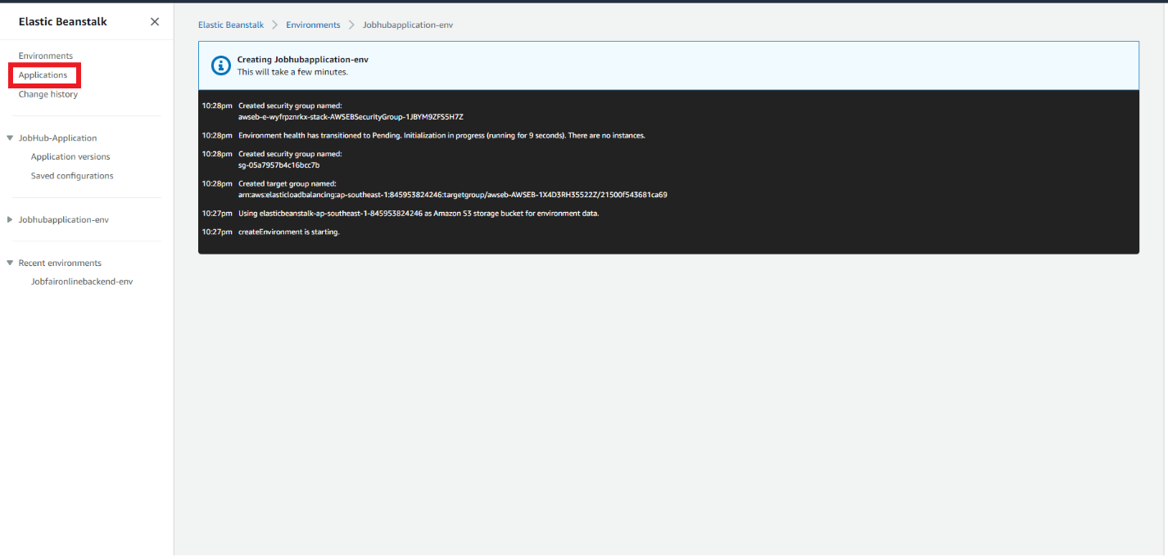

Figure 51. AWS Elastic Beanstalk – Access application

* Choose the environment was created before.

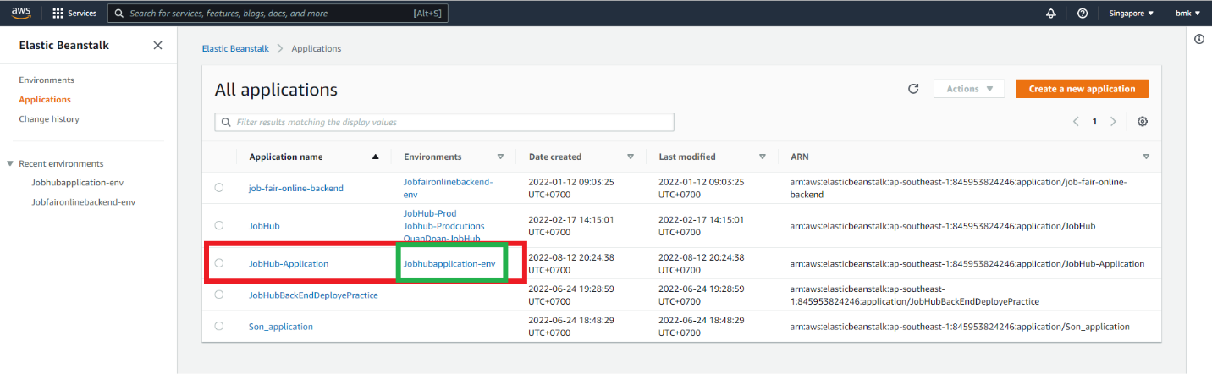

Figure 52. AWS Elastic Beanstalk – Link environment to application

* The link in red box is backend link.

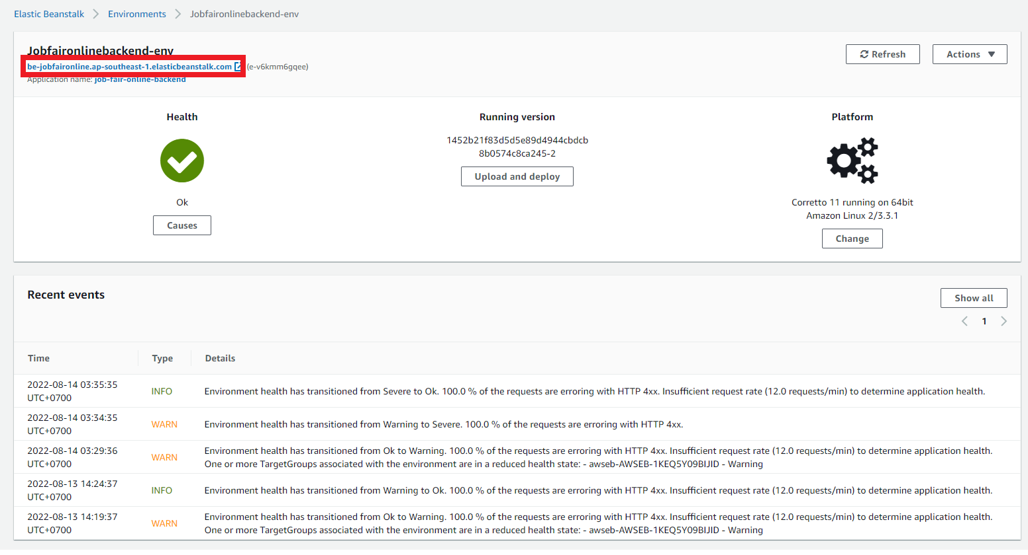

Figure 53. AWS Elastic Beanstalk – get back-end URL

* 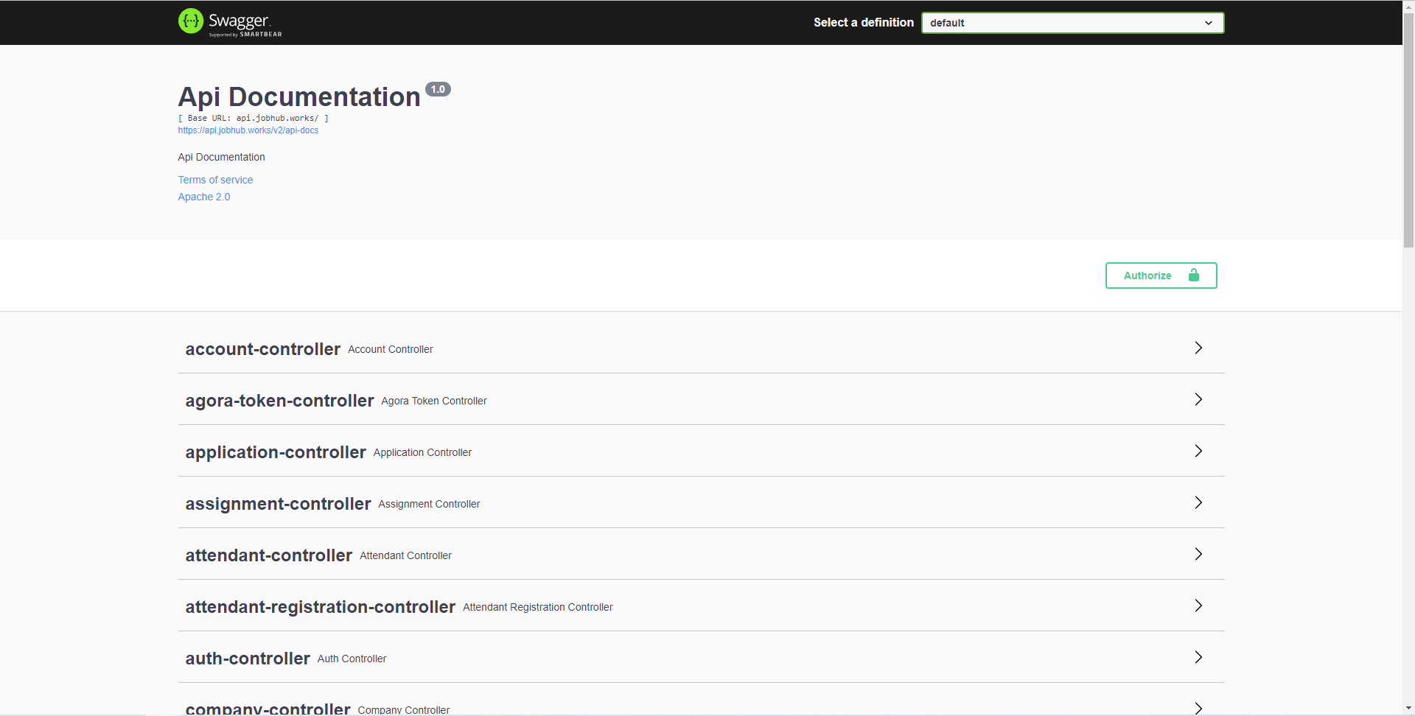Backend has successfully been loaded.

Figure 54. Back-end Swagger page

#### 2.3.2 Deploy multiple user server

* Go to **AWS Console** and search for **EC2**

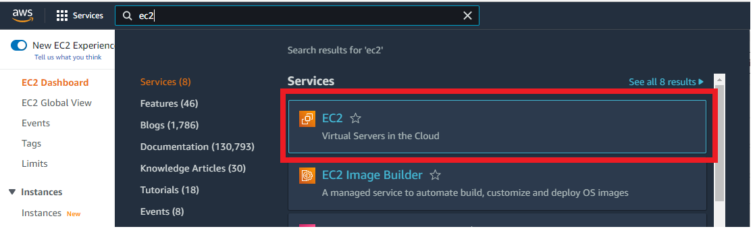

Figure 55. AWS EC2 – access from console page

* Choose **Launch instance** -> **Launch instance**

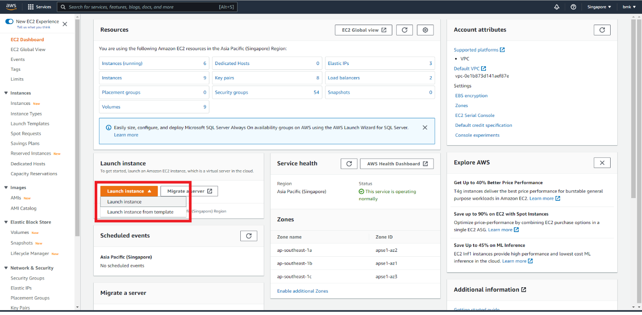

Figure 56. AWS EC2 – Launch instance

* 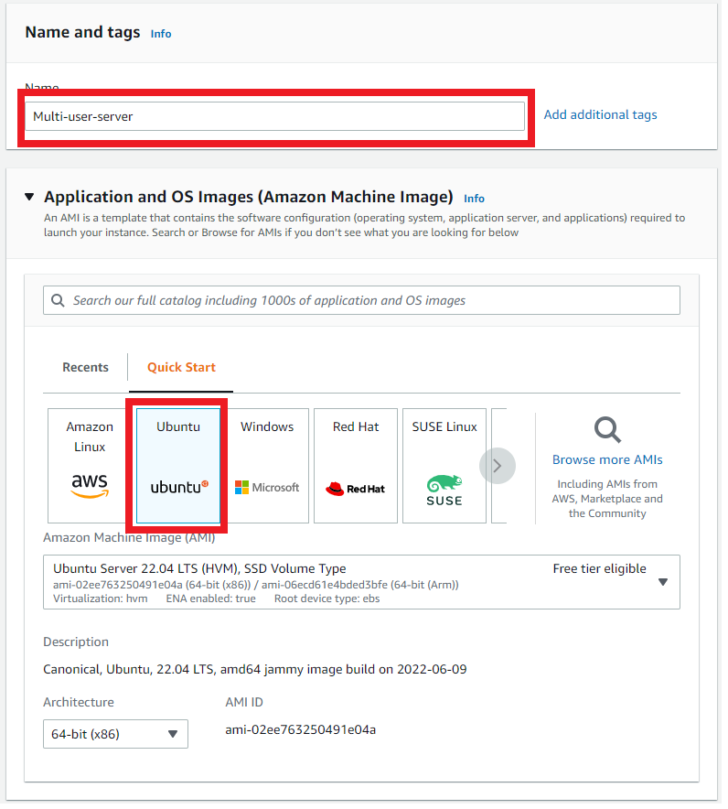Config EC2 with these options shown in these pictures below

Figure 57. AWS EC2 – Configure Operating System

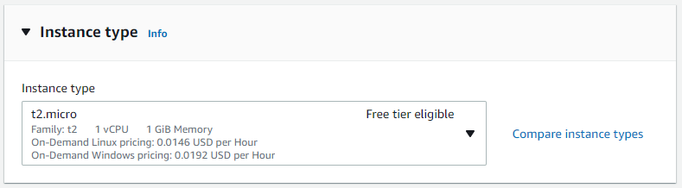

Figure 58. AWS EC2 – Configure instance type

* On Key pair section, choose **Create new key pair**

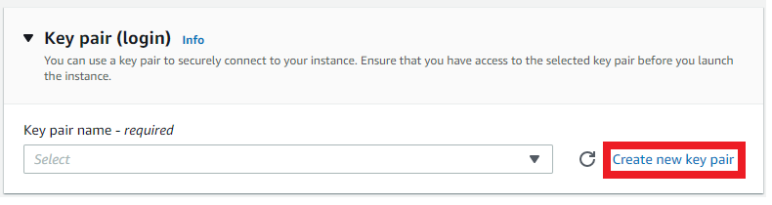

Figure 59. AWS EC2 -Generate key pair

* 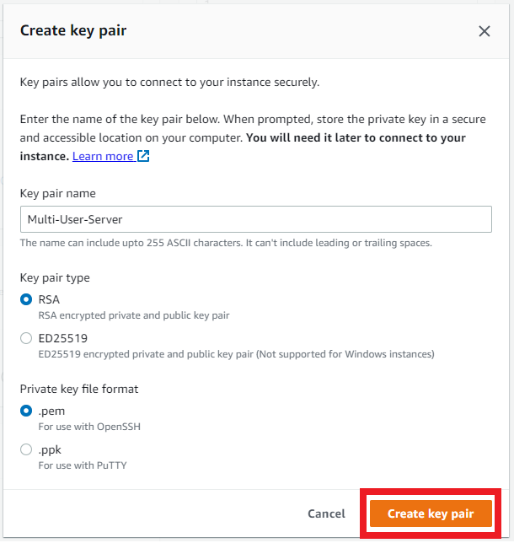Config key pair option like these options show in these pictures below. After that, press **Create key pair.** New .pem file will be downloaded to your computer. Save it for SSH access to EC2 instance.

Figure 60. AWS EC2 – confirm key pair

* On **Network settings** section, choose edit button.

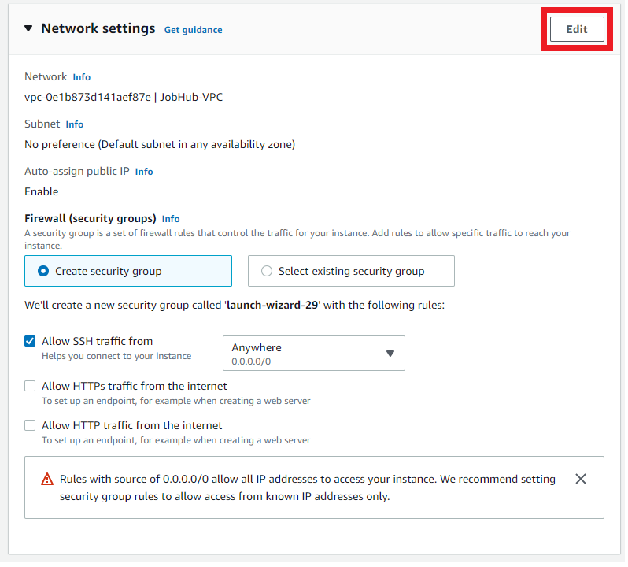

Figure 61. AWS EC2 – network setting

* Find **Inbound** **security group rules** section in **Network settings** section. Remove the first rule.

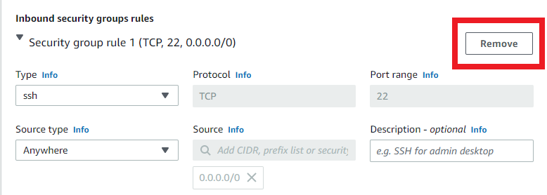

Figure 62. AWS EC2 – remove default security rule

* Press **Add security group rule** button

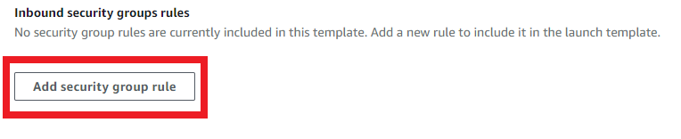

Figure 63. AWS EC2 – add new security rule

* Config the new rule with these options.

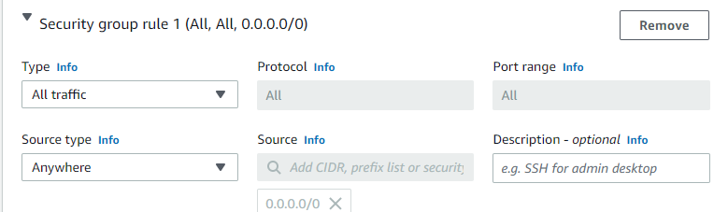

Figure 64. AWS EC2 – configure new security rule

* After finishing config EC2 instance, press Launch Instance

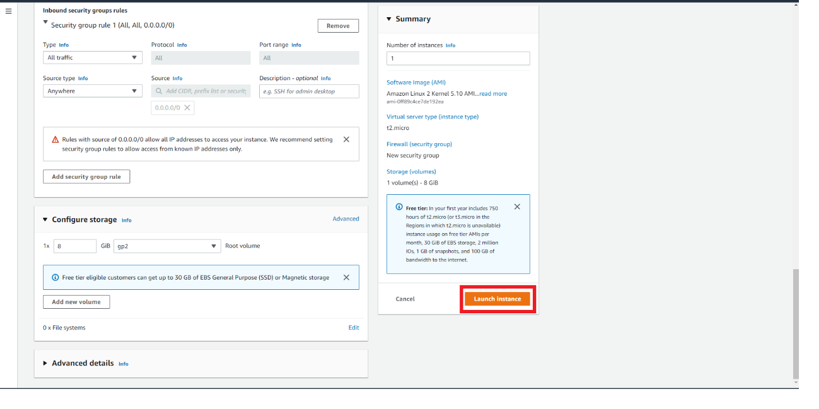

Figure 65. AWS EC2 – launch instance

* Press the instance id to go to this instance.

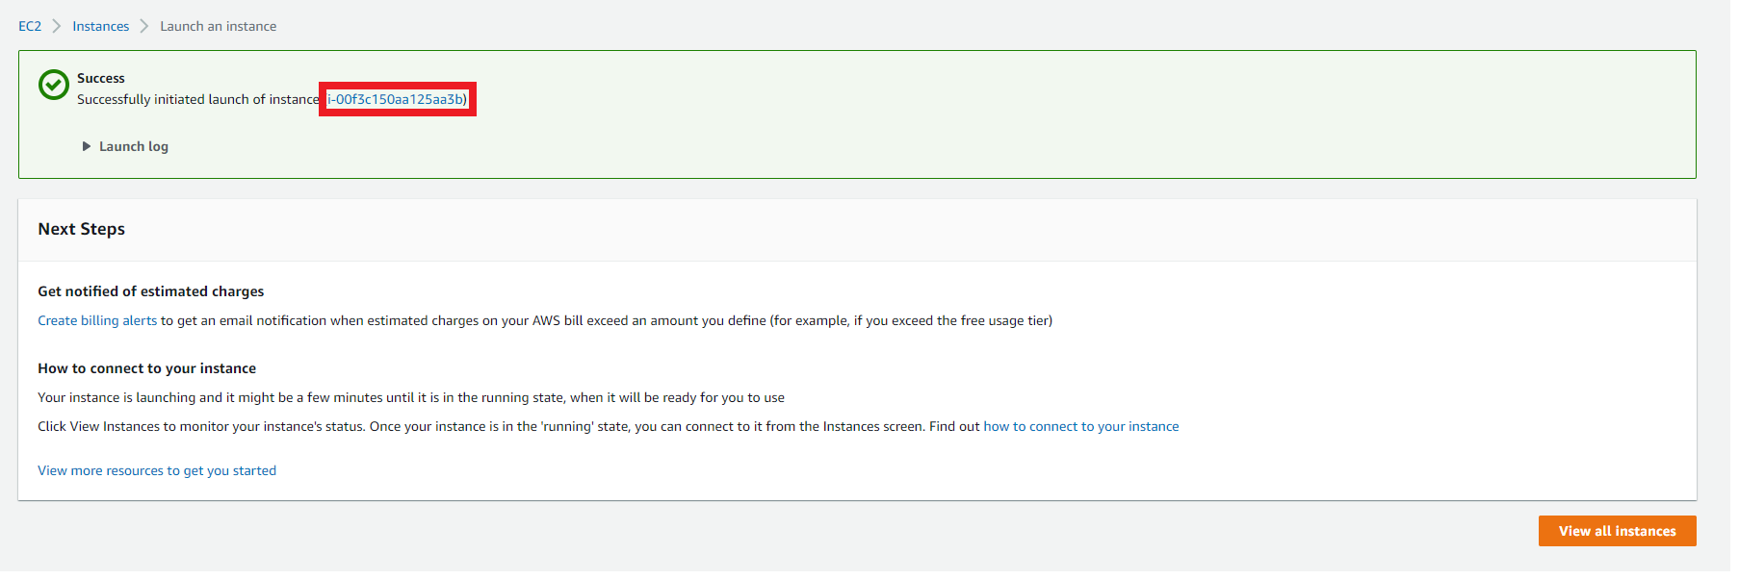

Figure 66. AWS EC2 – get instance ID

* Press instance id

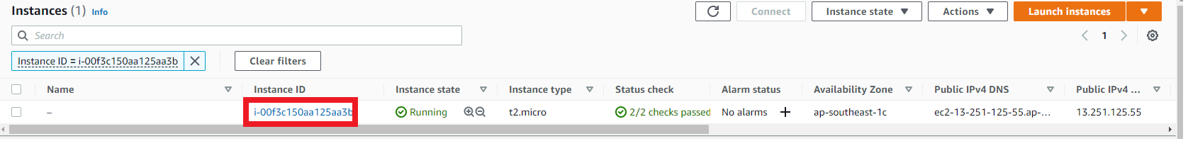

Figure 67. AWS EC2 – confirm instance ID

* Public IPv4 address is multiuser server IP address. Press connect to connect to server.

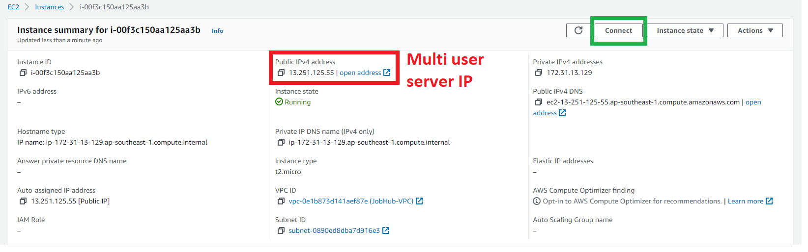

Figure 68. AWS EC2 – get instance IPv4

* 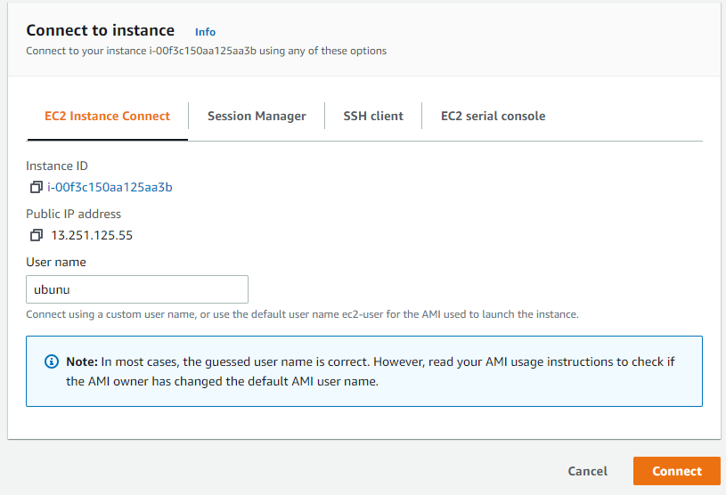Change username to ubuntu and press connect button

Figure 69. AWS EC2 – connect to instance’s console

* Run these commands to run game server

**git clone** [**https://github.com/jobfaironline/game-server.git**](https://github.com/jobfaironline/game-server.git)

**git checkout PRODUCTION**

**cd game-server**

**./install-script.sh**

**./run.sh**

* Multiuser server was successfully deployed



Figure 70. Multi-user server health check

#### Deploy Skill processor to EC2

* Repeat all steps in deploy Multiuser server except Run command to create a VM for skill processor.
* Run these commands to run Skill processor.

**git clone** [**https://github.com/jobfaironline/SkillProcessor.git**](https://github.com/jobfaironline/SkillProcessor.git)

**git checkout PRODUCTION**

**cd Skillprocessor**

**./install-script.sh**

**./run.sh**

* After running the script. Go to IP of the EC2. If Browser return health check ok, the Skill Processor has successfully been deployed.

#### 2.3.3 Deploy frontend to AWS S3

* Go to **AWS Console** and search for **S3**

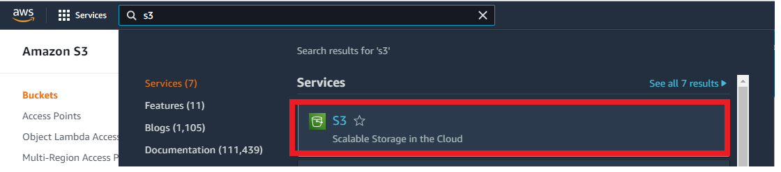

Figure 71. AWS S3 – access from console page

* Press **Create bucket** button

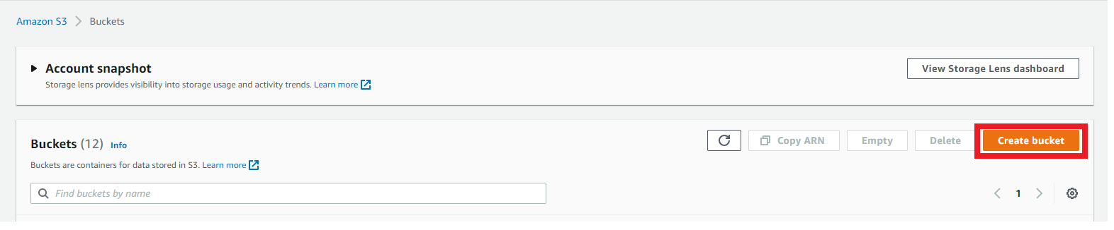

Figure 72. AWS S3 – create new bucket

* 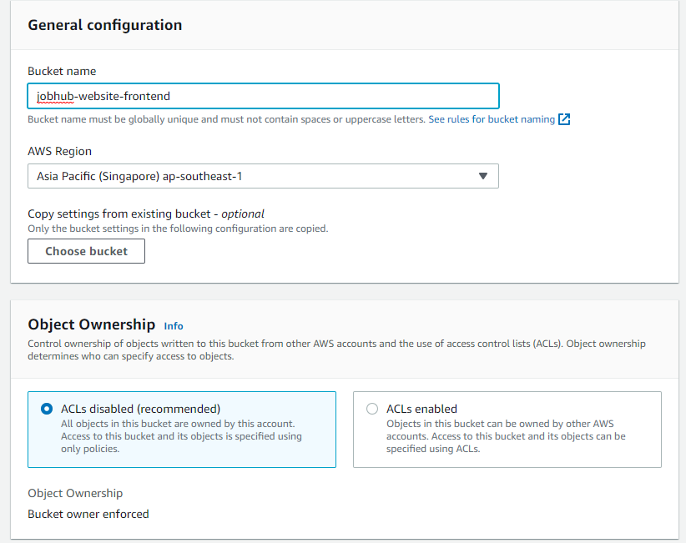Config S3 bucket like pictures shown below.

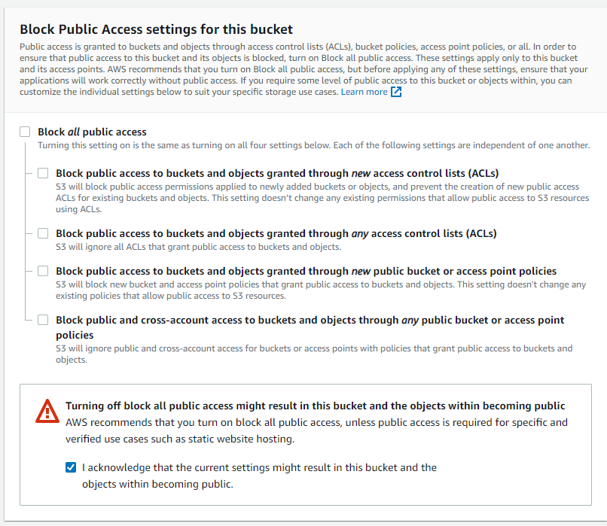

Figure 73. AWS S3 – configure bucket access rules

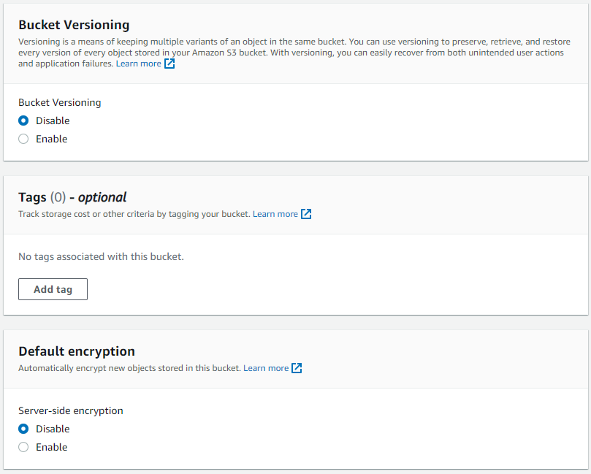

Figure 74 – AWS S3 – configure bucket rules

* After creating S3 Bucket. Go to this bucket

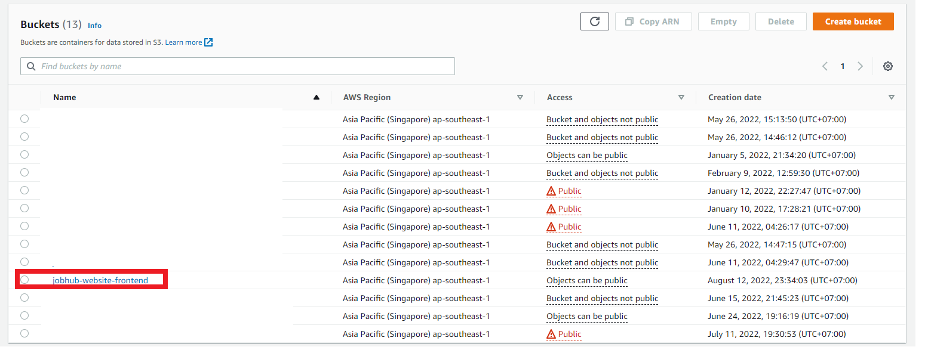

Figure 75. AWS S3 – Access new bucket

* Go to **Permission** tab

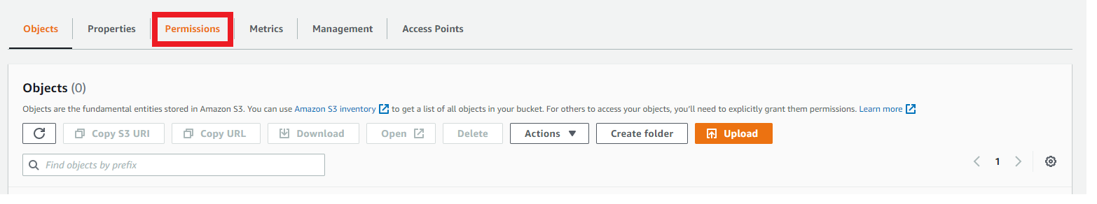

Figure 76. AWS S3 – access permissions tab

* Press **edit** on **Bucket policy** section and fill with this code bellow and press **Save change** at the end of page

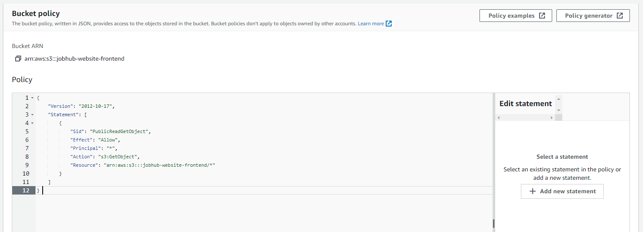

Figure 77. AWS S3 – edit permission rule

* Go back to **Object** tab. Press upload button on **object** tab

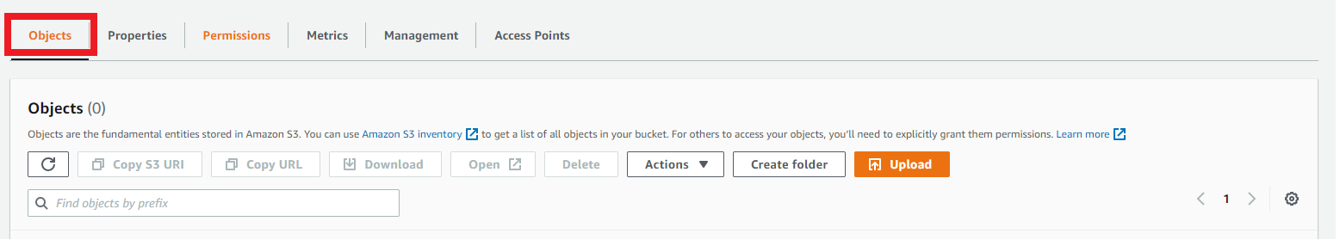

Figure 78. AWS S3 – access Objects tab

* 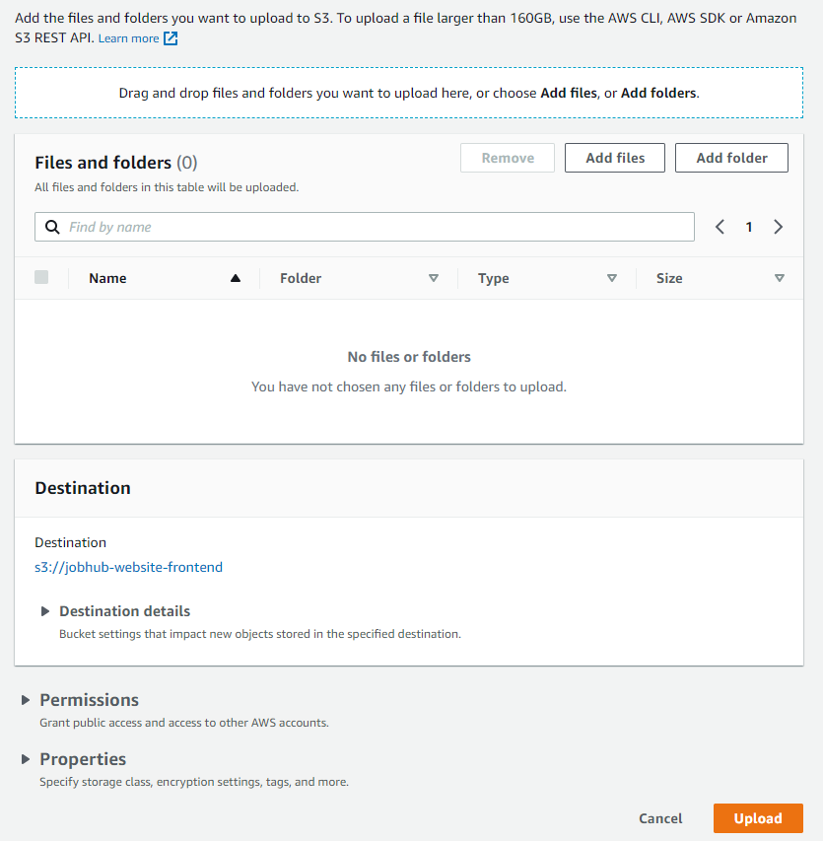Upload all file in build folder of **jobhub-frontend** folder, after that. Press **upload**.

Figure 79. AWS S3 – upload FE code

* After upload all file to S3, go to **Properties** tab. And scroll down to **Static Website hosting** section at the end of the page. And press **Edit** button



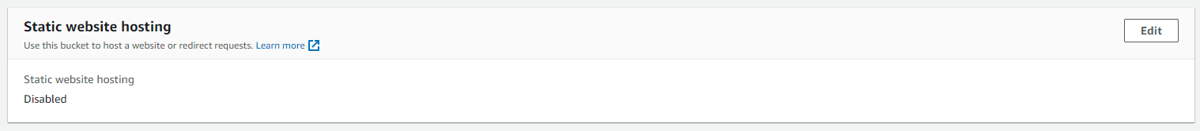

Figure 80. AWS S3 – configure static website hosting

* 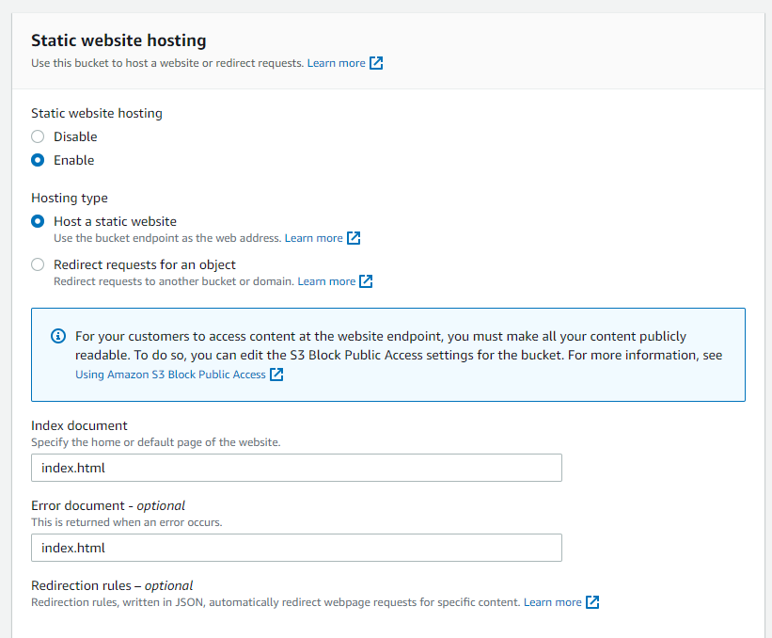Change option to enable and config these option like the picture below. And press **Save change** button at the end of page.

Figure 81. AWS S3 – configure static website hosting

* After enabling static website hosting of S3. Scroll down to **Static website hosting** again. There will be an URL for frontend website.

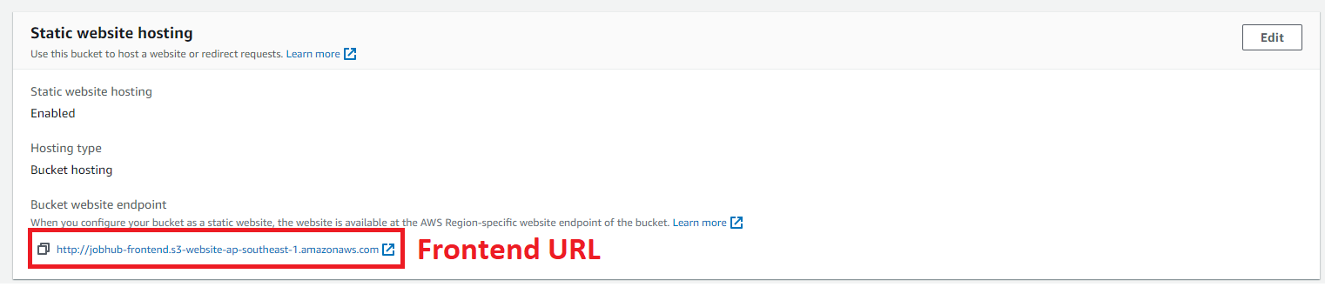

Figure 82. AWS S3 – get front-end URL

* Frontend has successfully been loaded

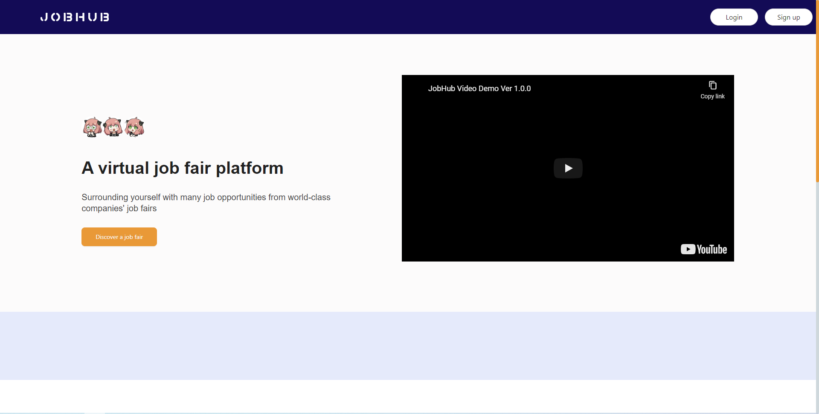

Figure 83. AWS S3 – access front-end URL

## 3. User Manual

### 3.1 Feature 1 – Organize job fair

#### Step 1: After login successfully, company managers click on “My company job fairs” tab

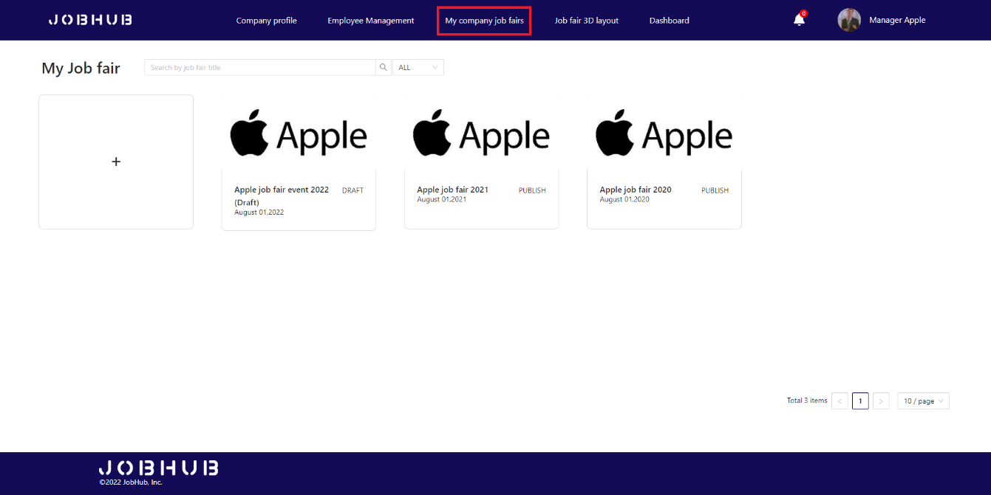

Figure 84. Organize job fair – Access “My company job fairs” page

#### Step 2: Company managers click on the plus icon to start organizing a job fair

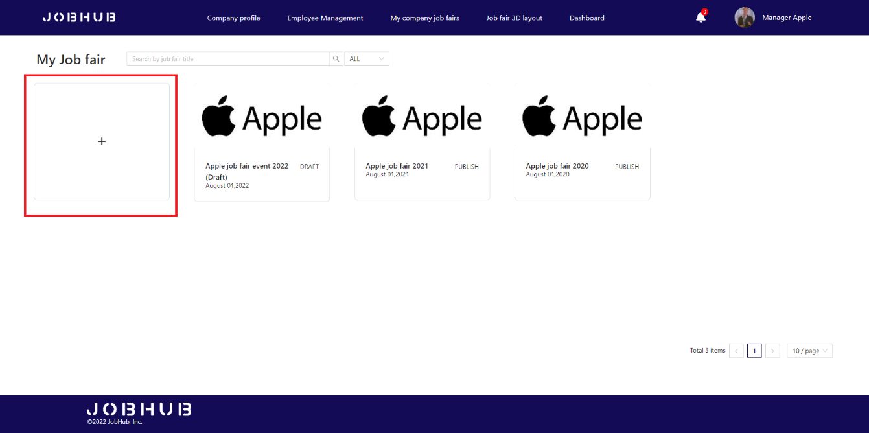

Figure 85. Organize job fair – Create new job fair

#### Step 3: Choose job fair layout

* In the “**Choose job fair layout**” screen.
* If company managers decide to use default layout of the system, they can click “**Use default template**” and choose the default layout below:

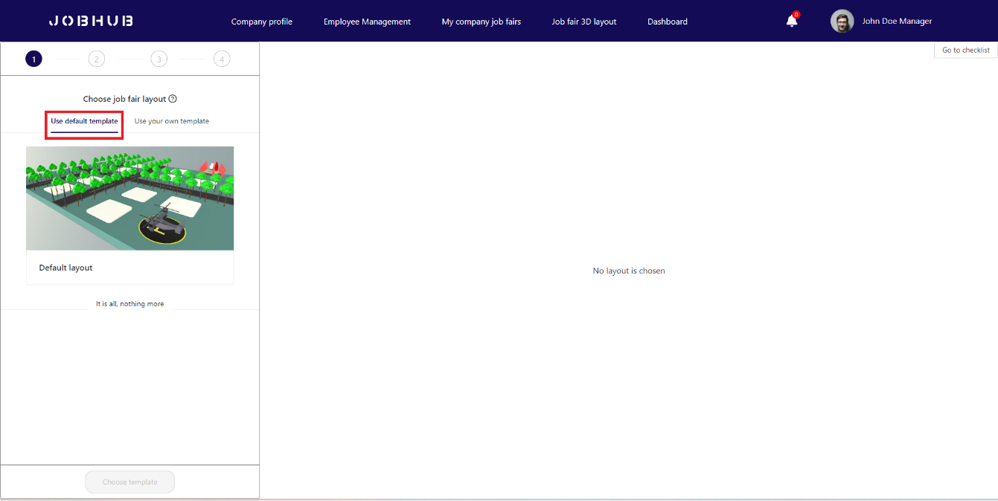

Figure 86. Organize job fair- Use default layout

* Company managers can click on “**Choose template**” button to choose template and move to next steps.

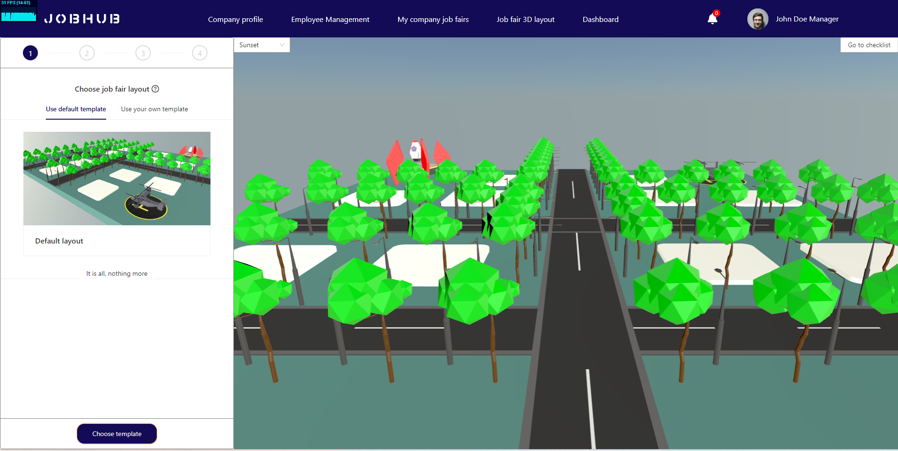

Figure 87. Organize job fair – Review layout

* **[Alternative]** - If company managers want to upload their template, they can click **“Use your own template**” to upload new company’s template, then click on “**Upload template**” button:

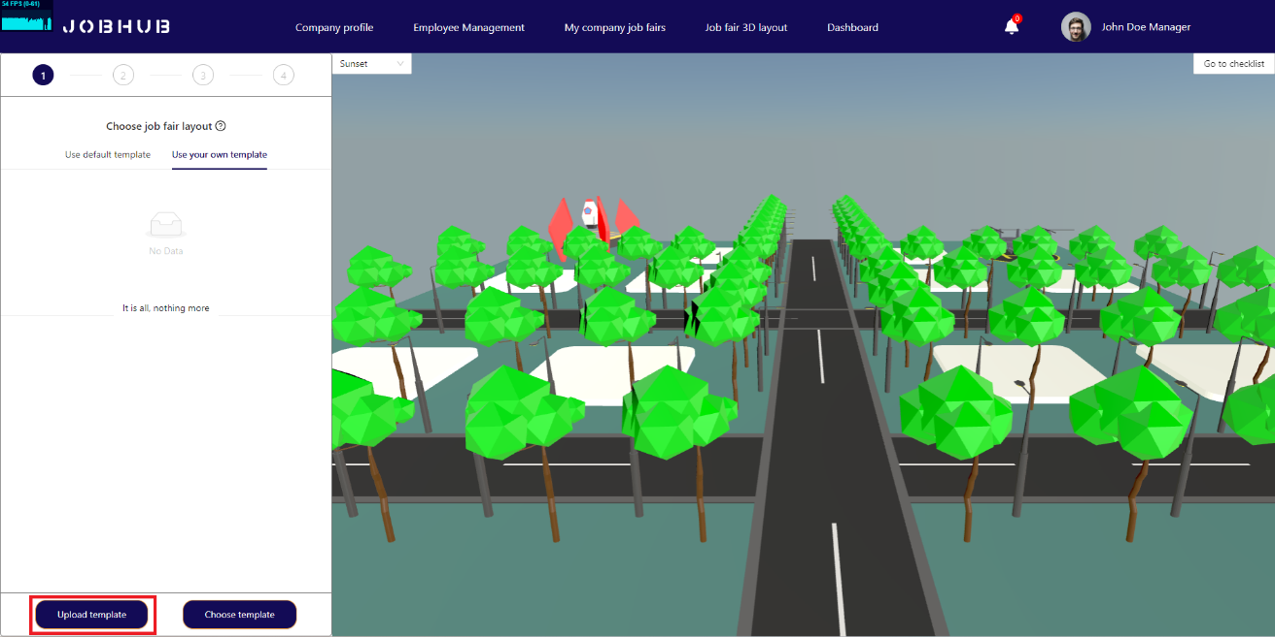

Figure 88. Organize job fair – Upload new layout

* A pop-up will appear and require some information about the layout such as: Layout name, description, glb file and layout thumbnail.

*Note: glb file must follow some rules for being able to process*.

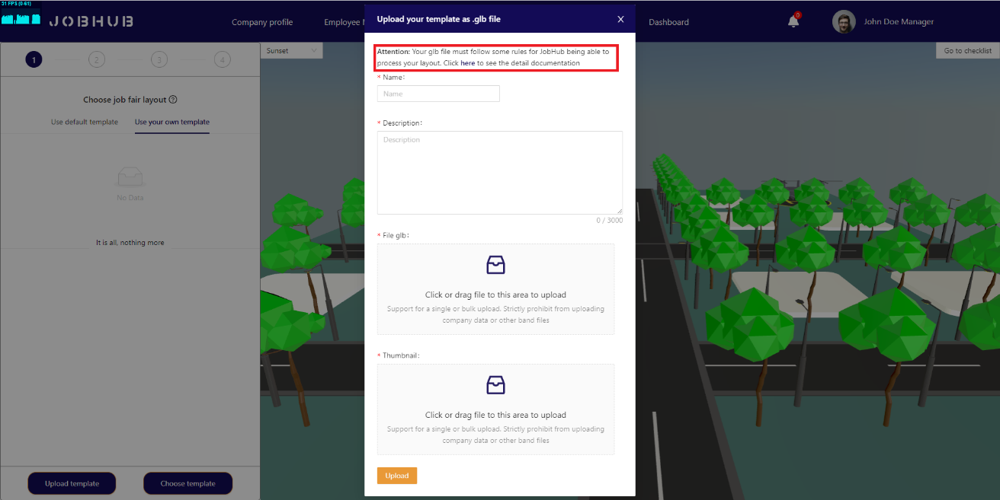

Figure 89. Organize job fair – GLB rules

* After upload template successfully, company mangers can choose the uploaded template and click “**Choose template**” button to move on next step:

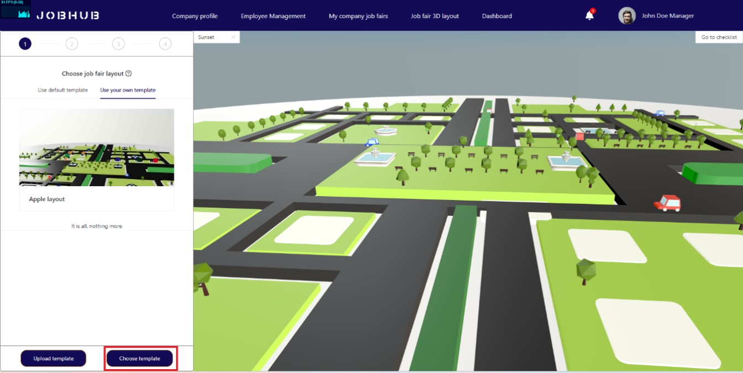

Figure 90. Organize job fair – Confirm choose layout

#### Step 4: Schedule job fair event

* In the “**Schedule job fair event**”, company managers need to provide about job fair, such as: Job fair name, time range for decoration booth, time range for public job fair, and time range for morning shift and afternoon shift of company employees.

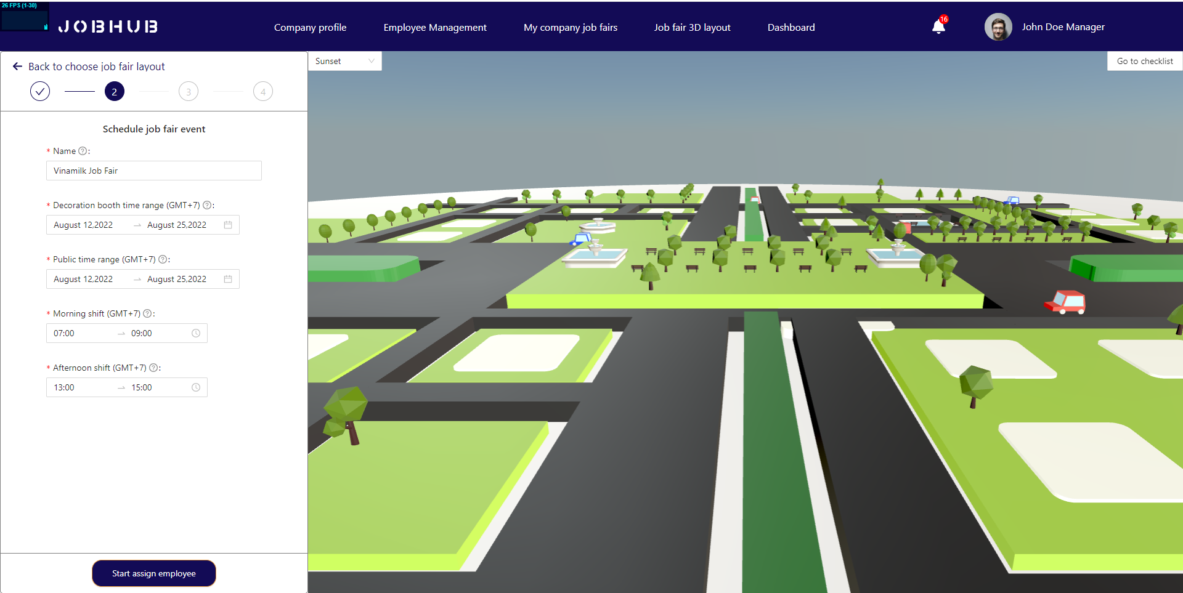

Figure 91. Organize job fair – Schedule job fair event

#### Step 5: Assign employees to booth

* Company managers can assign employees to multiple booths at the same time by uploading CSV file, and each booth requires **at least 4 employees** (**1 supervisor, 1 decorator and 2 staffs**).

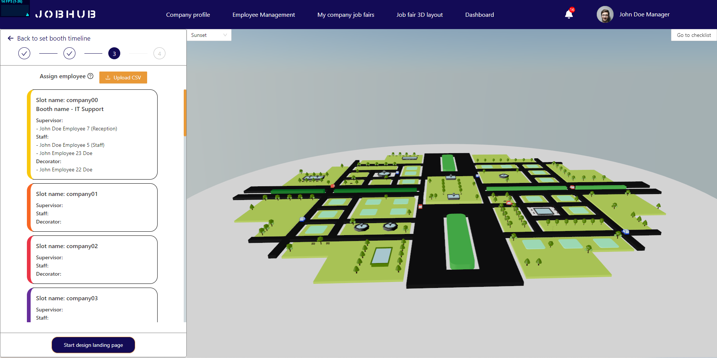

Figure 92. Organize job fair – Assign employees

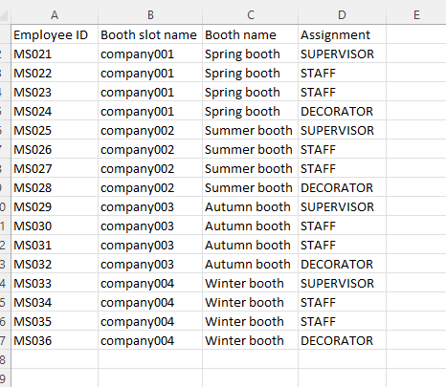

Figure 93. Organize job fair – Assign employees CSV format

* Company manager can click on “**Start design landing page**” to move on next step.

#### Step 6: Design landing page

* Company managers can design the landing page for job fair, by providing: Job fair thumbnail, target attendant and job fair description. They can preview landing page by clicking eye icon:

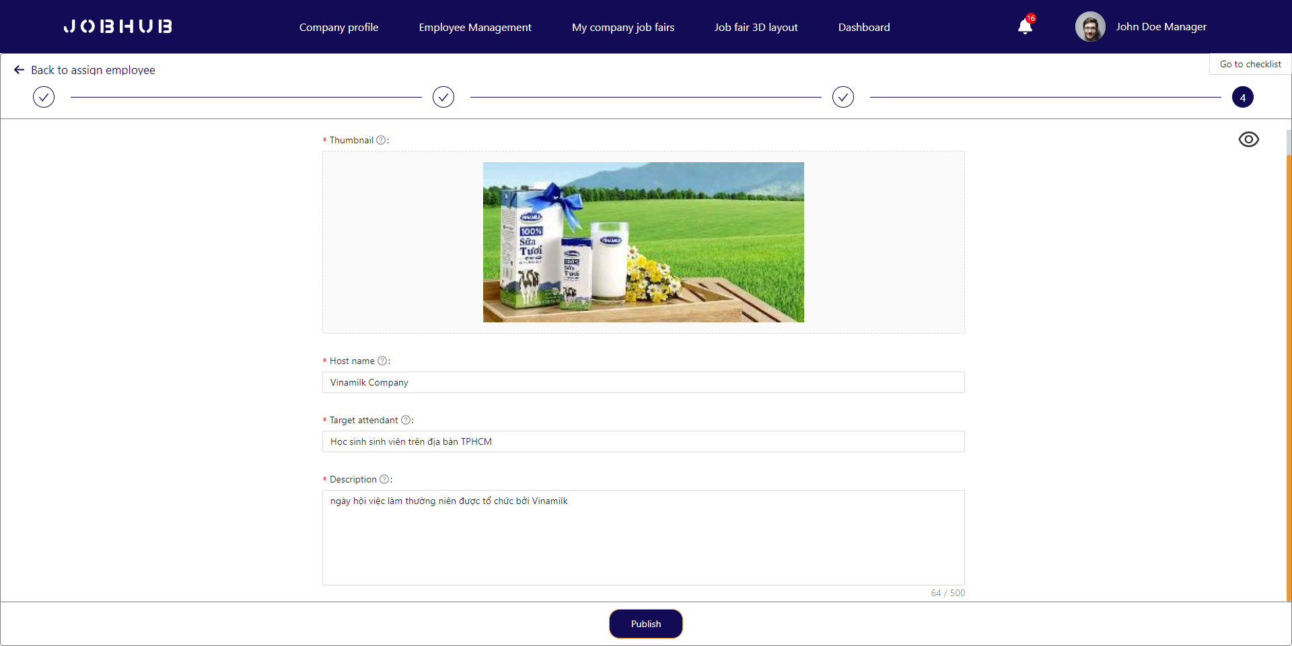

Figure 94. Organize job fair – Design landing page

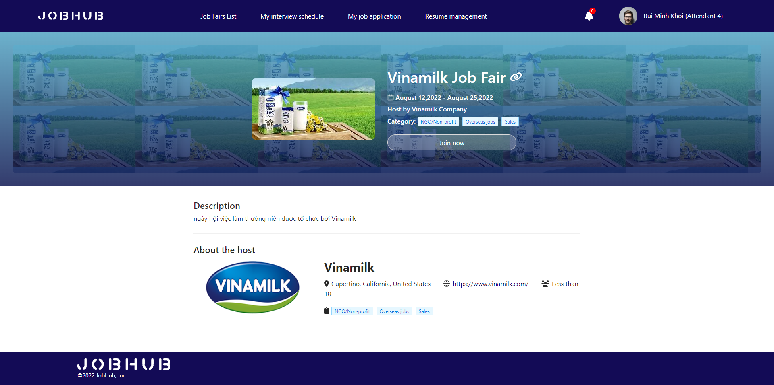

Figure 95. Organize job fair – Review landing page

#### Step 7: Confirm all information and publish job fair

* After organizing steps, company managers are required to confirm all information before publish job fair.
* If there is any mistake when organizing, they can move back to each step and fix.
* If everything is confirmed, they can publish the job fair by clicking “**Publish**” button.

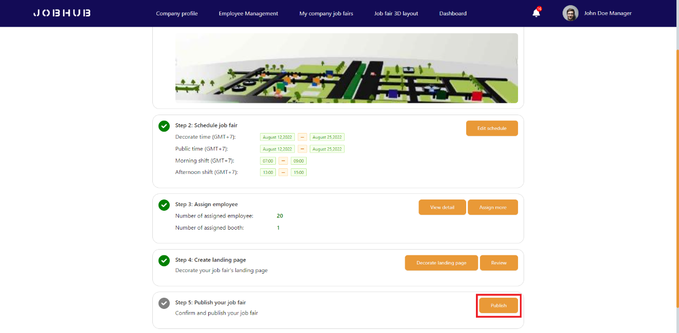

Figure 96. Organize job fair – Publish job fair

* Confirm all information, then click “**Confirm**” button:

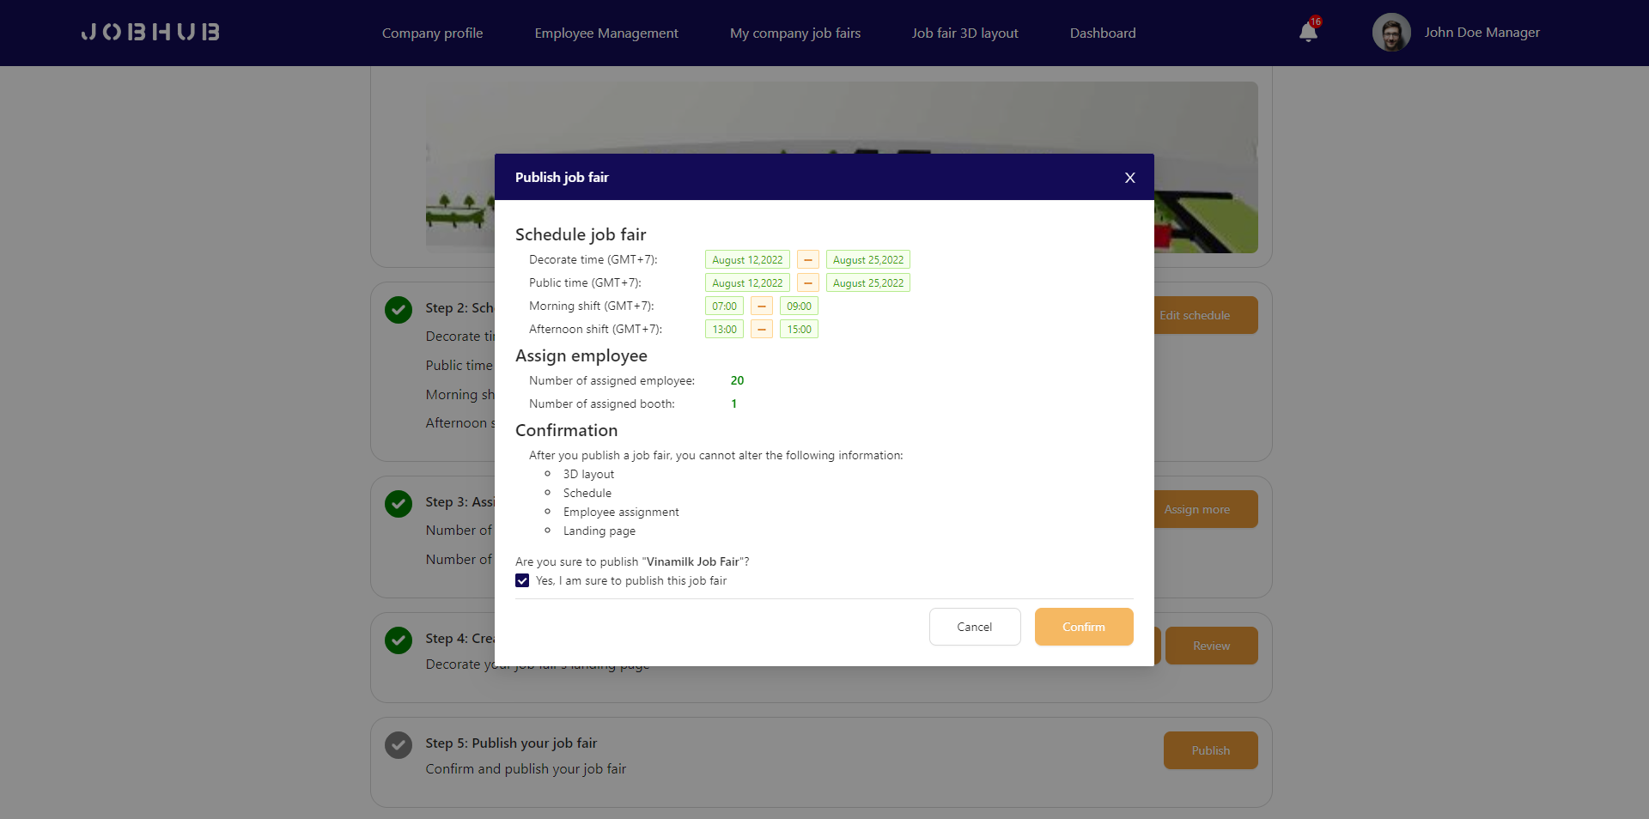

Figure 97. Organize job fair – Confirm publish job fair

* There is the new job fair has been published successfully:

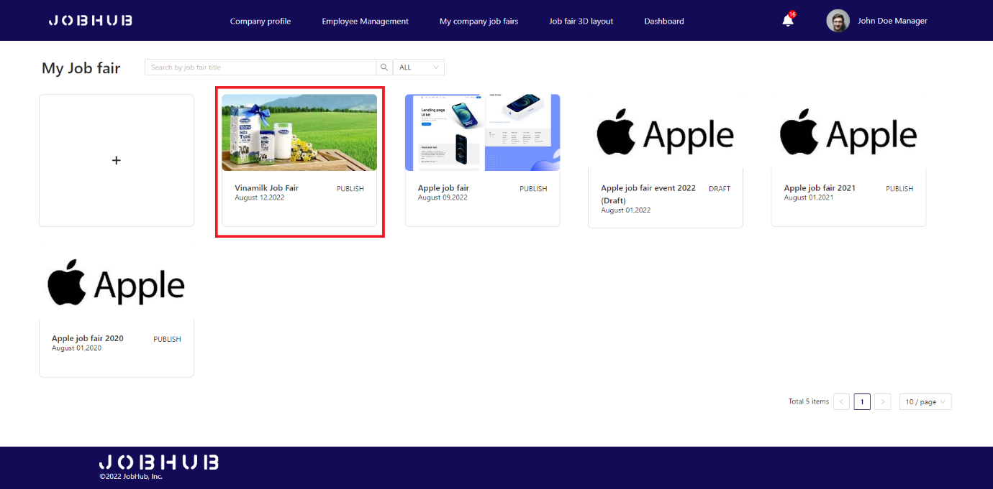

Figure 98. Organize job fair – Created job fair

### 3.2 Feature 2 – Decorate job fair booth

#### Step 1: Supervisor – Fill booth information and job positions for booth

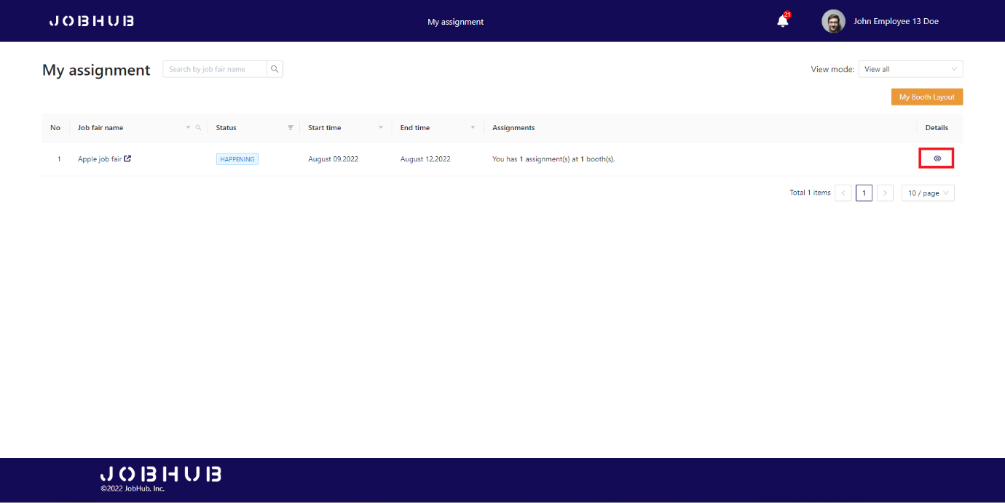

Figure 99. Decorate job fair booth – Supervisor task

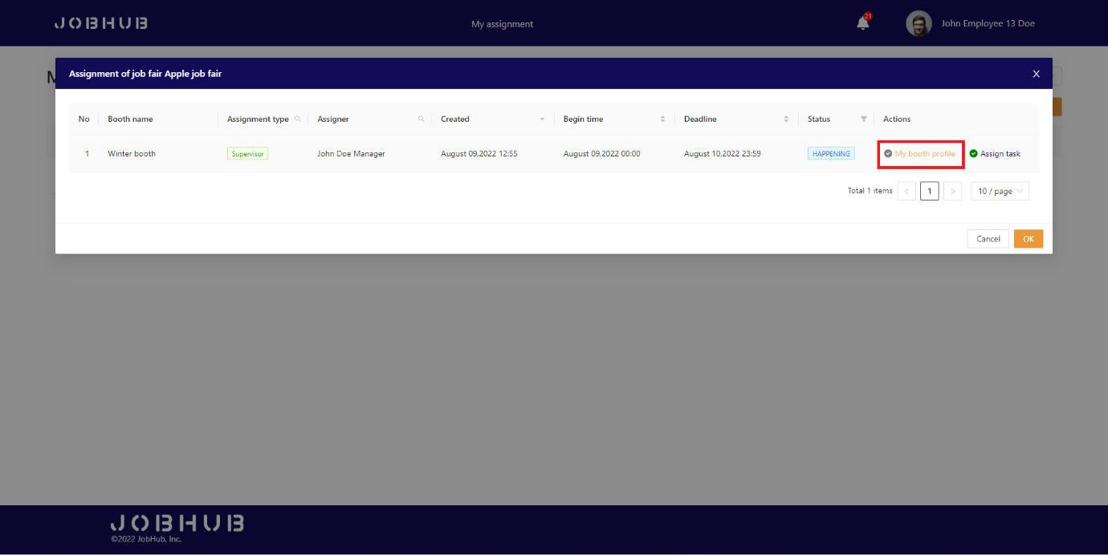

Figure 100. Decorate job fair booth – Supervisor access fill booth information task

#### Step 2: Supervisors need to add some information of booth like booth name, booth description and add some job positions to booth

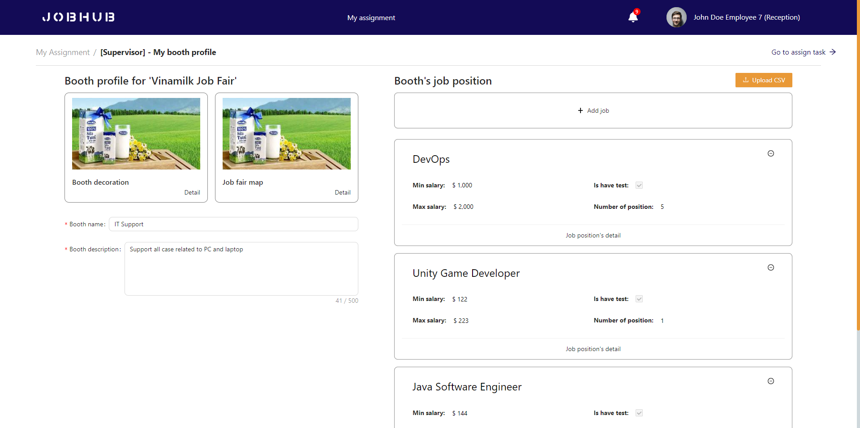

Figure 101. Decorate job fair booth – Booth information page

#### Step 3: Supervisors can add job position detail

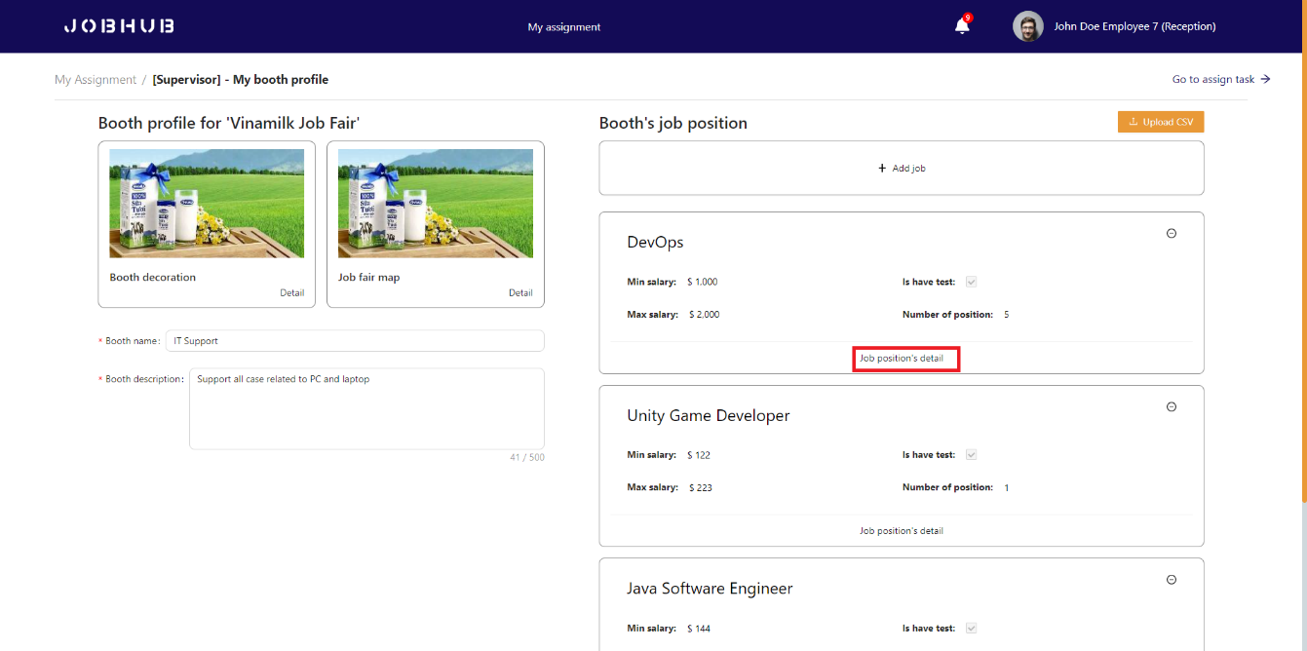

Figure 102. Decorate job fair booth – Booth job position detail

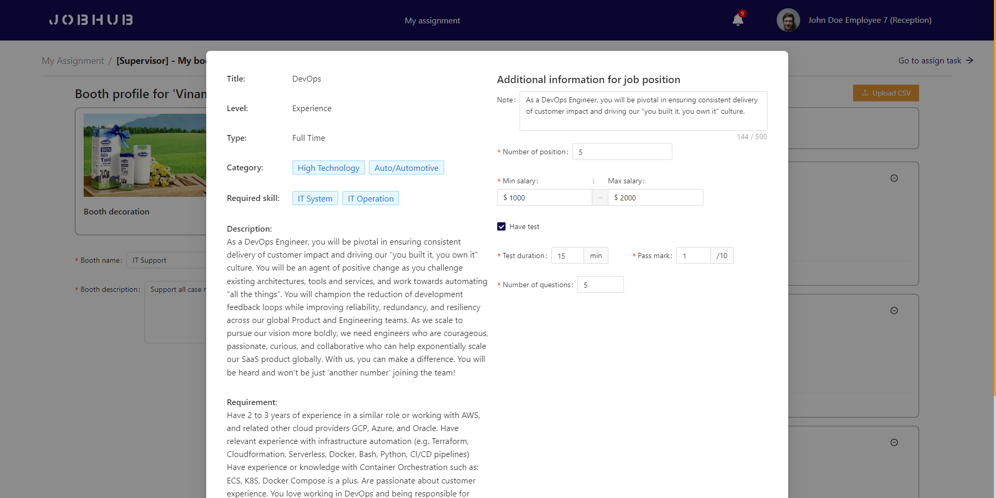

Figure 103. Decorate job fair booth – Fill booth job position detail

#### Step 4: Supervisor – Assign staff to morning and afternoon shifts

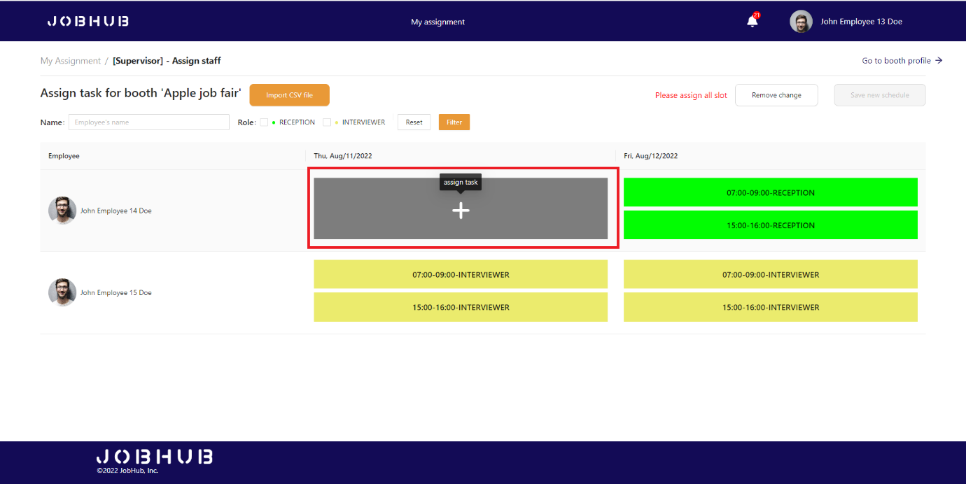

Figure 104. Decorate job fair booth – Supervisor assign task

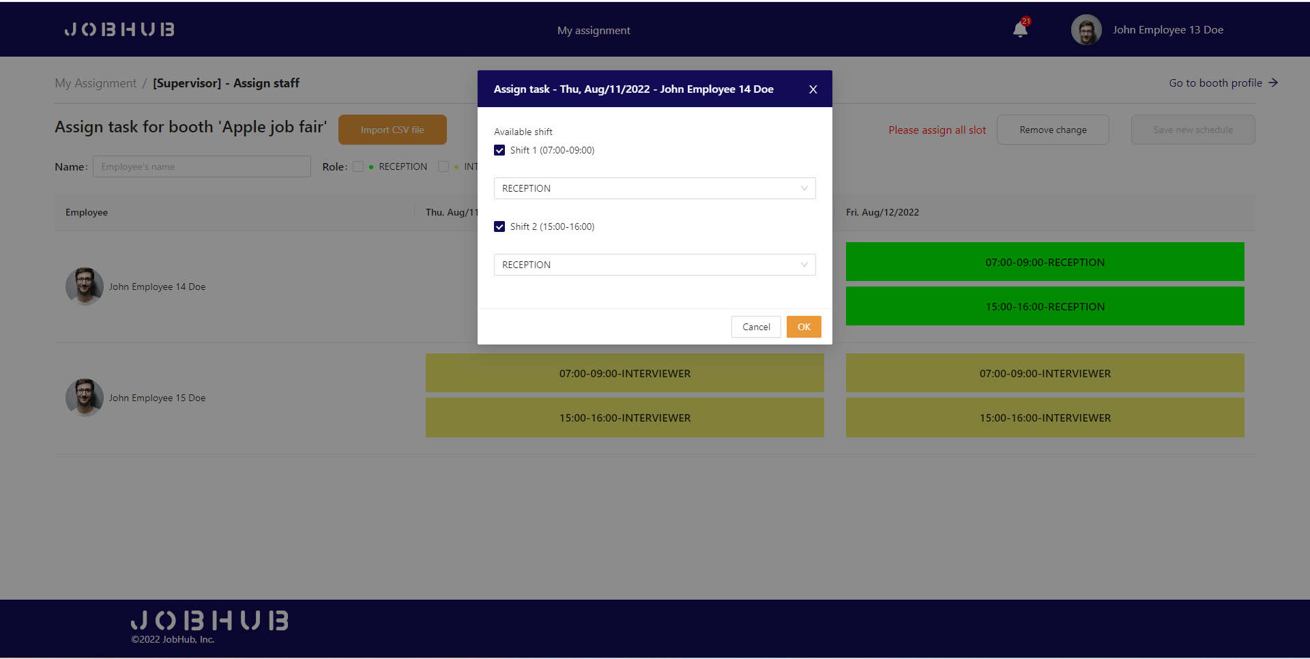

Figure 105. Decorate job fair booth – Supervisor assign task manually

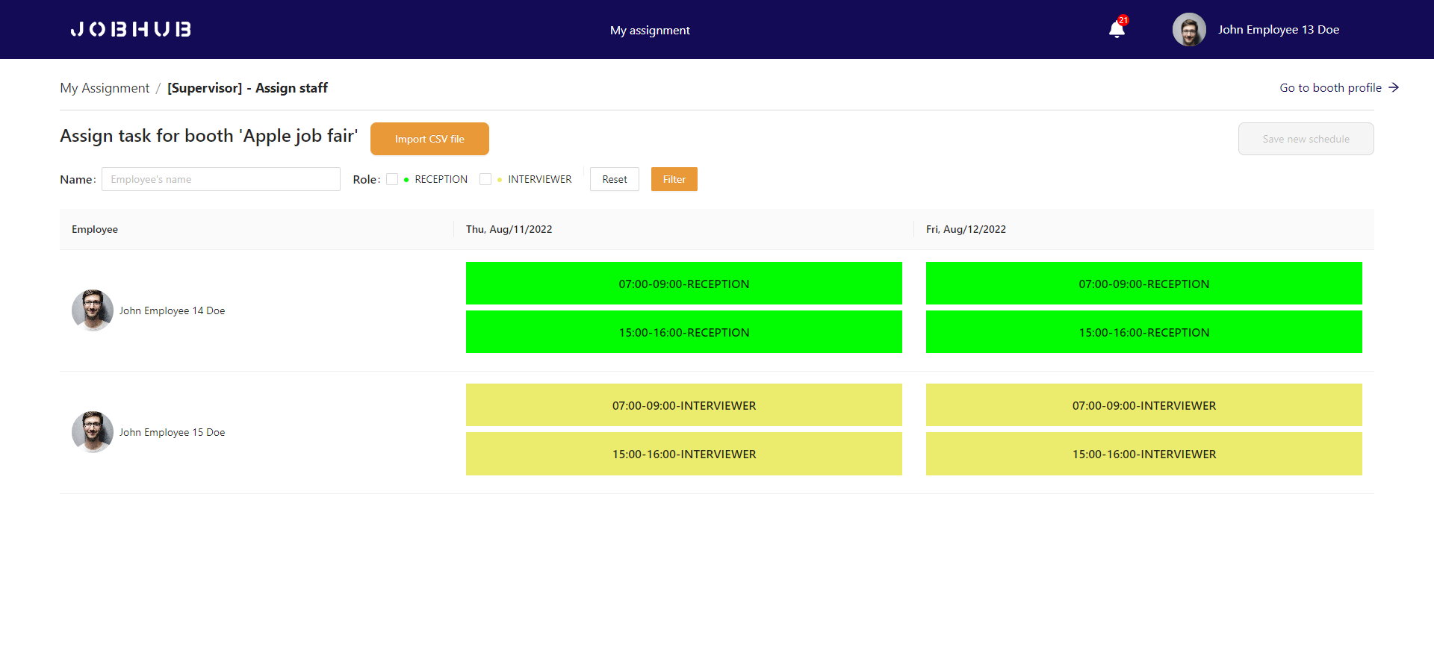

Figure 106. Decorate job fair booth – Supervisor confirm assign task

#### Step 5: Decorator – decorate booth

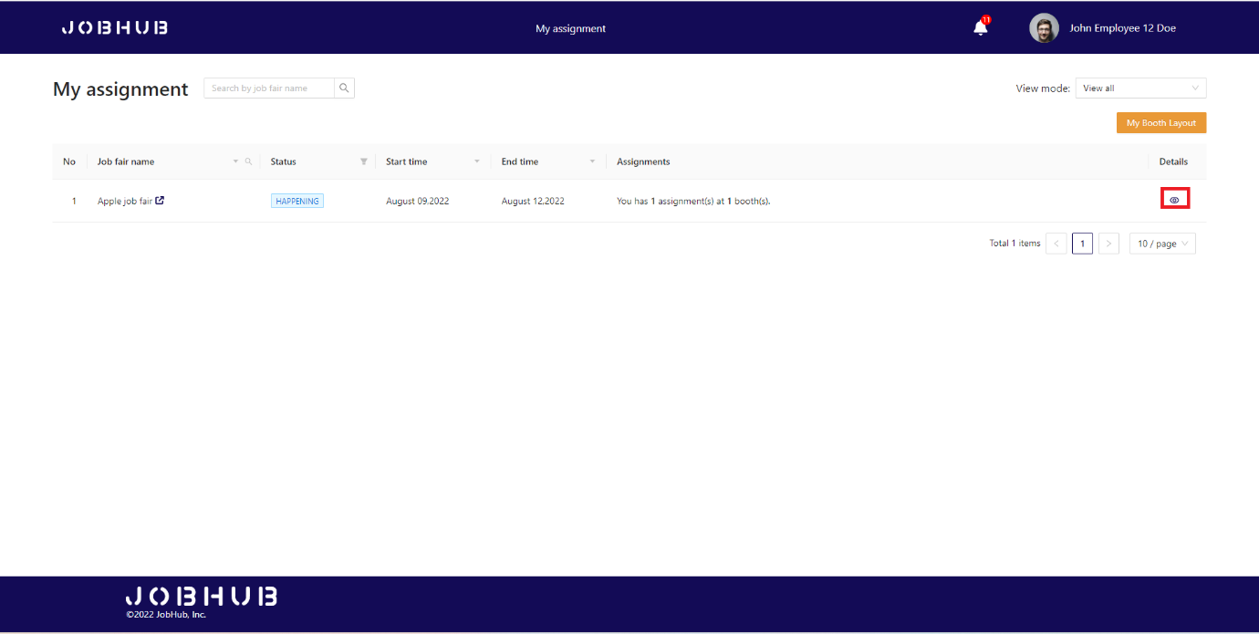

Figure 107. Decorate job fair booth – Decorator access decorate tasks

* Decorators click on “**Start decorate booth**” link to start booth decoration.

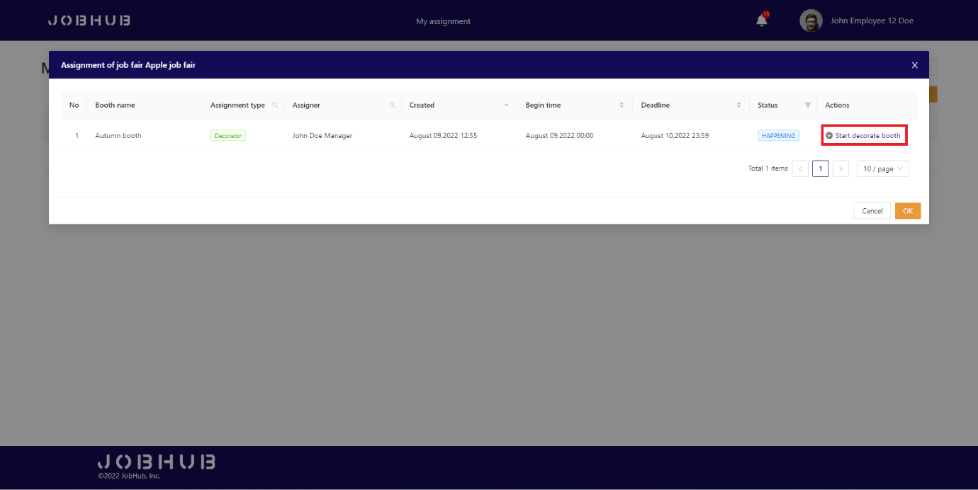

Figure 108. Decorate job fair booth – Decorator access decorate page

* Decorator can add more component to booth by clicking “**Add more component**” button.

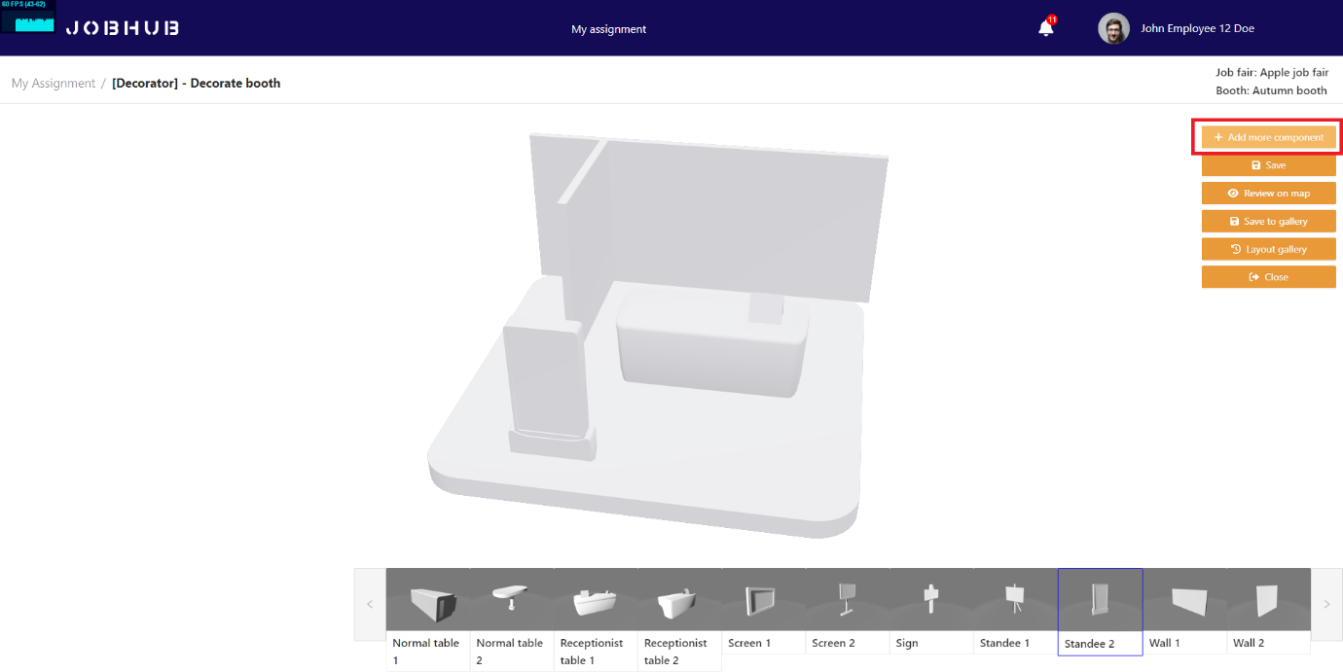

Figure 109. Decorate job fair booth – Decorator add more 3d component

* Decorator can also add colour to components.

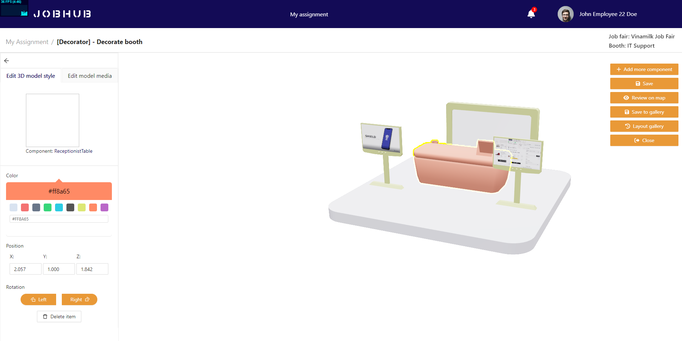

Figure 110. Decorate job fair booth – Decorator save decoration

* After finish decorate booth, decorator can click “**Save**” button to save their progress. When it finishes, click "**Review on map**” button to view the booth on the map.

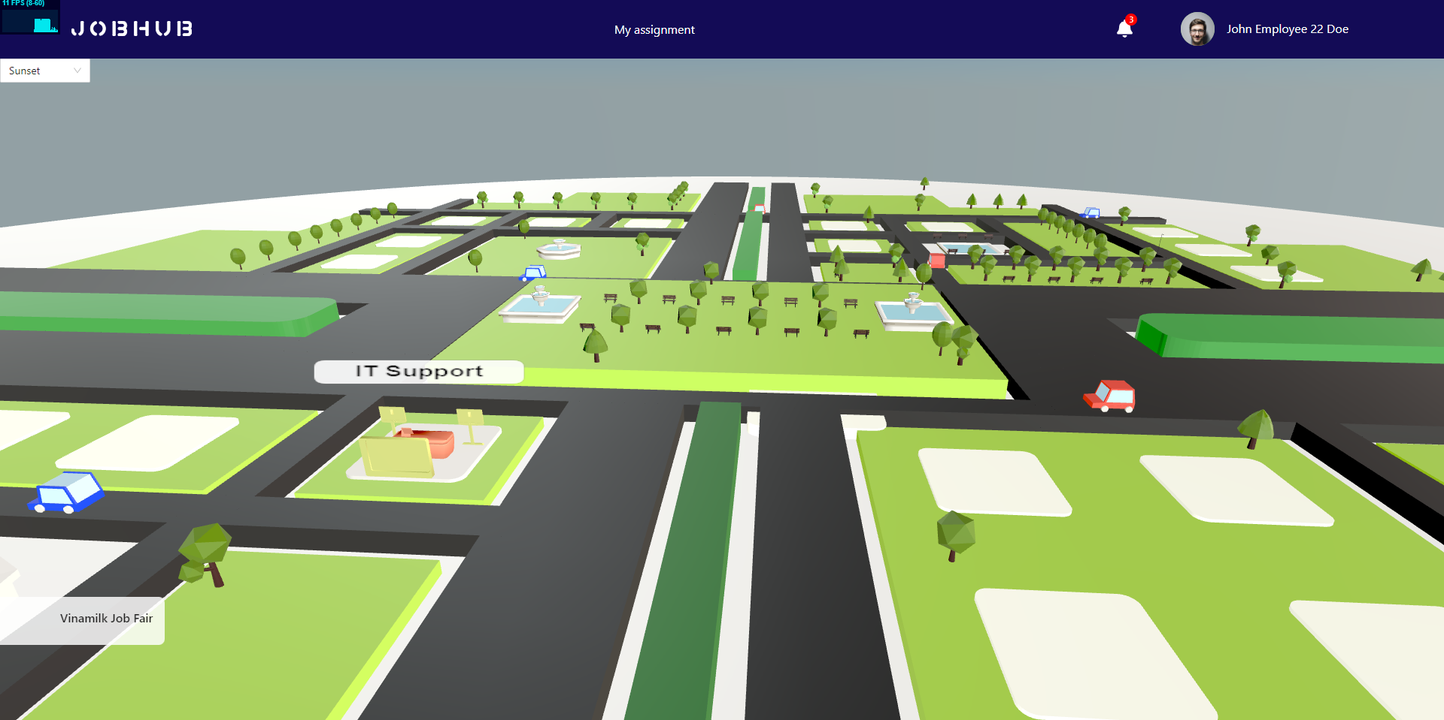

Figure 111. Decorate job fair booth – Decorator review decoration on map

### 3.3 Feature 3 – Attendant join job fair & Apply resume to job position

#### Step 1: Receptionist join job fair booth by clicking “Go to booth” link

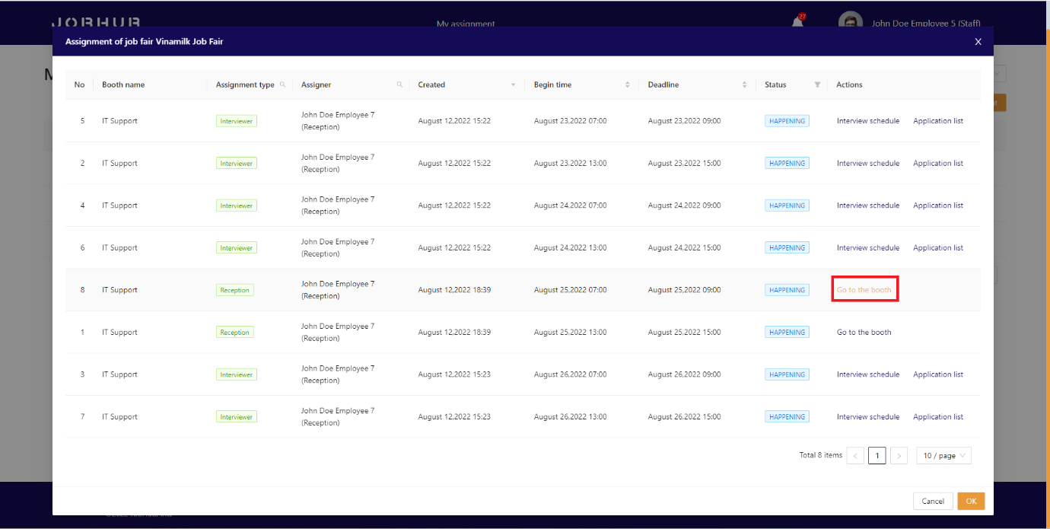

Figure 112. Receptionist joins 3D booth

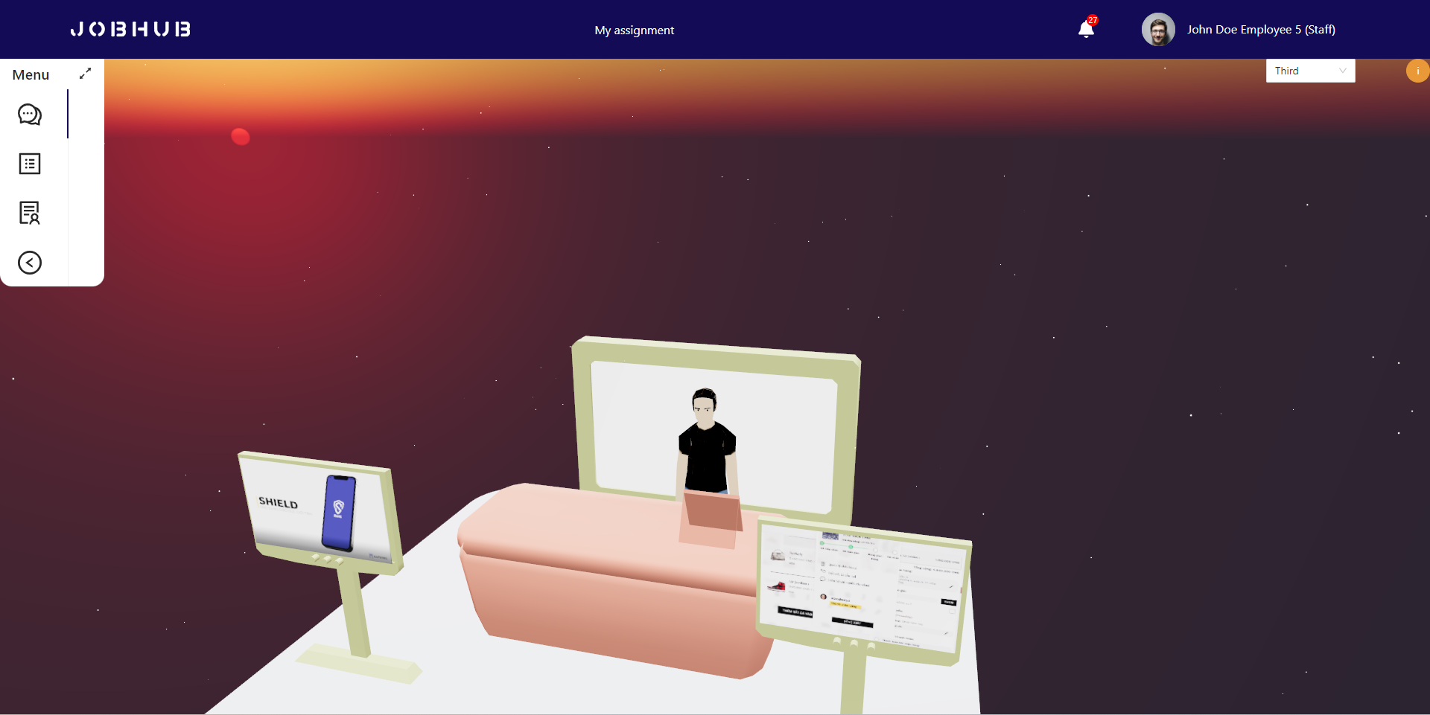

Figure 113. Receptionist waits for attendants

#### Step 2: Attendant go to “Job fair list” tab and select 1 job fair

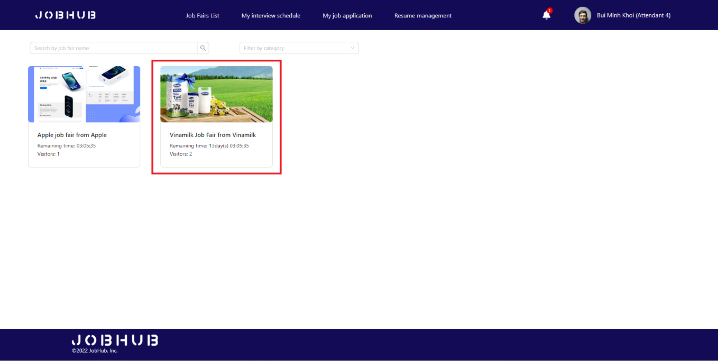

Figure 114. Attendant accesses job fair list

#### Step 3: At the landing page, attendant can click “Join now” to join job fair



Figure 115. Attendant accesses job fair’s landing page

#### Step 4: At the job fair map, attendant can preview all available booths in job fair. They can click on the booth to visit

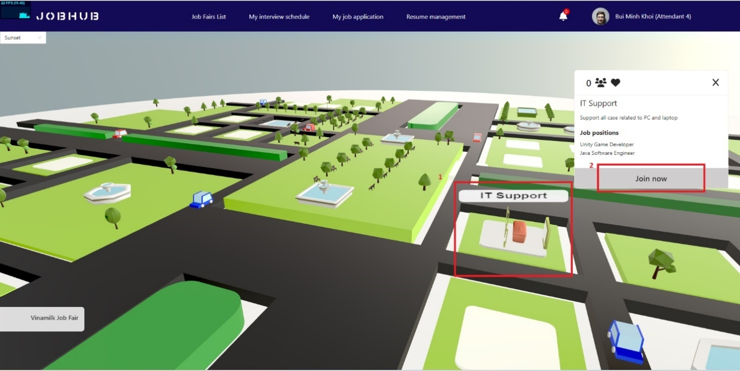

Figure 116. Attendant joins booth

***In the booth***:

* Switch to tab 1, attendant can interact with receptionist via video call and chat box.

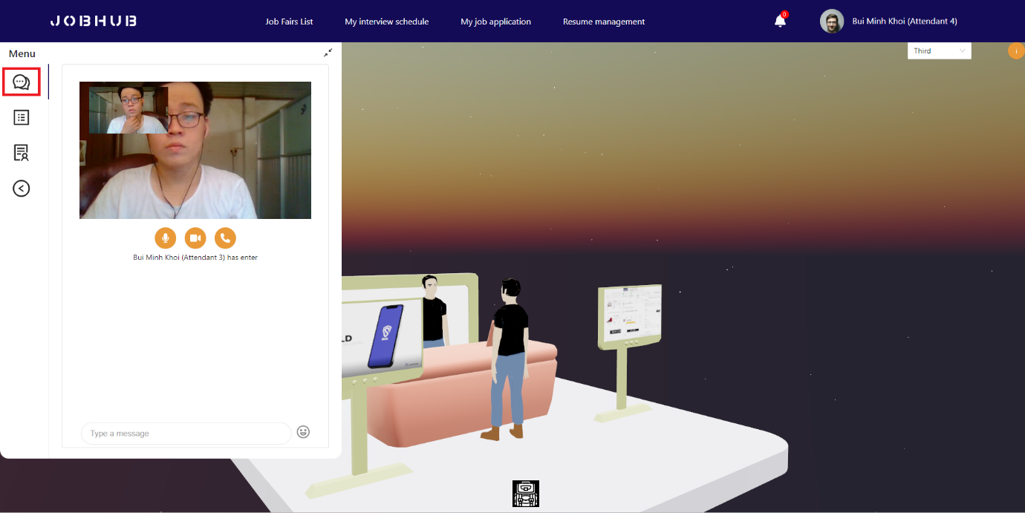

Figure 117. Attendant communicates with receptionist

* Switch to second tab, attendant can get company information.

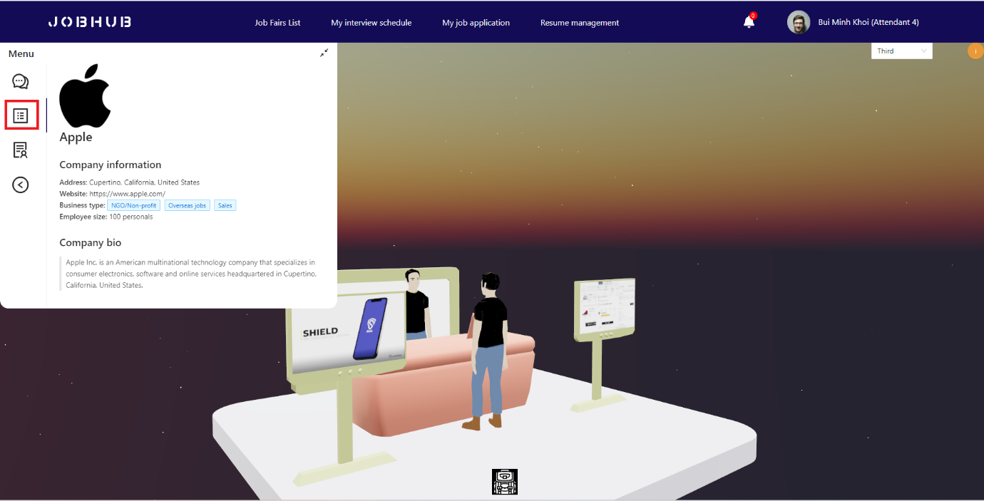

Figure 118. Attendant checks for company information

* Switch to tab 3, attendant can click on a job position to view detail, then drag cv to apply that job.

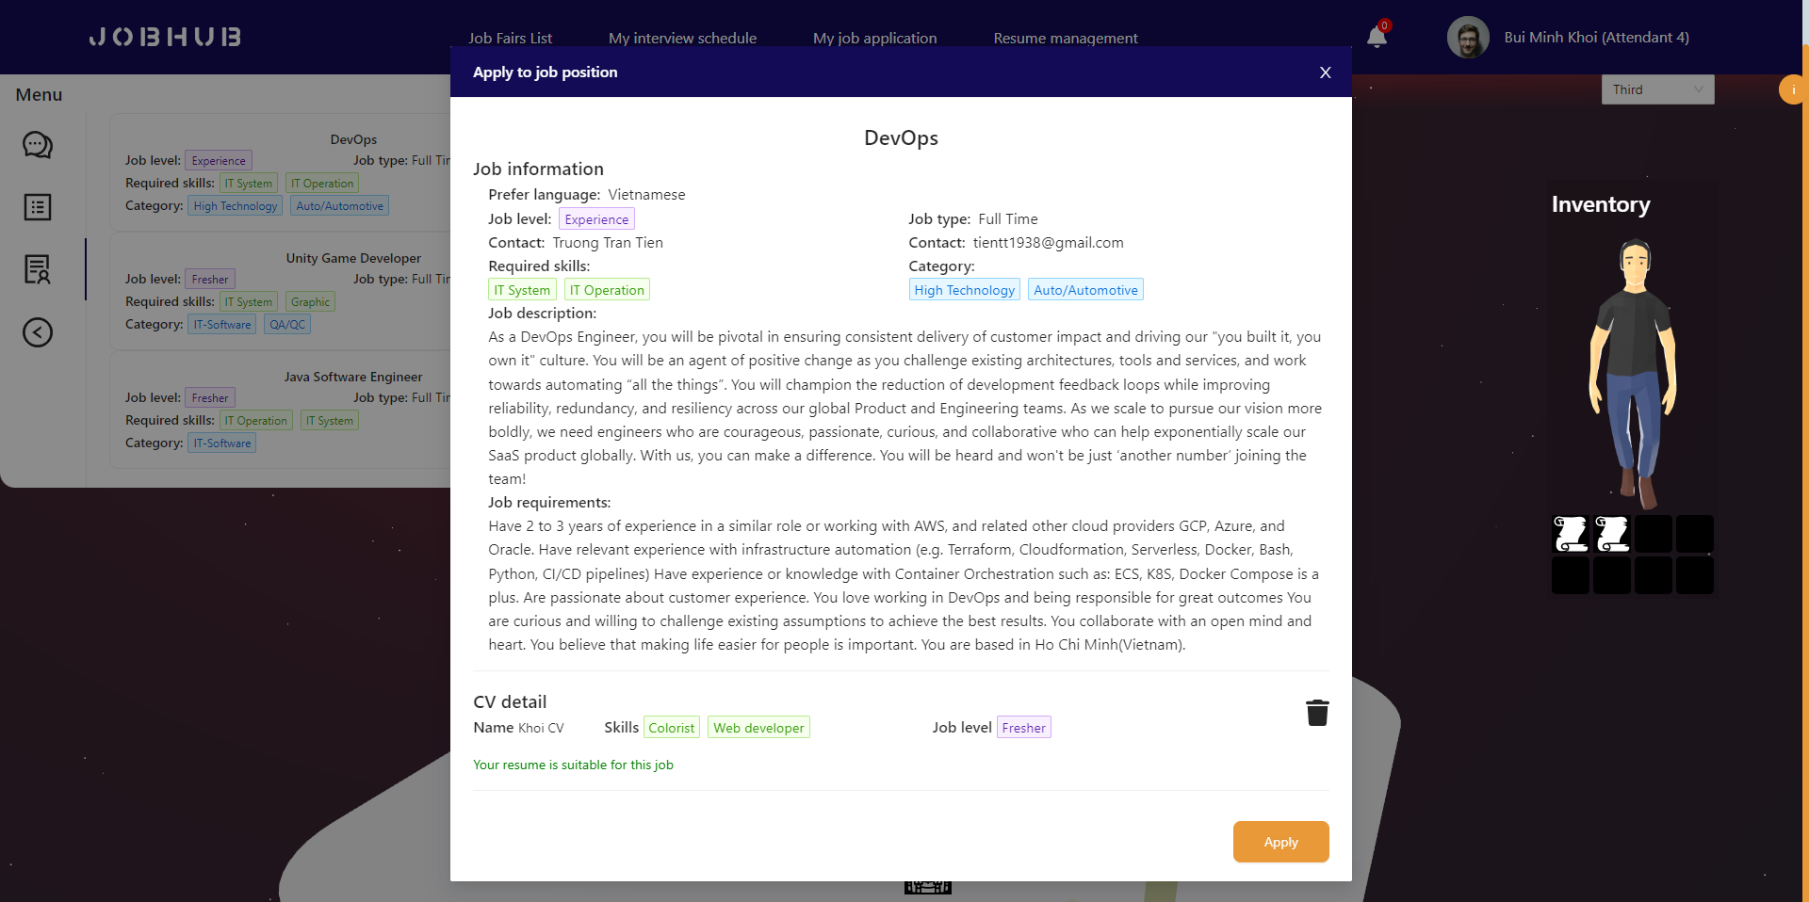

Figure 119. Attendant views job position detail

* If the job position requires test, attendant need to pass the entrance test to submit resume.

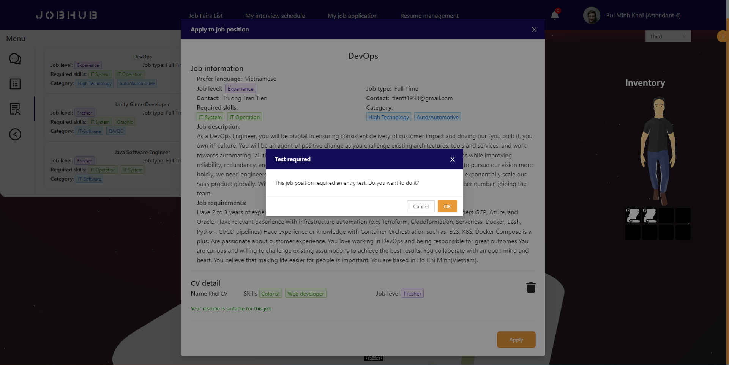

Figure 120. Attendant confirms do test

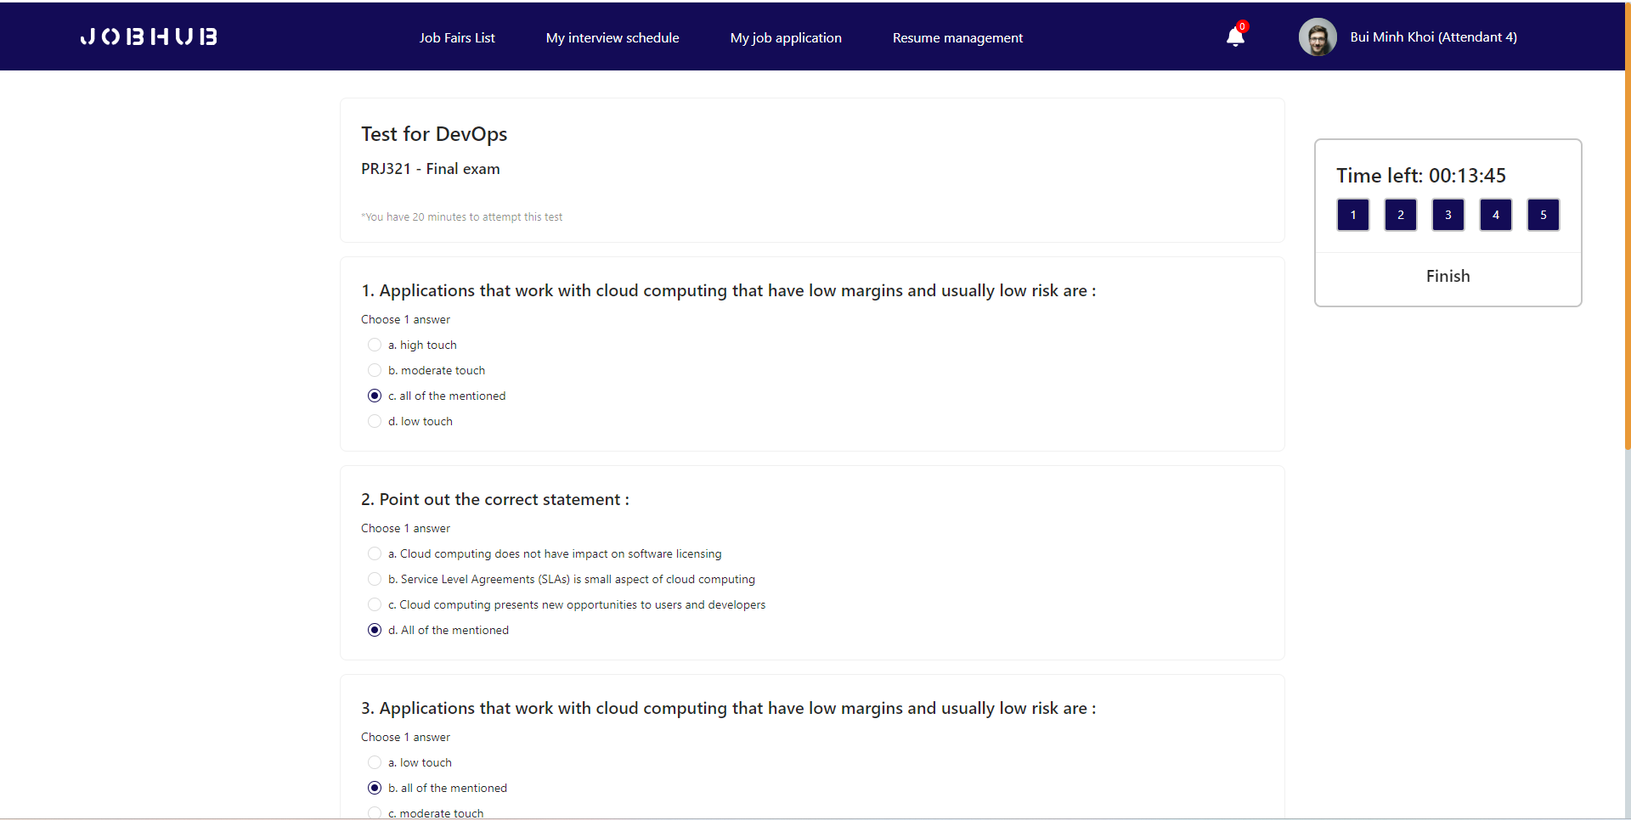

Figure 121. Attendant does test

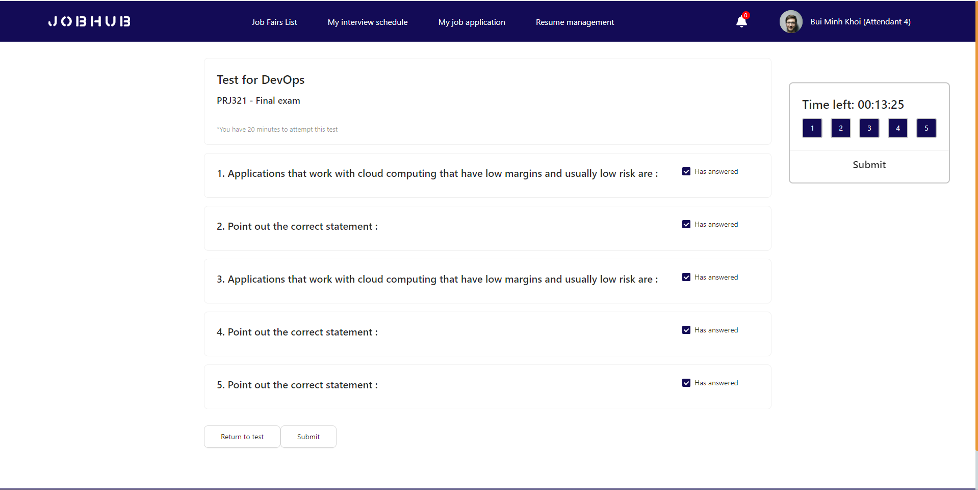

Figure 122. Attendant submits test

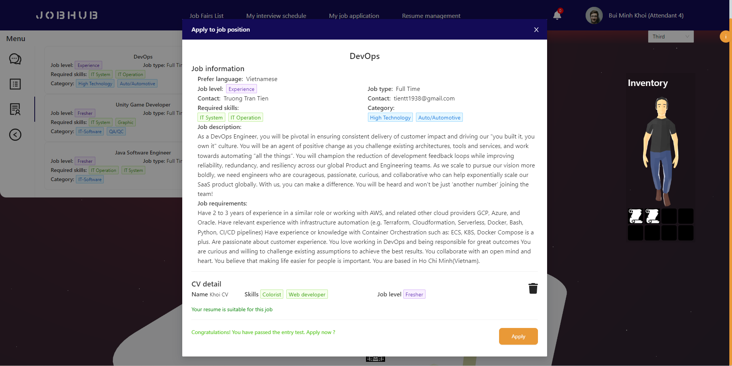

Figure 123. Attendant applies job position

### 3.4 Feature 4 – Interview process

#### Step 1: Interviewer evaluate attendant’s applications

* Interviewers can click “**Interview schedule**” link to get attendant’s applications that submitted to their booth.

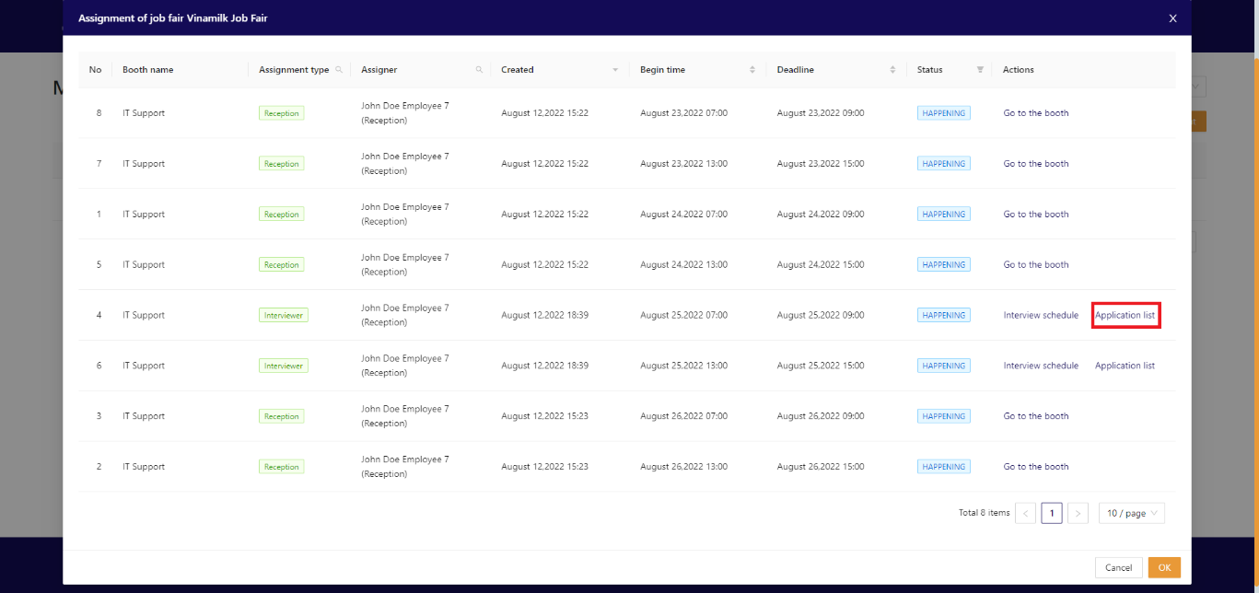

Figure 124. Interviewer accesses application lists

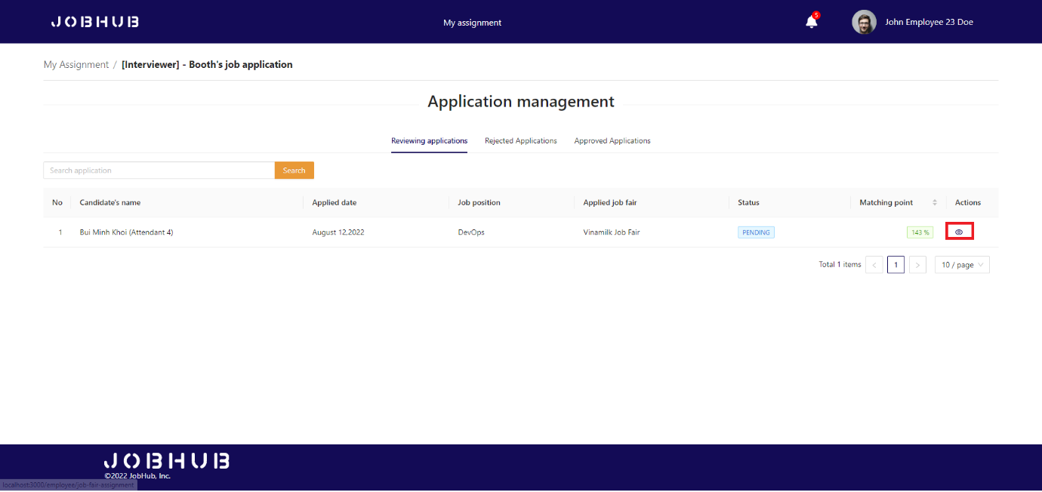

Figure 125. Interviewer views application list

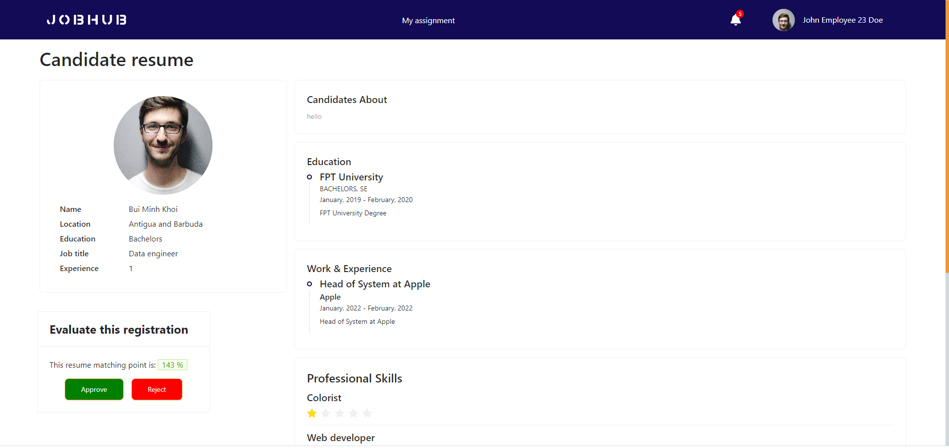

Figure 126. Interviewer views application details

* If application is approved, it will have status is approved and the interview schedule will be arranged automatically for both interviewer and attendant.

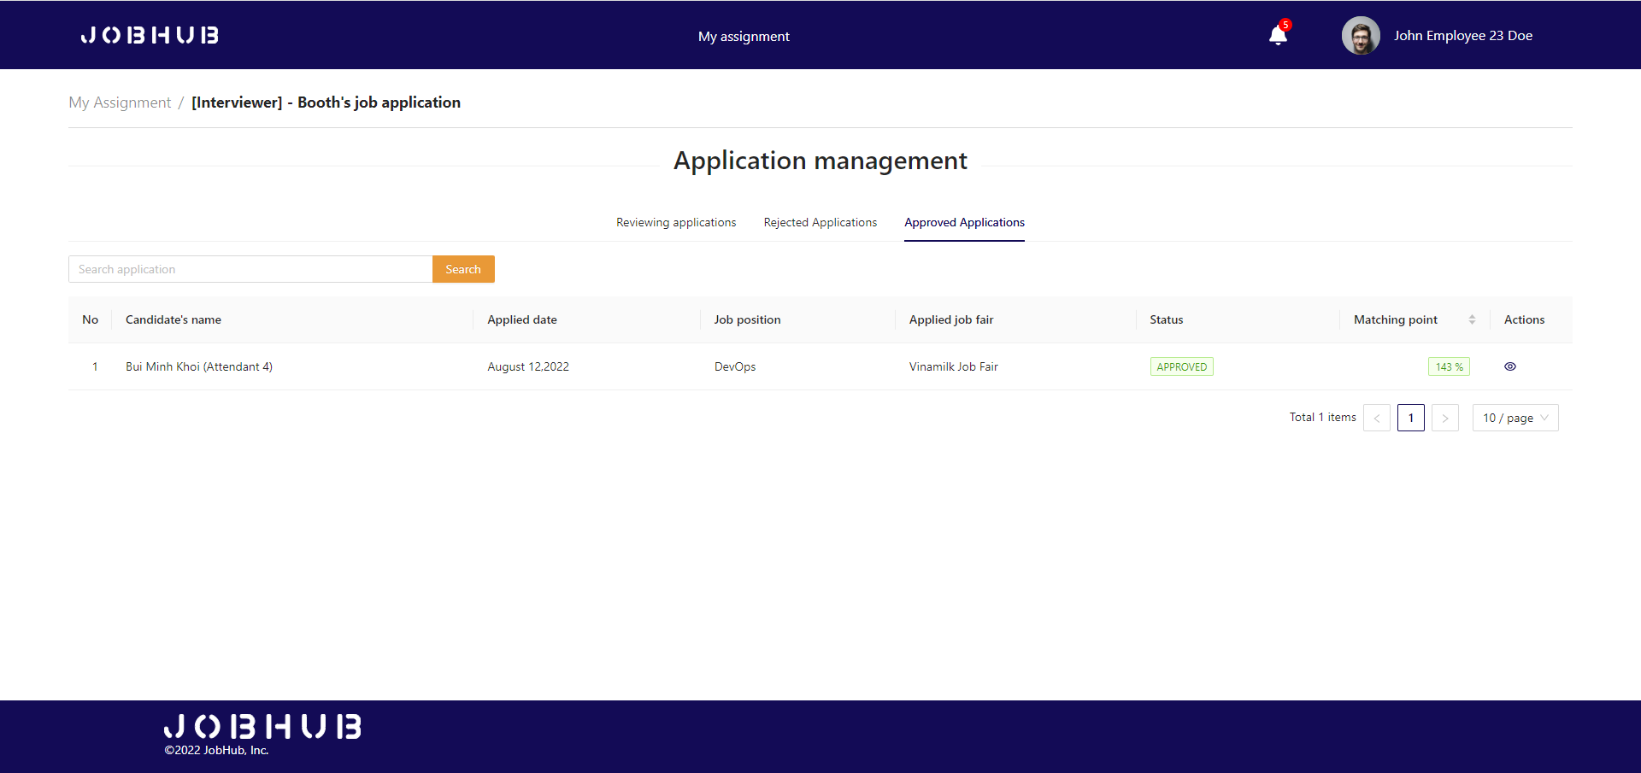

Figure 127. Interviewer views approved application list

#### Step 2: Interviewer click on “Interview schedule” link

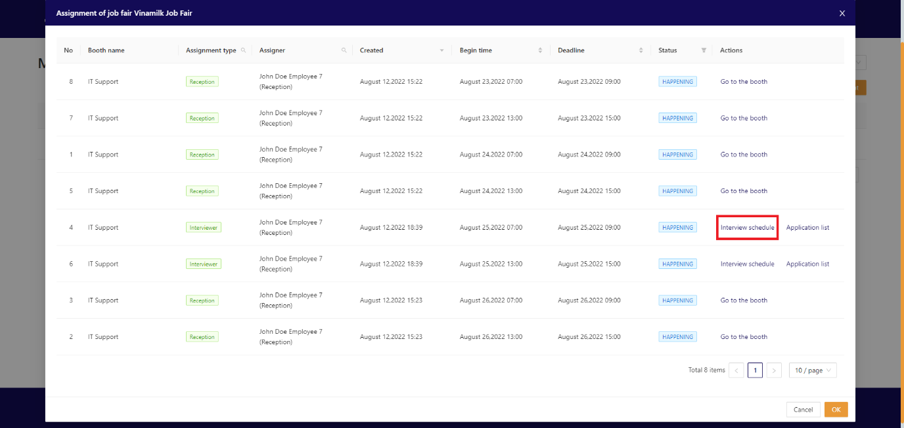

Figure 128. Interviewers accesses interview schedule

#### Step 3: Interviewer click on interview schedule on the table

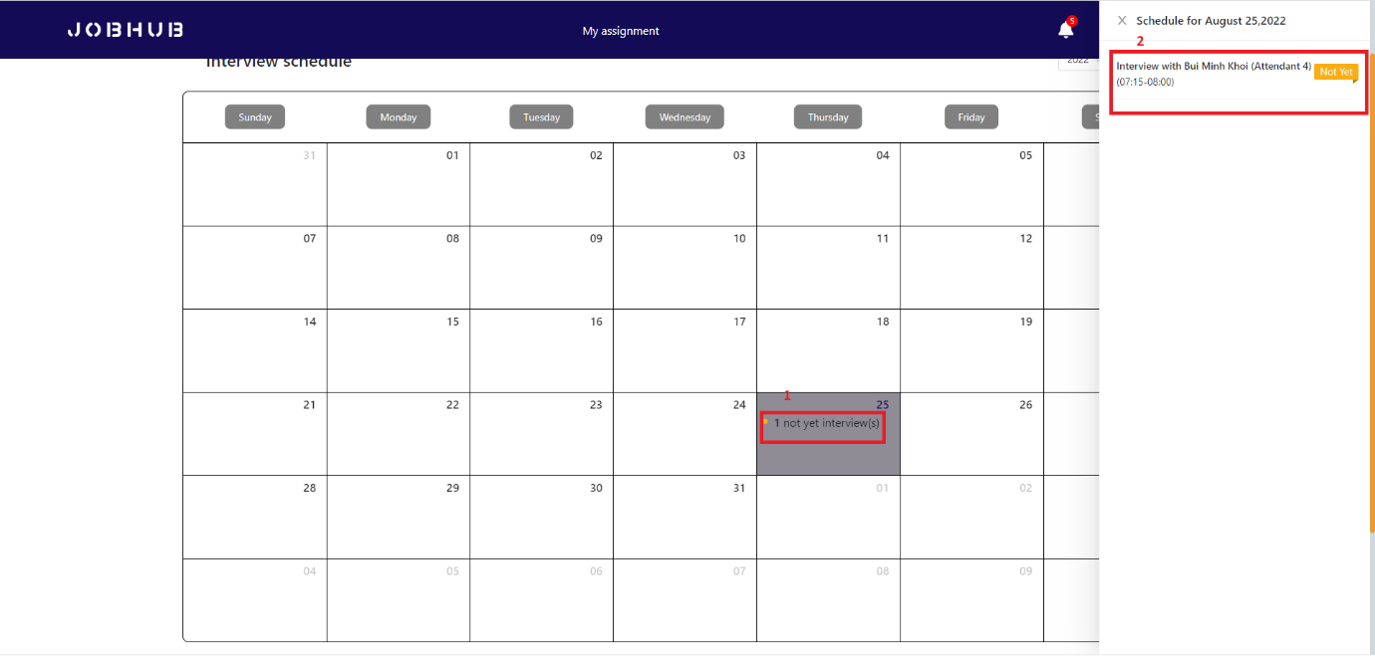

Figure 129. Interviewer accesses daily schedule

#### Step 4: Attendant click on “My interview schedule” on the nav bar

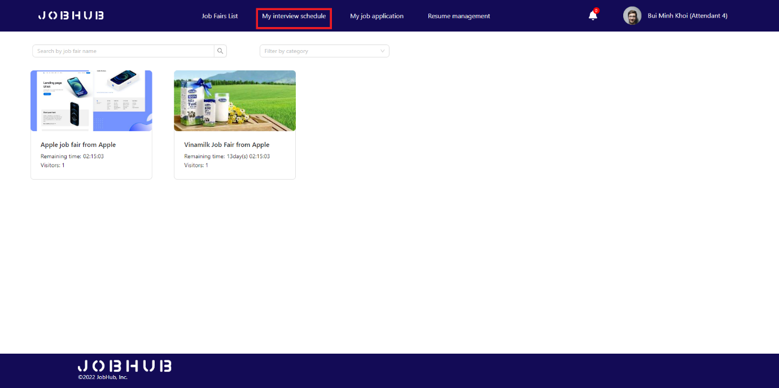

Figure 130. Attendant accesses interview schedule

#### Step 5: Attendant click on interview schedule on the table

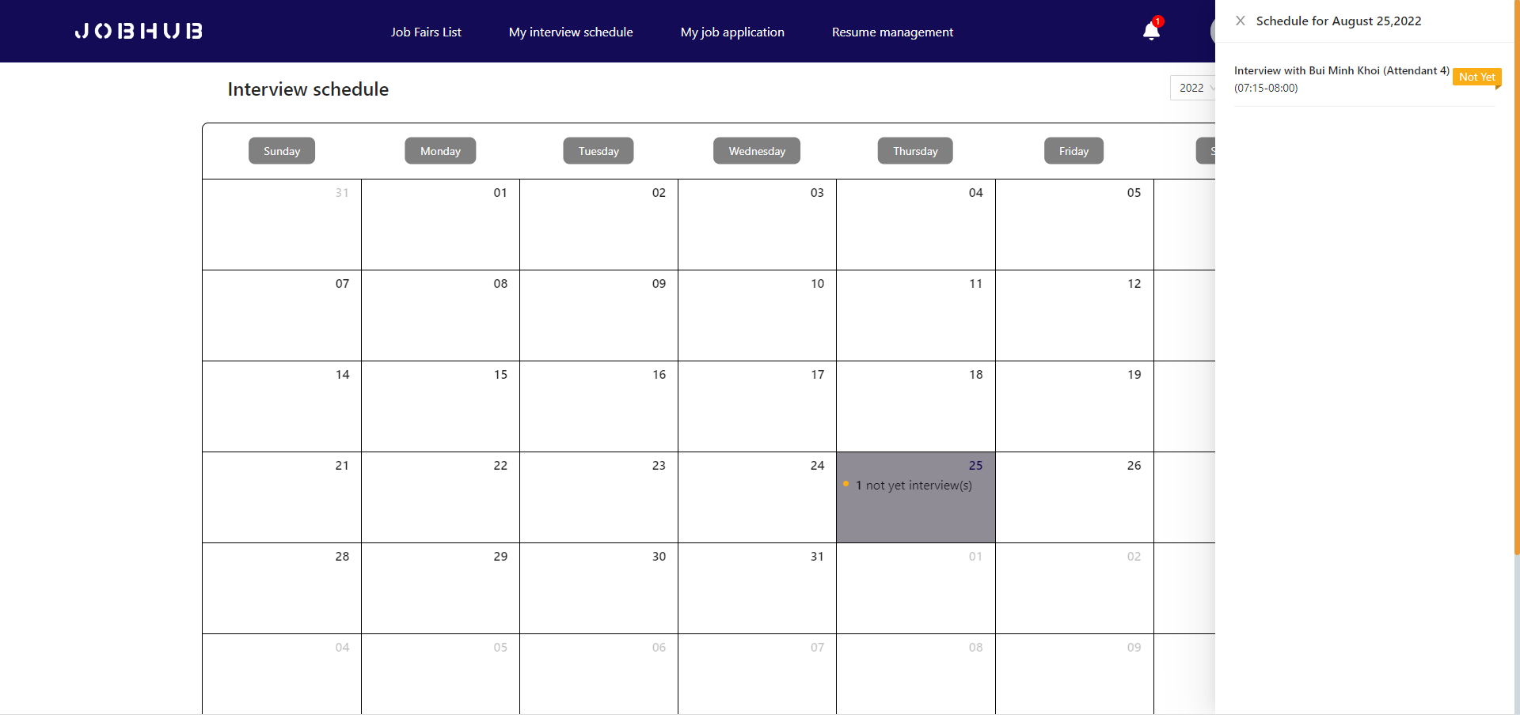

Figure 131. Attendant accesses daily interview schedule

#### Step 6: Interviewer join interview room and send invitation to attendant

* Interviewers click on “**Join interview room**” button to join interview room.

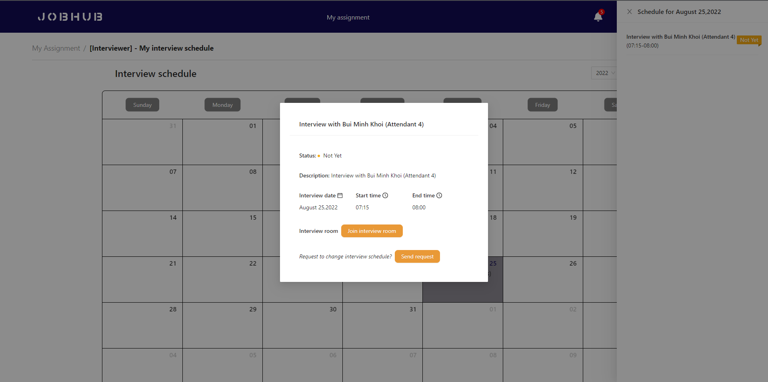

Figure 132. Interviewer joins interview room

* After joining interview room, interviewer can get attendants that are waiting in waiting room.

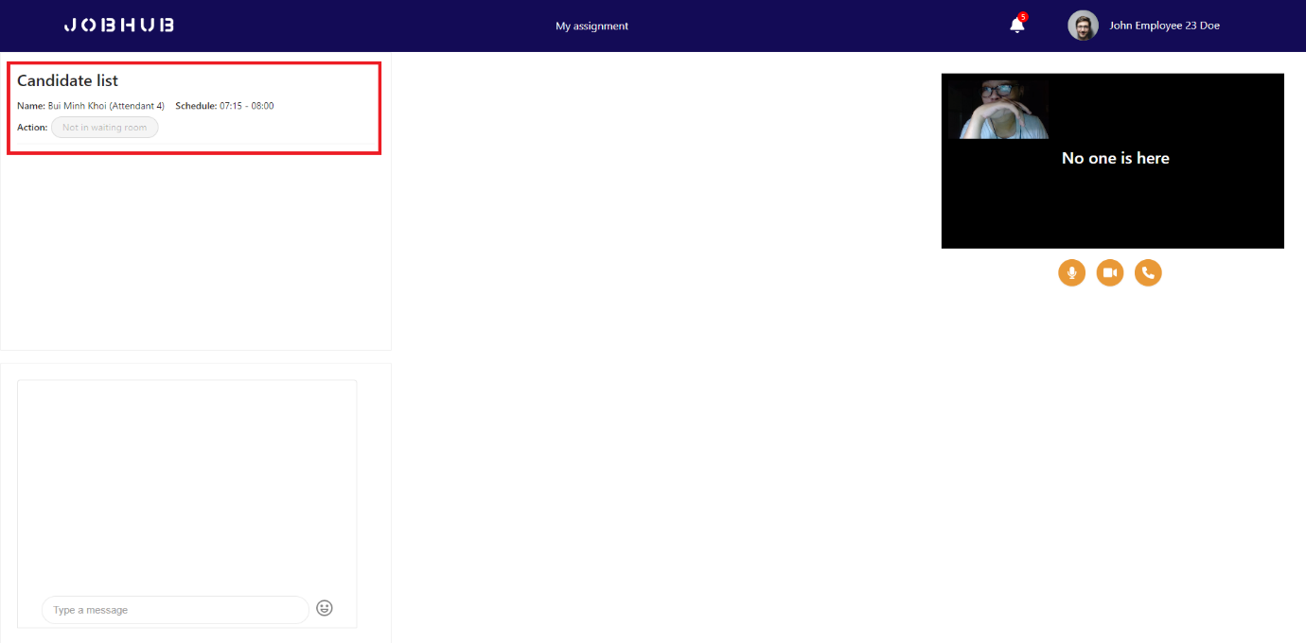

Figure 133. Interview room

* Attendants click on “**Join waiting room**” to join waiting room.

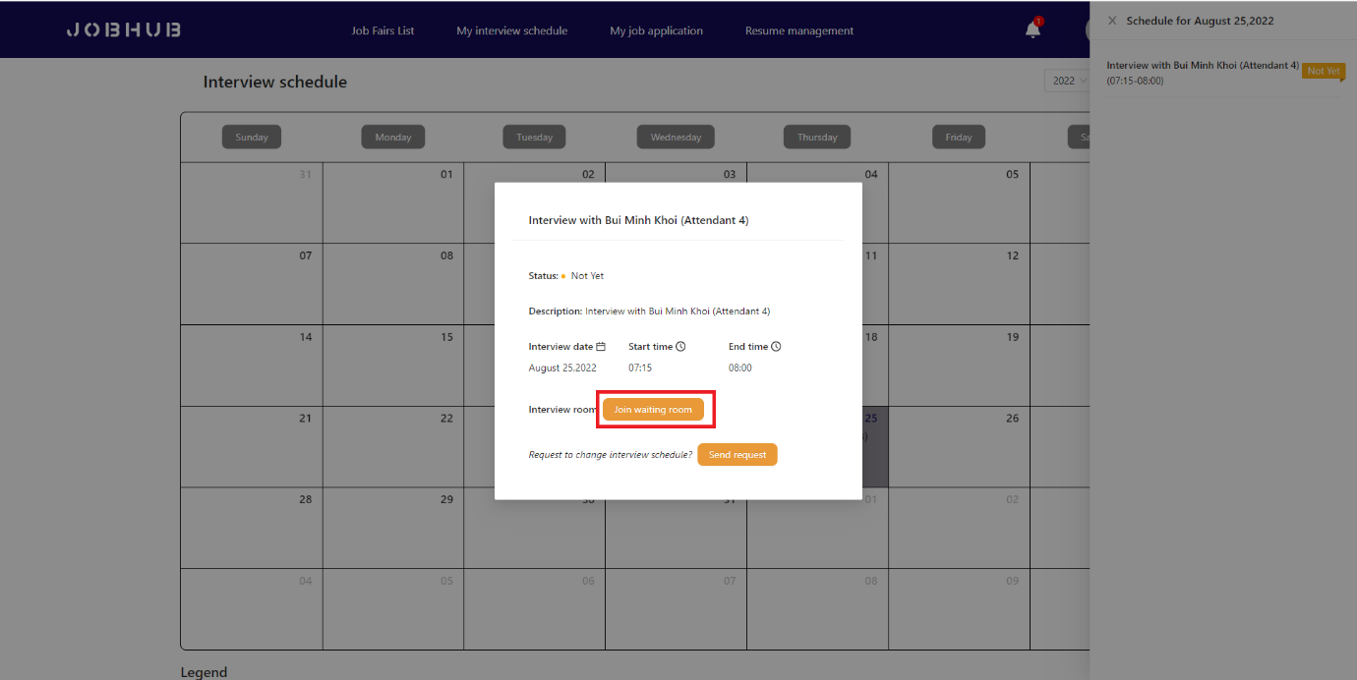

Figure 134. Attendant joins waiting room

* At interviewer aspect, they will see there is an attendant in waiting room. They can invite attendant to interview by clicking “**Invite**” button.

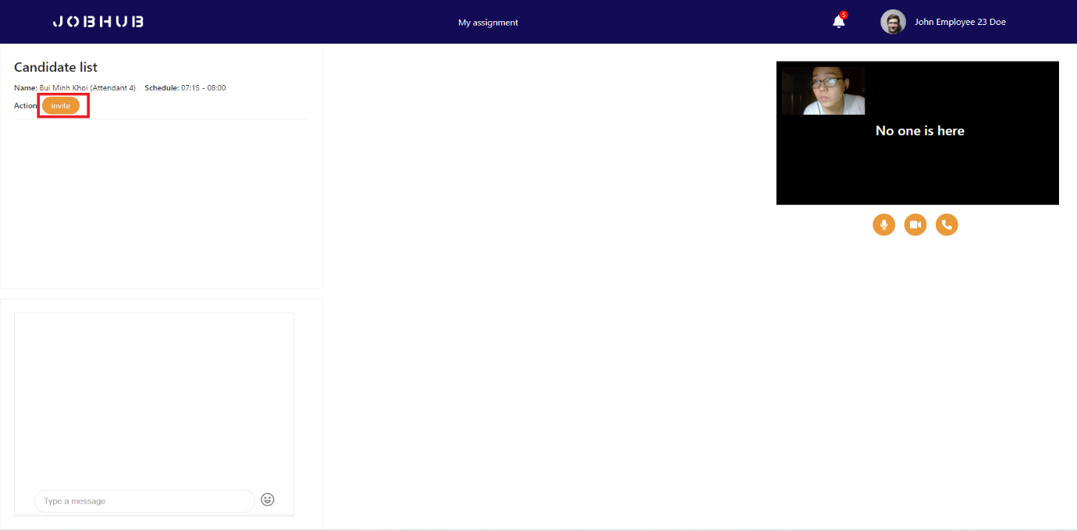

Figure 135. Waiting room

* After interviewer send invitation, attendant will receive notification to join interview.

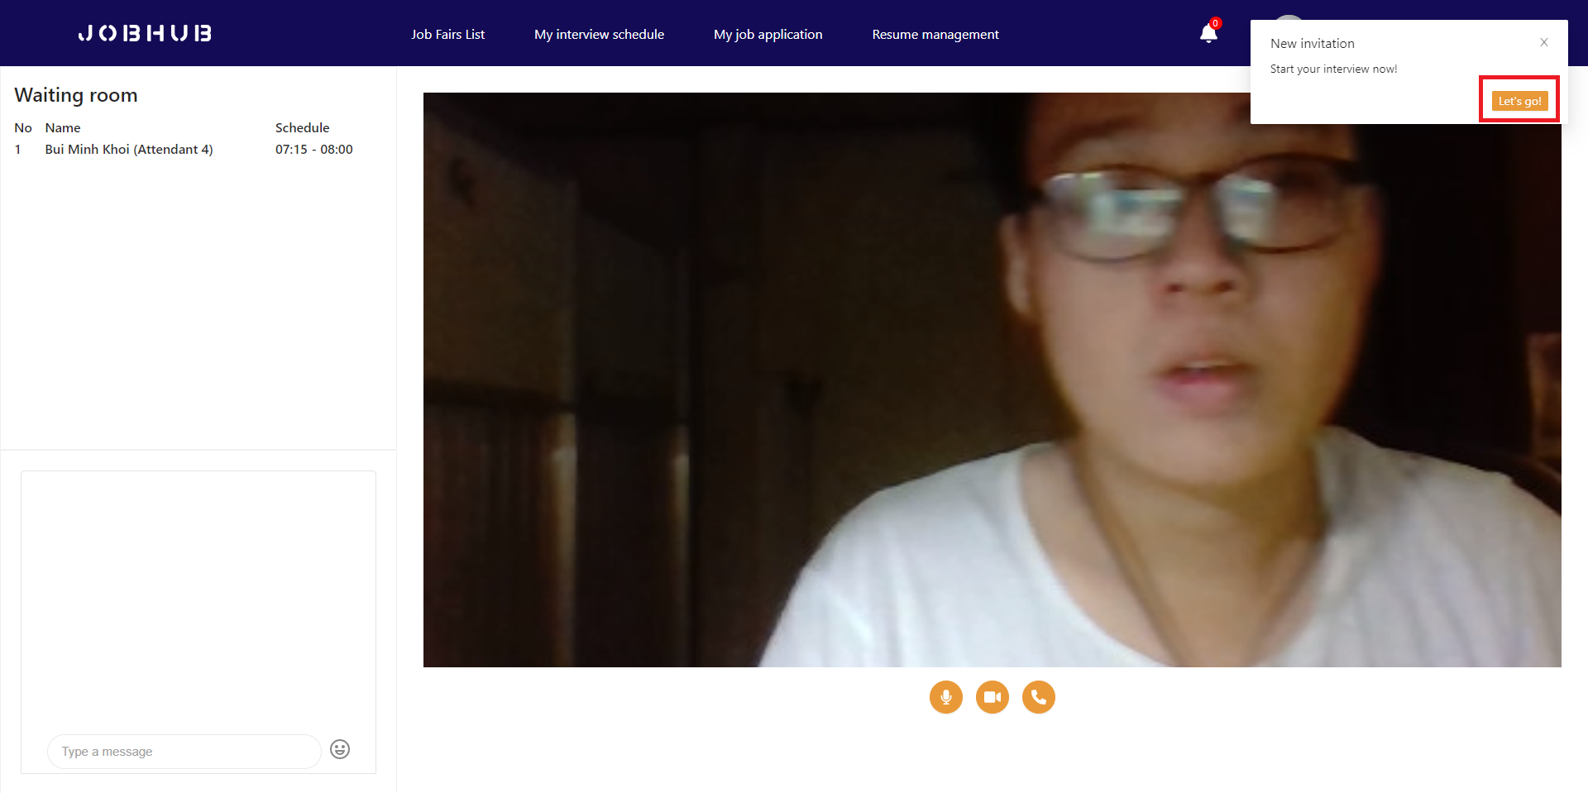

Figure 136. Attendant accepts interview invitation

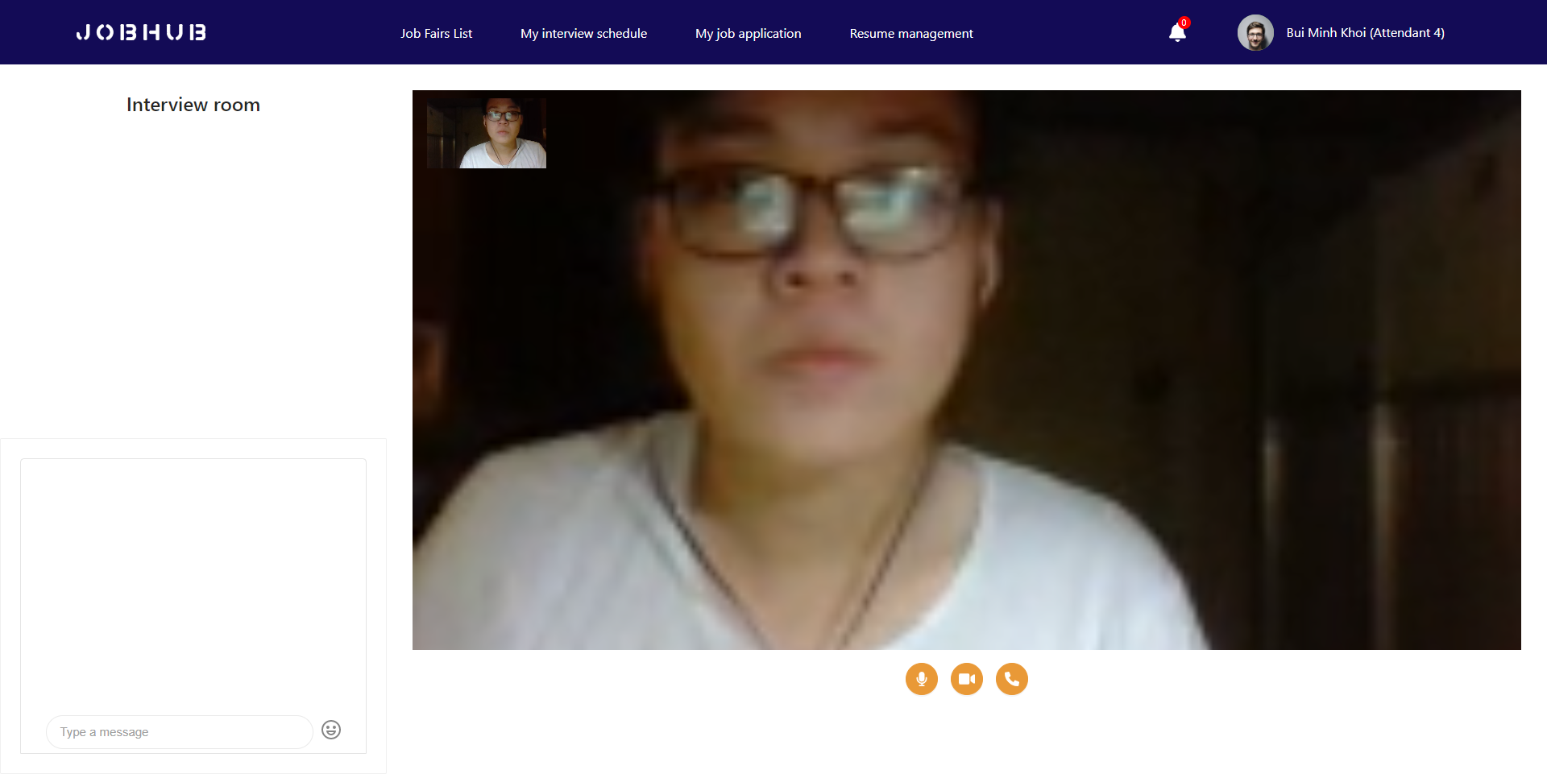

Figure 137. Attendant joined interview room

#### Step 7: Interviewer start interview

* After attendants join interview room, interviewers click on “**Start**” button to start interview.

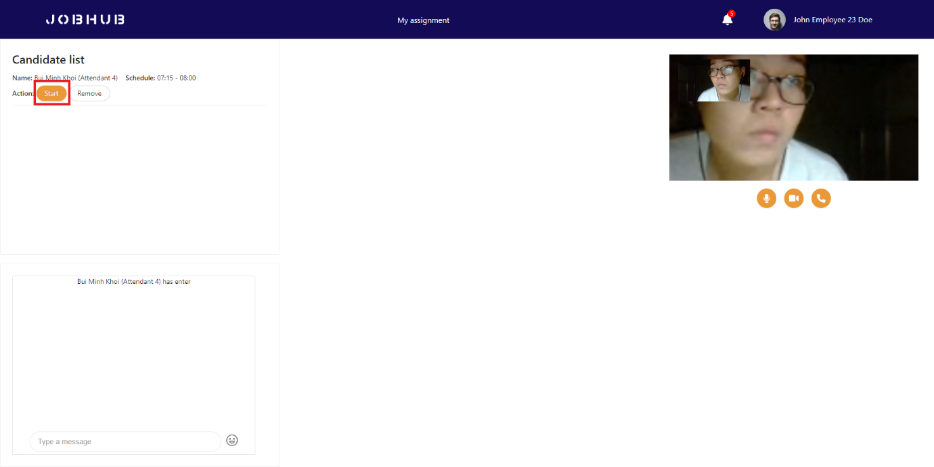

Figure 138. Interviewer starts interview

* During the interview process, interviewer can take interview report and view attendant resume.

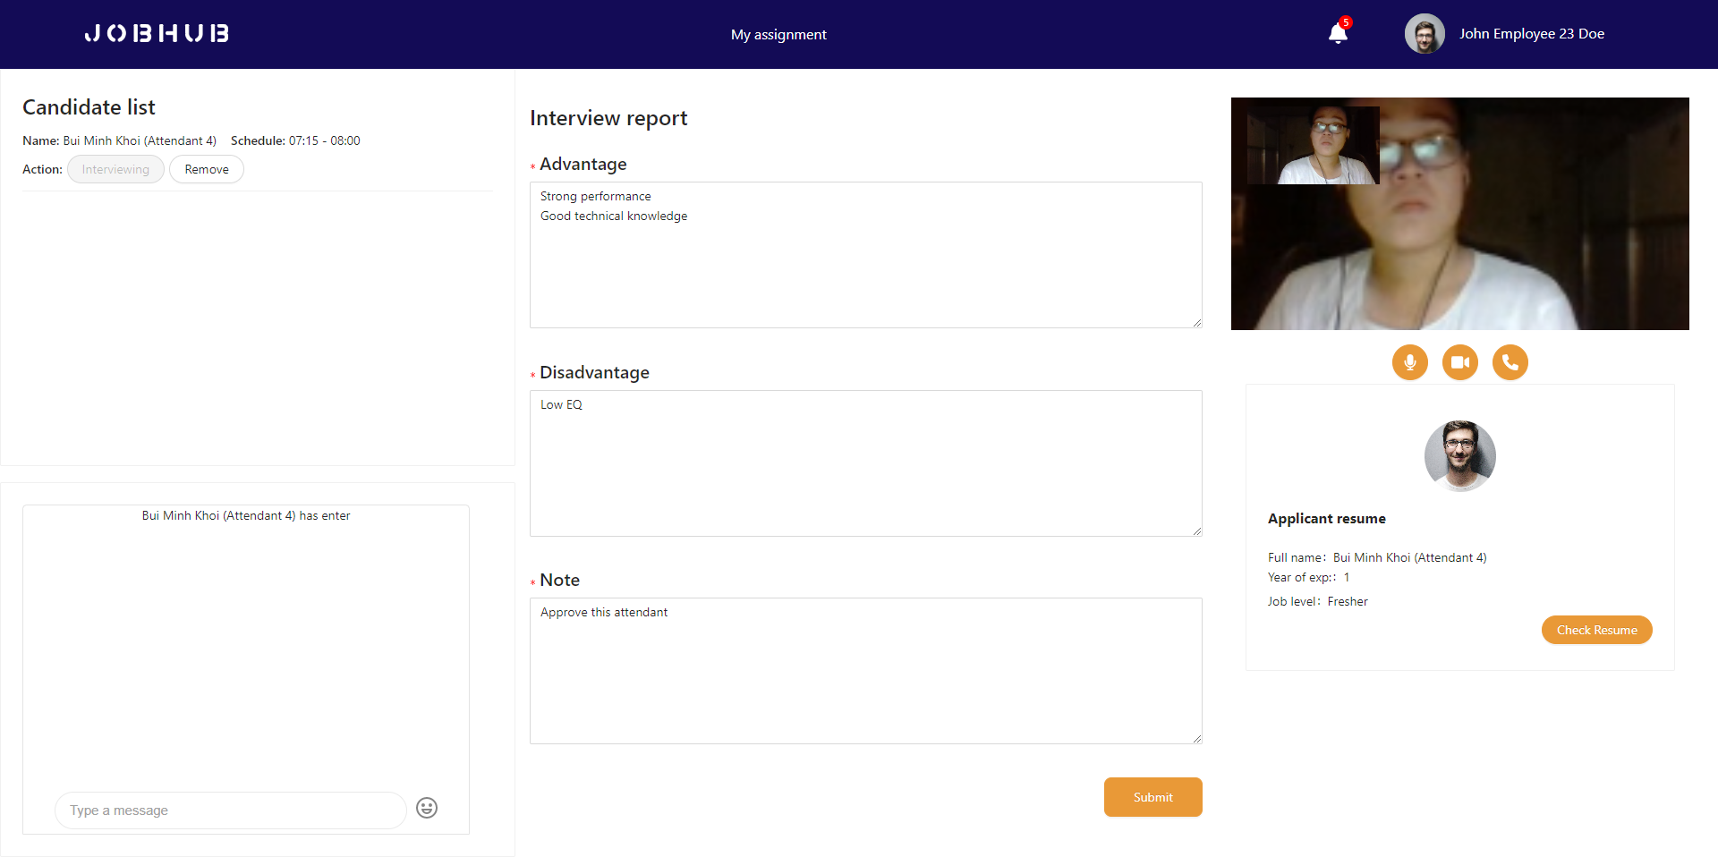

Figure 139. Interviewer takes report

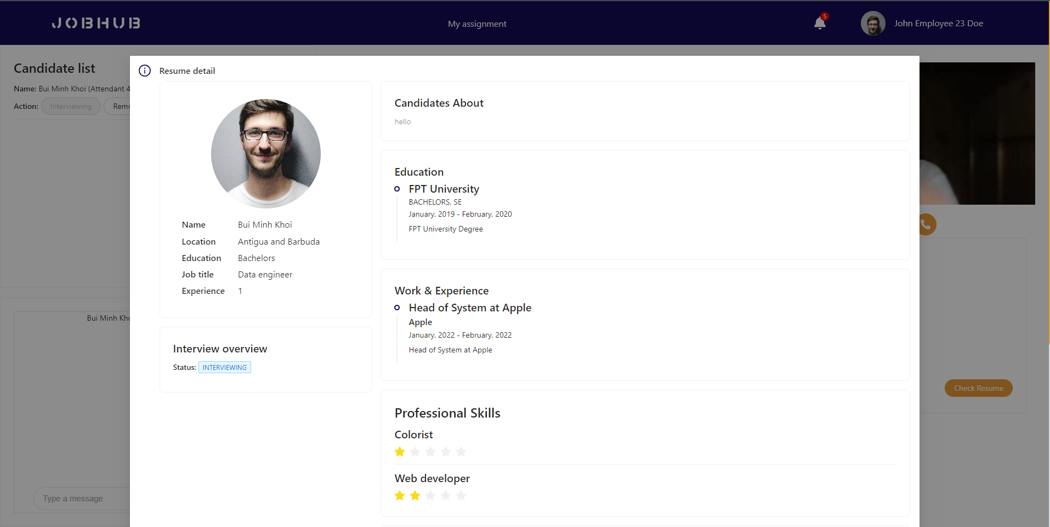

Figure 140. Interviewer checks attendant’s cv

* After finish, interviewer can submit interview result and end interview process.

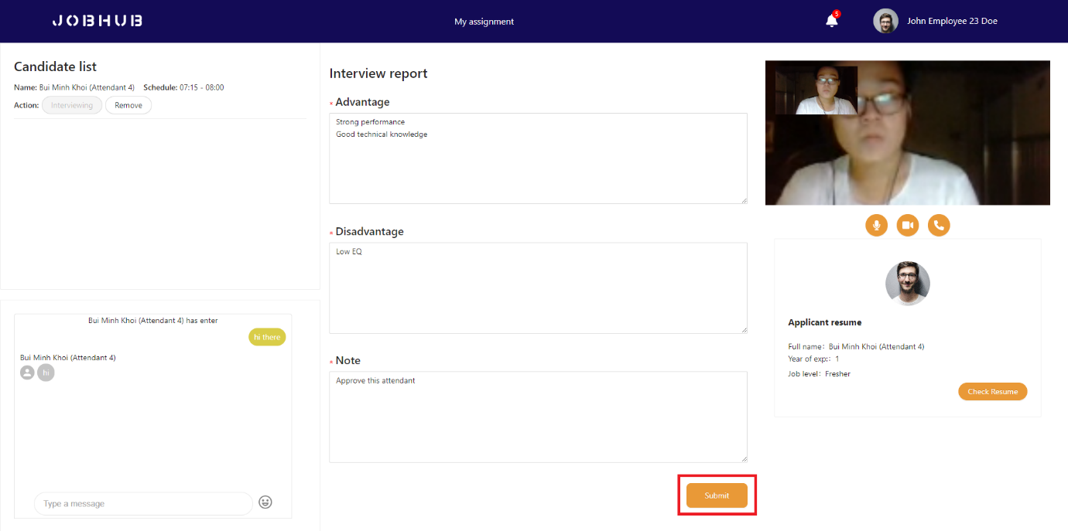

Figure 141. Interviewer submits report

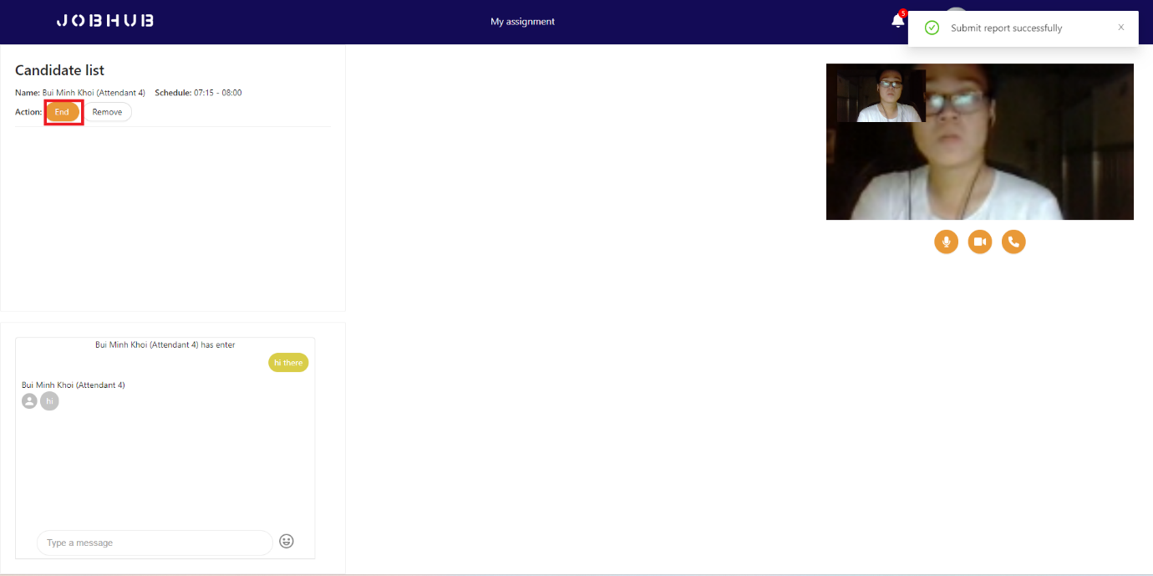

Figure 142. Interviewer ends interview

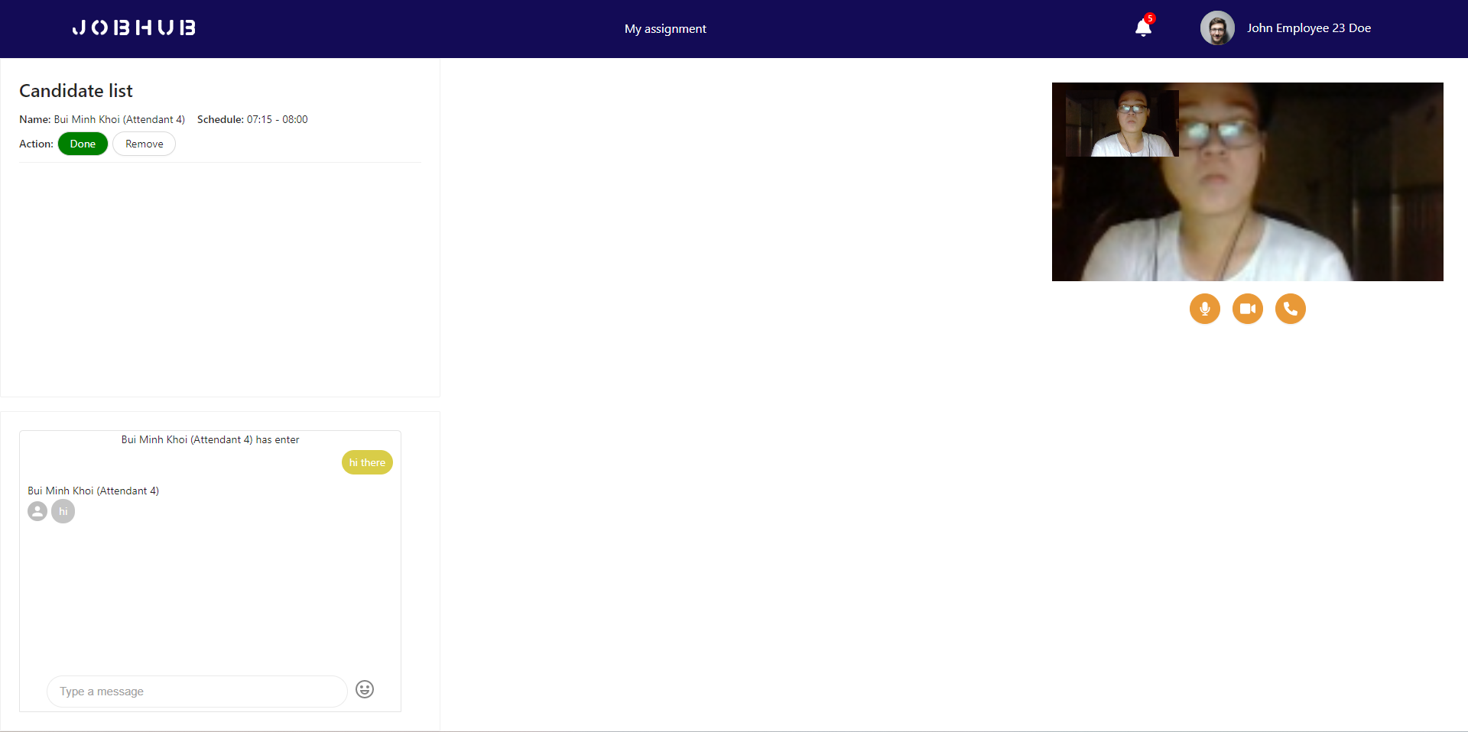

Figure 143. Interviewer removes attendant

***Interview process is done now.***

***Attendant’s aspect***

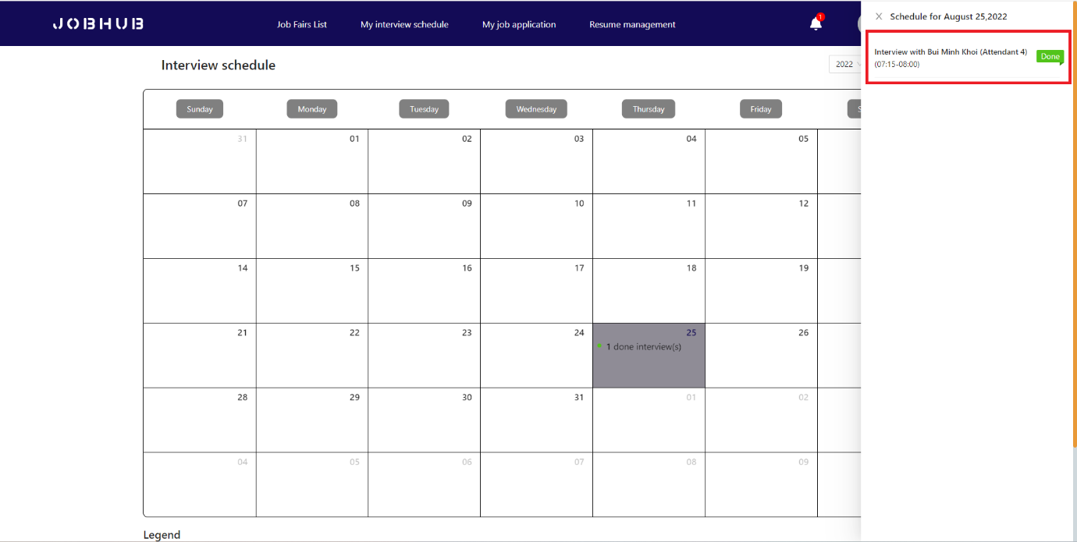

Figure 144. Attendant checks interview status

***Interviewer’s aspect:***

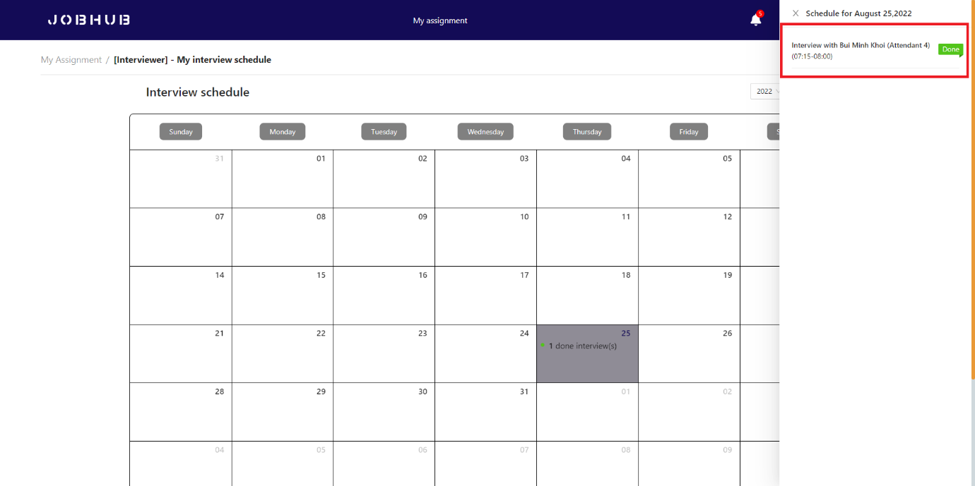

Figure 145. Interviewer checks interview status

### 3.5 Feature 5 – Job fair statistic

* During job fair period, Company Manager can view job fair statistic.

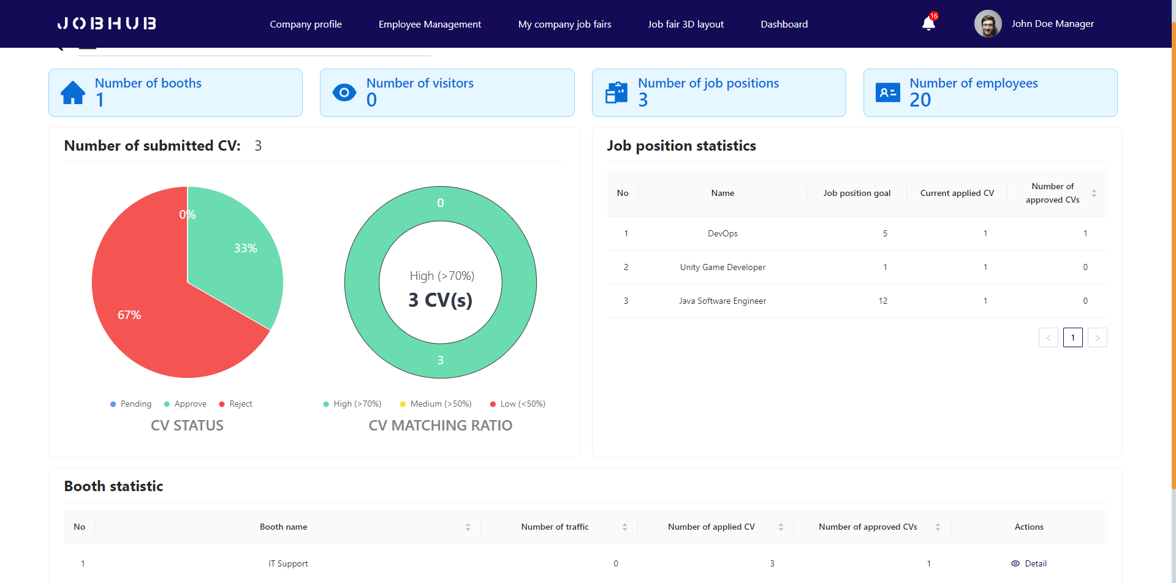

Figure 146. Job fair statistics page

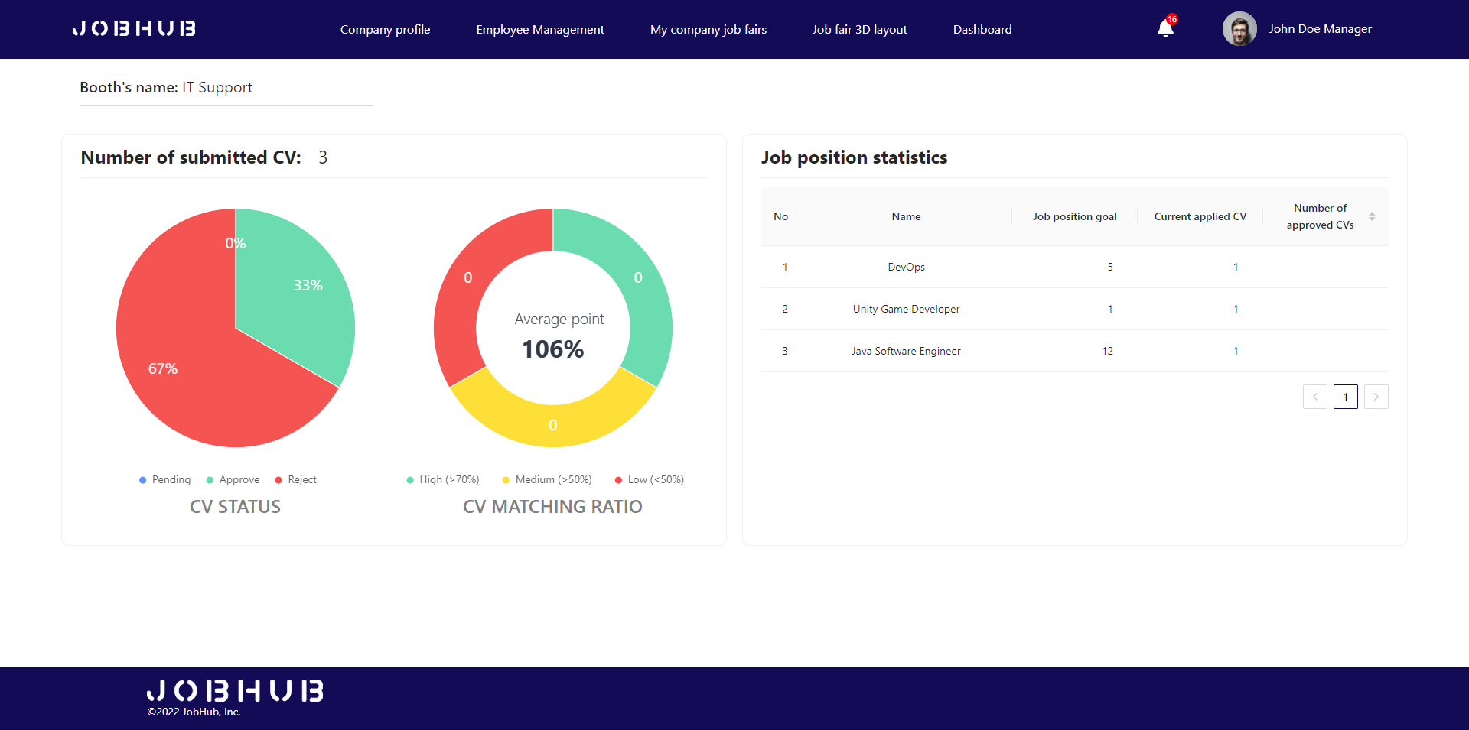

Figure 147. Booth statistics page

1. References: <https://vietnamnet.vn/en/vietnams-rise-in-digital-transformation-798977.html>
2. References: <https://tuoitre.vn/truong-hoc-mien-tay-dua-gan-1-000-hoc-sinh-giao-vien-vuot-100-cay-so-du-ngay-hoi-tu-van-tuyen-sinh-20220417093114704.htm>
3. References: <https://topdev.vn/blog/bao-cao-thi-truong-it-viet-nam-nam-2021/>